Africa Regional Management Committee Meeting

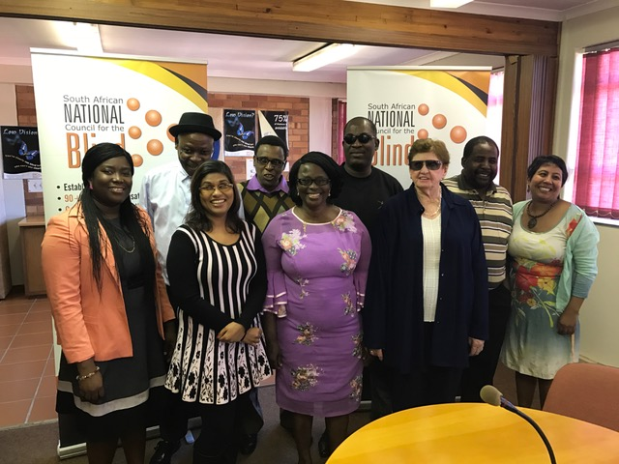

ICEVI Africa had its first face to face management committee meeting on the 18 and 19 April 2017 in Pretoria South Africa for this Quadrennium. The meeting was chaired by Gertrude Oforiwa Fefoame, Chairperson of ICEVI Africa and was well attended. The South African National Council for the Blind as they did in the last Quadrennium once again hosted the meeting at their offices and two of their employees attended the meeting as observers. The First Vice President of ICEVI, Dr Praveena Sukhraj-Ely attended the meeting in an ex officio capacity to support the deliberations and discussions and to provide guidance. Nafisa Baboo, (Management Committee Member) from Light for the World, Martin Kieti (Vice Chairperson) from Perkins and Gertrude Oforiwa Fefoame (Chairperson) from Sight Savers ensured that the voice of the international partner members were heard, whilst Miss Cathy Donaldson and Mr Komivi AYASSOU, country representatives of South Africa and Togo respectively also made significant contributions to the meeting discussions and action items.
Some of the significant decisions taken at the meeting were that ICEVI Africa will be registered as a non-profit company in Kenya once its Constitution is finalized. Further, focus will be given to country champions and the role that they can play to further the objectives of ICEVI in Africa. Moreover, using the discussions of the strategic planning of ICEVI held in February 2017, ICEVI Africa has finalized its strategic plan, goals and work plan for this Quadrennium. It is envisaged that ICEVI Africa will be playing a significant role and will have increased visibility in the next Africa Forum.

