Recognising ten years of English-Spanish translation

On behalf of the ICEVI Executive Committee, we extend our sincere appreciation to Ms Judith Varsavsky and Ms Gimena Blesa for completing the English to Spanish translation of the July 2008 to July 2017 Volumes of ICEVI’s Journal, The Educator. The accurate translation of each volume required great attention to detail, editing and proofreading. Judith and Gimena’s substantive contribution was undertaken without remuneration and has enabled Spanish readers around the world to access ten years of The Educator via the [ICEVI website.

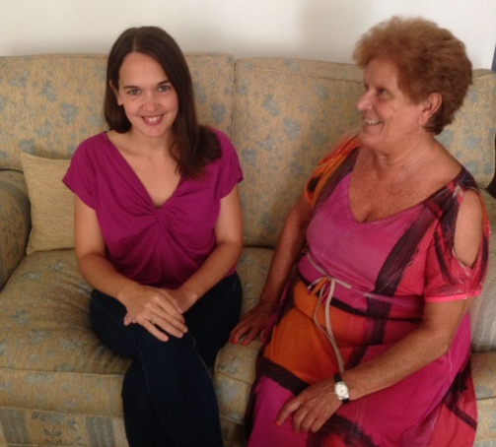
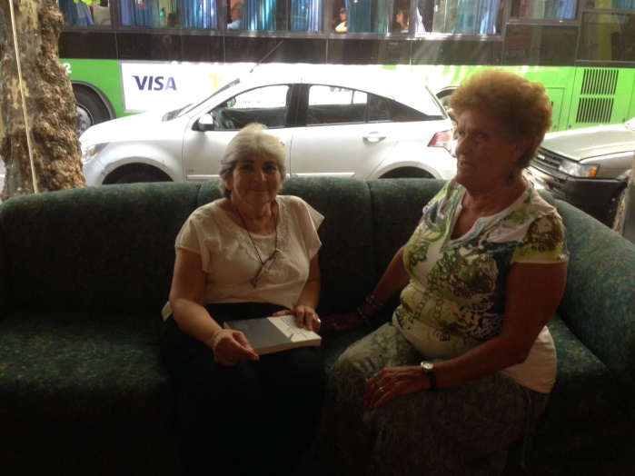
Ms Judith Varsavsky with Cristina Sanz Ms Gimena Blesa with Cristina Sanz

