CON 2006

Survival as rehabilitation for people
with a visual impairment

Drs. A.E.M. Blokker
Netherlands
annemiekeblokker@visio.nu

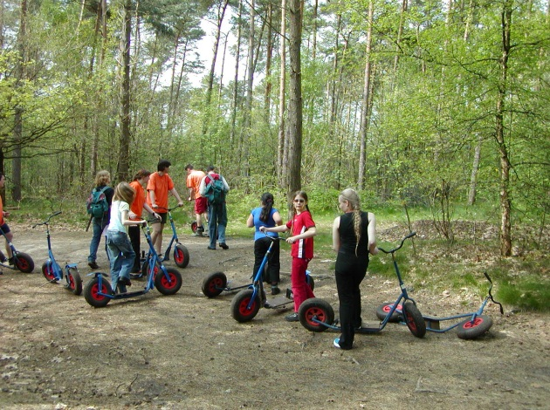

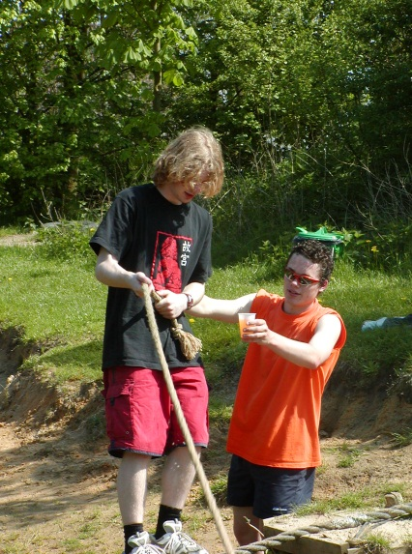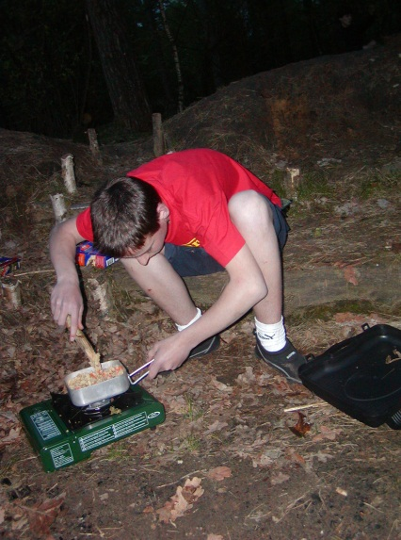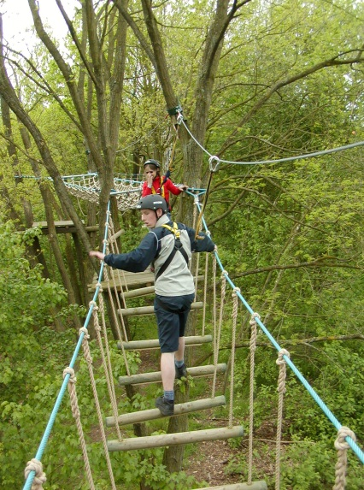

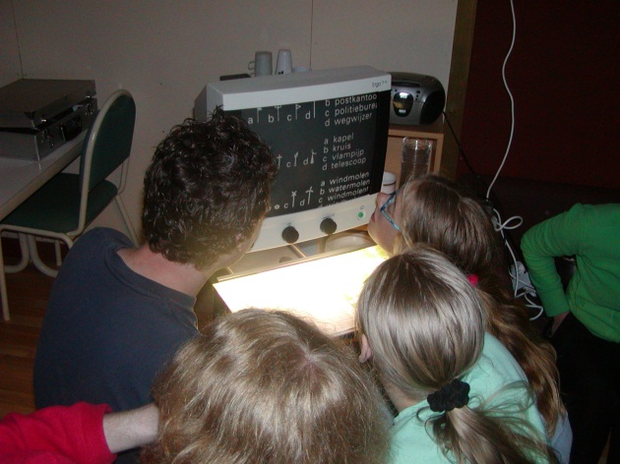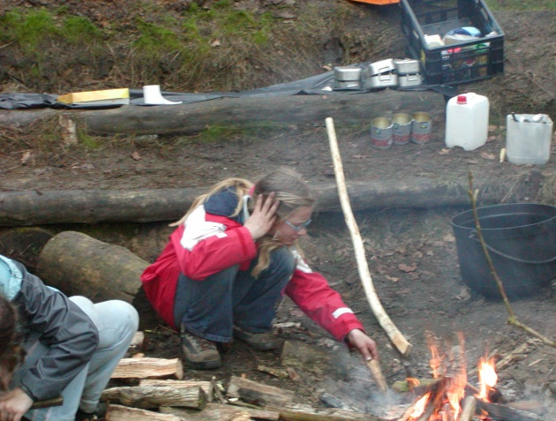

Our vision on survival
A survival course takes people out of their everyday patterns and if possible maybe even out of hospitalization. Due to the out-of-the-ordinary activities they experience during a survival course it is difficult to relate back to the normal everyday life. This generally, makes people more open-minded to the new situation, which makes it easier to encourage and dare them to take on challenges and experience success. By afterwards drawing parallels with society, we set out to enhance their self-confidence and promote the development of a positive self-image.

Survival as rehabilitation: The aim of a survival course with visually impaired people
The aim is to give people with a visual impairment a better foundation for functioning independently in society. By promoting self-confidence, assertiveness and a sense of personal worth, we strive to positively influence various aspects of life, such as, independent living, work or schooling.

Possible survival activities
Challenging activities include:
- Stacking crates
- Step photo trip
- Finding the way home
- Challenge course
- Building a raft
- Making a fire
- Canoeing
- Archery
- Coordinates trip/GPS trip
- Overnight stay in the woods
- Climbing/securing (safety)
- High rope course

Appendix 1, Rehabilitation objectives and required adjustments for survival activities, summarises the activities and rehabilitation objectives and the changes required to be able to offer an activity to visually impaired participants.
The current activities do not require significant adjustments for people with a ‘minor’ visual impairment. Severely visually impaired and blind people possibly need more adjustments, instructions might have to be adapted and one or two activities may not be feasible.

Visio’s expertise
Visio’s expertise in the field of the visually impaired and the blind, provides an excellent basis for supervising and supporting clients during survival activities.
This includes:
- mobility training
- knowledge of syndromes and their effects
- knowledge of available aids
- experience with coping problems that visually impaired people may have
- experience in the field supervision and explaining to third parties.

Rehabilitation aspects of the week
- Self-confidence
- Learning to set, discover and surpass boundaries
- Recognising your limitations, but mainly focusing on your capabilities which improve the development of a realistic self-image
- Learning from each other
- Teamwork, cooperation
  - For schoolchildren and people active in the labour market
- Physical effort
  - Finding a sport is often difficult, which does not help to promote good physical condition
- Encouraging body awareness, motor development
  - Balance tasks
- Taking responsibility: cause and effect
  - If you don’t take good care of your gear, you lose things and then there may, for example, be nothing for you – or even worse, the whole group – to eat!
- Learning to be assertive
  - Learning to tell a dominant member of the group that you are tired during a hike.
  - Indicating in a normal way that you are not happy with something rather than swearing or saying nothing
- Learning and experiencing structure
  - Cooking in the woods
  - Keeping your own gear in order and being able to pack your case again at the end of the week
  - Putting things away before it gets dark or even worse before they disappear under the sand
- Increasing self-reliance
  - Discovering your own abilities
- Training activities for daily life and mobility
  - Cooking your own meal
  - Walking in different surroundings
  - Using a stick

Nature education, visualisation
  - Touching and smelling plants and animals
  - Discovering and experiencing different materials
  - The weather

Having a group of people with visual impairments spending time together for a while makes it easier to learn from each other and helps to put the group or an individual into a desirable rehabilitation situation. In this kind of environment, people can cross thresholds: walking with a stick, for example, or realising that listening to a spoken book can be a really relaxing activity, or that you can still take on a lot of things yourself and don’t have to sit around at home all day.

Target group
- For young and old
- For people with or without a visual handicap
- People who don’t know each other
Improves the social network and the visually impaired don’t feel like outsiders
- For the visually impaired and family/friends/volunteers.
So that people come to understand more about how others function
- Both visually impaired and intellectually disabled clients

But also for people with:
- acceptance problems
- work related problems
- behavioural problems

Organisation:

The team:

Survival instructor
The survival instructor is responsible for the whole operation and for the coordination during the week. This starts with putting the programme together and selecting activities that are in keeping with the participants’ learning (rehabilitation) objectives.
The survival instructor is also responsible for the safety of participants and other supervisors who have no experience or have not participated in a training course at SBP Outdoor.
The survival instructor explains the activities and supervises them in a responsible way. He/she has overall responsibility for the equipment.

Occupational therapist:

An occupational therapist identifies the individual’s problems through observation. As a result, adjustments can be made and a e.g. specific aspect of an activity can then become the subject of training. The client can then be taught to think in terms of solutions and to make effective use of the available options.
The activities and participants’ responses are subsequently evaluated and current options are used to draw parallels with society.
Occupational therapists are also in an excellent position to estimate the skills and limitations of the individual clients as well as those of the group.This can help to decide whether a particular task is offered or not offered during the course, to make the right teams, or to adapt the task related instructions and explanations.
Afterwards, tasks or activities can easily be linked to practical everyday situations.

Social worker

A lot happens in a week like this and participants will surpass their boundaries – mentally as well as physically. It is therefore recommended to have a social worker available. The occurring developments can be discussed individually or in a group.
A social worker can also keep an eye on group processes during the week and make appropriate adjustments. Are the quiet children being given enough of a chance? What is the ‘big mouth’s’ background? What do people think of walking with a stick and how is it different to using a stick at home?
Before and after the survival week a social worker goes through a questionnaire with each participant. This includes questions on what participants want to achieve, what they think they can’t do, and what they think of themselves. Each participant’s personal functioning is given a rating. The questionnaire results can be used as a basis for setting personal rehabilitation goals for the week.
The questionnaires help in the evaluation of personal development and the achievement of the rehabilitation goals set at the start. Thus providing an insight into the process participants have gone through.

CIOS students
The work placement students from CIOS (a multi-campus institute for sport and movement education) are not only skilled in explaining the activities but are also trained to spot potentially dangerous situations. They give the survival instructor an extra pair of eyes to help activities run smoothly. CIOS students can also assist in helping setting up or clearing away equipment and preparing activities.

Domestic services
To ensure that the rest of the team can focus on the group and the processes taking place within it, it is good to have someone available to take care of the general shopping, the food and, if it is not part of the actual survival programme, the cooking.

Programme
A draft programme is prepared.
This can be adjusted, if necessary, following the daily evaluation in order to create better training situations or dilemma scenarios.
Activities dealing with aspects such as mobility, ADL and coping/dealing with a handicap are also incorporated into the programme.

Other survival week objectives
- New products from suppliers could be tried out during a week like this, e.g. the ‘Tracker’ (a GPS system for blind people). The supplier could then sponsor the equipment used
- A one-day course
- With a class that includes a visually impaired child
- Family day
- Course on camping: ‘camp coordination’, ‘tent troubleshooting’, ‘camp cooking’
- Preparation for scouting

Appendix 1: Rehabilitation objectives and required adjustments for the various survival activities

Scooter photo trip
Aim: to use photos and other navigational aids to ride a route through the woods on a scooter.
Objectives which need to be achieved:
- Cooperation and decision-making.
- Structuring the task (keeping the photos already used separately). Comparing photos with reality. ‘It looks a bit like’ is not enough
- Learning to ride a scooter (with two legs)
- Basic principles of navigation/deciding on a route

Stacking crates
Aim: to use crates to build as high a tower as possible, which the person concerned then sits on (with safety harness).
Objectives which need to be achieved:
- Encouraging each other and giving tips
- Thinking of ways to pass crates
- Body awareness, maintaining balance
- Exceeding your own expectations

Finding the way home
Aim: To find the way back home from an unknown place.
Objectives which need to be achieved:
- Walking with a stick; a wooden stick from the wood. (Children are usually more relaxed when walking, more self-assured and more upright)
- Cooperation between children who are night-blind and those who can see better in the dark
- Learning to make use of things you hear, see or feel in the dark

Challenge course
Aim: The course has a number of challenging tasks involving understanding, balance, agility, daring, cooperation and strength. Examples include: rope bridge, cableway, swinging over the water, building your own bridge (a kind of puzzle), agility on rope crossing, balancing beam etc., with most of the activities over water, so if anything goes wrong...
Objectives which need to be achieved:
- Maintaining balance
- Teamwork: everyone involved in the think/do task with the main emphasis on good communication. (If instructions are unclear, things go wrong and the task is not completed)
- Displaying nerve, but also daring to admit you are not bold enough to do something. And then surpassing your own boundaries

Building a raft
Aim: To build a raft using lengths of timber, rope and barrels, which the group can then use to sail over to the other side (while keeping dry).
Objectives which need to be achieved:
- Cooperation
- Planning
- Constructive activity
- Learning to tie knots
- Teamwork: everyone involved in the think/do task with the main emphasis on good communication. (If instructions are unclear, things go wrong and you don’t end up with a sturdy raft)

Paddling a ‘tub’
Aim: The main purpose of paddling a ‘tub’ is to have fun. Trying to move forwards in a round boat with a paddle. It may be possible to make a cooperative task of this, e.g. water ‘football’ in two teams.
Objectives which need to be achieved:
- Playing together
- Everyone turning a red, sunburnt colour

Baking bread
Aim: To make flour from grain and use it to bake bread rolls in a clay oven.
Objectives which need to be achieved:
- Learning a few facts about the origins of bread
- Experiencing how much work this used to involve
- Raising awareness of how to handle food

Making a fire
A workshop on the different ways of making a fire (in the past and now).
Objectives which need to be achieved:
- Knowing how to make a fire safely
- Daring to make a fire yourself
- Understanding the essence of fire

Canoeing
Aim: To paddle down the Dommel in a Canadian canoe.
Objectives which need to be achieved:
- Being responsible for your own boat
- Cooperation between the person in the front and the person in the back, in terms of visual capability as well as paddle power
- Learning how to right a submerged canoe and get ready to paddle again

Archery
Aim: to score as many points as possible by shooting arrows into the bull’s-eye.
Objectives which need to be achieved:
- Many visually impaired people find shooting arrows a special experience. Not being able to see the target very well, nevertheless trying to use residual vision to find some way of hitting it.

Coordinates trip
Aim: Following a workshop on reading a map and compass, the group is given a number of coordinates where they will find things required for their overnight stay; e.g. evening meal, tarpaulin, cutlery, breakfast, gas burner, fire etc. They can decide not to go and fetch particular objects, but this means they will not be able to use these objects during their two-night stay in the woods.
Objectives which need to be achieved:
- Understanding different maps and the coordinates they use
- Reading a compass
- Reaching agreement together on which objects are important for survival
- Choosing a good, effective route together
- Making decisions
- Improvising

Overnight stay in the woods
Aim: To survive two nights in the woods.
Objectives which need to be achieved:
- Children are given responsibility for the camp
- Planning what is required for survival (making their own fire, cooking, having a dry place to sleep, collecting wood etc.)
- Deciding who is going to do what
- Keeping an eye on the gear, because otherwise things get lost, and looking after things so that, for example, you don’t end up with snails in your food bowls. Giving structure to everything you do
- Learning to use tools like a knife, axe and shovel

Climbing
Aim: to successfully tackle a climbing wall.
Objectives which need to be achieved:
- When securing someone, children have the responsibility for the other person’s safety. It is literally “in their hands”. Safety awareness is the top priority
- This is also an excellent activity for promoting body awareness (hand/foot coordination and cooperation), balance and strength
- Personal boundaries are pushed back in climbing too

High rope course
Aim: to successfully complete an obstacle course set up four metres off the ground.
Objectives which need to be achieved:
- Children learn that they are responsible for each other’s safety
- They have to think up their own ways of overcoming different obstacles
- Discovering that hints from fellow team members can be very useful
- Solving problems together
- Becoming familiar with safety equipment

