



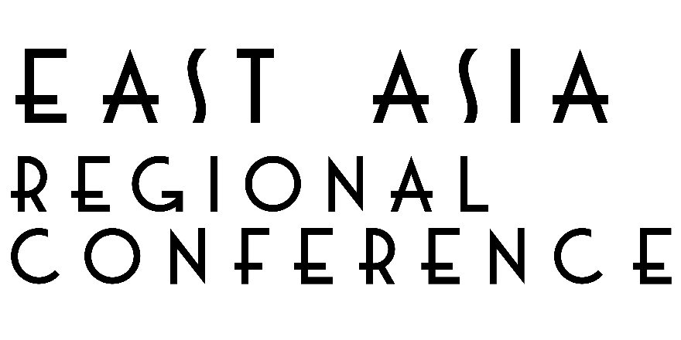

**Rights-Based Education and Sustainable Development Goals for Persons with Visual Impairment**

16-18 October, 2018

*Novotel Hotel and Resort*

*General Aguinaldo Ave., Cubao, Quezon City, 0810 Metro Manila*

**PHILIPPINES**

Hosted by:



In partnership with:

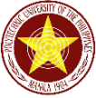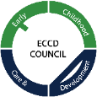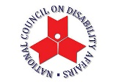

**ICEVI**

**International Council for Education of People with Visual Impairment (ICEVI)** is a global association of individuals and organizations that promotes equal access to appropriate education for all visually impaired children and youth so that they may achieve their full potential. For more information on ICEVI, visit the website at [www.icevi.org](http://www.icevi.org).

**East Asia Regional Conference**

Keeping in view the global agenda of “Education For All” children, ICEVI East Asia region is attempting to deliberate on the issue of treating education of children with visual impairment as their fundamental human right and ensuring that the global campaign 2030 addresses the Sustainable Development Goals in the East Asia region, which is reported to have the largest number of visually impaired persons of the world.

**Theme**

**Rights-Based Education and Sustainable Development Goals for Persons with Visual Impairment**

The conference theme will be discussed in the light of global perspectives on education for all, Sustainable Development Goals, legislations, curricular strategies, human resource development, technology and higher education and the plenary sessions will focus on the following main topics.

* **UNCRPD and the Incheon Strategies in the Light of SDGs in the ASEAN Perspective**

* **Inclusion, Assistance and Support Services: Progress and Prospects**
* **Human Resource and Development Program for Competence**
* **Transition Approaches Leading to Career Development in Higher, Technical and Vocational Education**

* **Appropriate and Effective Assistive Devices for the Education of Persons with Visual Impairment and Multi-Handicapping Conditions**

**Table of Contents**

**____________________________________________________________**

**Messages**

Message from ICEVI President, Dr. Frances Irene Gentle 4

Message from ICEVI East Asia Region Chairperson, Ms. Aria Indrawati 5

Message from RBI Emeritus Executive Director, Mr. Randy Weisser 7

Message from RBI Executive Director, Ms. Amy O. Mojica 8

Message from the Scientific Program Chairperson, Dr. Yolanda S. Quijano 9

Message from Dep Ed Undersecretary, Dr. Lorna Dig Dino 10

Message from NCDA Executive Director, Ms. Carmen Reyes Zubiaga 11

Message from PUP President, Dr. Emanuel C. De Guzman 12

Message from PAVIC President, Mr. Leo Q. Lee 13

Message from RBI Board of Trustees Chairperson, Ms. Goodwill M. Lansang 14

Conference Information 15

ICEVI Conference Scientific Program 17

ICEVI Working Committees 28

ICEVI Programs and Services 29

RBI Programs and Services 33

Acknowledgements 34

Wow Philippines! 36

**Advertisements**

Ambassadors of Light

Perkins School for the Blind

Christoffel Blindenmission CBM

Kabalikat para sa Maunlad na Buhay, Inc (KMBI)

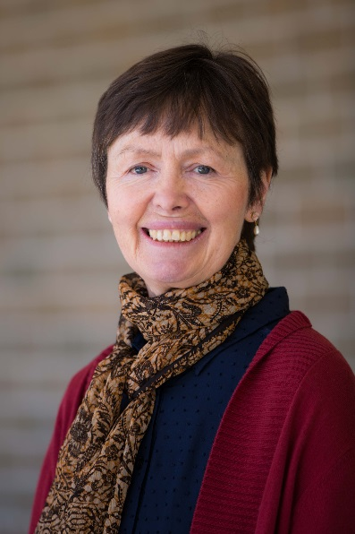

**MESSAGE**

Dear Friends and Colleagues,

On behalf of the International Council for Education of People with Visual Impairment (ICEVI), I am proud to present you with this Souvenir Program for the ICEVI East Asia Regional Conference. The plenary and concurrent sessions explore a diversity of perspectives on the conference theme of “Rights-Based Education and Sustainable Development Goals for Persons with Visual Impairment”.

We are honoured to welcome national and international dignitaries who champion the rights of children and young people with disabilities, as proclaimed in the United Nations Convention on the Rights of Persons with Disabilities and the Sustainable Development Goals.

This Program is a testament to the high level of collaboration in the East Asia Region. The work of the Host and Program Committees has brought together members of ICEVI, the Resources for the Blind, Inc., and local agencies and organisations in the Philippines. The benefits of such collaboration for young people with visual impairment and their families is exemplified in ICEVI’s East Asia partnership programs with the Nippon Foundation and the Overbrook School for the Blind. These programs have dramatically increased the successful inclusion of young people with visual impairment in higher education and employment by providing them with the required knowledge and skills to use current technologies for research and learning.

It gives me pleasure to welcome all delegates, presenters, exhibitors and supporters; and I look forward to greeting you in Quezon City, Metro Manila.

With warm regards!



**DR. FRANCES IRENE GENTLE**

President, ICEVI

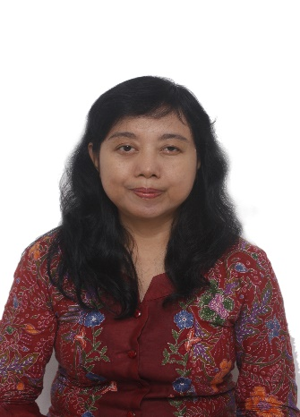

**MESSAGE**

Assalamualaikum Warahmatullahi Wabarakatuh.

Welcome on board. This is your captain speaking from the cockpit. We thank you for flying with ICEVI East Asia Regional Conference 2018, which is conducted in Manila, Philippines. You would be flying with us for three days during the conference. Lots of information would be shared during this ICEVI regional event; from policy level up to implementation as well as technical level.

Education for people with visual impairment is still such challenging issue around our globe, including our region, East Asia. Although education access has been more open nowadays, but still, we found many children with visual impairment are not yet in schools. We have to solve this problem. At the same time, many technical issues are also still in front of us, such as teaching strategy, curriculum modification, teachers’ skill in teaching students with visual impairment, including students with double or multiple disability and visually impaired, low cost teaching and learning media, etc. Or, if there is technology that could be created to solve some issues faced by students with visual impairment in studying.

Therefore, within this conference, information that would be shared is not only “what”; but the most important one is “how”.

Challenges faced by children with double or multi disabled and visually impaired still need to be highlighted. Reasons behind this are, because the quantity members of this group is getting more and more. The individual diversity among this group is also very wide, therefore service development for them still need to be done continuously. Lack of expertise as well as expertise distribution in this area also need to be addressed. To cope with those challenges, accommodative policy as well as strong commitment from the government and education authority is a must. There should be such belief that educating children with double or multi-disabled with visual impairment is very beneficial for the children themselves, as well as for the environment where those children are.

It is very good that currently ICEVI also touches the area of higher education as well as employment. For countries where ICEVI Higher Education Project are implemented, many students with visual impairment have gotten benefits from the effort of increasing access to quality higher education, and become more ready to find job and develop good future career through pre-employment soft skill trainings.

Proving that young people with visual impairment are able to work inclusively after finishing education is very important, in order to convince the government as well as community members, including parents and families who have children with visual impairment; that investing energy to educate our children with visual impairment is very beneficial. Showing that people with visual impairment could use technology also have made education and employment become more inclusive.

Three years ago, ICEVI East Asia conducted Regional Conference in Bali - Indonesia. Now, we are in the Philippines. Why are we in the Philippines? Perhaps we have already know that the Philippines is a country within East Asia region which is very strong in developing their education system, including education for students with visual impairment. Among ICEVI East Asia country members, the Philippines is known as such country which is good in developing teaching and learning strategies in math and science for students with visual impairment. Appreciation and gratitude for Resources for the Blind Inc. and all its local partners who have worked very hard to prepare and organize the conference. Congratulation also to RBI who celebrated its 30th anniversary this year. Being in existence for 30 years for a non-government organization who works for people with disability in such developing country must be challenging, but RBI has shown their achievement. This is because this organization has very committed human resources, who are willing to work hard for their beneficiaries.

Last but not least, please enjoy the conference. Make use of it as maximum as possible, to develop network and cooperation. Let’s make quality education for children with visual impairment in East Asia region real. Make sure that no one is left behind. Together we achieve more.

Wasalamualaikum warahmatullahi wabarakatu.



**ARIA INDRAWATI**

East Asia Regional Chairperson

ICEVI

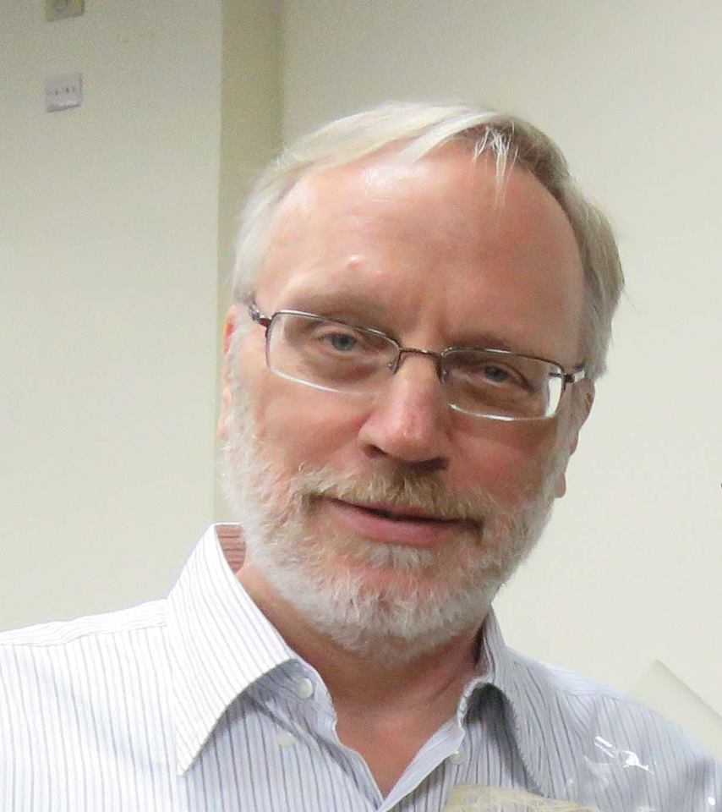

**MESSAGE**

To the Delegates of this year’s ICEVI East Asia Regional Conference, my warmest greetings to all of you!

It is my joy to know that the International Council on the Education of People with Visual Impairment (ICEVI) will hold the 2018 East Asia Regional Conference in the Philippines.

ICEVI, through its different partners, has played a vital role in promoting access to quality education, training and appropriate assistive devices for persons with visual impairment. This conference will be a great avenue for the participants to learn from.

I am sure the topics are carefully planned as well as the chosen speakers are gathered to a common platform that will help enlighten the delegates on the ***“Rights-Based Education and Sustainable Development Goals for Persons with Visual Impairment****”.*

It is very timely and important to help address these issues that are important in developing relevant programs and services to improve the lives of persons with visual impairment through access to education or employment.

I congratulate the ICEVI and its organizing partners and wish them a successful conference.

God bless you all!



**RANDY WEISSER**

Emeritus Executive Director

Resources for the Blind, Inc.

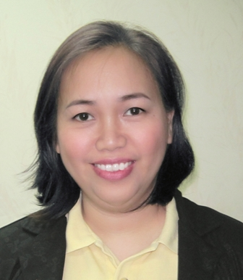

**MESSAGE**

For the first time, the International Council for Education of People with Visual Impairment (ICEVI) is holding its East Asia Conference here in the Philippines. Truly, Resources for the Blind, Inc. (RBI) is grateful to be the host organization and we are truly blessed to have the following as partners in making this event a reality: Department of Education, Early Childhood Care and Development Council, the National Council for Disability Affairs Office, Dept. of Tourism, Local Government Unit of Quezon City Government, Polytechnic University of the Philippines, Parents Advocates for Visually Impaired Children, Deafblind Support Philippines, Philippine Blind Union and Phil. Chamber of Massage Industry for the Visually Impaired.

The theme of this year’s East Asia Conference, “Rights-Based Education and Sustainable Development Goals for Persons with Visual Impairment” comes at a very opportune time as the global situation challenges us to sustain and spread good practices, while at the same time explore strategies to continue reaching out children remain out of school.

For this challenging period, it is highly essential for us to engage our peers in constant discussion and promote a deeper involvement in the process. We hope that this occasion will provide all of us invaluable opportunities for a vibrant exchange of views and ideas and work in synergy ensuring inclusive and quality education for learners with visual impairment and promote lifelong learning.

There are other highly topical issues that will be discussed in this conference, such as inclusive practices and policies, education and employment and East Asia’s role in support of the SDG 4 Quality Education. The range of topics of the conference papers reflects not only the diversity of education challenges in our region, but also the enthusiasm of educators, other professional’s, students and their families to combat these difficulties.

Let me extend my warmest welcome to all of you, and wish you all a fruitful discussion and successful conference. Mabuhay!



**AMY O. MOJICA**

Executive Director

Resources for the Blind, Inc.

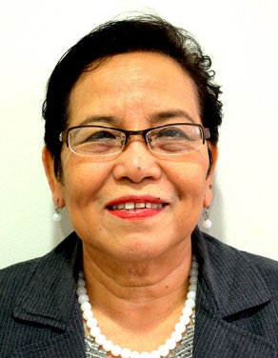

**MESSAGE**

It is my pleasure to welcome all delegates to the 2018 ICEVI East Asia Regional Conference. This Conference is a major event in the country as we bring together international and local experts, practitioners and advocates in the fields of visual impairment, low vision and multiple disabilities to deliberate on the issue of providing education as a fundamental human right in the context of the Sustainable Development Goals.

The Conference sessions are opportunities for participants to exchange experiences, discover novel ideas and discuss future directions. All the discussions in the sessions will culminate with recommendations in terms of policies and programs which participants should commit to implement in order that people with visual impairment will continue to uphold their dignity as they live a sustainable life in the family and society.

Finally, I hope that the participants will find time to network with colleagues, enjoy the social events as well as some sights in Metro Manila.

My personal thanks to all of you!

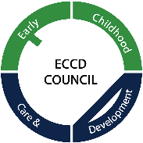

**YOLANDA S. QUIJANO, Ed.D.**

Chairperson

Scientific Program Committee



**MESSAGE**

First and foremost, I would like to congratulate each and every member of the International Council for Education of People with Visual Impairment (ICEVI) for its East Asia Regional Conference. Together, we all work towards the promotion of equal access for children and youth with visual impairment so they will realize their fullest potentials.

Religiously following our global agenda “Education for All,” it is a fundamental right of every child and youth with visual impairment to have an education that is sustainable to their needs. In a recent survey of the World Health Organization, there are an estimated 19 million children living with visual impairment all over the world, and a good portion of this are children and youth that falls under our care. These children deserve the best education that we can offer and the best opportunities that can showcase their gifts.

Following the likes of Italian philosopher Galileo Galilei, Inventor Louis Braille, or singer-songwriter Stevie Wonder, these people were given promising opportunities to explore their individual capacities. Unquestionably, loss of vision did not hinder their successes in work and in life, but even abetted their causes in ensuring that people like them are provided the help and support that they need in order to contribute meaningfully to the society.

Helen Adams Keller, a renowned author, activist and lecturer was famous in her quote “*The best and most beautiful things in this world cannot be seen or even touched; they must be felt with the heart.”*  Truth be told, the care and compassion that we regard persons with visual impairment magnifies their strengths, enables them to dream more, and empowers them to claim their rights in this world.

Together, let us work hand in hand in making sure that our children and youth with visual impairment achieve their mission so they may attain the future that they envision.

Again, congratulations and God bless.



**LORNA DIG DINO**

Undersecretary

Curriculum and Instruction

**A person smiling for the camera

Description generated with very high confidence**

**MESSAGE**

The National Council on Disability Affairs is always proud to be a part of initiatives in promoting the rights of persons with disabilities, especially in their rights to quality inclusive education from pre-school to tertiary education.

As a member of the Steering Committee of the ***International Conference on the Education of Visually Impaired***, NCDA assures all participants on the relevance of this conference as a venue of sharing of experiences from achievers who are blind and with low vision, good practices of the education sector in addressing the needs of learners with visual impairment and breakthroughs in policy development.

We also commend the Resources for the Blind as the local partner of ICEVI for their commitment in providing the best support services for the blind in their quest for quality education and empowering the young ones to change the way people look at them at the rights based perspective. We are happy to note that most of the successful people who are blind were all abreast with the use of assistive technology and are confident in their own fields. This is indeed the greatest milestone we can leave as a legacy to the younger and future generation.

We also extend our gratitude to all who supported this conference which will surely be a learning experience for all teachers, parents, community leaders and individuals who are blind to ensure that programs and services for inclusive education will be provided at the grassroots level.

Congratulations to all!

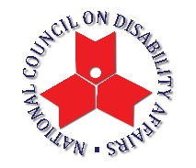

**CARMEN R. ZUBIAGA**

Officer in Charge

National Council on Disability Affairs

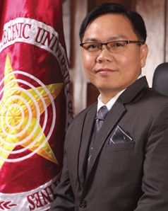

**MESSAGE**

Saying that the International Council for Education of People with Visual Impairment (ICEVI) is our visually impaired youth’s “light at the end of the tunnel” is an understatement. More than just an organization, ICEVI is a lighthouse, a beacon of hope for the individuals who are given a chance to achieve their full potential.

ICEVI has attained multiple achievements and its latest, organizing the East Asia Regional Conference, is a testament to its successful leadership in the promotion of equal access to appropriate education for the visually impaired. The conference paves the way to a stronger international mobilization of resources for blindness prevention programs, which most especially provide the grassroots the opportunity to grow and change their lives forever.

The advocacy of ICEVI is something all academic communities should uphold and its accomplishment is a vital reason to celebrate. Therefore, as a learning institution, the entire PUP community, which rejoices with the triumph of ICEVI and is honored to be tagged as its partner, extends its warmest congratulations to its hardworking leaders and members.

Congratulations and may you continue to be a significant source of inspiration

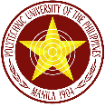

**EMANUEL C. DE GUZMAN, Ph.D.**

President

Polytechnic University of the Philippines

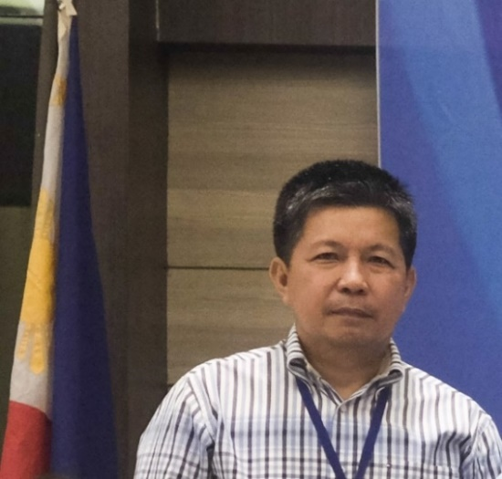**MESSAGE**

On behalf of Parent Advocates for Visually Impaired Children, Inc. (PAVIC), I would like to extend my heartfelt gratitude to the organizers of this conference, especially to the International Council for Education of People with Visual Impairment (ICEVI) and Resources for the Blind, Inc. for hosting this East Asia Regional Conference in Manila. This is a great opportunity for us parents to enhance our knowledge and skills by listening to international and local experts in the field of visual impairment, including those with multiple disabilities.

One of the struggles of parents is accessing the education for their children, especially in the tertiary level. The conference will highlight the “rights of our children” to education”, that will tackle issues and concerns of the learners with visual impairment.

The conference will also open opportunities to widen our network with other parents and stakeholders as well; share experiences and ideas, and affirm commitment to help people with visual impairment reach their full potentials and be a contributing members of our society.

So Welcome and Mabuhay!

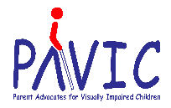

**LEO Q. LEE**

President

PAVIC

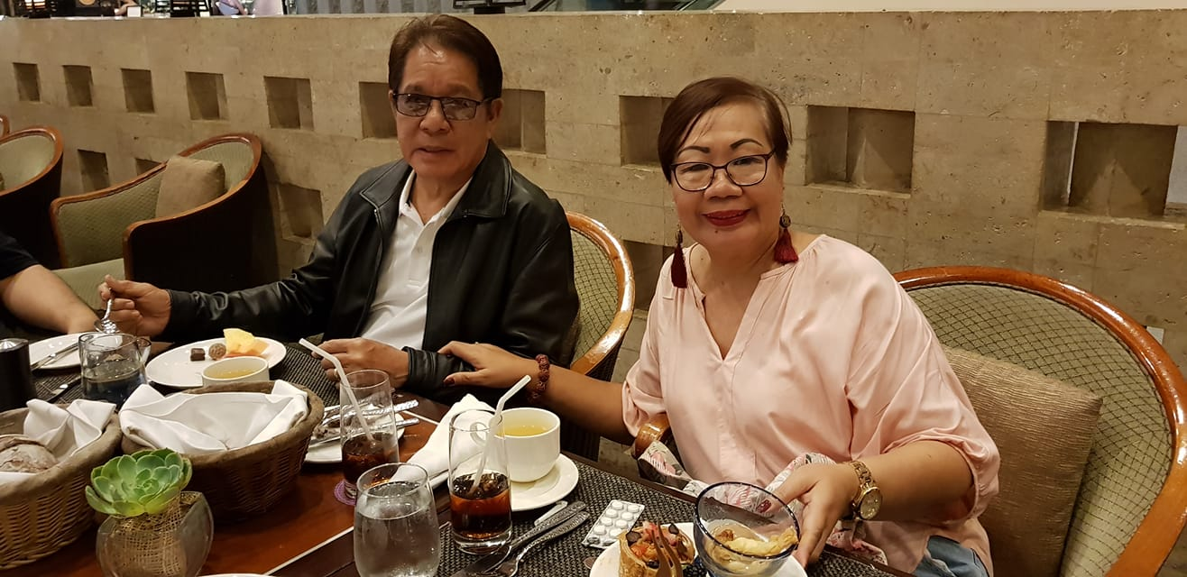**MESSAGE**

Warm greetings from Resources for the Blind to all the delegates, organizers, sponsors, partners and guests. It is with great pleasure that we acknowledge the International Council for the Education of Visually Impaired (ICEVI) for choosing the Philippines as the host country and RBI as the host organization for the 2018 ICEVI East Asia Regional Conference. Truly, the year 2018 combined the best that this side of the world has to offer in the field of providing services and enhancing education systems for persons with visual impairment.

As RBI celebrates its 30th year, our country is also opening its doors to our neighbors in the East Asia region and the international community to showcase how we all can work together to improve the lives of our fellowmen with visual impairment.

The 2018 ICEVI East Asia Regional Conference will pave the way for the long process of reflection, dialogue and building solidarity towards the goal. It can be painstaking at times, but always rewarding when we find unity amidst the diversity.

But this is just the beginning. As we lift this event in gratitude, faith and trust, may we all have the wisdom to continue this journey towards fullness of life for everyone and for the next generations to come.

Welcome to the 2018 ICEVI East Asia Regional Conference!



**GOODWILL M. LANSANG**

Chairperson

RBI Board of Trustees

**CONFERENCE INFORMATION**



**Registration Information**

October 15, 2018 09:00 am to 08:00 pm at 2nd Floor Lobby, Novotel

October 16, 2018 07:00 am to 08:00 pm at 2nd Floor Lobby, Novotel

Special counters are available for those pre-registered foreign, local and onsite participants at 2nd Floor Lobby, Novotel



**Dress Code**

Business or Smart attire is recommended.

Participants are advised to bring along light jacket or shawl as the conference venue is air-conditioned.

You may wear your cultural dress on October 17, 2018, 6:00 pm for the Cultural Night and dinner.

Image result for certificate symbols

**Certificate of Attendance/Participation**

All certificates will be available at the Secretariat on October 18, 2018, from 9:00 am to 3:00 pm.



**Conference Sessions**

October 15, 2018 ICEVI Executive Committee Meeting

October 15 & 16 Registration Venue: 2nd Floor Lobby

October 16, 2018 Opening Program Venue: Monet Ballroom 2 & 3

Plenary Sessions Venue: Monet Ballroom 2 & 3

Concurrent Sessions Venue: Monet Ballroom 2

Monet Ballroom 3

Gauguin and Renoir October 17, 2018 Plenary Sessions Venue: Monet Ballroom 2

Concurrent Sessions Venue: Monet Ballroom 2

Monet Ballroom 3

Gauguin and Renoir

October 18, 2018 Plenary Sessions Venue: Monet Ballroom 2 & 3

Image result for information symbols

**Speakers Information**

Speakers may go to the Secretariat at Room Pizzaro for preparation of their presentations.

Speakers must be at their designated session rooms 15 minutes before the time of their session.

Session Chairperson must coordinate with the Secretariat for assistance.



**On-Site Information**

For inquiries and further information about the conference, please look for the Secretariat.



**Weather**

The weather forecast for October 14-20, 2018 will be cloudy with few showers. Please bring your umbrellas.

Image result for twitter symbolsRelated image

**For Facebook, Instagram and Twitter Posts**

For your posts at Facebook and Twitter, please use **#ICEVIEastAsiaPhils**

**SCIENTIFIC PROGRAM**

**MONDAY, 15 October**

09:00 am – 08:00 pm **Registration** Venue: 2nd Floor Lobby

**TUESDAY, 16 October,** Day 1

Officers of the Day: Ms. Kaya Valila, Mr. Sonny Versoza & Mr. Marlo G. Lucas

07:00 – 08:30 am **Registration** Venue: 2ND Floor Lobby

08:30 – 10:00 am **Opening Program** Venue: Monet Ballroom 2 & 3

National Anthem and Doxology

**Philippine National School for the Blind (PNSB)**

**Welcome Messages:**

*Ms. Amy O. Mojica*, Director

Resources for the Blind, Inc. (RBI)

*Ms. Aria Indrawati*, East Asia Regional Chair, ICEVI

*Ms. Goodwill Mercado-Lansang*, Chairperson

Board of Trustees, (RBI)

**About the Regional Conference**

*Dr. Yolanda S. Quijano*, Chairperson

Scientific Program Committee

**Presidential Address**

*Dr. Frances Irene Gentle*, President, ICEVI

**Special Address**

*Honorable Secretary Leonor Magtolis Briones*

Secretary, Department of Education

**Keynote Address**

*Rights-Based Education and Sustainable Development*

*Goals for Persons with Visual Impairment*

**Honorable Congressman Antonio L. Tinio**

Party List – ACT TEACHERS

House of Representatives

10:00 – 10:30 am **Coffee Break**

10:30 – 12:00 nn **PLENARY SESSION 1**

**UNCRPD and the Incheon Strategies**

**in the Light of SDGs in ASEAN Perspective**

Venue: Monet Ballroom 2 & 3

Panel Discussion

***Mr. Monthian Buntan***, President

Thailand Association for the Blind

***Ms. Michiko Tabata***, President

World Blind Union – Asia Pacific

***Mr. Andrew Griffiths***, Head of Advocacy

Sightsavers, United Kingdom

***Dr. Praveena Sukhraj Ely***, Vice-President, ICEVI

Session Moderator:

***Ms. Carmen R. Zuabiaga***

Officer-In-Charge, National Council on Disability Affairs

12:00 – 01:00 pm **Lunch Break**

01:00 – 03:00 pm **CONCURRENT SESSION 1**

**INCLUSIVE POLICIES AND PRACTICES**

Venue: Monet Ballroom 2

***Mr. Ivan Neil Gomez***

Translating Scientific Evidence into Practical Point to Best Inform Policy and Practices

***Mr. Lauro Purcil, Jr.***

A Call to Focus on Aging Visually Impaired

***Ms. Karen Ongtangco***

Quality of Life of Adolescents

with Visual Impairment in Metro Manila

***Dr. Maximus Sefotho***

Education Pathway to Inclusion of

Visually Impaired Learners in South Africa

***Dr. Maria Cecilia L. Yu***

Centro Escolar University and RBI Partnership: Key to Attaining SDG for Patients with Visual Impairment

Chairperson: **Dr. Jose D. Tuguinayo**

Rapporteur : **Dr. Nancy Pascual**

01:00 – 03:00 pm **CONCURRENT SESSION 2**

**ASSISTIVE DEVICES AND TECHNOLOGY**

Venue: Monet Ballroom 3

***Mr. Allan Mesoga***

Free Technology for Inclusive Education

***Mr. Huang Kuei-Chih***

STARCRAFT: A Math Game for All

***Mr. Brad Turner***

Accessible Books for All

***Mr. Anderson L. Go***

Braille Music Technology, Where Music and

Technology Meets

Chairperson: **Ms. Mayette Regala**

Rapporteur : **Mr. Sohan Motwani**

01:00 – 03:00 pm **CONCURRENT SESSION 3**

**WORKSHOP ON BARRIERS FACED IN EDUCATION:**

**COUNTRY CHAMPIONS PHILIPPINES**

Venue: Gauguin

***Dr. Frances Irene Gentle***

Inclusion and the Fundamentals of Braille Literacy

***Mr. Abdulaziz Dapilin***

Building Self, Bridging Academic Success through Assistive Technology

***Mr. Gerard Perry Novela***

Attitudinal Barriers that Affects the Educational Journey of the Visually Impaired

***Mr. Mike Daryl Ocol***

The “Know-and-Assert” Strategies to Overcoming Education

Chairperson: Ms.Lench Ann Perilla

Rapporteur : Mr. Kneulvirn Hautea

01:00 – 03:00 pm **CONCURRENT SESSION 4**

**PAVIC WORKSHOP ON OVERCOMING BARRIERS TO EDUCATION AND EMPLOYMENT**

Venue: Renoir

**Part I: Sharing of Experiences**

***Ms. Maria Digna Parcon***, My Child Can Learn Too

***Ms. Cora Book***, Road to Success

**Part II: Groupings, Discussion, Presentations & Recommendations**

Chairperson: **Ms. Amparo Pelaez**

Rapporteur : **Ms. Gina Dela Cruz**

03:00 – 03:30 am **Coffee Break**

03:30 – 05:00 pm **CONCURRENT SESSION 5**

**LIFE SKILLS AND EMPOWERMENT**

Venue: Monet Ballroom 2

***Mr. Tuti Hendrawati***

Sayap Ibu Foundation Indonesia

***Dr. Shammah T. Quiroy***

Teacher’s Training in the Use of Electronic Devices as Tool for School-Based Visual Skills Training for Students with Visual Impairment in Nhat Hong School for the Blind, Vietnam

***Dr. Niyisabwa Odette Tumwesigye***

Enhancing Mobility Skill among Blind Children in Resource Constrained Communities:

Experiences from Uganda

***Ms. Maartje Dierick & Ms. Madelon Janssen***

Enable Participation: Common when Possible and Adjusted when Necessary

***Ms. Joyce Ann P. Villafania***

Community-Based Rehabilitation as a Response for Sustainable and Inclusive Development of Persons with Visual Impairment and their Communities

Chairperson: **Ms. Joyce Ann Villafania**

Rapporteur : **Mr. Ivan Neil Gomez**

03:30 – 05:00 pm **CONCURRENT SESSION 6**

**MULTIPLE DISABILITIES**

**AND VISUALLY IMPAIRED** **(MDVI)**

Venue: Monet Ballroom 3

***Ms. Deborah Gleason***

Identifying and Assessing All Children with Multiple Disabilities and Visual Impairment and Training Teacher in Shanxi Province, China: A Case Study

***Dr. Namita Jacob***

Developing Appropriate Services for Children who are Deafblind in Vietnam

Becoming Somebody

***Ms. Babylene An Palma***

Effectiveness of the Strategies in Teaching Learners with Visual Impairment with Multiple Disabilities

Chairperson: **Ms. Mila Wayno**

Rapporteur : **Ms. Ruth Camacho**

03:30 – 05:00 pm **CONCURRENT SESSION 7**

**CLASSROOM PRACTICES**

Venue: Gauguin

***Mr. Jahangir Alam***

Child-friendly Learning and Inclusive Education

Effective Classroom Adaptations for Students with Visual Impairment and Low Vision

***Ms. Daisy Corpuz***

Communicative Competence of a Senior High School Student with Visual Impairment

***Ms. Sarrah Villoria***

Effectiveness of Pre-Braille Instruction Using Modified Braille Instrument in Improving Reading Proficiency of Readers with Visual Impairment

***Mr. Tristan M. Eseo***

Inclusive Education and Special Education as a Catalyst for Quality Education: An Appreciative Inquiry of an Organizational Development in School

Chairperson: **Mr. Edwin Talleon**

Rapporteur : **Ms. Barbra Mae C. Dumlao**

03:30 – 05:00 pm **CONCURRENT SESSION 8**

**PAVIC WORKSHOP ON STRENGTHENING PARENTS’ GROUP**

Venue: Renoir

**Part I: Sharing of Experiences**

***Ms. Emma Louise Sutherland***

When Invisible Becomes Visible:

Mother’s Experiences with the Long Cane

***Mr. Leo Q. Lee***

Yes, We Can!

**Part II: Workshop: Participants will answer the ff.:**

1. Characteristics of Parents’ Group
2. Challenges faced by Parents’ Group
3. How to sustain the group
4. How organizations like ICEVI can help in promoting the “Parents’ Movement’?

**Part III: Discussion and Recommendations**

Chairperson: **Ms. Rosemary M. Alonzo**

Rapporteur : **Ms. Amparo Pelaez**

06:00 – 08:00 pm **GALA DINNER**

Venue: Monet Ballroom 2 & 3

Hosted by: Department of Education

**Hon. Secretary Leonor Magtolis Briones**

**WEDNESDAY, 17 October,** Day 2

Officers of the Day: Barbra Mae C. Dumlao, Mr. Wilson Diola & Ms. Rosemary Alonzo

07:30 – 08:00 am **Registration** (2nd Floor Lobby)

08:00 – 08:30 am **Preliminaries**

08:30 – 10:00 am **PLENARY SESSION 2**

**INCLUSION, ASSISTANCE AND SUPPORT SERVICES: PROGRESS AND PROSPECTS**

Venue: Monet Ballroom 2 & 3

***Prof. Kay Alicyn Ferrell***

Professor, University of Northern Colorado, USA

***Ms. Nandini Rawal*,** Treasurer, ICEVI

***Dr. Emanuel C. De Guzman***

President, Polytechnic University of the Philippines

Session Moderator:

***Dr. Divina T. Pasumbal***

Dean, College of Communication

Polytechnic University of the Philippines

10:00 – 10:30 am **Coffee Break**

10:30 – 12:00 nn **PLENARY SESSION 3** **EDUCATION, TECHNOLOGY AND EMPLOYMENT:**

**EXPERIENCES FROM THE NIPPON FOUNDATION**

**SUPPORTED HIGHER EDUCATION AND ONNET INITIATIVES**

Venue: Monet Ballroom 2 & 3

Country Perspective Resource Speakers

***Mr. Dang Hoai Phuc***, President

Sao Mai Center for the Blind, Vietnam

***Ms. Gerel Dondovdorj***, President

Mongolian National Federation of the Blind

***Mr. Marlo G. Lucas***, Project Coordinator

Resources for the Blind, Inc.

***Ms. Aria Indrawati***, Chairperson,

ICEVI East Asia Region

Higher Education Resource Speakers

***Mr. Mike Daryl Ocol,*** *Student*

*Western Mindanao State University*

***Mr. Abdulaziz Dapilin***

Teacher, Department of Education

***Mr. Sohan Motwa*ni,** Student, St Benilde University

Session Moderators:

**Ms. Wenru Niu,** Program Coordinator, ONNET

**Dr. M.N.G. Mani,** CEO, ICEVI

and Higher Education Co-Project Director

12:00 – 01:00 pm **Lunch Break**

01:00 – 03:00 pm **CONCURRENT SESSION 9**

**INCLUSIVE PRACTICES AND POLICIES**

Venue: Monet Ballroom 2

***Ms. Karen Ongtangco***

***Honorable Vice Mayor Ma. Josephina G. Belmonte***

KABAHAGI Program: Local Government Initiative for the Inclusion of Children with Disabilities in Quezon City

***Ms. Rosemary M. Alonzo***

***Ms. Ami Tango-Limketkai***

Parents’ Strategies in Addressing the Needs for Children with Visual Impairment and Multiple Disabilities

***Dr. Frances Irene Gentle***

SDG 4 and Education Target 4.1:

Applying the MTSS Framework

***Ms. Kristine Karla G. Bouffard***

***Dr. Edna Jalotjot***

Giving Hope to Children with Cancer Through

Hospital-based Educational Program:

An Impact Evaluation

***Ms. Kim Mikaela T. Agravante***

KASALI sa Pagbabasa: Building an Inclusive Culture among Young Children through Stories

Chairperson: **Dr. Salvacion Olinares**

Rapporteur: **Dr. Ma. Elsie C. Esmer**

01:00 – 03:00 pm **CONCURRENT SESSION 10**

**ASSISTIVE DEVICES AND TECHNOLOGY**

Venue: Monet Ballroom 3

***Ms. Kyebagandha Binasali***

Using Assistive Technology to Promote Inclusive Education in Primary Schools in Uganda

***Dr. Ma. Shiela S. Jimenez***

Different Strokes for Different Folks:

Tailor Fitting Low Vision Aids

***Ms. Criselda Valderrama***

***Ms. Jeraissa Olivares***

Empowering the Blind for Regional Integration

Through Learning English Online Program

***Ms. Davina Geraldine Moritt***

Accessing Foreign Language Curriculum in an Ever Changing World

***Ms. Annette Lee-Esparaz***

Eye Belong

Chairperson: **Mr. Genaro Sanchez**

Rapporteur : **Mr. Victor Rescober**

01:00 – 03:00 pm **CONCURRENT SESSION 11**

**WORKSHOP ON BARRIERS FACED IN EMPLOYMENT**

Venue: Gauguin

***Mr. Auray Aun***

Higher Education Provides Greater Employment Opportunity: Dynamics and Challenges Face by Visually Impaired Young Adults in Cambodia

***Mr. Robert Schulenberg***

The Three-Legged Stool: Balancing the Skills Needed for Successful Transition

***Mr. Alex Soriano***

Transition Approaches Leading to Career Development in Higher Technical and Vocational in the Philippines:

A Case Study

***Ms. Lench Ann Perilla***

My Journey to Employment: What Hindered Me?

***Ms. Hannah Mae Aldeza***

Successfully Conquering Employment Barriers: My Story

***Mr. John Vincent Cabizarez***

Technology: Access or Hindrance?

Chairperson: **Mr. Dang Hoai Phuc**

Rapporteur : **Dr. Namita Jacob**

01:00 – 03:00 pm **CONCURRENT SESSION 12**

**WORKSHOP ON ACCESSIBLE BOOKS WITH BLOOM**

Venue: Renoir

***Mr. Paul Frank*,** SIL-LEAD

Chairperson: **Ms. Loy De Vera-Ang**

Rapporteur : **Ms. Joyce Lopez**

03:00 – 03:30 pm **Coffee Break**

03:30 – 05:00 pm **CONCURRENT SESSION 13**

**LIFE SKILLS AND EMPOWERMENT**

Venue: Monet Ballroom 2

***Ms. Deborah Gleason***

***Mr. Pak Sam Yhon***

***Ms. Lina Kurniati***

Partnership to Achieve Education for All:

Training Teachers to Serve Learners with MDVI

***Mr. Jahangir Alam***

Special Education in Bangladesh:

Present Trend and Future Needs

***Ms. Anna Yap Pascual***

The Role of Occupational Therapists in Helping Children with Visual Impairment Reach Their Fullest Potential

***Dr. Shammah T. Quiroy***

Teacher’s Training in the Use of Electronic Devices as Tool for School-Based Visual Skills Training for Students with Visual Impairment in Nhat Hong School for the Blind, Vietnam

Chairperson: **Ms. Ami Tango-Limketkai**

Rapporteur : **Mr. Eduardo Jimenez**

03:30 – 05:00 pm **CONCURRENT SESSION 14**

**WORKSHOP ON USING MOBILE TECHNOLOGY FOR SENSORY DISABILITY SCREENING – FIELD EXPERIENCES FROM THE PHILIPPINES**

Venue: Monet Ballroom 3

***Ms. Jona Lai***

***Ms. Carmen Strigel***

Chairperson: **Mr. Angelito Baustista, Jr.**

Rapporteur : **Assoc. Prof. Adelio Sulit**

03:30 – 05:00 pm **CONCURRENT SESSION 15**

**WORKSHOP ON INDIGENOUS SOFTWARE**

Venue: Gauguin

***Mr. Effendi Susanto***

Making Mathematics Accessible

and Mathematics Understandable

Chairperson: **Ms. Aria Indrawati**

Rapporteur : **Ms. Lorrie Barboza**

03:30 – 05:00 pm **CONCURRENT SESSION 16**

**WORKSHOP ON STRATEGIES TO PROMOTE EDUCATION OF CHILDREN WITH LOW VISION IN MAINSTREAM SCHOOL**

Venue: Renoir

***Dr. Karin Van Dijk***

Chairperson: **Dr. Belle Ambrosio**

Rapporteur : **Dr. Candy Delos Reyes**

06:00 – 08:30 pm **CULTURAL NIGHT** (Monet Ballroom 2 &3)

Dinner and Entertainment with **PUP Banda Kawayan**

Hosted by:

***Tourism Promotions Board***

***Local Government Unit of Quezon City***

**THURSDAY, 18 October,** Day 3

Officers of the Day: Ms. Joyce Lopez, Mr. Randy Calsena & Ms. Ching O. Romares

07:30 – 08:00 am **Secretariat Open for Certificate Distribution**

08:00 – 08:30 am **Preliminaries**

08:30 – 10:00 am **PLENARY SESSION 4**

**SPECIAL SERVICES**

Venue: Monet Ballroom 2 & 3

***Ms. Deborah Gleason****,* Director

Asia and the Pacific, Perkins International

***Dr. Karin Van Djik***

Global Low Vision Consultant

Christoffel Blindenmission (CBM)

***Mr. Michael Barredo***, President

Philippine Sports Association for the Differently Abled (PHILSPADA)

Session Moderator:

**Mr. Ryan Operario**

Project Coordinator, Resources for the Blind, Inc.

10:00 – 10:30 am **COFFEE BREAK**

10:30 – 12:00 nn **PLENARY SESSION 5**

**LEGISLATION AND ADVOCACY**

Venue: Monet Ballroom 2 & 3

***Dr. Todd Reeves***

Chief Executive Officer

Overbrook School for the Blind, USA

***Dr. Bhushan Punani***

Executive Director

Blind People’s Association (BPA) Ahmedabad, India

***Ms. Aria Indrawati***

Regional Chairman, ICEVI East Asia

***Mr. Mateo Lee, Jr.***

Deputy Executive Director

National Council on Disability Affairs (NCDA)

Session Moderator:

***Ms. Kriztine R. Viray***

Director, Communication Management Office

Polytechnic University of the Philippines

12:00 – 01:00 pm **LUNCH BREAK**

01:00 – 03:30 pm **PLENARY SESSION 6**

Venue: Monet Ballroom 2 & 3

**Closing Program**

**Presentation of Resolution**

***Ms. Carmen R. Zubiaga***

Officer-in-Charge

National Council on Disability Affairs (NCDA)

**Valediction**

***Dr. Frances Irene Gentle***

President, ICEVI

03:30 pm **High Tea and End of the 2018 ICEVI**

**East Asia Regional Conference**

**ICEVI East Asia Regional Conference**

**Working Committees**

**DR. M.N.G. Mani**, Chief Executive Officer

International Council for Education of Persons with Visual Impairment (ICEVI)

**Ms. Aria Indrawati**, Chairperson

ICEVI East Asia Pacific Region

**Ms. Amy O. Mojica**, Executive Director

Resources for the Blind, Inc. (RBI)

Host Committee Chairperson

**Scientific Program Committee**

**Dr. Yolanda S. Quijano**, ECCD

**Ms. Mirla Olores**, RBI

**Ms. Carmen Zubiaga**, NCDA

**Director Mateo Lee**, Jr.

**Secretariat and Registration**

**Ms. Chesa O. Romares**, RBI

**Ms. Rosemary M. Alonzo**, PAVIC

**Ms. Lodeline C. Anile**, RBI

**Ways and Means**

**Retired General Eliseo Dela Paz**, PBU

**Mr. Jose Raῆola**, PBU

**Mr. Marlo G. Lucas**, RBI

**Welcome and Hospitality**

**Ms. Carmen R. Zubiaga**, NCDA

**Ms. Mila Wayno**, RBI

**Dr. Salvacion Olinares**, DepEd

**Cultural and Entertainment**

**Dr. Divina T. Pasumbal**, PUP

**Ms. Kriztine Viray**, PUP

**Ms. Corazon Salvador**, PNSB

**Finance**

**Ms. Amy O. Mojica**,RBI

**Ms. Josenita Dela Cruz**, RBI

**Ms. Rosemary M. Alonzo**, PAVIC

**Technical Committee**

**Ms. Marietta Regala**,RBI

**Ms. Ma. Cecilia Garcia**,PAVIC

# ICEVI at a Glance

Founded in 1952, the International Council for Education of People with Visual Impairment (ICEVI) is an international non-government organization of individuals and agencies that are concerned with equity of access to appropriate education for children and young people with visual impairment, including those with deafblindness or additional/multiple disabilities.

ICEVI members include some of the world’s leaders and decision-makers in education for children with visual impairment. ICEVI works closely with UN member agencies and international, government and civil society organizations that are concerned with education, as well as organizations of parents and persons with disabilities. ICEVI’s organizational structure facilitates advocacy, networking and information sharing at the global level and within the seven regions of ICEVI, in accordance with identified national and community needs and priorities.

## The Facts

* 285 million people are estimated to be visually impaired worldwide: 39 million are blind and 246 million have low vision.
* About 90% of the world’s population with visually impairment live in low-income settings.
* Less than half of the children with visual impairment in low-income countries are receiving an education.
* The girl child with visual impairment receives less attention and is doubly discriminated against.
* The growing number of children with visual impairment and additional disabilities or deafblindness are marginalized from educational services.

## Our Mission

In recognition of the continuing global challenges in achieving access to quality education for the millions of out-of-school children with blindness and partial sight, the International Council for Education of People with Visual Impairment (ICEVI) is a membership organisation with a mission to promote access to inclusive, equitable, and quality education for all people with visual impairment.

## Our Vision and Values

We believe that all children and young people with visual impairment and their families have the right to:

* Equitable access and participation in the full range of educational services and programs on the basis of equal opportunity;
* Receive early intervention and early childhood care and development services, and pre-primary education;
* Support by teachers and other professionals who possess knowledge and skills in education of children and young people with visual impairment;
* Educational materials, teaching methods and programs that are of a high standard, conform to best practices, and address each child’s learning needs; and
* Live in communities that are free of barriers and discrimination, where all people are valued and lead productive lives, in accordance with their personal aspirations and capabilities.

## Our Goals

Goal 1: Promoting access to quality education for people with visual impairment including those with blindness, partial sight, deafblindness and additional disabilities.

Goal 2: Influencing governments’ and relevant stakeholders’ implementation of the SDGs and UNCRPD in the area of education of people with visual impairment.

Goal 3: Improving networking, information sharing and collaboration at national, regional and global levels.

## Publications

Our biannual magazine, The Educator, is published in English and Spanish and is available for free download from the ICEVI website, [www.icevi.org](http://www.icevi.org). We also publish a biannual electronic newsletter that is distributed to 4000 individuals and organizations. New subscribers to the newsletter are welcome. Please contact Dr Mani, CEO of ICEVI, email [sgicevi@vsnl.net](mailto:sgicevi@vsnl.net).

## Key Activities

* Global Campaign on Education for All Children with Visual Impairment (EFA-VI), in partnership with the World Blind Union
* Project to promote higher education of students with visual impairment in the East Asia region, in partnership with The Nippon Foundation
* Development of a series of free, online video packages to facilitate the effective teaching of mathematics to students with visual impairment (first group of videos will be launched in early 2019)
* Development of a teacher preparation curriculum for teachers with limited access to professional training in vision impairment (available for free download from ICEVI website to computer or mobile phone)
* Development of a teacher preparation curriculum for teachers with limited access to professional training in vision impairment (available for free download from ICEVI website to computer or mobile phone)
* Country champion programs, supporting young people with visual impairment to become leaders, role models and mentors
* Mapping of national educational services for children with visual impairment
* Education capacity building programs
* Research and documentation

## ICEVI Organizational Structure

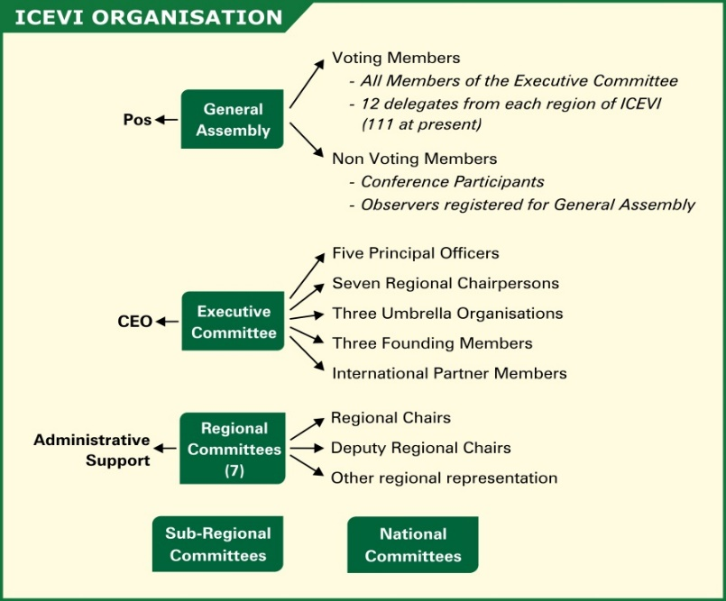

## Principal Officers

**PRESIDENT**

**Frances Gentle**

The Renwick Centre

Royal Institute for Deaf & Blind Children

Private Bag 29, Parramatta NSW 2124

AUSTRALIA

[frances.gentle@ridbc.org.au](mailto:frances.gentle@ridbc.org.au)

**FIRST VICE PRESIDENT**

**Praveena Sukhraj-Ely**

The Children’s Disability

Training Centre

CMI Building, 13A Joubert Street

Park Town Johannesburg

SOUTH AFRICA

[psukhraj@justice.gov.za](mailto:psukhraj@justice.gov.za)

**SECOND VICE PRESIDENT**

**Rima Canawati**

Bethlehem Arab Society for Rehabilitation

P.O. Box 100, Bethlehem

PALESTINE [rima.qanawati@gmail.com](mailto:rima.qanawati@gmail.com)

**TREASURER**

**Nandini Rawal**

Blind People’s Association

132 Ft. Ring Road, Vastrapur

Ahmedabad - 380 015

INDIA

[bpaiceviad1@bsnl.in](mailto:bpaiceviad1@bsnl.in)

**IMMEDIATE PAST PRESIDENT**

**Lord Low of Dalston**

Royal National Institute of Blind People

105 Judd Street, London WC1H 9NE

UNITED KINGDOM

[colin.low@rnib.org.uk](mailto:colin.low@rnib.org.uk)

**Regional Chairpersons**

**AFRICA**

**Gertrude Oforiwa Fefoame**

Sightsavers’

Global Advocacy Advisor

Densu Point, P.O. Box KIA 18190

North Dzorwulu, Accra

GHANA

[gofefoame@sightsavers.org](mailto:gofefoame@sightsavers.org)

**EAST ASIA**

**Aria Indrawati**

Pertuni

(The Indonesian Blind Association)

P.O.Box 386, Jalan Raya Bogor, Km.19

Ruko Blok Q No. 13-L, RT01 Rw04,

Kramat Jati, East Jakarta

INDONESIA

[aria.indrawati@gmail.com](mailto:aria.indrawati@gmail.com)

**EUROPE**

**Hans Welling**

Diependaalsedrift 32

1213cr Hilversum

THE NETHERLANDS

[wellingja@yahoo.com](mailto:wellingja@yahoo.com)

**LATIN AMERICA**

María Cristina Sanz

avda. 13 n 1207, flor 9 dpto. A

(1900) LA PLATA

ARGENTINA

[latinoamericaicevi@gmail.com](mailto:latinoamericaicevi@gmail.com)

**PACIFIC**

**Ben Clare**

Aspen Medical Foundation

PO Box 231, Deakin West ACT

AUSTRALIA 2601

[bwclare@gmail.com](mailto:bwclare@gmail.com)

**NORTH AMERICA / CARIBBEAN**

**Kay Alicyn Ferrell**

Professor of Special Education, Emerita

University of Northern Colorado

Campus Box 146

Greeley, CO 80639

USA

[kay.ferrell@unco.edu](mailto:kay.ferrell@unco.edu)

## ICEVI Secretariat

**M.N.G. MANI**

*Chief Executive Officer*

No 3. Professors’ Colony

SRK Vidyalaya Post

Coimbatore - 641 020

Tamil Nadu, INDIA

Telefax: (+91) 0422-2693414

E-mail: [sgicevi@vsnl.net](mailto:sgicevi@vsnl.net)

Web: [www.icevi.org](http://www.icevi.org)

**WEST ASIA**

**Bhusan Punani**

Blind People’s Association

132 Ft. Ring Road

Vastrapur

Ahmedabad 380 015

INDIA

[blinabad1@bsnl.in](mailto:blinabad1@bsnl.in)

**A Light to those in Darkness**

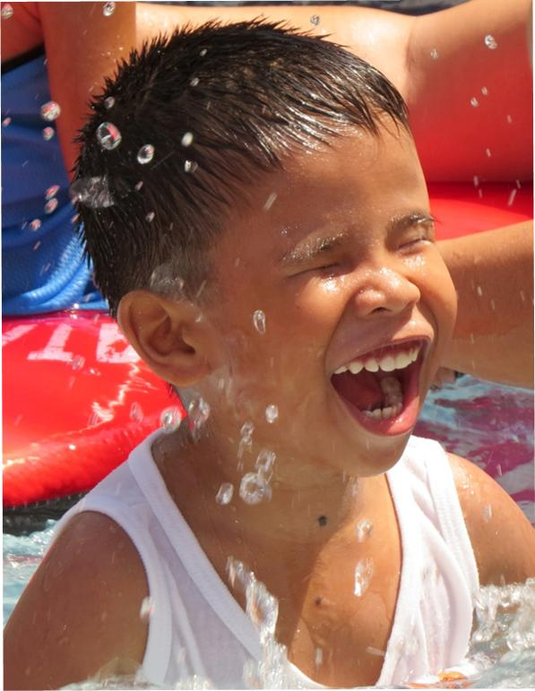

**Resources for the BLIND, Inc.** is a non-profit Christian organization that has been serving persons with visual impairment throughout the Philippines since 1988. We have devoted ourselves to providing the necessary services, training, materials and equipment in order for those who have visual impairment to reach their fullest potential in life and remove the obstacles that hinder them from doing so .

 With offices in Manila, Cebu, and Davao, RBI continues to reach out to those who are in need of our services in every corner of the country. We work together, with the grace of God, to turn the darkness into light for over half a million persons with visual impairment in the Philippines.

**Early Intervention & Preschool Program**

# RBI’s thrust is to include intervention at the earliest age possible to minimize or even avoid the expected developmental delays in cognitive, communication, motor and social skills of children with visual impairment. When children with visual impairment and their parents are trained early on how to deal with the disability, the results are better in terms of acquiring academic and life skills that will enable the person and everyone around him to live normally.

# 

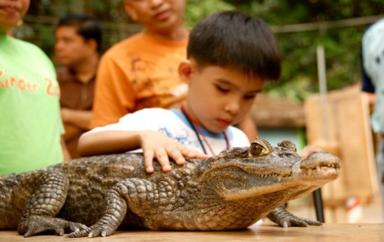

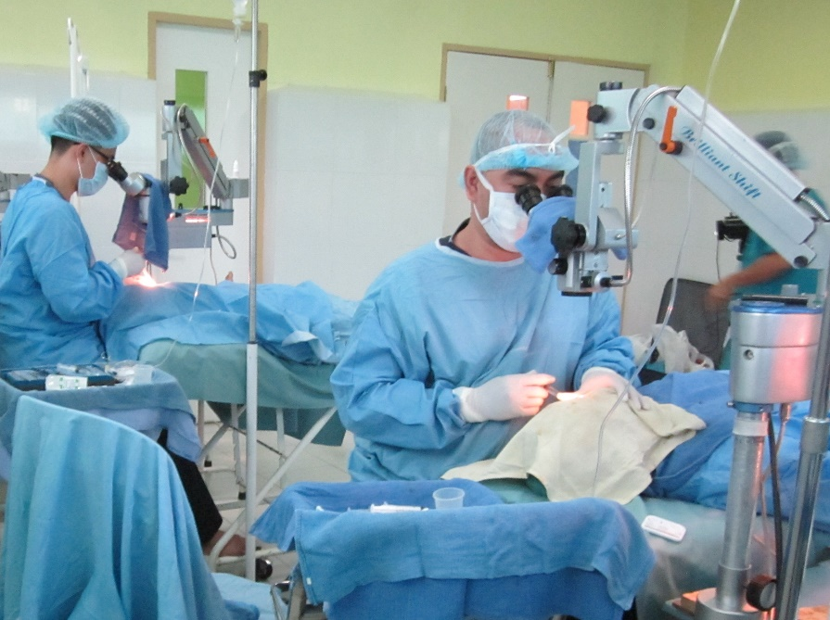

**Eye Care and Blindness Prevention**

Our program includes establishing linkages with government units to locate those who need eye care services and implement projects, then partner with eye care specialists to provide the necessary medical assessment and treatment. Nationwide trainings and awareness campaigns are also conducted to equip the community with knowledge and skills to help prevent blindness.

**Pediatric Surgery**

Focus is given to children because of the urgent attention needed in cases of childhood blindness. RBI International (US) has been our major partner in finding donors for children who need eye surgery.

**Low Vision Assessment and Intervention**

RBI provides assessment and treatment to low vision patients and devices are made available for sale at cost or for lending to students with varying degrees of visual loss. Our strategy to enhance RBI’s low vision services is to partner with optometry colleges and national associations of optometrists. Our programs now include low vision training for teachers, parents and other stakeholders.

**Job Placement**

RBI provides pre-employment trainings to persons with visual impairment in order for them to gain access to jobs suited to their education and skill level.

**Accessible Media**

RBI ensures that books and other learning materials are made accessible to persons with visual impairment by producing them in Braille and digital formats. Assistive devices like laptops and digital playback machines are also made available to help in their research and academic work.

**Advocacy**

RBI strongly advocates the United Nations Convention on the Rights of Persons with Disability (UNCRPD) which promotes, defend and reinforce the human rights of all persons with disabilities. 

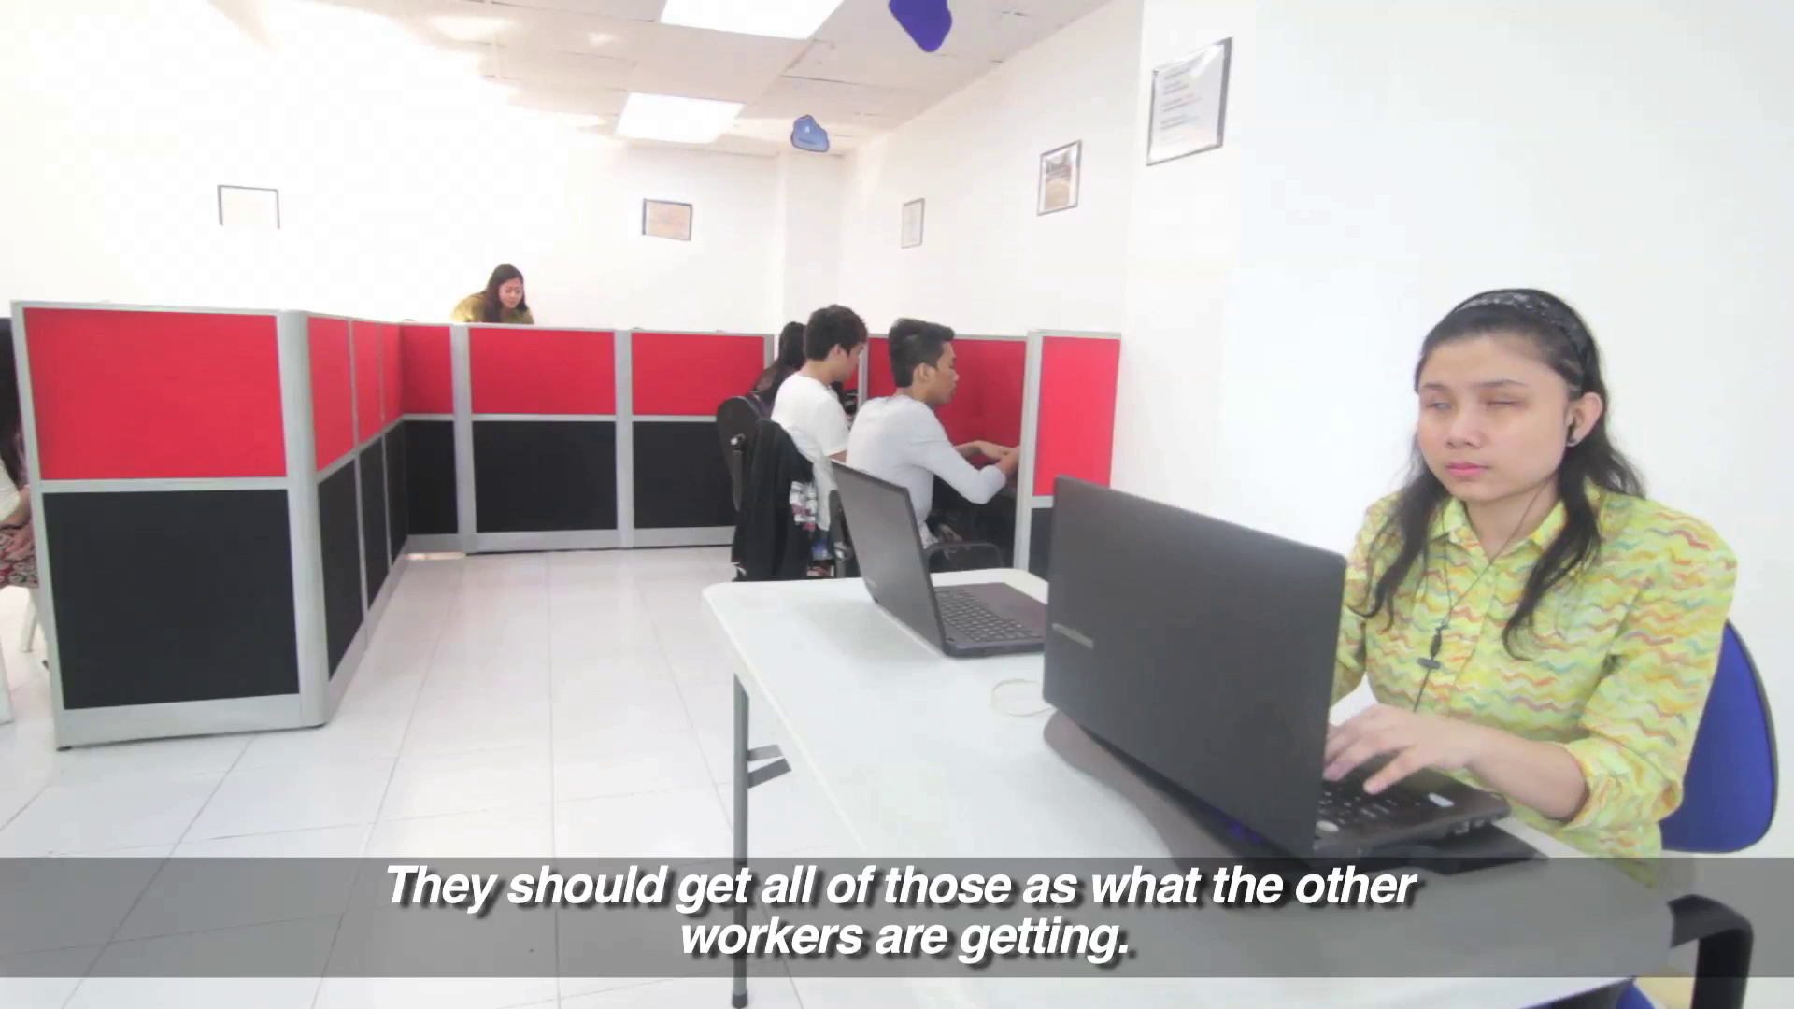



# WEBSITE: www.blind.org.ph



# info@blind.org.ph



facebook.com/resourcesfortheblind



RBI_PH

# resourcesfortheblindph



**CEBU**

Box 470 CCPO

Cebu City 6000

Tel. 032-415-0329

cebu@blind.org.ph

**DAVAO**

Box 80540 DCPO Davao City 8000

Tel. 082-225-8937

Fax 63-82-225-8938 davao@blind.org.ph

**MANILA**

Box 1831 CP

Manila 1099

Tel. 726-3021 to 24

Fax 63-2-727-0077

info@blind.org.ph

**ACKNOWLEDGEMENTS**



**Mission:**

We creatively market and promote unique and high value experience for the visitors.

**Vision:**

*Country*: Philippines is one of the most preferred tourist destination in Asia Pacific.

*Corporate*: To be recognized as the authority in marketing the Philippines as a tourism destination.

**Mission**

To provide direction to and coordinate and monitor the activities of government, non-government, and people’s organizations involved in the prevention of the causes of disability, rehabilitation, and equalization of opportunities in partnership with persons with disabilities.



**Mission:**

The Quezon City Government envisions itself to be a model of effective governance and responsible leadership, working in partnership with the citizenry in Building a Quality Community.

**Mission**

To protect and promote the right of every Filipino to quality, equitable, culture-based, and complete basic education where:

**Students** learn in a child-friendly, gender-sensitive, safe, and motivating environment.  
**Teachers** facilitate learning and constantly nurture every learner.

**Administrators and staff**, as stewards of the institution, ensure an enabling and supportive environment for effective learning to happen.

**Family, community, and other stakeholders** are actively engaged and share responsibility for developing life-long learners.

.

**Vision**

We dream of Filipinos who passionately love their country and whose values and competencies enable them to realize their full potential and contribute meaningfully to building the nation. As a learner-centered public institution, the Department of Education continuously improves itself to better serve its stakeholders.

**Vision:**

To provide quality service which will make Quezon City an ideal community where people live, work and do business in a hospitable, progressive and peaceful environment.

**Vision:**

All persons with disabilities are able to attain their fullest potential and to become active contributors and participants in nation-building.

Philippine Chamber of Massage Industry

for the Visually Impaired (PCMIVI)

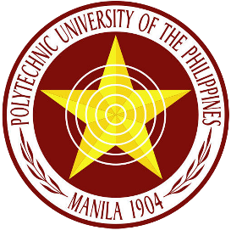

**Vision**

Clearing the paths while laying new foundations to transform the Polytechnic University of the Philippines into an epistemic community.

**Mission**

Reflective of the great emphasis being given by the country's leadership aimed at providing appropriate attention to the alleviation of the plight of the poor, the development of the citizens, and of the national economy to become globally competitive, the University shall commit its academic resources and manpower to achieve its goals through:

1. Provision of undergraduate and graduate education which meet international standards of quality and excellence;
2. Generation and transmission of knowledge in the broad range of disciplines relevant and responsive to the dynamically changing domestic and international environment;
3. Provision of more equitable access to higher education opportunities to deserving and qualified Filipinos; and
4. Optimization, through efficiency and effectiveness, of social, institutional, and individual returns and benefits derived from the utilization of higher education resources.



**Vision**

Filipino children aged 0-4 years whose rights are protected and promoted and whose potentials are developed to the fullest regardless of their conditions, socio-economic status, gender religion and cultural diversity.

**Mission**

Strengthen a system that raises awareness towards the improvement of the quality of life of young children 0 - 4 years old, their families and communities through cooperative and collaborative delivery of services on health, nutrition, early education and social development.



**Mission**

To advocate actively for all visually impaired children by providing support to their family and promoting partnership with social institution that will result to awareness acceptance and access.

To equip and empower parents through education, training and workshops for them to better advocate of their children.

**Vision**

Every visually impaired child will enjoy equal opportunities and access in all activities in life according to choice and ability.



**MISSION**  
That the PBU is recognized as a strong and united federation representing the blind and the partially  
sighted at the local and national level.

That our members are empowered to exercise their rights and implement programs.  
That the PBU serves as a collaborative network for gathering and sharing information.

**VISION**  
An inclusive Philippine society that recognizes the rights of the  
blind and partially sighted towards community and nation building.



Quezon City PDAO is set to be the lead agency which will ensure the efficient and potent delivery of social services necessary to enhance the health, physical fitness, economic and social well-being of PWDs in the metropolis.



**El Nido** is a Philippine municipality on Palawan Island. It’s known for white-sand beaches, coral reefs and as the gateway to the Bacuit archipelago, a group of islands with steep karst cliffs. Miniloc Island is famed for the clear waters of its Small and Big lagoons. Nearby Shimizu Island has fish-filled waters. The area has many dive sites, including Dilumacad Island’s long tunnel leading to an underwater cavern.



**The Chocolate Hills** are a geological formation in the Bohol province of the Philippines. There are at least 1,260 hills but there may be as many as 1,776 hills spread over an area of more than 50 square kilometres. They are covered in green grass that turns brown during the dry season, hence the name.



**Camiguin** is an island province in the Philippines located in the Bohol Sea, about 10 kilometres off the northern coast of Mindanao. It is politically part of the Northern Mindanao Region of the country and formerly a part of Misamis Oriental province.

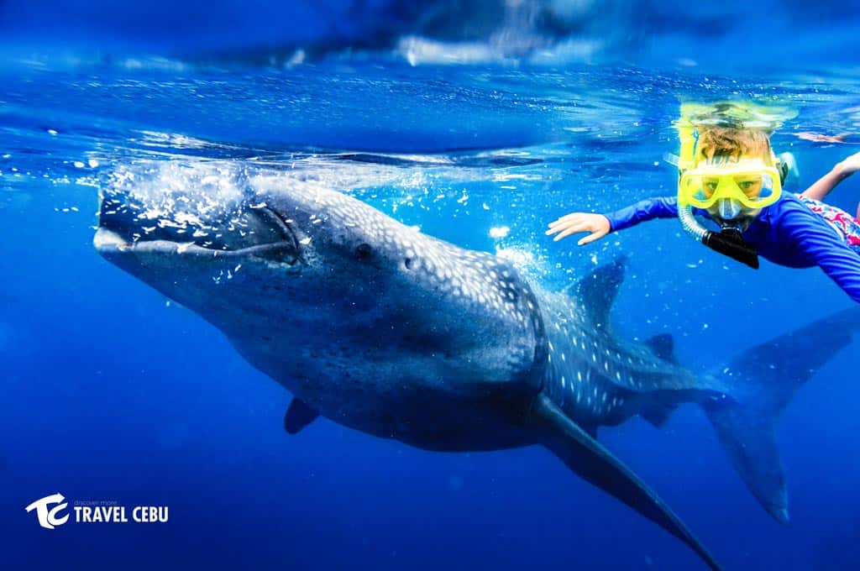

Whale sharks can be seen in a small barangay Tan-awan, which is 10 km away from the center town of Oslob**. Whale shark watching** in Cebu started last September 2011 and it became popular all over the world when the news hit in the internet last November 2011. By December 2011, local fishermen's interact with the whale sharks by feeding them that result to flocking of tourist to the beach of Tan-awan.

**Boracay** is a small island in the central Philippines. It's known for its resorts and beaches. Along the west coast, White Beach is backed by palm trees, bars and restaurants. On the east coast, strong winds make Bulabog Beach a hub for water sports. Offshore, coral reefs and shipwrecks are home to diverse marine life.



Places to visit in Metro Manila  
Rizal Park, Roxas Blvd, Malate, Manila, 1000 Metro Manila

Fort Santiago, Intramuros, Manila, 1002 Metro Manila

Manila Ocean Park, Quirino Grandstand, 666 Behind, Ermita, Manila, 1000 Metro Manila

National Museum of the Philippines, Padre Burgos Ave, Ermita, Manila, 1000 Metro Manila

Novotel Manila Araneta Center is a midscale hotel in Quezon City's business and leisure district with access to LRT and MRT stations. Relish modern comfort in 401 rooms and suites, indulge at Food Exchange Manila, and unwind at Gourmet Bar or The 6th Pool Bar and Lounge. Perfect for business or leisure, discover Kids Club by Novotel, In Balance Spa, In Balance Fitness, Bridal Garden, pillarless Grand Ballroom, and 7 meeting rooms.

Novotel Manila Araneta Center is the perfect base to explore Quezon City, located right beside Smart Araneta Coliseum and a few steps from Gateway Mall and Kia Theatre. Be it for business or pleasure, guests enjoy proximity to the country's government offices, business centers, shopping malls, historical sites and entertainment venues. Nearby attractions include Art In Island 3D Museum, Farmers' Market, Gateway Gallery and Quezon Memorial Circle.



**Vision and Mission**

**PEOPLE WITH DISABILITY SHOULD NOT BE A BURDEN TO SOCIETY**

AOL is committed to provide scholarship to the visually impaired and musically inclined indigents, and to assist these less fortunate brothers and sisters in achieving their dreams of becoming future performing artists.

**LACK OF SIGHT SHOULD NEVER BE A SOCIAL STIGMA**

AOL undertakes to uplift the dignity of the visually impaired but differently-abled people by expressing their innermost feelings, realilzing their dreams a nd achieving their aspirations in life through music.

**THE ULTIMATE MISSION OF AOL IS TO HAVE A MUSIC SCHOOL**

Graduating scholars can serve the Foundation and continue the ministry in training and developing new talents among the visually impaired in the

years to come.

Anderson Go, Founder and Board Chairman

Geraldine T. Osias, Vice President

Gloria Jamadre, Treasurer

Dr. Nenita Cura, Secretary

Sonia Atabug, PRO

Carlo dela Cruz, Auditor

Dr. Teruko Haga, Member

Atty. Rufino V. Abuda, Legal Consultant

Anthony R. Castañeda, Website Administrator

You are invited to participate in our “Adopt-a-Scholar Program” where you will have the opportunity to ‘adopt’ a scholar and be able to monitor his/her progress. For more information, you may visit and contact us at:

Rm. 202, 680 Pedro Gil St., Malate, 1004 Metro Manila

Phone: (632)-524-5687 loc. 214 Fax. No. 829 -3320

Email Address: [ambassadorsoflight@gmail.com](mailto:ambassadorsoflight@gmail.com)

[gtosias@aol.com](mailto:gtosias@aol.com), [mlmortil@yahoo.cocm](mailto:mlmortil@yahoo.cocm)

Website: [www.wix.com/aoliph/ambassadors-of-light](http://www.wix.com/aoliph/ambassadors-of-light)