International Council for Education of People with Visual Impairment
West Asia Region
------------------------------------------------------------------------------

COVID-19 and Mobility for Persons who are Blind

Compiled and coordinated by
ICEVI West Asia, June 2020

Summary of Recommendations
Moderator Comments: The need for a discussion group arose from a telephone call from a blind lady sharing her concern that, due to the coronavirus, people were not willing to help her when she needed assistance in crossing a busy road in an unknown area. While her question was simple, we had no definite answer. A WhatsApp post was created to invite suggestions regarding the measures that this blind lady should take to ensure that people came forward with offers of help when she needed to cross the road in unknown areas.
A large number of people from around the world participated in the WhatsApp discussion and shared their thoughts. Based on comments of all the participants, the following recommendations are proposed by ICEVI West Asia.

Recommendation 1:

1.1 Use of a Mobility Cane
- Use a mobility device, preferably a Smart cane, such as the Torchit (i.e., sensor based handheld object detection mobility device)
- Use a mask and gloves and change the same as per need;
- Always use goggles or other protective eyewear;
- Wash your hands with quality soap or use sanitizer to sanitise hand before leaving and returning to your place;
- Keep a small bottle of sanitizer with you; and
- Regularly sanitise both your hands and long cane.

1.2 ICEVI Mobility Technique during the COVID-19 pandemic or other emergencies
Based on the feedback of respondents, ICEVI West Asia has developed a cane technique named the “ICEVI Mobility Technique”. A video of the Mobility Technique is available on YouTube – go to https://youtu.be/gmVd6LErp5M
We recommend that the blind person follows the following steps while using this technique:
Step 1 : Ask for help from a sighted person who will be your Guide
Step 2 : Take out Sanitizer bottle and sanitize the hands of the Guide and yourself by pouring sanitizer first on your palms and then on the palms of your Guide
Step 3 : If you use a folding cane, unfold it by yourself
Step 4 : Take a tissue paper or clean cloth and wipe the tip of your cane by yourself
Step 5 : Take out your packet of 8 centimetre rubber bands and ask the Guide to take out one rubber band from the packet
Step 6 : Show the Guide the picture of the knot (picture shown below) that is to be tied on the lower tip of cane - it is best to have the picture on the rubber band packet
Step 7 : Request the Guide to tie the knot using the rubber band on the lower tip of your cane, forming a loop for the Guide to hold
Step 8 : Ask the Guide to hold the loop of the rubber band in his/her right hand and then move forward; you will follow the Guide holding the hand grip of the cane (resulting in the cane being held vertically between you and the Guide)
Step 9 : When you reach your destination, ask the Guide to dispose of the rubber band; thank the Guide, and continue along your journey using your cane.

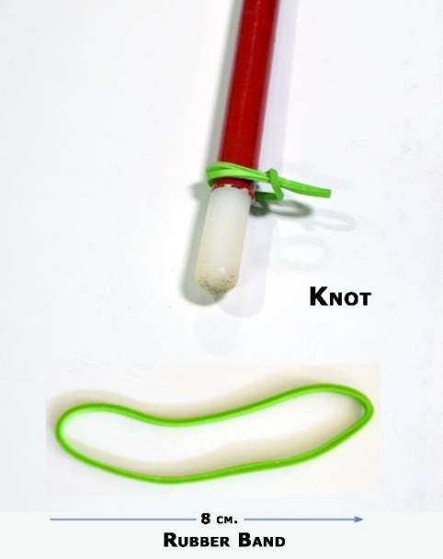
Picture of 8 centimeter rubber band and the knot used to attach the rubber band to the cane with a loop for the Guide’s to hold.

Recommendation 2:

2.1 Use of Human (Sighted) Guide Technique during the COVID-19 pandemic or other emergencies
In the standard human guide technique, the blind person follows the basic techniques of human guide, which include:
- Touch technique (for holding and using the cane),
- Hand position (i.e., hold hand just above the human guide’s elbow), and
- Distance (i.e., blind person positioned half a foot (30 cms) behind).
During the COVID-19 pandemic, please do not come into direct physical contact with your Guide.

2.2 ICEVI Reverse Human Guide Technique
During such conditions as COVID-19 when maintaining social distancing is mandatory, a new technique called “Reverse Human Guide Technique” has emerged through the comments of participants of the WhatsApp group. A video of the Reverse Human Guide Technique is available on YouTube – go to https://youtu.be/f5TVjUn684k
In this technique, the human (sighted) Guide directs the blind person while walking behind (rather than in front) of the blind person. We recommend that the blind person follows the following steps while using this technique:
Step 1 : The blind person asks for the help of a human (sighted) Guide
Step 2 : The blind person explains that human Guide should give verbal instructions while walking 3 feet behind the blind person
Step 2 : The blind person walks in front and the human Guide walks behind, maintaining a distance of 3 feet (approximately 100 cms)
Step 3 : The blind person takes out his/her long cane and walks as guided by the Guide’s instructions
Step 4 : The Guide directs the blind person by giving such instructions as “stop, walk slow, move right, move left, turn right, turn left, take right U turn, take left U turn”, etc.
Step 5 : The Guide announces when the final destination has arrived, as desired by the blind person
Step 6 : The blind person thanks the Guide and continues along their journey using his/her long cane.
Both the standard human guide and reverse human guide techniques ensure social distancing of 3 feet (100cms) is maintained, while completely avoiding human touch between the blind person and the human guide. It is important to ensure the complete safety of the blind person.
The cane techniques described above involve the cost of sanitizer, tissue paper and rubber bands which are affordable items. There is no cost involved in the reverse human guide technique – it is very simple to follow and has scope for universal application.

Recommendation 3: Other observations
During the COVID-19 pandemic or other emergencies, a blind person should:
- Avoid unnecessary movement in public places.
- Keep extra bags for items purchased.
- Follow all government guidelines on COVID-19 in respect to lock down, including knowing about containment areas, restrictions on movement, use of public vehicles, social distancing in public places, registration on relevant apps, sanitization of hands while entering public places, and requirements for wearing of masks.
- When speaking with others, do not remove your face mask, but rather speak loudly if the person cannot hear you.
- Listen to the radio, community radio or television for all relevant instructions and other appropriate information.
- See if it is possible to get work from home from your employer.
- Order groceries and essentials items online, and also make payments online.
- Use Google (or other) digital maps wherever possible when moving outdoors.
- Always carry bags, protective gloves, tissue paper, or pieces of rough paper or old cloth with you, and use these items whenever you want to accept mobility help from someone. These protective items can also be used in lifts, on ramps, and whenever and wherever you need to touch surfaces. After use of the protective items, immediately dispose of them carefully in a dustbin or by wrapping the item in a carry bag or another paper to take home with you.
- If you need to go out on a regular basis, try to hire the same vehicle and driver every time. If you have your own vehicle, hire the same driver on monthly payment basis.
- Use sanitizer before and after taking help from someone.

Note: This draft shall be further improved after receiving feedback from mobility experts and blind persons themselves.

