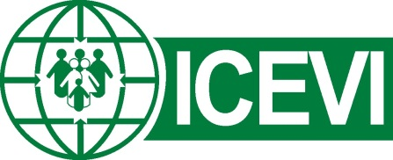
International Council for Education of People with Visual Impairment

World Braille Day - 4th January 2023
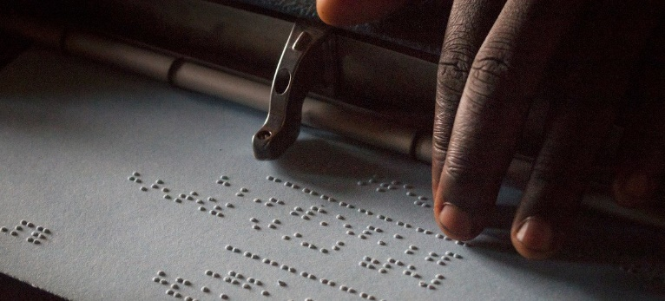
Caption: Child reading braille while using a Perkins brailler at a high school in Uganda.
Source: UNICEF, https://news.un.org/en/story/2021/01/1081312
This month marks the 214th anniversary of the birth of Louis Braille in Coupvray France in 1809. In recognition of Louis Braille’s life and legacy, the United Nations in 2018 proclaimed January 4th as World Braille Day. In passing the Resolution, Members of the UN General Assembly stated that the full realisation of human rights and fundamental freedoms relies on inclusive reading and writing systems.
ICEVI recognises the global challenges in realising the right to education for children with vision impairment in many regions of the world. Global eye health data presented in the Vision Atlas of the International Agency for the Prevention of Blindness (IAPB, 2020) show that 1.1 billion people experience vision impairment, including 43 million people with blindness and 295 million people with moderate to severe vision impairment. The IAPB data indicate that 80-85% of people with vision impairment globally live in rural and remote communities.
To progress the right to education for all children, we need teachers who ignite curiosity, self-confidence, motivation, and a love of learning in their students. We need knowledgeable and inspiring teachers of braille who provide children and young people with effective literacy skills to succeed in their chosen education and vocational fields, including science, technology, engineering, mathematics, music, and foreign languages. The Braille Literacy Position Statement of ICEVI and the World Blind Union emphasises braille literacy as a key to education, independence, and full participation for persons who are blind. Children and adults have the right to choose to learn and use braille, as articulated in Articles 21 and 24 of the United Nations Convention on the Rights of Persons with Disabilities (UNCRPD). The UNCRPD cites braille as an important means of communication and essential in education, freedom of expression and opinion, access to information, and social inclusion for those who use it.
ICEVI affirms the UNCRPD emphasis on braille instruction and production by competent people who have the relevant knowledge, skills, and experience. The ICEVI website includes a range of information and resources promoting the right to education and braille literacy, including braille articles in the bi-annual newsletter, The Educator, the Teacher Training Curriculum for countries with limited or no teacher training in VI education, the Include Me publication promoting braille literacy for children with deafblindness and multiple disability, and the ICEVI-WBU joint Position Statements on Braille Literacy (2016) and Education (2018). Other valuable sources of information have been produced by ICEVI partner members, including the Perkins School for the Blind World Braille Usage publication and Paths to Literacy website, and the NextSense UEB Online free braille literacy and mathematics training programs.
ICEVI invites you to join us in calling on national education leaders and decision makers to realise the right to education for children with vision impairment. We call upon leaders to invest in the human, physical, and financial resources required to deliver quality braille literacy instruction in preschools and schools, to produce and distribute braille materials and “born accessible” publications, and to make available accessible low-cost braille reading and writing devices.
Hellen Keller calls us from across time to make every effort to progress the right to braille literacy for children with vision impairment, leaving no-one behind.
"Through the magic of six dots the gates of knowledge have been flung wide, and the blind of each country can enter the world of enchantment beyond the reach of physical sense. Never at any time are we so free as when we hold a beloved book on our knee, and the braille dots flash into our fingers the greatness, the wonder, the boundlessness of life."
Helen Keller, 1930

