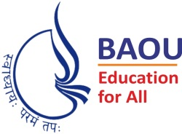
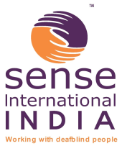
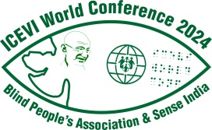

International Council for Education of
People with Visual Impairment

World Conference and General Assembly

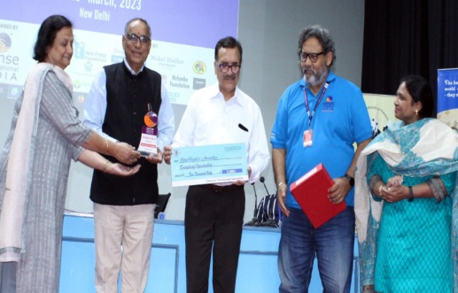

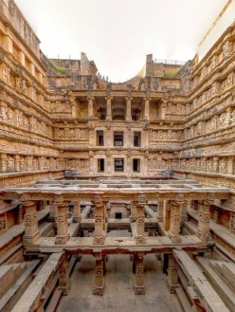
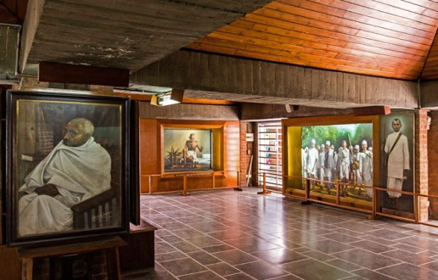

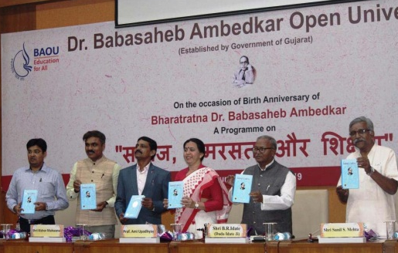

14 to 17 November 2024 | Ahmedabad, INDIA
First Announcement – Save the Dates
The International Council for Education of People with Visual Impairment (ICEVI) is pleased to announce its World Conference and General Assembly which will take place in Ahmedabad India on 14 – 17 November 2024.
The World Conference is hosted by the Blind People’s Association (BPA), Ahmedabad India, which is one of the premier organisations serving persons with visual impairment in India. The Conference Co-Host is Sense International India, a leading organisation in developing services for deafblind people in India, Bangladesh and Nepal.
The Host-Committee is organising this world event in collaboration with Dr. Babasaheb Ambedkar Open University, Ahmedabad, which is renowned for its higher education program promoting “Education for All”. The University campus is the venue for the conference.
Ahmedabad is well connected by international airlines from various world cities and we will be sharing details with you in further communications.
The Sabarmati Ashram situated on the banks of river Sabarmati was home to Mahatma Gandhi from 1917 to 1930 and served as one of the main centres of the Indian freedom struggle. It was from here on March 12, 1930 that Gandhiji launched the famous Dandi March, the Salt Satyagraha which ultimately resulted in freedom.
Conference Theme and Schedule
The broad theme of the conference is “Inclusion in Diversity: Equity and Accessibility for All”.
Following is the tentative schedule:
Day 1 | 14th November 2024 | Official inauguration, one plenary session and  12 parallel sessions
Day 2 | 15th November 2024 | Two plenary sessions and 12 parallel sessions
Day 3 | 16th November 2024 | Three plenary sessions and Closing session
Day 4 | 17th November 2024 | Forenoon : Regional Meetings of the Delegates from ICEVI’s seven regions and Regional Elections
 |  | Afternoon : ICEVI General Assembly
The Conference will feature pre- and post-conference workshops and a dedicated exhibition area for trade displays and service providers. Details will be available in the Conference Announcements released in the coming months.
Call for Papers
The Scientific Program Committee, headed by Ms Sian Tesni, is working closely with the Blind People’s Association to plan a world class program featuring current research, practice, and innovation in education for persons with visual impairment, deafblindness and multiple disabilities.
The Call for Papers and Abstract Submission Form will be posted in late June 2023 on www.icevi2024wc.org – a dedicated website for the World Conference and General Assembly, ICEVI website www.icevi.org and on the ICEVI West Asia website https://iceviwestasia.in. The e-mail address for submitting Abstract will be: icevi2024wc@gmail.com and oficevi@gmail.com. The Call for Papers will invite submissions for seminar and conference style presentations, topics for the parallel sessions, poster sessions, workshops on specific topics, demonstrations of assistive devices, etc.
Registration
The conference will accommodate approximately 700+ delegates. The registration options are as follows:
In-Person attendance
Registration before  31st March 2024 | Non-Indian delegates | US$ 400
 | Indian delegates | US$ 200 / INR 16400
Registration after  1st April 2024 | Non-Indian delegates | US$ 450
 | Indian delegates | US$ 250 / INR 20500
Accompanying person |  | US$ 200 / INR 8200
The registration fee is inclusive of conference materials, conference bag, welcome reception and Gala dinner. Additional details, including payment of registration fee, and bank transfers will be posted on the ICEVI website and published through ICEVI’s communication channels.
The organisers will also take a decision on offering the conference in the online mode too around November 2023 depending on the registrations for the in-person conference.
Hotels
Details of the recommended hotels for the conference will be announced by the Host Committee in the near future. Assistance with hostel accommodation at affordable rates will also be provided, if required, by the Host Committee.
Visas
The Host Committee, headed by Dr. Bhushan Punani, will assist conference delegates with the issuance of invitation letters to obtain visas for attending the conference.
ICEVI is delighted to host the 2024 World Conference and General Assembly. We look forward to welcoming you in-person to Ahmedabad India.
Save the dates and await more details in the coming weeks!

Dr. Frances Gentle, President, ICEVI
May 2023

Contact details of the Host Committee:

Dr. Bhushan Punani
Chairperson, Host Committee
General Secretary, Blind People’s Association (India)
132 Ft. Ring Road, Vastrapur, Ahmedabad, Gujarat - 380 015,
India.
E-mail: icevi2024wc@gmail.com
Website: www.icevi2024wc.org ; https://iceviwestasia.in

&

ICEVI Secretariat
No.3, Professors’ Colony, Sri Ramakrishna Vidyalaya Post,
Coimbatore 641 020, Tamil Nadu,
India.
E-mail: oficevi@gmail.com
Website: www.icevi.org

