The Educator

Volume XXXVI - Issue 1 July 2022

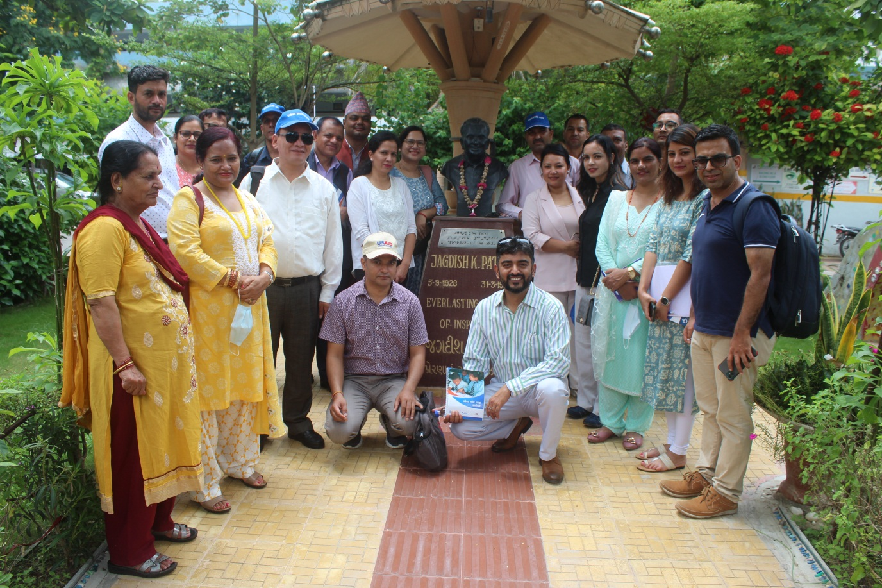

A Publication of
The International Council for Education of
People with Visual Impairment
PRINCIPAL OFFICERS

PRESIDENT
Frances Gentle
Lecturer, NextSense Institute
361-365 North Rocks Road, North Rocks NSW 2151, AUSTRALIA
e-mail: Frances.Gentle@nextsense.org.au

FIRST VICE PRESIDENT
Bhushan Punani
Executive Secretary, Blind People’s Association (India)
132 Ft. Ring Road, Vastrapur, Ahmedabad 380 015, INDIA
e-mail: bhushanpunani@gmail.com

SECOND VICE-PRESIDENT
Sabine Fijn van Draat
Secretary, Executive Board
NOVUM Foundation, Amersfoortsestraatweg 180, 1272 RR Huizen
THE NETHERLANDS
e-mail: sabinefijnvandraat@visio.org

TREASURER
Praveena Sukhraj-Ely
Department of Justice and Constitutional Development,
Momentum Centre, 329 Pretorius Street, Pretoria, SOUTH AFRICA
e-mail: psukhraj@justice.gov.za

IMMEDIATE PAST PRESIDENT
Lord Low of Dalston
Royal National Institute of Blind People
105 Judd Street, London WC1H 9NE, UNITED KINGDOM
e-mail: colin.low@rnib.org.uk

CHIEF EXECUTIVE OFFICER
Mani, M.N.G.
No.3, Professors’ Colony, Sri Ramakrishna Vidyalaya Post,
Coimbatore 641 020, Tamil Nadu, INDIA
e-mail: ceo201922@gmail.com
REGIONAL PRESIDENTS

AFRICA
Gertrude Oforiwa Fefoame
Sightsavers’ Global Advocacy Advisor
Densu Point, P.O. Box KIA 18190, North Dzorwulu, Accra, GHANA
e-mail: gofefoame@sightsavers.org

EAST ASIA
Aria Indrawati
President, Pertuni (The Indonesian Blind Association)
P.O.Box 386, Jl Pertanian Raya, No. 51 Jakarta, INDONESIA
e-mail: aria.indrawati@gmail.com

EUROPE
John Ravenscroft
Professor of Childhood Visual Impairment, Moray House School of Education and Sport
University of Edinburgh, Holyrood Road, EH8 8AQ, Edinburgh, UNITED KINGDOM
e-mail: john.ravenscroft@ed.ac.uk

LATIN AMERICA
Julio César Canizález
Autopista a Comalapa Urbanización Los Héroes N° B-5, San Salvador,
EL SALVADOR
e-mail: presidencia@icevilatinoamerica.org

NORTH AMERICA/CARIBBEAN
Susan LaVenture
North America and Caribbean Regional-ICEVI Office
C/O New York Institute for Special Education, 999 Pelham Parkway, Bronx, NY USA
e-mail: laventuresusan506@gmail.com

PACIFIC
Joanne Mosen
Disability Inclusion Consultant, Director, Disability Inclusion PTY LTD.
PO Box 2123, Forest Hill 3131, Victoria, AUSTRALIA
e-mail: joanne@disabilityinclusion.com.au

WEST ASIA
Birendra Raj Pokharel
Action on Disability Rights and Development (ADRAD)
10/80 (Kha) Kopundole, Lalitpur, NEPAL
e-mail: birendra.abilis@gmail.com
FOUNDING ORGANISATIONS

American Foundation for the Blind

President & CEO
1101, Wilson Blvd, 6th Floor, Arlington, VA 22209, USA
e-mail: kadams@afb.org

Perkins School for the Blind
Deborah Gleason
Director, Asia and Pacific Region, Perkins International
Perkins School for the Blind, 175 North Beacon Street, Watertown, MA 02472, USA
e-mail: deborah.gleason@perkins.org

Royal National Institute of Blind People
David Clarke
105 Judd Street, London WC1H 9NE
UNITED KINGDOM.
e-mail: david.clarke@rnib.org.uk

INTERNATIONAL NON-GOVERNMENTAL ORGANIZATIONS

Deafblind International
Mirko Baur
Vice President, DbI & CEO, Tanne, Swiss Foundation for Congenital Deafblindness
Alte Dorfstrasse 3d, CH-8135, Langnau am Albis, SWITZERLAND
e-mail: mirko.baur@tanne.ch

World Blind Union
Martine Abel-Williamson
President
68 Meadway, Sunnyhills, Auckland 2010, NEW ZEALAND
e-mail: martine.the1@xtra.co.nz

International Agency for the Prevention of Blindness
Peter Holland
Chief Executive Officer
4-108, 8 Devonshire Square, London EC2M 4PL, UNITED KINGDOM
e-mail: pholland@iapb.org

INTERNATIONAL PARTNER MEMBERS

CBM
Monika Brenes
Stubenwald-Allee 5, 64625 Bensheim, GERMANY
e-mail: monika.brenes@cbm.org

Norwegian Association of the Blind and Partially Sighted (NABPS)
Terje Iversen
Director for International, Development Cooperation
P.O. Box 5900, Majorstua0308 Oslo, NORWAY
e-mail: terje.iversen@blindeforbundet.no

Organización Nacional de Ciegos Españoles
Ana Peláez
Director, C/ Almansa, 66, 28039 Madrid, SPAIN
e-mail: apn@once.es

Overbrook School for the Blind
Todd Reeves
CEO and Executive Director
6333 Malvern Avenue, Philadelphia, PA 19151-2597, USA
e-mail: todd.reeves@obs.org

Perkins School for the Blind
Katherine Holland
Regional Coordinator – Asia and the Pacific
175 North Beacon Street, Watertown, MA 02472, USA
e-mail: katherine.holland@perkins.org

NextSense Institute
Frances Gentle
Lecturer
361-365 North Rocks Road, North Rocks NSW 2151, AUSTRALIA
e-mail: Frances.Gentle@nextsense.org.au

Royal National Institute of Blind People
David Clarke
105 Judd Street, London WC1H 9NE, UNITED KINGDOM
e-mail: david.clarke@rnib.org.uk

Sightsavers
Andrew Griffiths
Head of Advocacy
35 Perrymount Road, Haywards Heath, West Sussex RH16 3BW UNITED KINGDOM
e-mail: agriffiths@sightsavers.org

Visio
Marcel Janssen
NOVUM Foundation
Amersfoortsestraatweg 180, 1272 RR Huizen, THE NETHERLANDS
E-mail: MarcelJanssen@visio.org

International Partner Members

CBM
www.cbm.org

Norwegian Association of the Blind and Partially Sighted (NABPS)
www.blindeforbundet.no

Organización Nacional de Ciegos Españoles
www.once.es

Overbrook School for the Blind
www.obs.org

Perkins School for the Blind
www.perkins.org

NextSense Institute
www.nextsense.org.au

Royal National Institute of Blind People
www.rnib.org.uk

Sightsavers
www.sightsavers.org

Visio
www.visio.org

Organisational Members

American Printing House for the Blind
www.aph.org
Canadian National Institute for the Blind
www.cnib.ca
Federazione Nazionale Delle Istituzioni Pro Ciechi
www.prociechi.it
Hadley Institute for the Blind and Visually Impaired
www.hadley.edu
LES DOIGTS QUI REVENT (Typhlo & Tactus)
www.tactus.org
Lions Clubs International Foundation
www.lcif.org
Round Table on Information Access for People with Print Disabilities
www.printdisability.org

Editor
Kay Ferrell
Professor Emerita, Special Education
University of Northern Colorado
10806 Bear Cub Drive
Broomfield, CO 80021
USA

Associate Editor
M.N.G. Mani
Nandini Rawal

Assistant Editor
Bhushan Punani

Editorial Committee
Frances Gentle
Kay Ferrell
M.N.G. Mani

Designing
ICEVI Secretariat
No.3, Professors’ Colony
S.R.K. Vidyalaya Post
Coimbatore - 641 020
Tamil Nadu, INDIA
Telefax : 91-422-2693414
e-mail : ceo201922@gmail.com
Contents

Message from the President and CEO 11
Message from the Editor 12
INTER-COUNTRY LEARNING VISIT 13
Prof Kay Ferrell inducted into the Hall of Fame for Leaders and Legends 18
Acknowledging the Contributions of ICEVI Member Organisations 19
CBM 20
NextSense 25
Norwegian Association of the Blind and Partially Sighted (NABP) 28
ONCE (National Organization of Spanish Blind People) 31
Overbrook School for the Blind 36
Perkins School for the Blind 42
Royal National Institute of Blind People (RNIB) 50
Sightsavers 56
Royal Dutch VISIO 60
Talking Technology 64
STATEMENT ON THE PROTECTION AND SAFETY OF PERSONS WITH VISUAL IMPAIRMENT IN WAR-AFFECTED COUNTRIES 72
ICEVI’s 70th Anniversary 75

Front Page Photograph:
Participants in the Nepal-India Inter-Country Learning Visit pose for the camera after an informative yet exhausting day of meetings and visits.

Message from the President and CEO

Dear Readers
ICEVI is a convening organisation that brings together organisations and individuals who are concerned about the education rights of children and young people with blindness, low vision, deafblindness, and multiple disability. Our members are drawn from the seven ICEVI world regions and their services and programs progress the ICEVI mission of inclusive and equitable access to quality education for all people with visual impairment (VI).
We acknowledge with thanks the work of our global, regional and national members and partners. With the easing of COVID-related travel restrictions, our members are implementing in-person and hybrid projects, conferences, and training workshops, with a focus on low- and middle-income countries. However, we recognise the challenges in VI education. The United Nations Sustainable Development Group highlighted the impact of COVID-19, noting the pandemic “has created the largest disruption of education systems in history, affecting nearly 1.6 billion learners in more than 190 countries and all continents”. The Mission of ICEVI and the work of our members and partners is just as important today as it was 70 years ago.
In preparation for this issue, we invited our nine international member organisations to introduce their services and perspectives as ICEVI members. We are delighted to feature their introductions in this issue, together with our regular column, Talking Technology, and a report on the high-level learning exchange visit between the countries of Nepal and India.
In the next issue we will report on the commencement of our 70th anniversary celebrations and the first in-person meeting since 2019 of the ICEVI Executive Board which took place in the Netherlands in October 2022.

Frances Gentle, President;
and
M.N.G. Mani, Chief Executive Officer.

Message from the Editor

This issue of The Educator is devoted to information about our international partners, the organizations that form the foundation of ICEVI Global. Each of these organizations provide financial and leadership support to ICEVI, and each plays an important role on ICEVI’s Executive Board. We are grateful for that support and have benefitted immensely from their wisdom and experience.
I cannot tell you how much it means to me to have Nandini Rawal working with me on this issue! What a joy she is! Someone who is always positive, always creative. She adds so much to both ICEVI and to The Educator, not the least of which is cultural balance. Nandini is already known to many of you as the former Treasurer of ICEVI, a position she held for many years. Thank you, Nandini!
ICEVI adopted a position statement about protection and safety of persons with disabilities in war-affected countries in March 2022, which we should have included in the last issue. We hope to devote a future issue to refugees and displaced persons with disabilities. (Let us know if you can contribute something.) In the meantime, we hope for an end to the hostilities and the restoration of all displaced persons to their homelands.
Our Talking Technology columnist, Ben Clare from Australia, returns with a wonderful article about accessibility, particularly in conjunction with the Covid-19 pandemic, rapid antigen tests, Apple’s new operating system, and NVDA. It always amazes me that Ben knows about technology news before it’s common knowledge.
And, in this, the 70th year of ICEVI’s existence, we encourage everyone to send birthday greetings that we can include in the next issue of The Educator. Share your memories with your friends and colleagues! I especially remember my first General Assembly in Thailand in 1992, and the year I became the Regional Chair for the North American-Caribbean Region. I bet you have memories, too, and we would love to hear about them!

Happy reading!

Kay Alicyn Ferrell
kay.ferrell@unco.edu
Broomfield, Colorado, USA

INTER-COUNTRY LEARNING VISIT

21-26 AUGUST, 2022

by
Nandini Rawal (nandinirawal@gmail.com)
Associate Editor of The Educator

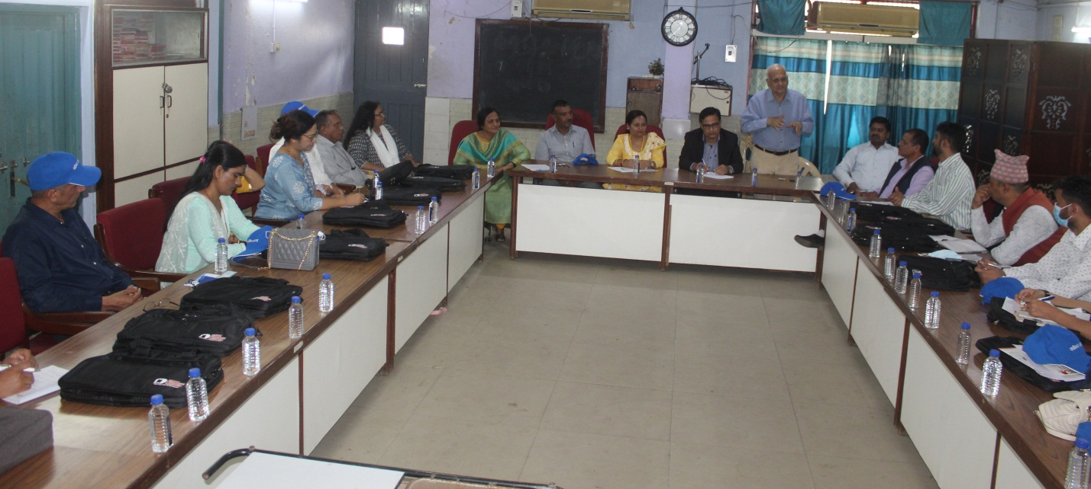

ICEVI Global facilitated ICEVI West Asia to have an Inter-country visit between the countries of Nepal and India. The Government of Nepal was very keen to study the Inclusive Education systems set up in India with the ultimate objective of replicating these good practices in Nepal.

This visit was facilitated by the Reading for All (R4A) program of Nepal—implementing partners that are working in close collaboration with the Center for Education and Human Resource Development (CEHRD), National Center for Educational Development, Curriculum Development Center (CDC) and the Education Review Office (ERO), relevant non-governmental organizations (NGO), and the Organization of Peoples with Disabilities (OPDs) in Nepal.
The learning visit was to enable 10-12 government officials under the Ministry of Education Science and technology (MoEST) to participate in an exposure visit to India and to support MoEST to learn from the best practices within the region that are similar to the Nepalese context. This visit offered the opportunity for cross-learning in the following areas within disability-inclusive education.

The host organization was Blind People’s Association, Ahmedabad, Dr. Bhushan Punani, Vice President, ICEVI, and Mrs. Nandini Rawal, Former Treasurer, ICEVI, who designed the visit for the team in the following manner:

- To learn how India is identifying children with disabilities and how it manages and uses the data.
- To learn how India is ensuring that children with disabilities in the early grades achieve the core learning outcomes.
- To learn how the OPDs, civil society organizations, and the Governments (health, women and children, and education ministries) are collaboratively working to respond to the needs of children with disabilities.
- To observe classroom practice in special schools, resource classes, and mainstream schools.
- To learn how India is mainstreaming children with disabilities in the higher grades.
- To understand how Indian policies and plans are guiding the implementers to address the educational and other needs of children with disabilities.
- To learn other best practices such as using universal design for learning (UDL), individualized education programs (IEP), and Information& Communication Technology (ICT) to improve the learning outcomes of children with disabilities.

The following officials from Nepal were part of this visit:
- Mr. Shree Prasad Bhattrai, Deputy Director General – Joint Secretary, CEHRD
- Dr. Divya Dawadi, Director - Under Secretary - Inclusive Education Section, CEHRD
- Mr. Ram Chandra Sharma, Director - Under Secretary - Inclusive Education Section, CEHRD
- Mr. Narayan Prasad Jha, Director - Under Secretory, ERO
- Mr. Narad Prasad Dhamala, Section Officer - Inclusive Education Section, CEHRD
- Ms. Kunti Adhikari, Technical Officer - Training Section, CEHRD
- Ms. Rajani Dhimal, Technical Officer- Training Section, CEHRD
- Ms. Indu Khanal, Curriculum Officer, CDC
- Mr. Deepak Majhi, Section Officer, MoEST
- Mr. Baldev Bhandari, Section Officer, MoEST
- Ms. Sarita Devi Sharma, Section Officer Development Aid Coordination Section, MoEST
- Mr. Rajkumar Dulal, Education Specialist, US Agency for International Development (AID)
- Ms. Seema Acharya, Technical Advisor - Capacity Development Specialist, R4A
- Mr. Sambedan Koirala, Inclusive Education Specialist, R4A
- Ms. Kabita Kunwar, Inclusive Education, focal person
- Mr. Lal Bahadur Chaudhary, Senior Program Officer, R4A
- Mr. Shaurabh Sharma, Handicap International (HI)
- Mr. Gobinda Fulara, Coordinator & Mr. Yadav Bhushal, Coordinator, Disabled Empowerment and Communication Centre Banke, Nepal (DEC - Nepal) & DEC - Surkhet
- Mr. Sachin Khadka, Senior Monitoring & Evaluation Officer, R4A
- Ms. Shanti Barmashkha, Senior Technical Officer, R4A

The visit occurred on 22 and 23 August, 2022, with visit and observation of the activities of the Blind People’s Association (BPA), which included:
- Early Intervention
- Skill Centre for Multiple Disabilities
- Printing, tailoring, artificial limb & assistive device making department
- School of Physiotherapy & Japanese Medical Massage
- Industrial Training Institute (ITI) for the disabled, which included computer programming, hair and skin care, desktop publishing
- Meeting with sports heroes and BPA’s role in athlete preparation
- Day care centres for persons with visual impairment and multiple disabilities (VIMD), Deafblind Unit
- School of Physiotherapy and Japanese Medical Massage
- Distance education (special education courses in various disabilities recognized by universities)
- Low Vision Assessment
- Observation of special school primary & secondary—Teaching math with the Tailor frame, teaching with tactile diagrams and braille teaching, computer training, activities of daily living, teaching of abacus, math and science
- Work in advocacy, accessibility and inclusion (examples of successful cases)
The BPA also conducted a one-day seminar for the visiting team consisting of the following presentations:
- New policy on education and Right to Education (RTE) 2009 (Dr. Bhushan Punani)
- Inclusive education – Personnel preparation (Mrs. Nandini Rawal)
- Education and children with disabilities (Mr. Bharat Joshi)
- Importance of technology in inclusive education (Mr. Ranchhod Soni & Ms. Vidhi Shah)
- Children with deafblindness and multiple disabilities in the mainstream curriculum (Mrs. Krupa Velani)
- Role of early intervention and school preparatory services for inclusion of children with special education needs (Abha Joshi)

Meeting/interaction with Government Officials in Gandhinagar
An excellent presentation of the Governmental initiatives and the digital information on inclusive education was presented to the visiting Nepal team by the State Project Director, Mrs. Jayashree Devangan, Additional State Project Director, Mr. Vinod Rao, Secretary, Primary & Secondary Education Samagra Shiksha, on 24 August 2022. The State Project Director of the Education for All Department, Dr. Ratan, was also present. The government officials showed the visiting team the different dashboards and monitoring mechanisms developed for tracing the progress of inclusive education. Mr. Rao showed how the system could do live observation of a child with disability in the regular government school and also whether the teacher was engaged with the child. The visiting team, which consisted of top government officers and NGO representatives, was very impressed and lost for words by the remarkable achievements of the Government of Gujarat in the sphere of inclusive education.

The team also visited children with disabilities in regular schools on 25 August, 2022, met the principals and class teachers, and also had a detailed discussion with them. They also met Dr. Ami Upadhyay, Vice- Chancellor of Baba Saheb Ambedkar National Open University (BAOU), who did an excellent presentation of BAOU and its initiative to the visiting Nepal team. The team got many ideas of starting various distance education programmes in the field of disability in Nepal. That evening they also met around 15 children who have studied in regular schools and who are now adults and are earning a living. Some of these children with disabilities are now PhDs and working in universities, working in banks, are teachers, or are self-employed. Their parents were also present and explained how Inclusive Education has helped their children to develop in a comprehensive manner.

CONCLUSION
ICEVI Global and ICEVI West Asia have successfully demonstrated that an inter-country visit is extremely useful in cross-pollination of expertise, experience, and knowledge and can lead to the replication of good practices in the participating countries. As the visit had components of theoretical learning as well as practical observation of programmes and exposure to the various stakeholders, the experience gained was robust and comprehensive.

Prof Kay Ferrell inducted into the Hall of Fame for Leaders and Legends

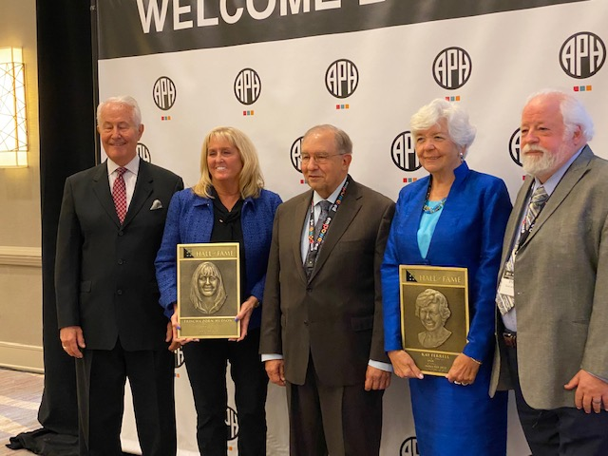
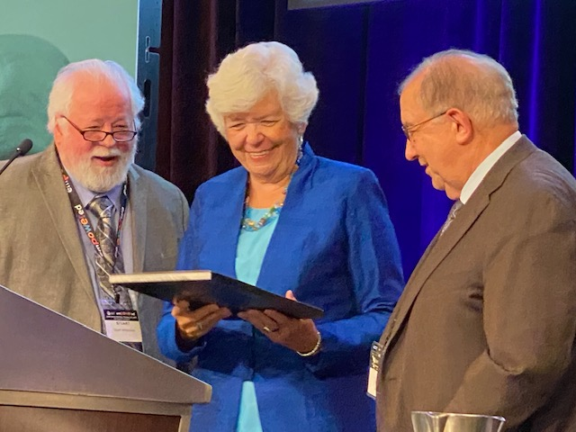

We are delighted that Prof Kay Ferrell has been inducted into the Hall of Fame for Leaders and Legends of the Blindness Field.

Kay is a world renowned expert in the field of blindness and low vision. She is currently the Editor of the ICEVI Educator and previously served as President of the ICEVI North America and Caribbean region.

Kay’s contribution to the vision impairment field is described in the APH Hall of Fame news at https://sites.aph.org/hall/news/

Please join us in congratulating Kay on this accolade and in recognising, with thanks, her continued contribution to the lives of children with vision impairment.

Dr. Frances Gentle, President
and
Dr. M.N.G. Mani, CEO, ICEVI

Acknowledging the Contributions of
ICEVI Member Organisations

The Executive board of the ICEVI consists of five categories of members. The first category includes the elected Principal Officers who look after the day-to-day functioning of the organisation. The second category includes the presidents of the seven regions of ICEVI who primarily deal with the activities at the regional and national levels. The third category includes the umbrella organisations, namely the International Agency for the Prevention of Blindness (IAPB), The World Blind Union (WBU) and The Deafblind International (DbI). The fourth category includes the three founding members, viz., The Perkins School for the Blind, Royal National Institute of Blind People and the American Foundation for the Blind. The members representing the above categories are either elected or nominated for every Quadrennium. Key members of the ICEVI Executive Board are our international partners who are not only advocating for ICEVI’s global mission and values but also contributing to the organisation in terms of membership fees and designated project grants. ICEVI is a convening organisation that promotes networking, information sharing and promotion of the work of members and partners in progressing the rights of children with visual impairment to education and social inclusion. ICEVI amplifies the voices of our international partners wherever appropriate and vice versa.

During the last two decades, the international partner members have been closely involved with many flagship activities of ICEVI, including the Global Campaign on Education For All Children with Visual Impairment (EFAVI) which was launched in 2016 in partnership with the World Blind Union. In recognition of the contributions of member organisations, the 2021 annual report featured information about the activities of our international partner members (IPMs), and additional information is included this July 2022 issue of The Educator. The ICEVI Publications Committee of The Educator, which is ICEVI’s official magazine, has dedicated the July 2022 issue to the international partner members. The Publication Committee and Principal Officers of ICEVI are of the view that IPM information will be of interest to governments and organisations of parents and persons with disabilities across the seven regions of ICEVI and will be appreciated by The Educator readership.

Links to the websites of our partner organisations are provided on the homepage of ICEVI website/ www.icevi.org.

CBM
CBM Christoffel-Blindenmission Christian Blind Mission e.V.,
Bensheim, Germany
CBM is active around the world. CBM’s work is divided between their office in Germany, which hosts some of the organisation's central functions, and their regional hubs and country offices in the field. CBM supports programmes and raises funds to build the capacities of its partners in the world's poorest communities. CBM’s mission of improving the quality of life of persons with disabilities includes a focus on Africa, Asia, and Latin America.

Contact
Michael Schwinger (Michael.Schwinger@cbm.org)

About CBM
CBM is an international Christian Development Organisation, and our vision is an inclusive world in which all persons with disabilities enjoy their human rights and achieve their full potential.

Based on its core values and over 100 years of professional expertise, CBM addresses poverty as a cause, and a consequence, of disability, and works in partnership to create an inclusive society for all.

Our four strategic goals are to:
- Strengthen the voice and autonomy of people with disabilities;
- Build inclusive, resilient communities;
- Build inclusive and sustainable local and national systems and services; and
- Ensure that populations affected by disasters have access to inclusive humanitarian assistance and protection.

Our work promotes a whole-of-life, person-centred approach for individuals with disabilities. It does not just address change at an individual level, but challenges systemic discrimination by strengthening inclusive systems and services, and by supporting the voice and power of persons with disabilities as agents of change in both development and humanitarian action.

CBM’s Current Projects
In 2021 CBM supported 492 projects, working with partners in 46 countries.

We implement our work by focussing on two main programmatic areas.

The Inclusive Eye Health Initiative, in collaboration with our partners, focusses on creating inclusive, sustainable and locally owned, eye health and Neglected Tropical Diseases (NTD) services. Our main areas of support include eye surgery, conducting drug campaigns against NTDs, training medical staff and community volunteers, performing eye screenings, participating in educational projects, and using new technology to improve our reach and understanding. We also work to support our local partners to establish good referral networks so that patients have easier access to services.

The Community Based Inclusive Development (CBID) Initiative puts the focus on creating inclusive communities. Together with our partners, we aim to ensure people with disabilities are respected and included in their communities on an equal basis in all areas of life. CBID is people centred, community driven, and human rights based. CBID is an essential contribution to CBM’s Vision and a key approach to realise the Convention on the Rights of Persons with Disabilities (CRPD) and leave no one behind in achieving the Sustainable Development Goals (SDGs).

Our CBID programmes can include health, education, livelihood, social and empowerment activities, working closely with local partners, local governments and the disability movement to bring about change. CBID particularly promotes the participation and voice of people with disabilities in decision-making processes at the local level. In high risk areas, CBID programmes include activities that address community preparedness and resilience for when natural and human-caused disasters strike. CBID enhances and strengthens earlier work described as Community Based Rehabilitation (CBR) and encourages more inclusive, responsive, and accountable communities.

Our work in education includes:
- Raising awareness at the community level about the rights of children to go to school, including those with disabilities, and the importance of early identification and early intervention.
- Taking a multi-sectoral approach to education provision by, for example, working with health departments for early identification and referral, including early intervention, and working with ministries to support implementation of inclusive education from the national to the community level.
- Working with persons with disabilities and their organisations to support implementation, monitoring, and evaluation of education projects.
- Supporting the provision of quality inclusive education within communities using a twin-track approach along the lines of Universal Design for Learning.
- Supporting specialist centres to provide inclusive education.
- Recognising the important role of caregivers, supporting them to find ways to best support their child, and supporting them in their livelihood.
- Using our technical expertise to support partners to include a variety of activities within education programmes as appropriate (e.g., Livelihood, Disability Inclusive Disaster Risk Reduction, Eye Health, Ear and Hearing Care, and Physical Rehabilitation).
- Building the capacity of teachers (pre-service and in-service; mainstream and specialist) in inclusive education.
- Supporting education in emergencies.

We are also active at the global level. Our Senior Advisor for Education, Sian Tesni, is co-chairing the Inclusive Education Task Group of the International Disability and Development Consortium (IDDC). The Task Group aims to promote disability-inclusive education by influencing policies, strategies, and financing through evidence-based advocacy, sharing information and knowledge.

CBM is also an international member of the Global Campaign for Education (GCE). Through its membership CBM aims to make education accessible for all learners, including those with disabilities, so that none are excluded. Through joint advocacy and lobbying we aim to make sure that governments act now to deliver everyone’s right to a free, quality, public education.

CBM Response to COVID-19. In spite of the many challenges CBM and partners experienced during the pandemic, educational provision continued to be active. Some of the key activities included:
- Provision of psychosocial support to parents and children.
- Awareness campaigns so that communities understand what the virus is, how it spreads and what they can do to mitigate spreading the virus.
- Supporting government distance education provision.
- Supporting the provision of accessible materials and resources for teachers and learners.
- Teacher training in inclusive education and Universal Design for Learning.

For further details please see: Learning from a Crisis: http://cbm.org/learning-from-a-crisis

Relevant Publications
You can read more about our CBID work in the recently published CBID Report 2022: CBM CBID Report 2022

The following publications related to our work in education can be found on our website www.cbm.org:

CBM Inclusive Education Training Guide: https://www.cbm.org/fileadmin/user_upload/Inclusive_Education_Training_Guide__Accessible.pdf

My Right is Our Future: The Transformative Power of Disability-Inclusive Education: https://www.cbm.org/fileadmin/user_upload/Publications/DID_Series_-_Book_3.pdf

Learning from a Crisis:
http://cbm.org/learning-from-a-crisis

Guidelines on Best Practices for Working with Persons Living with Deafblindness: https://www.cbm.org/fileadmin/user_upload/Publications/Guidelines_on_best_practice_for_persons_living_with_deafblindness_EN.pdf

Locked Down, not Locked Out: CBM’s Community Based Inclusive Development Covid-19 Response:
https://www.cbm.org/fileadmin/user_upload/CBM_locked_down_not_locked_out.pdf

CBM and ICEVI
CBM is a longstanding member of ICEVI. In our view, the real added value of ICEVI is the broad reach to educators worldwide and the practical orientation, which manifests itself in the tools and materials developed as well as in the very hands-on, practical workshops organised by ICEVI, particularly at conferences.

ICEVI and CBM promote the education of persons with visual impairment. Whilst CBM’s vision is about improving the quality of life for persons with disabilities in general, persons with visual impairment are part of that target group.

CBM has over the years been a strong supporter of ICEVI. We share a common objective of reaching out to children with visual impairment who are currently unreached. CBM is actively engaged in the Global Campaign on Education for All Children with Visual Impairment being implemented by ICEVI in partnership with the World Blind Union.

In the future, we would like ICEVI to continue and to strengthen its emphasis on the practical and hands-on aspects of the work, ensuring that teachers are trained so children can learn in inclusive settings. This requires having access to resources that are easily found on the ICEVI website and meet the different needs of educators, caregivers, and service providers in different country contexts. It would be important for ICEVI to expand its membership base. To do that, greater emphasis is needed on what ICEVI has to offer.

For further information please go to: https://www.cbm.org/

Submitted by
Sian Tesni, Senior Education Advisor, CBM, and
Monika Brenes, Senior Manager, Capacity Development and Support, and Member, ICEVI Executive Board.

NextSense, Australia
NextSense is a not-for-profit organisation which supports people across Australia who are deaf, hard of hearing, blind, or have low vision. NextSense is a world leader in research, technology, and professional education in the field of sensory disability. The organisation’s purpose is to enhance lives by working with people who have hearing or vision loss, so we can redefine what’s possible, together.

Contact Person
Prof Greg Leigh, Director, NextSense Institute
Email : greg.leigh@nextsense.org.au
Website : https://www.nextsense.org.au/about

About NextSense
NextSense is a not-for-profit organisation which supports people across Australia who are deaf, hard of hearing, blind, or have low vision. NextSense is a world leader in research, technology, and professional education in the field of sensory disability.

Our purpose is to enhance lives by working with people who have hearing or vision loss, so we can redefine what’s possible, together.

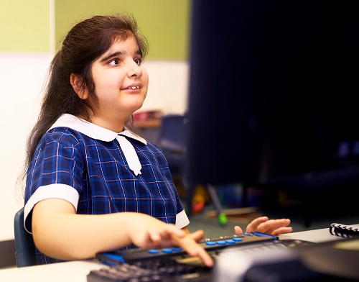  Figure 1 Student using a refreshable braille display and computer to access the curriculum. | 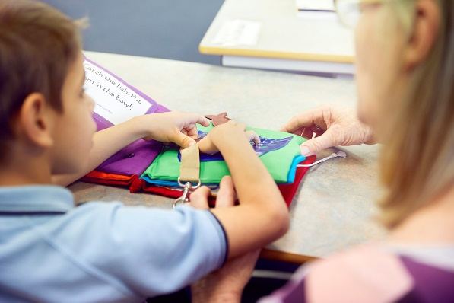  Figure 2. Student exploring a tactile book with his teacher.

NextSense’s Current Projects
In addition to our direct services for children, adults, and families of people with sensory disability, NextSense offers continuing professional education and postgraduate degree and research programs for professionals. Of particular interest to ICEVI members and partners is our accessible literary and mathematics training programs in Unified English Braille, which are offered free of charge through our dedicated website, “UEB Online”— https://uebonline.org/. The target audience for the braille training programs includes educators, parents and families, allied health professionals, braille teachers, braille transcribers, and education administrators—essentially, anyone who supports children and adults who learn by touch. Access to a computer and internet are the only requirement. By offering the online braille training programs free of charge, geographical location and economic circumstance are no longer barriers to learning braille.

The UEB Online training programs address two global challenges identified by the World Blind Union: (a) the chronic shortage of teachers qualified to teach braille; and (b) braille not being included in teacher training programs or offered by education systems in many countries. Since launching the UEB Online website in May 2014, we have achieved the milestone of 30,000 subscribers from 147 countries. Looking to the future, we are now developing online literary and mathematics competency examinations in Unified English Braille, which we expect to launch in January 2023 during the virtual conference of the South Pacific Educators in Visual Impairment (SPEVI).

Relevant Publications
d’Apice, T., & Silveira, S. (2021). Braille oral reading fluency rates in Australian and New Zealand students. Journal of the South Pacific Educators in Vision Impairment (SPEVI), 13(1), 37-51.https://www.spevi.net/jspevi/#2021

Bellio, M., & Silveira, S. (2020). Social-cognition and dog-human interactions: Is there potential for therapeutic-interventions for the disability sector? Vision Rehabilitation International, 12(1). https://doi.org/10.21307/vri-2021-001

Silveira, S., Martin, F., Flaherty, M., & Russell, H. (2020). Reporting on Australian Childhood Visual Impairment: the first ten years. EYE, 1-7. https://doi.org/10.1038/s41433-021-01656-1

NextSense and ICEVI
NextSense is proud to support Dr Frances Gentle in her role as President of ICEVI. Frances is a long-standing academic staff member of NextSense Institute and a lecturer in the Master of Disability program offered in affiliation with Macquarie University.

Our vision for the future of ICEVI is to continue to actively promote and support the right to education of children and young people with blindness and low vision, including those with deafblindness and multiple disability, through information sharing and collaborative partnerships with organisations such as our own.

Submitted by
Frances Gentle, Lecturer, NextSense Institute, President of ICEVI and Member of the Executive Board.

Norwegian Association of the Blind and Partially Sighted (NABP), Norway
NABP was established in 1900 and its main objective is to achieve equal opportunities and status in society for people with visual impairment and other groups of disabled people. Influencing political authorities and other decision-makers is important in reaching this goal. The decision-making committees of NABP consist of a majority of persons with blindness and partial sight. NABP provides a multitude of specialist products and services for blind and partially sighted people in Norway and other regions of the world.

Contact
Norwegian Association of the Blind and Partially Sighted (NABP), Oslo, Norway
Norges Blindeforbund (blindeforbundet.no)
https://www.facebook.com/blindeforbundet
https://twitter.com/Blindeforbundet
https://www.youtube.com/user/NorgesBlindeforbund
iCare — Norges Blindeforbund (blindeforbundet.no)

About the Norwegian Association of the Blind and Partially Sighted (NABP)
History
The first association of the blind in Norway was established in the year 1900. This organization later became what we today know as the Norwegian Association of the Blind and Partially sighted (NABP). The International work of NABP started in 1978 in South Sudan. The international work spread to other countries in Africa, Latin America, and Asia. Today NABP only supports projects in Africa and Asia.

Main Objective or Mission Statement
Our overarching goal is societal equality for the blind and visually impaired and other groups with disabilities.

NAPB’s Current Projects
NABP works mainly in Norway with about 300 people employed. NABP has 19 branch offices all over Norway and runs three rehabilitation centers for blind and partially sighted. At the rehabilitation centers we offer many different courses both for blind and partially sighted as well as for family members. The centers also have youth camps and many other activities. NABP also runs a guide dog school. At the headquarter of the organization there are departments doing political lobby work, rehabilitation department, Information department and among others an international department. The international department currently has 8 staff members. Internationally NABP currently run 14 projects. The projects are currently in:
- Angola—Eye health, organizational strengthening, rehabilitation, and inclusive education
- Ethiopia—Organizational strengthening and inclusive education
- Laos—Organizational strengthening, rehabilitation, and inclusive education
- Lesotho—Eye health, organizational strengthening, rehabilitation, and inclusive education
- Malawi—Organizational strengthening, rehabilitation, and inclusive education
- Mozambique—Eye health, organizational strengthening, rehabilitation, and inclusive education
- Nepal—Eye health, organizational strengthening, rehabilitation, and inclusive education

In addition, we run a project in cooperation with the African Union of the Blind (AFUB) which has its headquarters in Kenya.

The main purpose of NABP's engagement in developing countries is to enable blind and partially sighted people to fight for their rights by strengthening organisations of the blind and supporting education and rehabilitation programmes. NABP contributes towards the global fight against blindness by supporting eye health and prevention of blindness programmes. We want to achieve this by working in the following three complementary areas:
- Organisational strengthening
- Education, learning and rehabilitation
- Eye health and prevention of blindness
NABP shall strive to combine all three of these target areas. All areas mutually strengthen and complement each other. We believe that it is with a combination of these three areas that the needs of the population regarding eye health and visual impairment will be met. In practise this means that if a blind or partially sighted person is identified in a survey, this person should get his/her eyes checked before embarking on specific training like mobility or braille. If the person just needs a small operation to see again, no need to spend time and energy on learning mobility. The same goes for the eye hospital. When the hospital gets a patient whom they cannot help by fixing the vision, it is devastating for the person to be sent home with the message that you will be blind for the rest of your life. When the hospital can refer the patient to a rehabilitation project and association of the blind that look after her/ his rights, then at least the person leaves with some hope.

Relevant Publications
Publications for members and the public in Norway are in the Norwegian language.
Medlemsbladet Synspunkt — Blindeforbundet
Brosjyrer — Blindeforbundet

NABP and ICEVI
NABP decided to join ICEVI in 2006, when the global campaign (EFAVI) was launched. We saw this as an opportunity to get involved and contribute to education for the blind and partially sighted. We envision that ICEVI will secure some funding for a big common project/campaign for ICEVI as there is an increased need for focus on education of visually impaired children and youth as the last years with closed schools and home schooling has been very challenging for our group.

Submitted by
Terje Iverson, Director, International Development and Cooperation,
Norwegian Association of the Blind and Partially Sighted and
Member of ICEVI’s Executive Board.

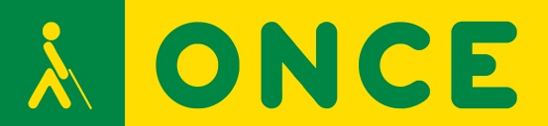

ONCE (National Organization of Spanish Blind People), Spain

Since it foundation in 1938, ONCE has laid the foundation for a system of specialized social services for the blind that today forms the basis for associations for the blind worldwide and is a requisite standard for social services professionals. Self-reliance, educational services, job normalization and universal accessibility are some of the core elements that comprise the ONCE service structure. ONCE offers a range of international programs that support and empower persons with visual impairment.

Contact
Ana Isabel Ruiz Lopez
Director of Education, Employment and Braille
Member of the ICEVI Europe Executive Committee, representing subregion South European countries
Email : AIRL@ONCE.es
Website : https://www.once.es, https://educacion.once.es

About ONCE
The Spanish National Organisation of the Blind (ONCE are the initials in Spanish) was founded on 13th December 1938. It’s a corporation under Spanish public law, and it is considered a singular entity in the social economy. It is a non-profit organisation based on association and democracy, run by its own members all over the country under the aegis of the state.

ONCE's foremost mission is to achieve the full social inclusion and personal autonomy of people who are blind or severely partially sighted. To reach this goal, throughout the history of the organisation we have built up and developed a range of services, support systems, benefits, and specialised programmes so that our members can be more autonomous and independent, can reach full inclusion, and can take part in their environment just as safely and confidently as any other person.
To reach these social goals, ONCE sells a range of responsible gaming products, so the solidarity shown by thousands of citizens who buy the products we market every day is returned by ONCE to society in the shape of specialist services for the blind and severely partially sighted communities.

Education is absolutely one of ONCE’s priority areas. Our intervention model with blind and severely partially sighted students in Spain enables them to achieve academic and social inclusion. It is based on so-called “inclusive education,” a concept that is included in our current education legislation and must be followed by all public authorities in the country (in Spain responsibility for education has been devolved to the regional governments).

This is why ONCE has signed co-operation agreements covering education with all of the regional public authorities in charge of the topic. Thanks to this arrangement, students enjoy access not only to all the available mainstream education resources, but also to specific resources provided by ONCE through its network of Educational Resource Centres (ERCs) located in Alicante, Barcelona, Madrid, Pontevedra and Seville. Our ERC deliver services directly to students and also provide complementary services.

Currently over 99% of all visually impaired students attend mainstream schools in their home towns, neighbourhoods, or cities and follow the official school curriculum. They receive tailor-made supplementary support based on the specific needs as a result of their visual impairment, such as braille lessons, accommodations due to their disability, new technologies, personal autonomy training, orientation and mobility, and social skills, among others. These complementary services are delivered by specialist teachers who form part of the teams providing education services to students with a visual impairment.

The goal is for the student to attain the highest possible standard of normalisation and inclusion in the family setting, in society and in education. To achieve this, we deliver the following activities:
- Diagnostic assessment of the capabilities and difficulties of each student;
- Welcoming and assisting the family, if necessary;
- Expert assessment of the needs of the child and the family;
- Guidance on the intervention programme;
- Interventions by specialist practitioners who make up our Specialist Teams (psychologists, teachers, social workers, rehabilitation technicians, etc.);
- Co-ordination with other centres, schools and early intervention services;
- Information on available resources.

ONCE’s Current Projects
Considering the outline above, we can highlight the following ongoing projects:
- The supplementary training services departments in our ERCs are delivering several training courses to the teachers from our Specialist VI Education Teams, such as in visual pathologies, early intervention, digital skills, among others.
- The ONCE Group for Digital Access to Educational Content recently concluded research into the accessibility of different communication tools in the field of education.
- We designed and launched BRAITICO, a teaching system to develop braille literacy and reading and writing skills. This method involves four sequential modules with a range of material to handle and a computer-based element involving different activities on paper and also using braille displays and tablets.
- With the involvement of practitioners with a range of professional profiles, we are delivering thematic seminars in a number of areas that complement material covered in the curriculum and need to be reinforced in our work with visually impaired students. These areas include, among others, braille, accommodations, ICT and personal autonomy.
These seminars take place in spaces where work is based on networks, both in the ERCs and centrally, and where more experienced professionals with greater expertise generate resources to respond to multiple needs. During the 2021-2022 academic year, we have held two day-long sessions with almost 100 professionals taking part in each, sharing best practises, experiences, and concerns about accommodations for people with a visual impairment and working with families.
- We have signed a memorandum of understanding with the British Council. In the framework of this co-operation agreement, we are advising the Council to ensure its in-person and on-line courses are as inclusive and accessible as possible.

Relevant Publications and Products
- The ONCE education web page—https://educacion.once.es/. This page contains information on each of the five ONCE ERC and special resources to respond to the needs of students with a visual impairment.
- The BRAITICO braille teaching method—https://educacion.once.es/braitico. The modules for this inclusive braille literacy programme can be downloaded from this link.
- The ONCE Centre for Technologies and Innovation for the Visually Impaired—https://cti.once.es/. This website offers a range of technical devices for people who are blind or partially sighted and information on new technologies, innovation, and accessibility, for instance in the on-line magazine Arroba Sonora (https://cti.once.es/el-rincon-del-conocimiento/arroba-sonora) or through the InnovaTeC webinars (https://cti.once.es/el-rincon-del-conocimiento/innovatec).
- The downloadable ONCE Scientific Editing Tool (EDICO) - https://cti.once.es/repos/edico/setup.exe. This tool allows people who are blind or have a severe visual impairment to edit scientific content in several subjects such as mathematics, physics, and chemistry in a way that is accessible, making it possible for them to interact with fully sighted people around them.
- The RED Visual journal—https://www.once.es/dejanos-ayudarte/la-discapacidad-visual/revista-red-visual. This is a specialist journal in visual impairment where the proceedings of the seminars for practitioners on adapting to visual impairment (https://www.once.es/dejanos-ayudarte/la-discapacidad-visual/revista-red-visual/numeros-publicados-red-visual/2021-redvisual-78/jornadas-de-ajuste-a-la-discapacidad-una-perspectiva-transversal) and the seminars on care for the family (https://www.once.es/dejanos-ayudarte/la-discapacidad-visual/revista-red-visual/numeros-publicados-red-visual/2022-redvisual-79/jornadas-de-atencion-familiar-familia-la-puerta-a-la-inclusion) were published.

ONCE and ICEVI
The ONCE Education Department participates with a representative on the ICEVI Europe Board, engaging in all projects and focussing mainly on improving training for the practitioners working to satisfy the needs of people who are blind or partially sighted in Europe in the field of education and to generate spaces where we can share our experiences, such as seminars, thematic conferences, and congresses. We believe ICEVI Europe should continue the same approach it is taking, that is to say promoting a Europe-wide professional network to enable practitioners to acquire the skills they need to meet the needs of people with a visual impairment.

Through the ONCE Foundation for Latin America (FOAL), ONCE has demonstrated a strong commitment to supporting and fostering ICEVI Latin America and all the work it carries out in the Latin American region, with a view to ensuring all blind and partially sighted boys and girls in the region enjoy their right to an inclusive education.

At the same time, FOAL also engages closely with government in Latin America, and especially with the national disability councils in the countries, in order to eliminate obstacles that currently still prevent full inclusion and equality in education systems for students with a visual impairment. Support to produce text books in braille, training in and fostering access to new technologies in our information society, and teacher training, including the use of specific support during the pandemic, are just some examples of the work delivered to assist this group.

Submitted by
Ana Peláez Narváez
High Commissioner for Solidarity and International Co-operation,
ONCE Social Group, ONCE General Council
Madrid, SPAIN

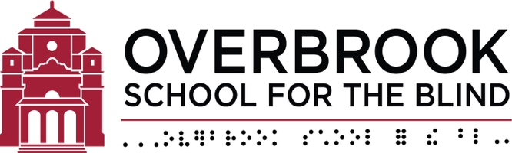 | Making a World of Difference:  Overbrook's International Program

Overbrook School for the Blind, USA

Founded in 1832, Overbrook School for the Blind (OSB) prepares students who are blind, visually impaired, or living with other challenges to have the greatest opportunity to experience active and fulfilling lives. At OSB, teams of highly qualified teachers and specialists work together to create a caring, can-do environment. OSB's International Program reaches thousands of children and adults in Southeast Asia and builds the capacity of local teachers and administrators to work with students with blindness and visual impairment.

(The Educator queried the leadership of the Philadelphia, Pennsylvania-based Overbrook School for the Blind [OSB] to reflect upon Overbrook's nearly-forty-year commitment to transformative international work and Overbrook's partnership with the International Council for Education of People with Visual Impairment [ICEVI]. Specifically, we asked Mark Richert, Overbrook's new International Program Coordinator, to highlight the past, present, and future of Overbrook's international initiatives and how, together, Overbrook and ICEVI are truly making a world of difference both for and with people who are blind or partially sighted.)

About Overbrook
How does Overbrook's International Program connect with and further the overall mission of the Overbrook School for the Blind?

Since 1832, OSB has been one of the leading schools for the blind in the United States, pioneering educational opportunities for children and youth who have visual impairments of all types and degrees, as well as for those students who may have additional disabilities. Our mission to provide the highest quality educational services for these young people has been primarily carried out in the state of Pennsylvania, but our high caliber faculty and staff recognized nationally for their excellence, to say nothing of the tremendous lifetime achievements of so many of our graduates, means that OSB's impact really has no boundaries or borders. The international work that OSB began nearly forty years ago by providing leadership, technology, language and related skills training to students who came to Philadelphia from a host of other countries fit perfectly with our overall objective of demonstrating that there are limitless possibilities for young people living with vision loss when education throws open the door. And wow, what a world of difference that decision to go global has made; I'm so proud to now be part of this ongoing story.

While you have worked for nearly thirty years for U.S.-based organizations of and for the blind, particularly focusing on U.S.-specific public policy and systems change, your involvement internationally very much begins with your joining the Overbrook team relatively recently in January, 2022. Now that you've settled in a bit in this new role, what has it been like to work in a decidedly global context?

Well it's been a bit of a split screen in a way because, while the context is so much broader, and for sure the disparities across global regions and individual countries so profound, the issues we face around the world are also so very familiar. Technology is liberating for people who are blind or partially sighted wherever they live. Those technologies are quite costly, training resources are limited, the personnel available to offer technology training or educational services generally are scarce, and on and on. Again, the socioeconomic and other circumstances of young people around the world can be very stark indeed, but ultimately all individuals living with vision loss can and should benefit from opportunities that we know are decisive in terms of quality of life, productivity and self-determination. Our international work promotes the unparalleled importance of technology, but the work we do is also undertaken in the very real knowledge that orientation and mobility and a whole array of so-called soft skills must be integral components if our technology-focused efforts are to be successful.

Let's hear a bit of the history of Overbrook's International Program up to this point. What have been some of the major milestones along the way?

Well in the relatively short time we have together, it would be impossible to give you a comprehensive survey of the decades of history that OSB has made on the international stage. But I'd encourage your readers to do is to check out a publication that we're so very proud of, “Partnerships for Change: National Strategies – Regional Collaboration,” which is nothing short of a thorough biography, memoir, history, and interactive multimedia platform showcasing what OSB has done in gratifying partnership with ICEVI and with the overwhelming generosity of the Japan-based Nippon Foundation.

One of the things I love about the publication especially is that you don't have to just take our word for it; the reader is invited to engage with hundreds of videos introducing the major players who have contributed so much to our work, as well as the many individuals who benefit from it. The publication is available for download on the OSB and ICEVI websites [www.obs.org and www.icevi.org]. You'll learn how OSB's successful Philadelphia-based international student leadership training program sparked a deep desire to take educational opportunity to young people wherever they happened to live. You'll learn how the lessons learned from our first regional network with incredible partners in Eastern Europe that brought the promise of assistive technology to visually impaired young people in that part of the world ensured the effectiveness of our current regional commitment in Southeast Asia. And you will learn how a global philanthropic leader, the Nippon Foundation, has so tangibly helped us change what it means to be blind, as we and our ICEVI colleagues and friends support each other in this worthy endeavor.

Overbrook’s Current Projects
Well, let's get a bit more specific. What exactly are you doing today, how does it all operate, and what is being achieved?

For more than twenty years, OSB has maintained a network of non-governmental and related organizations across nine countries in Southeast Asia, and these groups are our powerhouse partners who truly make it all happen. Currently we have active projects with five partners in four countries: Indonesia, Myanmar, the Philippines, and Vietnam. Whenever possible, we encourage and support inter-organizational and cross-country collaboration so that resources and impact are maximized. And wow, talk about impact! One of my favorite examples of the amazing work our partners have achieved is the development of a Burmese text-to-speech engine. Our partners in Myanmar and Vietnam came together to solve a remarkable problem, namely the lack of any available screen reader for Burmese language speakers. Sure, if you have even some limited spoken English capacity, then maybe existing screen reader software would be of some use to you. But imagine knowing that there is all this incredible technology out there just waiting for you if only you could understand at all what the speech program was saying. Well visually impaired Burmese speakers now have the whole world of computerized technology open to them, which I am told has virtually overnight revolutionized the lives of so many who, just a couple years ago, might not have ever benefited from a personal computer. As someone who has been blind all my life and who has had access to computers voicing to me in my native tongue for more than forty years, I can only begin to fathom what it must be like to have this kind of technological barrier so recently swept away from my path.

In the late 1990s, the Nippon Foundation so very generously endowed Overbrook's international program and challenged us to wisely invest and grow it so that the endowment's growth can fund the work of the partner organizations I'm describing. We enter into mostly year-long agreements with our Southeast Asian partners and make funding available to them on a semi-annual basis to support specific projects that they design and implement. Yes, we engage in dialogue with individual partners to assess the need for the specific work they are proposing, and we meet periodically as a group with all our partners to plan strategically for future work, especially work that would be beneficial to the entire region. But really it is our individual partner organizations who we look to for the best assessment of their local needs. We want to be supportive and provide input as appropriate, but we always want to put the partners first and not presume that we know better than they do what's most needed on the ground.

I had a particularly eye-opening experience very early on after I joined Overbrook. One of our partners has been providing significant computer literacy training to students in an environment that is exceedingly difficult to say the very least. Political unrest and dodgy infrastructure make the provision of any kind of meaningful skills training a challenge. Well, I got a very nice email from the brilliant director of the program who was letting me know that they would actually not be spending all of the money budgeted for the super-fast powerful laptops they originally intended to acquire. They found less expensive laptops that nevertheless would be powerful enough for the students and the purposes of the training, but the single greatest advantage that the less expensive laptops afforded was their battery life. Because these less demanding laptops can run on battery power for much longer periods of time, that was what was most important, because, as the program director told me, they were being restricted to only six hours of electricity per day. And we hear these kinds of stories frequently, which just reinforce to us how hard our partners work and how much they achieve in spite of often trying circumstances.

Overbrook’s Relevant Publications
(2005). Mathematics made easy for children with visual impairment. Philadelphia: Towers Press. Available for download at https://www.obs.org/what-we-do/mmall.pdf

Campbell, L., Mani, M. N. G., Niu, W. (2021). Partnerships for change: National strategies—Regional collaboration. Overbrook-Nippon Network on Educational Technology (ON-NET) and the International Council for Education of People with Visual Impairment (ICEVI). Available for download at https://www.obs.org/International/TNF%20Book%20PARTNERSHIPS%20FOR%20CHANGE%20-%20FINAL.pdf.

(2021). ICEVI math made easy (YouTube channel with 147 videos explaining how to teach mathematics concepts to children with visual impairment. https://www.youtube.com/c/ICEVIMathMadeEasy/videos

Overbrook and ICEVI
Before we wrap up, you've mentioned OSB's partnership with ICEVI, so please say more about that if you would.

It is an honor and privilege for OSB to serve as a member of the Executive Committee of ICEVI, and we have a very strong commitment to the international community of organizations that both speak on behalf of people who are blind or visually impaired themselves and organizations like us that provide direct educational and other services. But OSB's relationship with ICEVI is so much deeper and more meaningful than mere committee or work group participation. Any discussion of OSB's international work must include grateful acknowledgement of the legacy of Larry Campbell who headed Overbrook's International Program for decades and who, of course, serves as President Emeritus of ICEVI. Simply put, Larry's impact on both ICEVI and OSB is incalculable. Larry's leadership also led to the relationship that both OSB and ICEVI enjoy with the Nippon Foundation, which has been so openhanded with both of us right up to the present day. OSB and ICEVI work in tandem with each other to support educational and employment opportunity; OSB's International Program primarily focuses on primary and secondary educational support, and that learning continuum is further supported through ICEVI's higher education-related work equipping young people with the technology and self-advocacy skills that are so critical for post-secondary success. Ultimately, though, a principal value of ICEVI is its role as a convener and catalyst of change, and we are committed to being a vibrant part of this global community now celebrating its 70th anniversary.

Finally, what's next on the horizon for OSB's International Program?
We're not kidding when we say we're wanting to make a world of difference. I've got a big challenge ahead of me given the standard set by my predecessors, Larry and Wenru Niu. But we are already beginning to implement the strategic planning Overbrook undertook immediately prior to my coming on board to expand our reach to additional continents, particularly focusing on sub-Saharan Africa. We have a proven model for the development of a meaningful presence there, and now, as is always the case, it's about relationship building, meeting new colleagues, making new friends, and continuing to tap into the rich network of ICEVI partners with whom OSB has been consistently standing shoulder-to-shoulder for years. There's a world of difference to make, and not a moment to lose, so let's get to it!

Submitted by
Mark Richert, International Program Coordinator, Overbrook School for the Blind

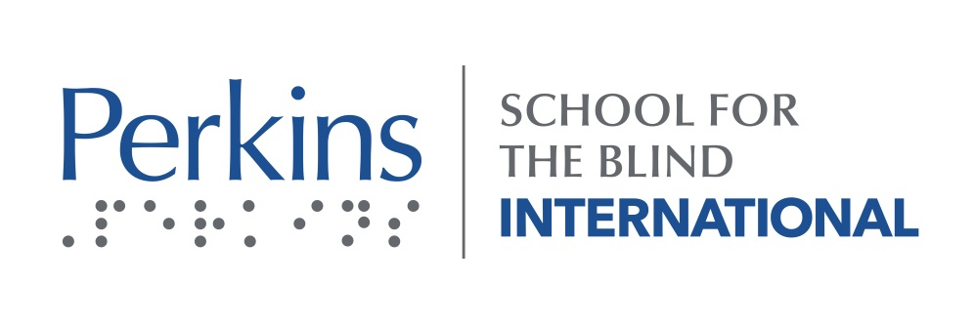
Perkins School for the Blind, USA
Perkins School for the Blind is the worldwide leader in education services for children and young adults with visual impairment and multiple disabilities. Perkins focuses on innovative solutions to longstanding and emerging problems facing communities, students and their families. Perkins International works in approximately 100 countries, providing programs and service to facilitate children’s access to highly trained teachers and accessible education. Perkins also works closely with parents in the USA and around the world.

Perkins School for the Blind—International Program

Contact
Katherine Holland, katherine.holland@perkins.org

About Perkins School for the Blind
Perkins School for the Blind is the worldwide leader in education services for children and young adults who have multiple disabilities and visual impairments. We believe every child can learn and learning is for life. We believe building sustainable programs across the globe today means brighter futures for children tomorrow.

We go where the need is. From identifying children with multiple, complex disabilities in India, to supporting inclusive model education programs in Mexico, we partner with governments and communities to create a world of opportunities. We don’t build schools — we build capacity, empowering families and professionals to ignite change and unleash possibility. And together, we set new standards for what is possible – for children with multiple disabilities and for our world.

Perkins School for the Blind’s Current Projects
At Perkins School for the Blind we believe that every child can learn. For 200 years, Perkins has developed innovative, practical solutions to help every child learn. Around the world, we knit together frayed education, health, and social services; we coach and mentor professionals, building local capacity to design and deliver inclusive learning; and we unlock the power of parents as educators, leaders, and advocates. Our holistic approach collaboratively builds up local model programs to show inclusion is possible and expands learning through play to include learning to play, a key for diverse children.

Perkins meets ministries of health, education, and social welfare, community organizations, families, and professionals where they are, then co-creates solutions to assess local needs, goals, and potential. Together, we build capacity in multi-year collaborations. Over time, we cultivate trust through meaningful partnership, sharing expertise, and investing in a pipeline of skilled local leaders who step up to drive change.

For example, in Armenia and Argentina, Perkins and local universities enhance curricula in teachers’ colleges to better prepare educators for inclusive classrooms. In Mexico and Israel, we work with Ministries of Education to build the capacity of current classroom teachers, including early education programs. In the Philippines, we coach and connect parent support groups. In Indonesia and Serbia, we transform institutions/-orphanages into community day programs, and sensitize doctors to these alternatives to prevent referral to residential care and keep families together. And in Bhutan, we work with the Ministry of Education in classrooms and homes to build an inclusive education system from the ground up. Everywhere, we draw on innovation and expertise from both our USA campus and local partners and use our Adaptive Design approach to build custom tools like chairs or Bhutan Blocks, which use local materials and traditional symbols to help young children connect with their rich cultural heritage and learn through play.

A Deeper Dive into a Few of the Perkins Programs
Perkins India brings learning to the estimated 1 million children with multiple disabilities and vision impairment in India. Backed by two centuries of global expertise from Perkins School for the Blind, Perkins’ work in India for the last 30 years has resulted in the creation and development of strong local institutions that demonstrate how children with multiple disabilities and vision impairment can participate in and learn about the world around them. The path to education for children with multiple disabilities and vision impairment begins with the right start in life and access to learning. Perkins India is making this happen.
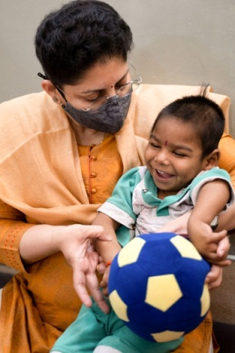
The Perkins India program model brings together hospitals, government agencies, schools, and NGOs to identify children with multiple disabilities, connect them with health/vision care and government benefits, help them access individualized education and be included in schools. At the same time, through training and coaching, we are building the capacity of local education and health systems to address the needs of these children.

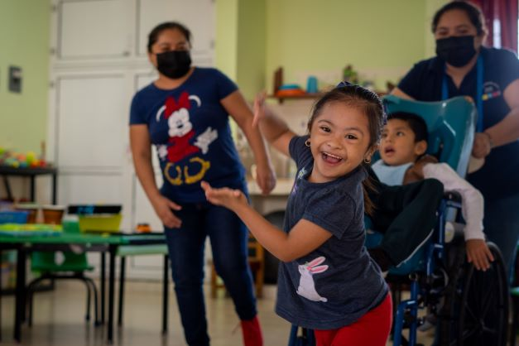
Project Pixan: In Mexico, Perkins is increasing access to quality education for children with multiple disabilities in partnership with Ministries of Education, universities, civil society leaders, educators, and parents. We’re building a foundation so that every child in Mexico has access to education that is both accessible and adapted for their needs.

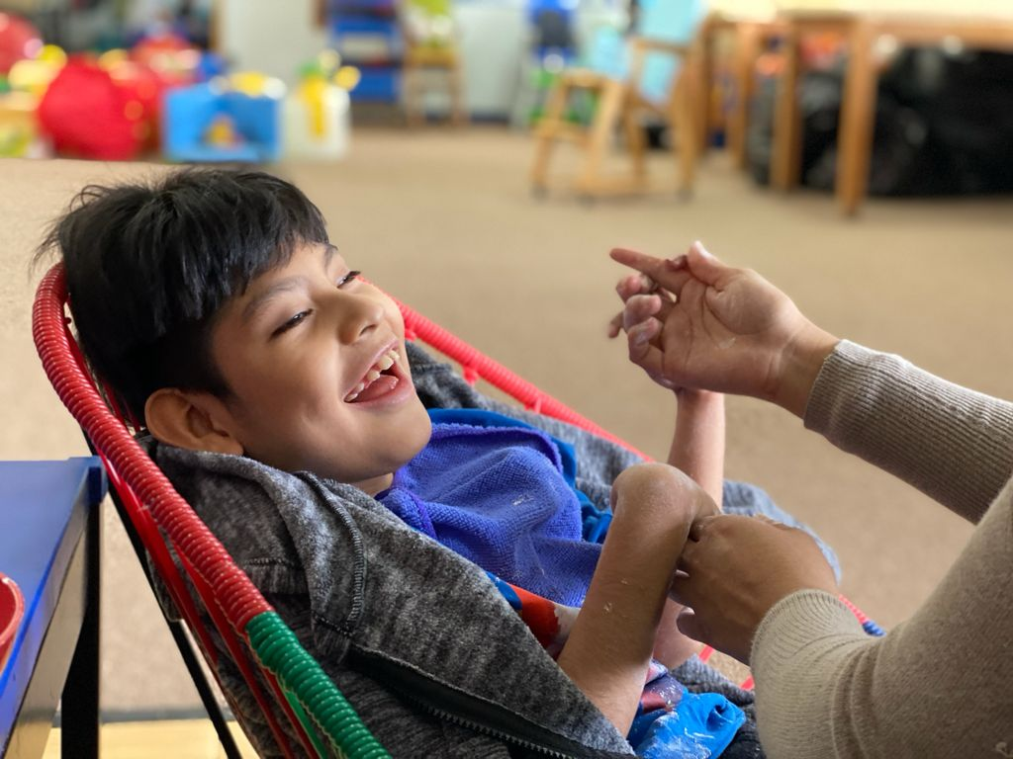
In Mexico today, more than 50% of children with multiple, complex disabilities are out of school, and most of those who are in school are in programs that need significant improvement. With the expert support and education provided by Perkins’ Project Pixan, we are helping these children engage with family, school and community, leading to a more fulfilling life.

By 2030, Perkins, in partnership with Ministries of Education, educators, and parents, will increase access to quality education for children with multiple disabilities in Mexico. In alignment with the UN Sustainable Development Goals, our goal is to increase the enrollment of children with multiple disabilities in 15 of the 32 states including the three most populous states (Mexico City, Mexico State, and Jalisco).

The public education system in Mexico includes special schools called CAM (Centros de Atención Múltiple). With Perkins support and leadership, along with a network of local, regional, and national partners, the goal is to help 71 public schools enhance their programs.

Indonesia—Keeping Families Together by Helping Children Learn: In Indonesia, about 96% of children and youth with multiple disabilities are not in school. Furthermore, children with disabilities are the invisible majority in orphanages in Indonesia.

We collaborate closely with the National Ministry of Education and Culture (MoEC) and work side by side with local Indonesian partners to concurrently transform orphanages into local outreach and day programs, enhance the quality of school and community education programs, and support parents—three essential elements that form a ‘triangle of support’ to help children with disabilities learn and thrive at home with family.

Our holistic approach of building a supportive, local, child-focused system helps keep children at home with their families and is laying the foundation for systemic change. Partnering with UBS Optimus Foundation allows us to scale up this model in 7 programs on Java Island, to make sure children with disabilities in Indonesia can learn and thrive today and for generations to come.

Croatia- Developing a Regional Resource Center: In Croatia, Perkins models best practices and brings quality education to children with complex needs who are often neglected. We meet children wherever they are and we create an environment where children can learn and thrive — whether children are in residential institutions, schools, community-based programs or at home.

Perkins is supporting systemic change. Over the past 20 years, Perkins has coached and mentored staff from key programs in Croatia, resulting in a network of model programs across the country. Children with multiple disabilities participating in these model programs now access quality education and have the opportunity to learn and thrive.

Recently, one of these model programs, Mali dom, has become a Resource Center for the region. Resource centers play a vital leadership role in supporting expanded access to quality education for children with multiple disabilities and increasing impact. As a regional resource center, Mali dom will share their expertise more widely—supporting teachers, schools and institutions throughout the region to develop a deeper understanding of the context of their work, broaden their skills, implement new approaches, improve their practice, and develop leadership within their respective communities.

Unlock Family Power: Unlocking the power of families, supporting parent networks, and partnership with families are key pillars of our global work.

In Mexico, as in many countries, mothers and female caregivers are most often a child’s lead educator and chief advocate. Perkins builds the capacity of a group of “Mother Leaders” through support groups, training, coaching and mentoring to foster strong parent associations. Mothers then become more proactive in their child’s education and a better advocate for their child and the children of others.

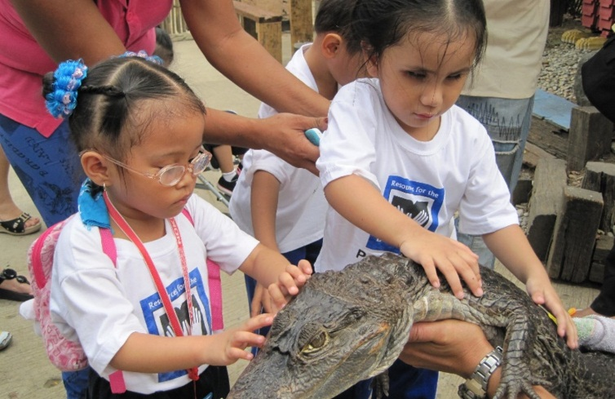
Parent Leaders in the Philippines (PAVIC) has an important voice at the national policy level—and PAVIC members play critical roles in supporting families throughout the country. In addition, PAVIC Parent Leaders mentor and support growing parent networks throughout Asia, including Phensem in Bhutan and Akadini in Indonesia.

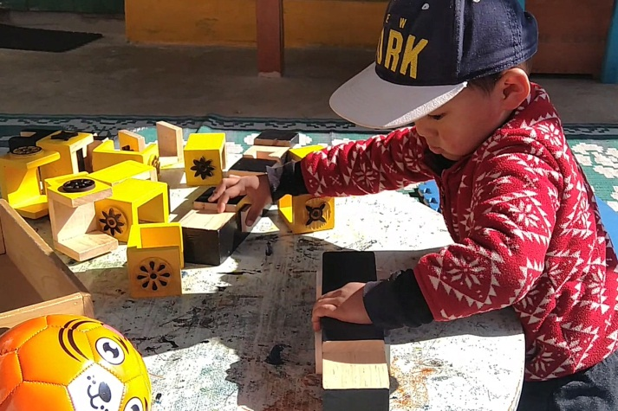
Phensem parents now have a voice in national conversations in Bhutan related to children and youth with disabilities. In collaboration with Perkins, Phensem parent mentors are supporting families and teachers to implement a “Positive Futures Planning” approach for their children.

Akadini, the Indonesian Family Association of Children with Visual Impairment, is actively engaged in advocacy efforts and building partnerships. Akadini also facilitates training and information sharing among families, preparing families to support their children to learn and thrive.

In Armenia, parents have opened up and provided deep insights into the decision making process of putting one’s child into a residential care institution. They are driven by the idea that this decision is the safest option for their child, because it provides access to specialists who know how to care for their child. With Perkins’ support, they are raising their voices to speak out about the need to prevent institutionalization by continuing the productive transformation of institutional care into community and family-based services.

And around the world, parents create fun activities in which entire families can participate—from a 5K toddler run in Indonesia, to family zoom zumba classes, camping trips, a global 100k virtual team relay, and even a high altitude obstacle course race in which seven blind Filipino youth athletes qualified to climb Mount Kilimanjaro in March 2023.

The impact of unlocking family power and supporting parent networks ripples far and wide.

Educational Leadership Program: Participants travel from across the globe to take part in an immersive education experience on the Perkins School for the Blind campus. Graduates become leaders in their home countries—expanding educational opportunities for children with visual impairment and multiple disabilities wherever they work.

The goal of the Educational Leadership Program is to prepare teams of highly-trained leaders, united in a supportive global network, who lead and create teacher training programs and excellent educational services for children with visual impairment and multiple disabilities. Our global impact began in 1920 when Perkins School for the Blind established the first Teacher Training Program, and the Educational Leadership Program continues that tradition of sharing advanced training, educational strategies, and real-life experience in almost 100 countries. Today, as we celebrate more than 100 years of impact for children, hundreds of graduates are working around the world to ensure that every child with visual impairment and multiple disabilities receives a quality education.

Relevant Publications and Websites
Learning through play and learning to play: An approach for all children: https://www.perkins.org/learning-through-play-and-learning-to-play-an-approach-for-all-children/
Perkins e-learning (resources including publications, webinars, online courses, etc.): https://www.perkins.org/perkins-elearning/
CVI Now. Perkins School for the Blind: https://www.perkins.org/cvi-now/
Guidelines for Parents and Teachers of Children with Special Education Needs: https://perkinsglobalcommunity.org/asia/resources-and-stories/guidelines-for-parents-and-teachers-of-children-with-special-education-needs-2/
Home Exercises for Children who are Blind: https://perkinsglobalcommunity.org/asia/resources-and-stories/home-exercises-for-children-who-are-blind-multiple-languages/
Caring for Ourselves is Caring for Others: Recommendations for Mothers and Caregivers: https://perkinsglobalcommunity.org/asia/resources-and-stories/you-are-not-alone-multiple-languages/
Families in Latin America participate in a research project sharing their experiences: https://perkinsglobalcommunity.org/lac/recursos/proyecto-de-investigacion-con-familias/
Creating Learning Opportunities: A Step-by-Step Guide to Teaching Students with Visual Impairment and Additional Disabilities, Including Deafblindness:
https://www.perkins.org/resource/creating-learning-opportunities/

Perkins and ICEVI
Perkins is a founding member of ICEVI. Katherine Holland, Executive Director of Perkins International, and Deborah Gleason, Director Asia and Pacific Region, serve on ICEVI Executive Committee (EXCO).

What is Our Vision for ICEVI’s Future?
As a membership organization, ICEVI plays an important role in lifting up and amplifying the existing and future work of ICEVI member organizations, and creating opportunities for networking and sharing. Our vision for ICEVI’s future is to build on our already collaborative partnership, so we can share best practices and success stories, and replicate success for more children who are blind and visually impaired, in more communities and countries around the world. We believe every child can learn, and we are a part of ICEVI because we also believe in real, global change. Only together can we build a world where children with visual impairments and disabilities can truly belong—and succeed.

Submitted by
Katherine Holland, Executive Director, and Deborah Gleason, Director, Asia and Pacific Region, Perkins International, and Members of the ICEVI Executive Board.

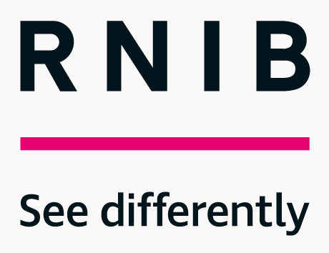 | Supporting you . . . Connecting communities . . . Changing society  Royal National Institute of Blind People (RNIB)

Royal National Institute of Blind People (RNIB),
United Kingdom

The Royal National Institute of Blind People (RNIB) is one of the UK’s leading sight loss charities and the largest community of persons with blindness and partial sight. RNIB recognises the unique experience of sight loss and offers support for persons with blindness and partial sight. The organisation is a catalyst for change, inspiring people with sight loss to transform their own personal experiences, their community, and, ultimately, society as a whole. RNIB focuses on providing persons with visual impairment the support and tools they need to realise their aspirations.

Contact
David Clarke, Chief Operating Officer
Tel: +447925035915
Email: David.clarke@rnib.org.uk

About RNIB
We are the Royal National Institute of Blind People (RNIB), one of the UK’s leading sight loss charities and the largest community of blind and partially sighted people across Great Britain and Northern Ireland. RNIB has been supporting people with sight loss since 1868, when the charity had its first meeting with just a few people. Today, RNIB is here to support the almost two million people in the United Kingdom who are living with sight loss.

At RNIB we recognise everyone’s unique experience of sight loss and offer help and support in a variety of ways and through our various customer channels. This can be anything from practical and emotional support, campaigning for change, provision of reading services for learning or leisure and through the accessible products we offer in our online shop.

We are a catalyst for change seeking to inspire people with sight loss to transform their own personal experience, their community, and ultimately, society as a whole, in pursuit of our vision of enabling blind and partially sighted people to participate in society equitably. Our focus is on giving people with sight loss the help, support, and tools they need to realise their aspirations.

Current Projects
In the UK it is estimated that everyday 250 people begin to lose their sight. RNIB has a crucial role to play in creating a world where there are no barriers to people with sight loss. We want society, communities, and individuals to see differently about sight loss.

RNIB’s Strategy is centred around changing attitudes and breaking down barriers to create an equitable society for blind and partially sighted people. The charity is proud to have played a key role in driving positive change over the last 150 years. However, we are deeply dissatisfied that so many blind and partially sighted people continue to suffer injustice and inequality to the extent that it’s having a negative impact on their quality of life.

It is now time to disrupt the status quo by challenging attitudes and changing behaviours to create a fair and equal society. We must shatter the deep-rooted misconceptions which mark out visual impairment as a weakness, and which lie at the heart of the inequality blind and partially sighted people face.

We know we can’t do this alone; we’ll work with customers, supporters, charities, and key partners such as ICEVI in both the public and private sectors to lead the change we want to see. Until that day, we will continue to provide practical and emotional support to anyone who needs it, helping them to overcome barriers and get on with their lives.

Around two in every 1000 children in the UK has a vision impairment, and statistics show that these children have worse educational outcomes than children without a disability. Participation of disabled children in inclusive education is now well established in policy and practice, however, evidence shows that the quality of provision is patchy, that learning materials are not consistently made available in alternative formats, and that a drift towards generic services is depriving blind and partially sighted children and young people of specialist support. Research in this area includes the accessibility of exams, education attainment, and provision of specialist educational services by local authorities.

As a result, children with a primary Special Educational Need (SEN) of vision impairment have lower attainment compared to children without a SEN. This attainment gap is present at Foundation Stage, and continues through education stages:
- 32% gap at Foundation Stage
- 33% gap at Key Stage 1
- 28% gap at Key Stage 2
- 21% gap at Key Stage 4

Equipping children and young people who have a vision impairment with appropriate social and independence skills is essential to ensure that they grow up socially included, confident, and ready to make a successful transition to independent adulthood and the workplace.

One of our most recent major collaborative initiatives was to launch the UK wide Curriculum Framework for Children and Young People with Vision Impairment (CFVI). This Framework, launched in March 2022, was developed by RNIB, VICTAR — University of Birmingham, Professional Association for the Vision Impairment Education Workforce (VIEW), and Thomas Pocklington Trust and is designed to support children and young people with vision impairment aged from 0—25 to access an appropriate and equitable education. The framework is the result of a two-year research project.

Children and young people with vision impairment need to be actively taught a range of independent learning, mobility, everyday living, and social communication skills. Currently access to those learning areas and specialists who teach them can vary from region to region across the UK meaning many young people are missing out.

The organisation’s plan to engage with Government education departments to ensure the framework reaches every child and young person with VI in the UK, through measures such as being referred to in official guidance or receiving statutory status.

The CFVI presents outcomes within 11 teaching areas and its main aim is to clarify and define the elements of specialist skill development, interventions and best practice support that are essential for children and young people with vision impairment.

RNIB Head of Education, Caireen Sutherland said: “Having the CFVI in place will provide a structure and best practice reference for families, young people and professionals alike to refer to in order to advocate for the input a child or young person with vision impairment needs and deserves.

“We hope the framework will address the jigsaw provision and ensure children and young people with vision impairment get access to the specialists and opportunities to develop skills they need and that this in turn will improve their life outcomes.”

The eleven teaching areas of the CFVI are:
- Facilitating an Inclusive World
- Sensory Development
- Communication
- Literacy
- Habilitation: Orientation and Mobility
- Habilitation: Independent Living Skills
- Accessing Information
- Technology
- Health: Social, Emotional, Mental & Physical Wellbeing
- Social, Sports and Leisure
- Preparing for Adulthood

To find out more about the CFVI visit the RNIB website: www.rnib.org.uk/cfvi

Note: Previous ICEVI article which refers to the CFVI:

ICEVI European Newsletter; ISSN Number 2666-1527; Issue 79, Volume 28 number 1, April 2022; Page 7; Launch of a new UK wide curriculum framework for children and young people with vision impairment (CFVI).

Other Ongoing Work
RNIB continues to work with The LEGO Foundation on a number of initiatives to support the roll out and adoption of LEGO Braille Bricks. A truly game changing initiative that enables children with vision impairment to develop essential skills through play.

RNIB Bookshare, our online collection of curriculum and academic books continues to grow, providing support to 45,000 learners in the UK with over 865,000 accessible titles made available to our readers. RNIB also works hard to support students in other countries to access the UK curriculum.

Through the International Council for English Braille (ICEB), RNIB continues to support the improvement of the Unified English Braille tables (UEB) for LibLouis, an open source braille translation programme used by several organisations and in many popular products such as the braille support in screen readers and mobile devices. With thousands of fixes already made—and more to do—this work is already benefiting braille readers around the world and in English speaking countries that have adopted UEB.

Relevant Publications
Hewett, R., Douglas, G., McLinden, M., James, L., Brydon, G., Chattaway, T., Cobb, R., Keil, S., Raisanen, S., Sutherland, C., Taylor, J. (2022). Curriculum framework for children and young people with vision impairment (CFVI): Defining specialist skills development and best practice support to promote equity, inclusion and personal agency. RNIB.

For other research reports and policy statements, please visit www.rnib.org.uk.

RNIB and ICEVI
RNIB was a founding member of ICEVI and continues to be a keen and active member, as the quality of education blind and partially sighted people are able to access sits right at the core of our vision for a society in which blind and partially sighted people can participate equitably. We very much look forward to working closely and collaboratively with ICEVI colleagues around the globe to make this vision a reality for children and young people everywhere.

Key Contacts
David Newbold, Director of Sight Loss Advice
Tel: +447506689777
Email: David.newbold@rnib.org.uk

Caireen Sutherland, Head of Education
Tel: +44752261060
Email: caireen.sutherland@rnib.org.uk

Ali Long
Director of Consumer and Business Services
Tel +44796796012
Email: alison.long@rnib.org.uk

Submitted by
David Clarke, Chief Operating Officer, and Member of ICEVI Executive Board.

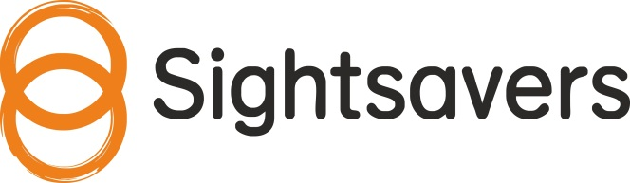

Sightsavers, United Kingdom
The vision of Sightsavers is a world where no one experiences blindness or low vision due to avoidable causes, and where people with disabilities participate equally in society. Sightsavers works in more than 30 countries to prevent avoidable blindness and fight for the rights of people with disabilities and advocates for the rights of people with visual impairments and other disabilities. The organisation promotes development of quality, sustainable local health services and provides many international programmes particularly in the regions of Africa and Asia.

Contact
Andrew Griffiths, Head of Advocacy, agriffiths@sightsavers.org

Sightsavers’ Main Objective
Sightsavers works in more than 30 countries to prevent avoidable blindness and fight for the rights of people with disabilities.

We treat eye conditions such as cataracts and tackle debilitating diseases, many of which cause sight loss. To do this, we work with governments and local, national, and international partners, to advocate for the rights of people with disabilities, improve local health services so they are sustainable, and strengthen education systems.

Our approach is based on understanding that the path to sustainable change in the delivery of quality, accessible, and equitable health services, and the realisation of the UN Convention on the Rights of Persons with Disabilities and other human rights frameworks, cannot rely on the role of International NGOs, such as Sightsavers. In the long run, it is the decisions taken by national governments, related to international commitments made within global frameworks—particularly the UN Sustainable Development Goals—that will bring about lasting change.

We have more than 70 years of experience behind us, and we are proud to be a leader in our field. Our programmes consistently achieve high performance ratings from the United Kingdom’s (UK) Foreign, Commonwealth and Development Office, and we are one of the United State’s (US) evaluator GiveWell’s top charities.

Current Projects
Sightsavers works with local and national partners in our programme countries to promote inclusive, quality education, giving all children the chance to go to school. Despite significant increases in school attendance over the past decade and efforts to reduce gender disparities, children with disabilities continue to be left behind, with girls more likely to miss school than boys.

We work with schools, communities, governments, and disabled people’s organisations around the world to ensure children can learn and play alongside their peers in pre-school, all the way through to primary and secondary school.

We make schools more inclusive for children with disabilities. We make sure lessons are stimulating and classrooms are as accessible as possible, and we ensure children with disabilities have the necessary equipment, receive specialist support, and can learn with their peers.

We promote inclusive education throughout communities. We encourage parents to play an active part in education. “Mothers’ clubs” have been set up in Sierra Leone to make school uniforms for students with disabilities, and community members in Malawi help young children to travel to pre-school using adapted bicycles.

We also work with governments to improve education systems. We make sure schools get the support they need: We develop teacher training and help ministries of education collect data on children with disabilities enrolled in their schools and promote joined-up services by linking health and social services with schools and families. Disabled people’s organisations are key partners, and we work with them across sub-Saharan Africa and South Asia to ensure people with disabilities have a meaningful say in education decision-making.

At the global level, we influence international development actors to ensure that inclusive education for children with disabilities is prioritised and mainstreamed. These actors include multilateral organisations, such as UN agencies and the World Bank, and bilateral organisations, such as the Foreign, Commonwealth and Development Office in the UK. Our national and international influencing is closely linked—for example, through our support for the implementation of international policy frameworks at the national level.

Sightsavers also has a research centre, and has Independent Research Organisation (IRO) status. We continue to develop our partnerships with universities and research institutes, particularly those based in low and lower middle income countries in order to develop local research capacity to build evidence on inclusion in education. Recent research publications include on: Promoting Inclusive Education for Girls and Boys with Disabilities in West and Central Africa; and Understanding the Current Provision of Early Childhood Development and Education for Children with Disabilities in Rural Malawi through Community-based Participatory Research.

Some examples of our work include:
- In Kenya, we work with national assessment and resource centres to ensure children with disabilities are assessed and given follow-up support where needed.
- In Uganda, we work with teacher training colleges to ensure trainee teachers have the skills needed to include children with disabilities in their classrooms.
- In Cameroon, we work with the Ministry of Education’s national network of 64 inclusive primary schools, including providing teacher training packs.
- In Malawi we work with pre-schools run by community volunteers to encourage children with and without disabilities to play and learn together. Including children with disabilities in pre-schools supports their development and helps them progress and adapt well to primary education.
- In Senegal, we have worked with the Ministry of Education to ensure more resources are available for the education of children with disabilities, and the need for a more strategic approach to inclusive education.
- In Sierra Leone, we worked with the Ministry of Education on the new National Policy on Radical Inclusion in Schools.

Publications and Products of Note
- Sightsavers inclusive education strategy: https://www.sightsavers.org/reports/2021/07/sightsavers-inclusive-education-strategy-2021/
- Sightsavers programme strategy: https://www.sightsavers.org/reports/2022/05/sightsavers-programme-strategy/

- The Sightsavers research hub contains links to reports of several studies: https://research.sightsavers.org

Sightsavers and ICEVI
Sightsavers is an international partner of ICEVI, and our founder Sir John Wilson was instrumental in the setting up of ICEVI. We are a committed supporter of the work of ICEVI and are represented on the Executive Committee. Gertrude Oforiwa Fefoame, Sightsavers Global Advocacy Manager for Social Inclusion, chairs the African Region of ICEVI; we are also on the governance committee, and leading the development of the ICEVI advocacy strategy.

We believe ICEVI has an important role in convening and supporting educators of people with visual impairment, and representing the educational rights of people with visual impairment with key international stakeholders. We will continue to play a leading role in the development and growth of ICEVI in the coming years.

Submitted by
Andrew Griffiths, Head of Advocacy, and Member of the ICEVI Executive Board

Royal Dutch VISIO, The Netherlands

The Royal Dutch Visio provides information, advice, and a range of services relating to research, counselling, rehabilitation, education and living for persons who are partially sighted or blind, and those with intellectual, physical and sensory disabilities. Visio also offers information and professional development for people who are personally or professionally involved with the areas of partial sight or blindness.

The Royal Dutch Visio provides information, advice, and a range of services relating to research, counselling, rehabilitation, education and living for persons who are partially sighted or blind, and those with intellectual, physical and sensory disabilities. Visio also offers information and professional development for people who are personally or professionally involved with the areas of partial sight or blindness.

Contact Information:
Marcel Janssen
Director Royal Dutch Visio education
Amersfoortsestraatweg 180, 1272RR Huizen
Phone : 0031 6 5181 4406
Email : marceljanssen@visio.org
Website : https://www.visio.org/en-gb/home

About Royal Dutch Visio
Royal Dutch Visio is a centre of expertise for blind and partially sighted people of all ages, including those with additional disabilities. “Full participation of persons in society who have low vision or who are blind by developing their full potential” is our mission.

Visio enables visually impaired people to live, learn, and work independently and provides its expertise in these areas. Visio has a countrywide coverage with over 40 locations in The Netherlands and employs more than 2500 people. Our departments Rehabilitation, Employment, Residential & Day Care, Education and Expertise all focus on different aspects of the life of visually impaired people.

Visio’s Current Projects
Rehabilitation: We provide professional advice and/or training in assistive technology, orientation and mobility, daily life skills and much more. Rehabilitation can take place at home or in a Visio rehabilitation center.

Employment: We inform, guide, and advise employees and employers as well as insurance or re-integration agencies and other intermediaries about possibilities, courses, rehabilitation, (re)integration, assessments, counselling and training about employing visually impaired people.

Residential & Day Care: We offer persons that are (multiple disabled and) visually impaired various accommodations for living and working, and various types of sensible daycare activities.

Expertise: We manage knowledge and expertise on Visual Impairment in a unique way by stimulating constant innovation, research & development, knowledge sharing, transferring and applying knowledge.

Education: Our ambition is to achieve the best education and the best guidance. The motto of Visio Education is "prospects for every child.” Visio wants to support every child or young person with a visual impairment, with all their possibilities, limitations, and talents, in preparation for the future. Visio Education provides students with a visual impairment and students with multiple disabilities and visual impairment (MDVI) all the necessary support, help and tools suited to their abilities in order to:
- Go through life as independent, self-reliant and autonomous as possible.
- Fully participate in an ever-changing society.
- Approach the world as a global citizen.

Visio focuses on qualification, personal development, and participation, to encourage every student to develop to the maximum of their abilities on every level. Nurturing socio-emotional development, increasing the children’s independence, teaching children to take their own responsibilities, participation in society and an individual approach tailored to each pupil. Visio opts for contemporary education with a great deal of input from and engagement by the students. The educational concept adopted for this approach is called ‘Learning to Learn’.

International Knowledge Development and Innovation
Royal Dutch Visio is also internationally active. Together with our partners and professionals from all over the world we aim to further develop our knowledge and innovate together. By actively participating in (research) projects and networks, we can improve our care for visually impaired and blind people in the Netherlands and abroad.

International Programmes in Africa and the Middle East
Besides focusing on international knowledge development and innovation we also run six international programmes in Africa and the Middle East.

Together with a local coordinating partner, we closely cooperate with different stakeholders in which we always look for sustainable collaboration with children and young people with visual impairment, their caregivers, communities, government, education, and care professionals. Based on a Theory of Change, all international programmes build on access to relevant information, resources and affordable services, empowerment and quality care and education for children and young people who are low vision or blind.

Publications and Products
Professionals from Visio take part in conferences, write publications and participate in (research) projects all over the world. Visio’s experts and researchers have been working on collaborative (scientific) projects related to diverse themes such as shared spaces, Cerebral Visual Impairment, Acquired Brain Injury and tactual functioning in children. We also work on the development of products and tools together with our international partners. Some examples of products we developed internationally are the Arithmetic Box, iExpress Toolkit (https://www.iexpressmyself.com), Sensemath (https://www.visio.org/en-gb/professional/expertise/onderzoeken/digitale-ontwikkelingen-innovaties/sensemath) and Tactual Profile (https://www.tactualprofile.org/en-gb/wat-is-tactiel-profiel-1). Also in the area of sports, ICT, CVI and 3D printing (www.3d4vip.eu) and VR have we developed many practical products that are available in English, such as screening tools, videos and guidelines with and for our international partners. Examples are the CVI Handbook, the Visual Assessment Scale for the visual functioning of persons with PIMD (VAS CVI-PIMD), and the Active Learning Handbook.

Visio and ICEVI
To exchange knowledge and develop expertise Visio also participates in several European and international networks concerning visual impairment, such as ENVITER, ISLRR, ICEVI and MDVI Euronet. ICEVI is important for us since it allows us to connect with education professionals from all over the world dealing with the same challenges. This leads to a valuable knowledge exchange and development which is crucial for our target group. The children need us to join forces to utilize the most effective methods and put their needs first at all times. In the coming years we expect ICEVI to further develop as a knowledge sharing platform also outside the annual conferences and we are eager to take on an active role in communities of practices on different relevant themes such as Cerebral Visual Impairment (CVI).

Visio International enables Visio’s professionals to share, inspire, grow and work together to ensure that the work of Visio makes maximum impact; to make sure that people with a visual impairment, no matter where in the world, can fully participate in life.

Submitted by
Aukje Snijders, Programme Manager, International Knowledge, Development and Innovation

Talking Technology
by
Ben Clare (bwclare@gmail.com)
Inclusive Education and Media Specialist, Greater Newcastle Area, Australia

Welcome to the 4th edition of Talking Technology, the column that explores the latest in assistive technology solutions for people who are blind, have low vision and-or additional disabilities.

As I write, it is late winter here in Australia and where I am, on the east coast near the city of Newcastle, it has been extremely wet and flooding has occurred several times since the year began.

Wherever you are in the world and whatever challenges you are facing, there is always hope.

In the last edition of Talking Technology, we discovered the benefits of utilising the smartphone as a mobility tool, through the use of inbuilt features such as the camera and apps that rely on satellite navigation. While the smartphone will feature in this edition of the column, I thought we'd do something a little different this time and cover three topics that are not directly related to one another. This is to address a number of exciting things currently happening in the assistive technology space and also, I do hope these topics will be of interest to you. Here's what we'll be discussing today.

- The accessible RAT.
- An Eloquent Sound: JAWS Bites into Apple.
- Get Ou fait with NVDA.

A little disclaimer before we get underway. This column will make mention of several commercial companies, products, and organisations. Neither the author of this column, nor the ICEVI, endorses these products and-or entities. Mention is made of these products and entities solely for informational and educational purposes. Information related to any product or company is gathered from freely available sources on the Internet, backed up by personal research to ensure statements made are as correct as possible at the time of writing. Any further information about mentioned products should be gathered from official sources, such as websites and brochures.
The Accessible RAT
So we're hearing a bit less about Covid-19 these days. Throughout most of the world, the reopening has begun. School is in session, people are travelling, the shops and restaurants are full again, traffic lines the boulevards and freeways, people are basking in the sunshine, busily catching up on their social lives, visiting relatives and trying to forget the past two miserable years.

While some parts of the world continue to experience great disruption (our Ukrainian friends come to mind,) many are hopeful the worst of the pandemic along with its impact is behind us and we can simply get on with our lives.

While Covid may not be on the front pages anymore, delve a little deeper into a news bulletin and there it is, still causing great hardship to whoever it touches, along with straining health systems. Scientists and epidemiologists continue to warn the pandemic is far from over and Omicron variants and sub variants continue to pose a threat.

The reopening that's happening in many countries, the relaxation of restrictions is progressing due to two advances in technology that is believed to at least lessen the threat of Covid-19, the first of these being vaccinations. While you could be forgiven for thinking these vaccinations were developed in record time, without wanting to understate the great achievement, vaccination research and production was actually spurred by the emergence of the original SARS virus in 2002, followed by Middle East Respiratory Syndrome (MERS) a decade or so later. This head start enabled effective vaccines to be made available within the first year of the Covid-19 pandemic. With a relatively successful rollout in industrialised countries at least, the leaders of these countries, along with begrudging support from health officials, felt the time for lockdowns and isolation had come to an end. The fact that economic factors continue to play a major role in relaxation of restrictions, together with the unequal availability of vaccines across the world, are rightly controversial and divisive issues.

(Of course, the seemingly non technological mask, worn by some and not by others could be the biggest protector against the virus, let's see.)

The second technological advance, the second key to unlocking our lives was the invention of the humble rapid antigen test (RAT). While this technology existed well before the pandemic began, its adaptation into something that could relatively accurately indicate whether a person is carrying the Covid-19 virus in 15-20 minutes suddenly meant that holding gatherings, events, and so forth, was possible. A person could do a quick RAT before leaving home, receive their results and be somewhat confident they would not be spreading the virus when going out into the community, a solution sought from the moment restrictions came into place in early 2020.

As rapid antigen tests became available around the world, the inevitable question came up: Are these tests accessible for people with vision impairment? The answer, not surprisingly, was a resounding no! From the outset, the many companies that began manufacturing rapid antigen tests had not factored in accessibility for people with disabilities. It was not immediately possible for a blind person to independently take a home test and read the results.

Fortunately, this is starting to change, perhaps not quickly enough for many, but there is a concerted effort in some quarters to have accessible tests manufactured and made available to those who require them.

My personal research into accessible RATs began back in January 2022, a time when the Omicron variant of Covid-19 was making its first devastating journey around the world, threatening to have restrictions reimposed. Here in Australia and elsewhere, the public went wild for RATs, seeing these crude little devices as a key to ongoing freedom and an end to disrupted plans. Predictably and inevitably, stores ran out of tests and what was left soared in price. Eventually national governments intervened, making RATs freely available to pensioners and others in need and greatly boosting the supply of the tests.

While there are many varieties of RAT available, just about all of them are totally inaccessible, having no means of result detection beyond the use of eyesight.

So, with all this explained, are there accessible RATs in existence? The pleasing answer is yes, but this "yes" is uttered with a great deal of caution because the accessible tests are very difficult to procure and are not available in all countries. The accessible delivery of rapid antigen tests is done in two ways, each will be explained.

Aira and Be My Eyes
Aira, the organisation that provides on demand mobility and other services to blind people through the use of a smartphone or custom made glasses, currently offers a free RAT interpretation service to all explorers (subscribers.) Operational since the beginning of the year, this service is done via a remote consultation with an Aira staff member who instructs the customer on how to set up the RAT, how to administer it and provides audible and-or written feedback on test results. This is a first of its kind service and has provided immediate relief to those wishing to self-administer home rapid antigen tests.

While this service is made available free of charge and is available in all markets where Aira operates, it is necessary to be a subscriber to the service in order to take advantage of the RAT interpretation service. In some countries, assistance with covering subscription costs is available and is worth checking to see whether you can apply for such assistance.

Be My Eyes, while extensively providing a similar service does have some differences. The organisation, operated by volunteers is available for free and they are, in theory, providing a RAT result interpretation service. The positive is that Be My Eyes is free, is available in a lot more markets and there is the possibility volunteers speak other languages besides English. This said, volunteers may not feel comfortable assisting with RATs, and so it can sometimes be difficult locating a volunteer through the service who is willing to help. The negative side to both these offerings is that other people are aware of your results, meaning total privacy is not assured.

Accessible Tests
In recent months, accessible rapid antigen tests for home and individual use have become available. In April, the National Federation of the Blind (NFB) in the United States undertook an extensive study of all the rapid antigen tests approved for use by the American Food and Drug Administration, focusing on whether each test allowed for independent use, ranging from unpacking to interpreting results. It was found that only two approved tests met these requirements. NFB was also quick to point out that while these tests met the criteria for accessibility, they could be much easier to use, and development of a fully accessible product remains desirable. These tests rely on a smartphone with an installed app and Bluetooth devices that are included in the test packaging to analyse samples and communicate results. In both instances, the smartphone apps are connected to company-specific laboratories that claim to be able to examine submitted samples in minutes and communicate results to customers in a push message notification format.

Cue Health: https://www.cuehealth.com/products/how-cue-detects-covid-19/, a San Diego, US based company, has a product that can be used independently, although I am told it is very necessary to read and understand the user manual before attempting to use it. This test ,which can be taken at home, features a customised cartridge reader where the test sample is placed and is then communicated to the company's laboratory via a Bluetooth connection. Results are then sent back to the user in approximately 20 minutes, and it is apparently easy to interpret. These results can then be stored in the app and can be shared using standard procedures on the smartphone.

This product is available in the US where it has emergency use authorisation status from the US Food and Drug Administration. It is also available in India, Canada, and the European Union. Theoretically, this product can be used in other countries, but it's important to check importation laws, as well as what devices are approved for use before attempting to procure this test.

A somewhat similar product, manufactured by Ellume: https://www.ellumehealth.com/products/consumer-products/covid-home-test is only available in the United States at this time. While it operates in a similar manner to the Cue Health product, sources tell me the app associated with the Ellume product is easier to use, featuring a well described video of instructions and step by step procedures as the test is taken. The screen connected to the cartridge reader is apparently easy to see for those with low vision, making for a better experience.

In June, the Biden Administration in the US announced it would make more accessible at home Covid-19 test kits available free of charge for people with vision impairment.

While the advent of these accessible products is very welcome, it is very disappointing to see these are not available in the majority of countries. Thus, the technology barrier continues on for the vast majority of the world's population who require such assistive devices. Perhaps this issue could be a point of advocacy for blindness groups around the globe?

Going off topic just a little, whilst researching for this column, a friend of mine posted a question on my Facebook page, welcoming the accessible RATs but wondering why accessible pregnancy tests were yet to be developed. After some heavy Googling and subsequent contact with co-workers, I learnt the Royal National Institute of Blind People (RNIB) in the UK produced a prototype device that enables a blind person to accurately detect pregnancy through the use of tactile markers. Let us hope this device is just around the corner!

An Eloquent Sound: JAWS Bites into Apple

IPhone, iPad, Apple Watch and Mac users rejoice! The sound of JAWS is coming!

At the annual developer’s conference held in early June, Apple unveiled the latest version of their operating systems. Always an event keenly followed by Apple product users, blind users who utilise the built-in Voiceover screen reader discovered a great surprise when testing the first beta release on the IOS system, used in supported iPhone models. There, among the new voices added to the screen reader was one that anyone remotely familiar with JAWS for Windows would immediately recognise. Developed by Eloquent Technologies in the mid 1990s and later acquired by Nuance, the Eloquence speech synthesiser has long been a favourite of screen reader users the world over, this despite its somewhat muffled and robotic sound compared to the myriad of human sounding voices currently available, with no substantial upgrades since the early 2000's and a limited number of supported spoken languages. For many, the reading inflection is just right, the synthesiser responds quickly and effortlessly to input commands, speech rate, word pronunciation, accent, and more, are unmatched.

This is a big win for Apple users who have been lobbying the software giant for years to include the Eloquence synthesiser across all products. According to technology forums which were buzzing immediately following the discovery, not only were Apple customers happy about the inclusion of their beloved speech synthesiser, but many felt they had been listened to by Apple and acknowledged through the addition. The company does pride itself on being a fully accessible entity, especially its products, which include phones, laptop and desktop computers, watches, televisions, and portable music players. Company personnel appear to be familiar with accessibility issues and inbuilt mechanisms to support receiving feedback and reporting accessibility bugs abound.

While the Eloquence speech synthesiser is a new addition for Apple operating systems, it has been present in other screen readers and devices for some years. Most prominently, JAWS for Windows began using Eloquence as their default synthesiser in 1998, packaging it as part of JAWS version 3.2, the first edition of the screen reader to run independently of external synthesiser hardware which had to be physically connected to a computer. This alone was a technological breakthrough, as it became no longer necessary to purchase an external device to have speech on any computer running Windows. Instead, the internal sound card would output the speech, as is the case today.

Other devices and screen readers that work with Eloquence include the Android operating system via download of synthesiser software, NVDA screen reader via a plug-in sold by Code Factory (often pirated by users to avoid purchase), Nuance Talks screen reader compatible with legacy Nokia phones, and various devices including reading machines and handheld devices manufactured by Freedom Scientific.

Contrary to popular belief, the Eloquence speech synthesiser is a licensed, copyrighted product where permission needs to be obtained before it can be used in conjunction with other software products. A recent change in ownership of the software is believed to be behind its inclusion in Apple software.

So, how does Eloquence work in Apple?

With the latest operating system complete with Eloquence available to download in mid-September, this will become an option in the list of Voiceover voices across all Apple products. When activating Eloquence, the default voice, Reed will be selected. Using standard features such as the rotor and Voiceover settings will allow access to all of Eloquence’s familiar features, including speech rate, inflection, screen echo, and so forth. All the voice variants are present, and there are additional voices that sing, whisper, and do other funny things. The standard Eloquence languages, which include British English, French Canadian and Latin American Spanish, are also available. In addition to Eloquence, many voices from the Vocaliser range, also available as an NVDA and JAWS addition are able to be downloaded free of charge. All this, along with the voices available in Voiceover, make Apple a very appealing choice for screen reader users.

Get Ofey with NVDA
Are you an absolute wiz at using screen reading software? Have you ever wanted to be fully certified? Would having a certificate that says you're a screen reader wiz help your career? If you answered yes to all those questions, you should look no further than NV Access, the developers of everybody's favourite free screen reader for Windows, NVDA!

For starters, you should take a look at the NV Access website: (http://www.nvaccess.org) is far more than just a place to obtain the NVDA screen reader. As well as offering all sorts of exciting plug-ins and other resources for the software, the team has developed a series of E-books for purchase that feature excellent step by step guides on using NVDA with Outlook, PowerPoint, Word, Excel, and the screen reader itself. These books are available in a variety of alternative formats, including Braille and audio.

Once you've had a good read through and are satisfied you know all there is to know about NVDA, you can attempt the exam which quizzes you on all aspects of NVDA and its use with Microsoft Office and other products. Taking the exam is totally free and can be done online at any time. Alternatively, you can purchase a specialised certificate for a nominal fee and have your name included on the website as a fully certified NVDA specialist. Being present on this list means people can reach out to you for advice or training.

This exam is good for those of us who've been using the software for years and those who have been introduced more recently. You just might find a new and useful keystroke you didn't know before!

Well, that's it for now, a very full and hopefully interesting Talking Technology column.

Please feel free to contact me via Email: bwclare@gmail.com

Until next time...

Ben Clare

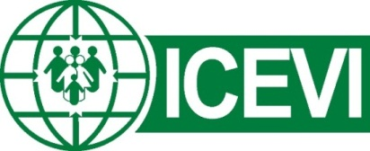

THE INTERNATIONAL COUNCIL FOR EDUCATION OF PEOPLE WITH VISUAL IMPAIRMENT

STATEMENT ON THE PROTECTION AND SAFETY OF PERSONS WITH VISUAL IMPAIRMENT IN WAR-AFFECTED COUNTRIES

The International Council for Education of People with Visual Impairment (ICEVI) calls for all States Parties to international conventions to ensure the protection and safety of persons with visual impairment, including those with additional disabilities and deafblindness, in all war affected countries by recognizing:

- Their obligations under Articles 11, 15, and 16 of the UN Convention on the Rights of Persons with Disabilities, to take “all necessary measures to ensure the protection and safety of persons with disabilities in situations of risk, including situations of armed conflict, humanitarian emergencies and the occurrence of natural disasters” (Art. 11);
- UN Security Council Resolution 2475 (2019) on Protection of Persons with Disabilities in Conflict, which calls upon “all parties to armed conflict to allow and facilitate safe, timely and unimpeded humanitarian access to all people in need of assistance. . . . [and] to prevent violence and abuses against civilians in situations of armed conflict, including those involving killing and maiming, abduction and torture, as well as rape and other forms of sexual violence in conflict and post-conflict situations”;
- International Humanitarian Law and the Humanitarian Principles, which limits the effects of armed conflict on persons not involved in the hostilities, including those with visual impairment, and which applies to all sides involved in armed conflict;
- 3.2% of the world’s population has a visual impairment, suggesting that in any armed conflict, a large number of adults, children, and young people with visual impairment are at risk; and
- Visual impairment presents unique challenges in mobility, literacy, and access to information, requiring specific accommodations targeted to these unique needs.
In any situation of crisis or conflict, persons who are blind or visually impaired face disproportionate risk of abandonment, violence, death, and lack of access to safety, relief, and recovery support. Women with visual impairment are at increased risk of sexual violence, and children with disabilities are more exposed to abuse and neglect. Crucial information on safety and evacuation is often inaccessible, and the UN DESA estimates that 79% of people with disabilities cannot evacuate independently. In addition, visual impairment is often an invisible disability, unknown to anyone except the individual who experiences it, thus creating an additional risk for rescue and evacuation to safety.

We call on the political leadership and all humanitarian actors dealing with any armed conflict to ensure that all persons with visual impairment:

- Have full access to all humanitarian aid;
- Are protected from violence, abuse, and ill treatment;
- Are provided with accessible information about safety and assistance protocols, evacuation procedures and support, in braille, enlarged print, or digital formats;
- Have full access to basic services including water and sanitation, social support, education, healthcare, transportation, and information;
- Have full access to and use of their assistive, mobility, and rehabilitation devices, which provide needed information and support to navigate and adjust to new environments;
- Are accounted for and not abandoned: It is essential that measures are in place that fully incorporate people living in institutions, specialized schools, and orphanages. Relocation and evacuation measures should not result in more isolation for persons with visual impairment than already created by war itself; and
- Are meaningfully involved in all humanitarian action, through their representative organisations, if not themselves.
The International Council for Education of People with Visual Impairment implores States and other relevant parties to ensure the protection and safety of all blind, deafblind, and visually impaired persons, including those who may have additional disabilities. As an organisation involved in the education and re/habilitation of children and young people with visual impairment, we ask that their needs are acknowledged, addressed, and remembered.

For correspondence, contact the ICEVI Secretariat, Email: ceo201922@gmail.com

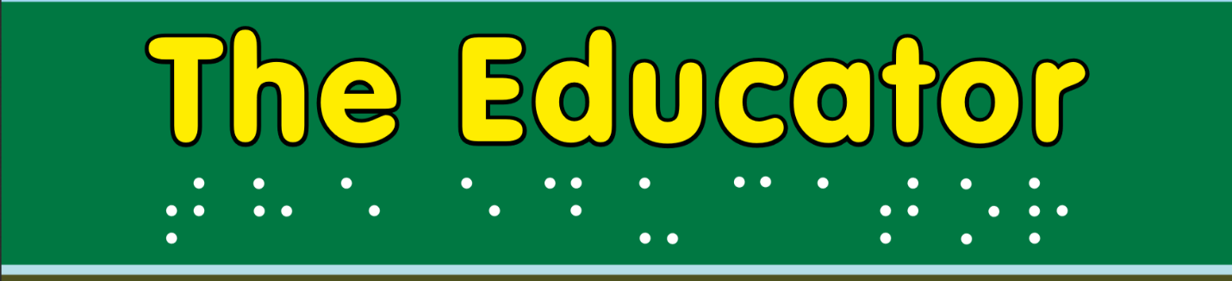

The January 2023 Issue of The Educator will be devoted to

ICEVI’s 70th Anniversary

Everyone is encouraged to share your memories of ICEVI—perhaps your first global meeting, or someone from ICEVI who has made a difference, or what ICEVI has accomplished in your country. Personal stories are encouraged.

Manuscripts of 500-2500 words from individuals and organizations will be considered for publication

Please send your digital manuscript by
January 31, 2023
to

Kay Ferrell kay.ferrell@unco.edu
or
Nandini Rawal nandinirawal@gmail.com

[Manuscripts not selected for the January 2023 issue may be reserved for a future issue, at the editor’s discretion and with the author’s permission.]

