The Educator

Volume XXVII - Issue 2 January 2014

Expanding Educational
Opportunities

A Publication of
The International Council for Education of
People with Visual Impairment
PRINCIPAL OFFICERS

PRESIDENT
Lord Low of Dalston
Royal National Institute of Blind People (RNIB)
105 Judd Street, London WC1H 9NE, UNITED KINGDOM
e-mail : colin.low@rnib.org.uk

FIRST VICE PRESIDENT
Lucia Piccione
Urquiza 2659, 5001 Cordoba, ARGENTINA
e-mail : lpiccione@arnet.com.ar

SECOND VICE-PRESIDENT
Frances Gentle
The Renwick Centre, Royal Institute for Deaf & Blind Children
Private Bag 29, Parramatta NSW 2124, AUSTRALIA.
e-mail : frances.gentle@ridbc.org.au

TREASURER
Nandini Rawal
Blind People’s Association, Jagdish Patel Chowk, Surdas Marg,
Vastrapur, Ahmedabad 380 015, INDIA.
e-mail : bpaiceviad1@sancharnet.in

PRINCIPAL OFFICER
Praveena Sukhraj
42 Windswawel Street,
Monument Park Extension 4, Pretoria 0181,
SOUTH AFRICA
e-mail : psukhraj@justice.gov.za

PRESIDENT EMERITUS
Lawrence F. Campbell
1, Center Street, Rockland, Maine 04841, USA
e-mail : larry.icevi@gmail.com

CHIEF EXECUTIVE OFFICER
Mani, M.N.G.
No.3, Professors’ Colony, Palamalai Road, S.R.K. Vidyalaya Post,
Coimbatore 641 020, INDIA
e-mail : sgicevi@vsnl.net

REGIONAL CHAIRPERSONS

AFRICA

Tigabu Gebremedhin
CBM Country Office Ethiopia, P.O.Box 694, Addis Ababa, ETHIOPIA
e-mail : tigabucbr@gmail.com

EAST ASIA
Suwimon Udompiriyasak
Faculty of Education, Suan Dusit Rajabhat University, 295 Ratchasima Road
Dusit Dist., Bangkok 10300, THAILAND
e-mail : suwimonu@gmail.com

EUROPE
Betty Leotsakou
Ministry of Education, K.D.A.Y of Athens, 12 Ioannou Kotsou Street
Glyka Nera 15354, Athens, GREECE
e-mail : bl@icevi-europe.org

LATIN AMERICA

María Cristina Sanz
avda. 13 n 1207, flor 9 dpto. A, (1900) LA PLATA, ARGENTINA
e-mail : latinoamericaicevi@gmail.com

NORTH AMERICA/CARIBBEAN
Kay Alicyn Ferrell
Professor of Special Education University of Northern Colorado
Campus Box 146, 501, 20th Street, Greeley, CO 80639, USA

e-mail : kay.ferrell@unco.edu

PACIFIC
James D Aiwa
Divisional Head - Special Education, School of Education, University of Goroka
P.O.Box 1078, Goroka, EHP, PAPUA NEW GUINEA
e-mail : aiwaj@uog.ac.pg

WEST ASIA
Bhushan Punani
Blind People’s Association, Jagdish Patel Chowk, Surdas Marg
Vastrapur, Ahmedabad 380 015, INDIA
e-mail : blinabad1@bsnl.in

FOUNDING ORGANISATIONS

American Foundation for the Blind
Scott Traux
11 Penn Plaza, Suite 300, New York, NY 10001, USA.
e-mail : struax@afb.net

Perkins School for the Blind
Steven M. Rothstein
175 North Beacon Street, Watertown, MA 02472, USA.
e-mail : president@perkins.org

Royal National Institute of Blind People
Lord Low of Dalston
105 Judd Street, London WC1H 9NE, UNITED KINGDOM.
e-mail : colin.low@rnib.org.uk

INTERNATIONAL NON-GOVERNMENTAL ORGANIZATIONS

Deafblind International
Bernadette M. Kappen
999, Pelham Parkway Bronx, New York 10469, USA
e-mail: bkappen@nyise.org

World Blind Union
Rina Prasarani
Secretary General, Indonesian Blind Union (Pertuni)
Jl. Raya bogor Km 19, Ruko Blok Q no 13L, Kramat Jati
Jakarta, 13510 INDONESIA
e-mail : rinalamsyah@gmail.com

International Agency for the Prevention of Blindness
Peter Ackland
London School of Hygiene & Tropical Medicine
Keppel Street, London WC1E 7HT, UNITED KINGDOM
e-mail : packland@iapb.org

INTERNATIONAL PARTNER MEMBERS

CBM
Lars Bosselmann
CBM EU Liaison Office (EU LO)
Third Floor, Rue Montoyer 39, 1000 Brussels, BELGIUM
e-mail: lars.bosselmann@cbm.org

Light for the World
Manuela Krauter
Christoffel Development Cooperation, Niederhofstrasse 26
A-1120 Vienna, AUSTRIA
e-mail: m.kraeuter@light-for-the-world.org

Norwegian Association of the Blind and Partially Sighted (NABPS)
Arnt Holte
P.O. Box 5900, Majorstua0308 Oslo, NORWAY.
e-mail: arnt.holte@blindeforbundet.no

Organización Nacional de Ciegos Españoles
Ana Peláez
C/ Almansa, 66, 28039 Madrid, SPAIN
E-mail: apn@once.es

Perkins School for the Blind
Aburey Webson
175 North Beacon Street, Watertown, MA 02472, USA.
E-mail: Aubrey.Webson@perkins.org

Royal National Institute of Blind People
Pete Osborne
105 Judd Street, London WC1H 9NE, UNITED KINGDOM.
E-mail: Pete.Osborne@rnib.org.uk

Sightsavers
Caroline Harper
Grosvenor Hall, Bolnore Road, Haywards Heath,
West Sussex RH16 4BX, UNITED KINGDOM.
E-mail: charper@sightsavers.org

Visio
Marten de Bruine
Amersfoortsestraatweg 180, 1272 RR Houses, THE NETHERLANDS.
E-mail: martendebruine@visio.org

Education For All children with Visual Impairment (EFA-VI) Global Campaign

The Education for All Children with Visual Impairment (EFA-VI) is a Global Campaign and programme of the International Council for Education of People with Visual Impairment (ICEVI) acting in partnership with the World Blind Union (WBU) to ensure that all girls and boys with blindness and low vision enjoy the right to education.

The Campaign, launched on July 16, 2006 is focusing on children in the developing world where currently it is estimated that less than ten-percent have access to education.

Highlights of the Campaign
- addresses three key Millennium Development Goals: -achieving universal primary education, -promoting gender equality and -developing global partnerships for development.
- stresses the right to education as emphasised in the UN Convention on the Rights of Persons with Disabilities.
- works within the framework of the general and special education systems.
- focuses on awareness and demand creation for education of children with visual impairment.
- Stresses on the provision of appropriate support in educational settings.
- Capacity building of teachers and others, development of literature, production of assistive devices and operational research are important elements.

Indicators of success
- increased enrolment rates,
- reduced dropout rates,
- improved access to support services, and
- educational achievement for children with visual impairment, on par with non-disabled children.
Global Campaign on
Education For All Children with Visual Impairment (EFA-VI)

Regions | Existing Focus Countries | Proposed Focus Countries
Africa | - Ethiopia  - Mozambique | - Burkina Faso  - Ghana  - Kenya  - Malawi  - Mali  - Rwanda  - Uganda
East Asia | - Vietnam | - Cambodia  - China  - Laos
Latin America | - Ecuador  - El Salvador  - Guatemala  - Honduras  - Nicaragua  - Paraguay  - The Dominican Republic | - Bolivia
Pacific | - Fiji | - Papua New Guinea
West Asia | - Nepal  - Pakistan | - Bangladesh  - Palestine  - Sri Lanka  - Tajikistan

Editor

W. Aubrey Webson

Director, Perkins International

Perkins School for the Blind

175 North Beacon Street

Watertown

MA 02472

USA

Associate Editor

M.N.G. Mani

Chief Executive Officer, ICEVI

Editorial Committee

W. Aubrey Webson

Lord Low of Dalston

M.N.G. Mani

Designing and Printing

ICEVI Secretariat

No.3, Professors’ Colony, S R K Vidyalaya Post,
Coimbatore – 641 020, Tamil Nadu, INDIA

Phone : 91-422-2469104

Fax : 91-422-2693414

e-mail : sgicevi@vsnl.net

Our International Partners
- CBM
- Light for the World
- Norwegian Association of the Blind and Partially Sighted
- Organización Nacional de Ciegos Españoles
- Perkins School for the Blind
- Royal National Institute of Blind People
- Sightsavers
- Visio

CONTENTS

01. Message from The President

02. Message from The Editor

03. Message from The Guest Editor

04. Reflections from the President of Perkins
- Steven M. Rothstein

05. A Paradigm Shift
- Penny Hartin

06. The First Swahili Braille News Paper in Tanzania
- Rajabu A. Mtunge

07. Snapshot of Education for Students with Visual Impairments from Singapore
- Meng Ee Wong

08. Overview of the Education of Persons with Visual Impairment in Argentina
- Delia Góngora & Gabriela S. Rusell

09. Overview of the Current Status in Education of Blind and Partially Sighted Boys and Girls in Spain
- Ana Isabel Ruiz López

10. Counting on Technology: Critical Solutions for Education in STEM Subjects in Developing Countries
- Stacy C. Rowe

11. Education for Children who are Visually Impaired in the Netherlands
- Annelies Buurmeijer

12. ICEVI’s Collaboration with Mainstream Organizations 25

13. Latin American Permanent Survey on Services for People with Multiple Disabilities
- Osvaldo Bertone, Graciela Ferioli, Maria Elena Nassif,
Stephen Perreault, Paula Rubiolo & Maria Vazquez

14. ICEVI Executive Committee Meeting – Action Points

15. Regional Update - North America/Caribbean
- Kay Ferrell, Celene Gyles & Kim Zebehazy

16. National Inclusive Education Programme launched in Palestine

17. Education for All Children with Visual Impairment (EFA-VI) Global Campaign – Strategic Goals

18. Education for All Children with Visual Impairment (EFA-VI) Global Campaign – Accomplishments and Challenges

19. Human Interest Stories

Message from the President

Dear Readers,

At the outset, I should like to thank Steven Rothstein, President of Perkins School for the Blind, for serving as Guest Editor for this issue of the Educator. Steven and Aubrey Webson, the regular Editor, have made an excellent job of bringing us up to date with the latest educational developments in different parts of the world. Amid his many other responsibilities, Steven has contributed a great deal to ICEVI. We shall miss his wise counsel as a member of our Executive Committee as he steps down from Perkins to take up new challenges, and on behalf of the entire ICEVI family I should like to place on record our appreciation for all that he has done and wish him well in all his future endeavours. In the meantime, he gives us his uniquely authoritative perspective on the state of the field after a decade of fantastically successful development at Perkins.

I am happy that ICEVI is now working much more closely with the UN and broader organisations in the fields of education and disability to fulfil its mission to expand educational opportunities for children with visual impairment. Last September I represented us at the High Level Meeting of the UN General Assembly on Disability and Development in New York and at UNICEF’s Global Partnership for Children with Disabilities. Here we have become members of working groups dealing with Policies beyond 2015 and Teacher Preparation. In the International Disability and Development Consortium (IDDC) we have joined the Integrated Education Task Group, which seems very active. We have submitted our application to become a member of the Global Campaign for Education (GCE) which has to go through a formal approval process. However in the meantime the ICEVI regions are formulating plans to contribute to the Global Action Week on Disability in May 2014.

We have enlisted the services of Richard Orme to help us develop the strategy for harnessing technology to enable blind and partially sighted children to be included in mainstream schools alongside their sighted peers that Gordon Brown, UN Special Envoy for Global Education, asked us to come up with so that he could promote our work with leading technology companies, the World Bank, the Global Partnership for Education, etc.

Richard has worked extensively in the field of accessible technology, most recently with RNIB. He has more than 20 years experience of visual impairment and education technology, and led the successful effort to create accessible solutions for school textbooks in the UK.

He is frequently invited to advise on accessibility by governments and agencies internationally, and has extensive links with the world’s largest technology companies, so we are very lucky to have him on board.

In response to suggestions from members of our Executive, we plan to re-launch the Global Campaign on Education for All Children with Visual Impairment
(EFA-VI) in Kampala, Uganda in October 2014 in conjunction with the IDP Africa Forum. This joint campaign with the World Blind Union has enabled thousands of children with visual impairment in the developing world to go to school and is unquestionably making a difference. ICEVI is the catalyst, but our thanks must go to the governments and our INGDO partners whose efforts have brought this about. More information on campaign activities can be accessed on ICEVI’s website www.icevi.org. It should be noted, however, that at its recent meeting in Vienna the Executive decided not to change the name of the campaign, as had been suggested, to Education4All, amongst other reasons because this did not translate well into other languages such as Spanish.

I recently attended the launch of the EFA-VI campaign in Palestine which is being supported by CBM and ICEVI along with the local Ministry of Education and Higher Education. Such collaboration at national and regional level is what ICEVI is all about, and this is the model we will be seeking to replicate as we roll the campaign out to further countries.

I am also pleased to report that ICEVI has been awarded a further – by the Nippon Foundation for our higher education project for the year 2014-15. ICEVI works closely with project partners in Cambodia, Indonesia, Lao PDR, Myanmar, Philippines and Vietnam to equip students with visual impairment with the skills they need to operate independently in higher education, and so far more than 1200 students have been supported by the programme.

So 2014 has started well for ICEVI and I am excited at the prospects for the rest of the year as I contemplate the activities which we have lined up.

Colin Low

President, ICEVI

Reflections from the President of Perkins

Steven M. Rothstein, President
Perkins, U.S.A.

The core of our mission at Perkins is to change lives for the better. As president for the last 11 years, I’ve had the opportunity to witness such transformation on a daily basis. Our students graduate and move on to lives of independence. More children with disabilities in developing countries are discovering literacy through Braille and assistive technology. Societies are taking critical steps to reverse discrimination by writing inclusive laws, passing accessibility treaties and adopting a more open-minded view of the potential of all people.

The past 11 years at Perkins have enriched me personally. I have learned, grown and changed throughout this period. I’d like to share what I consider some especially noteworthy observations gathered during this transformative time:

1. People in this field are doing remarkable work.
Perkins works with nonprofit and government agencies all around the world. We partner with teachers, university professors and government officials who have started services where none existed. Faced with minimal resources, they take it upon themselves to volunteer, raise money and work creatively to do more. I am encouraged every day by the thousands of professionals who display unparalleled determination and focus on behalf of the children they serve.

2. All we see is possibility – and for good reason.
You may have heard our slogan. Chances are, if you’re in this field, you live it. Our students have proved repeatedly that potential is limitless, given the right tools, training and opportunity. And that truth reflects the way most of our partners work: rather than dwelling on what may seem impossible, they emphasise the positive, focusing on what students, clients or a community can do, and build from there. The results are tremendous. Thanks to Perkins and our hundreds of partners – many of whom are responsible for starting the first programmes of their kind in their countries -- I remain an incurable optimist.

3. Individuals with disabilities are role models for us all.
I am regularly humbled by the amazing potential, determination and success of people I meet around the world. Particularly poignant was my introduction to a young woman in Kenya, who is deafblind and had been abandoned by her father at a young age. Despite the challenges she faced, this woman refused to bend. She attended one of Perkins’ partner schools and learned many skills, including how to knit. She created and sold beautiful sweaters, which enabled her to support herself. Today she is a teacher at that same school, and has even reconnected with her father. She, and hundreds of others like her whom I have had the good fortune to meet, are truly my role models.

4. Parents are the ultimate educators.
No one knows a child better than his or her parents. While public and private educators undoubtedly play a vital role, parents who are empowered and engaged have the most power to transform their child’s world and create opportunities where none previously existed. Many of our partnerships have been initiated with parents as leaders, who go on to start schools, advocate with government officials for their children’s rights, and establish parent support groups.

5. Accessible technology creates new opportunities daily for people with disabilities.
Individuals with a range of disabilities have more opportunities today because of the availability of accessible technology and some mainstream technology. Computers that convert text to speech, low vision devices, refreshable Braille displays, and countless other tools are changing lives every day. People with disabilities have more ways to interact with and contribute to society thanks to these invaluable devices. Unfortunately, much of this technology is out of reach for consumers in developing countries due to cost, unavailability, and a lack of training – a challenge we must address with immediacy.

6. Patience is overrated.
While you are reading this article, more than 4 million children are not in school simply because they are blind. They are losing precious time waiting for society to evolve and for education services to appear. Having witnessed firsthand what opportunity means to children with disabilities, I am today a less patient man than I was 11 years ago. How would our world be different if Helen Keller’s parents had given up after the first, second or third “expert” had suggested there were no opportunities for her? We must be less tolerant with government officials and leaders who delay taking action that would benefit these deserving individuals. We should be less respectful of the systems that exclude young people who are unable to speak for themselves. We must not accept the word “no.” Our students cannot wait.

7. Accountability is more critical than ever.
As funding grows ever more competitive, we need a much broader base of private and government supporters to continue and expand our work. These parties increasingly – and rightfully so -- expect to see clear indicators of success. We must be ready to provide key performance indicators and engage in regular, open communication about the people we serve, the services we provide and more. As a field, we must embrace the fact that measurement is part of our management responsibility.

8. Power lies in numbers.
Blindness is considered a low-incidence disability, compared to the number of individuals affected by other conditions such as autism. Our political support and advocacy power could significantly expand if we consistently and systematically networked beyond the blindness field. There are natural, unexplored allies throughout education and health care that can magnify our voice and our impact if we work together.

9. Collaborations are vital.
Groups like ICEVI, the World Blind Union, Deafblind International and others are critically necessary, and we need to find additional ways to support each other. While we are all working hard in our respective countries or regional and international groups to strengthen our organisational impact, ultimately we all want the same thing: for the world to acknowledge the rights of children with disabilities. Together, we are so much stronger. The need for collaboration is particularly important when it comes to post-2015 Millennium Development Goals, to policies regarding literacy through Braille and a growing need for early intervention services.

10. Margaret Mead was right.
Working with ICEVI members and many other people around the world over the course of these 11 years has inspired, encouraged and motivated me immensely. Whether I joined you in places from Peru, Ghana, India or elsewhere, being part of your movement for change has been one of my life’s true honours. Seeing the impact that you and your colleagues are making all over the globe, I am reminded of the words of Margaret Mead: “Never doubt that a small group of thoughtful, committed citizens can change the world; indeed, it's the only thing that ever has.”You are today’s “thoughtful, committed citizens.” I will always be grateful for the opportunity to learn from each of you.

Steven M. Rothstein is president of Perkins, a global organisation that provides education, services and products to more than 880,000 people in 67 countries who are blind, deafblind, or visually impaired with other disabilities. After 11 years of leadership, he will step down to pursue new professional goals in 2014.

A Paradigm Shift

Penny Hartin, World Blind Union

A dramatic shift has occurred over the past decade, positively impacting the lives of blind and partially sighted persons of all ages. This is the paradigm shift in programme and service delivery: from a medical/institutional model to a social and human-rights based model. The genesis of this shift was the development and adoption of the UNCRPD (United Nations Convention on the Rights of Persons with Disabilities). It was adopted by the UN General Assembly in 2006, came into force in May 2008, and has now been ratified by approximately 140 countries.

The adoption of the UNCRPD is significant to the education and general well-being of persons with visual impairment for a number of reasons:

▪ Promotes the right to inclusive education for children with disabilities;
▪ Recognises the unique needs of children who are blind, deaf, and deafblind for the development of specific skills;
▪ Identifies Braille as the key to literacy and education for blind children;
▪ Asserts the need for information in accessible formats.

These recognitions, written into international law, are creating a different level of expectation for inclusion and access as a basic human right.

The Convention has also been the catalyst for other positive developments.
▪ Many other UN Agencies are making efforts to better understand the implications of disability, and to incorporate disability awareness into their programmes and policies. This is particularly true of UNICEF, WHO and the Human Rights Council.
▪ The UNCRPD requires monitoring processes, and this has created opportunities for input from NGO’s like WBU and ICEVI, compelling governments to consider how to ensure more inclusive education for blind and partially sighted children.
▪ The World Intellectual Property Organisation’s recent adoption of the Marrakesh Treaty would likely not have been possible without the provisions contained within the UNCRPD. This international copyright treaty, once ratified and implemented, will have a profound influence on the availability of accessible books and educational materials for blind students. This long-held dream was brought to reality by the collaboration of many international partners.

National organisations of and for the blind have become more engaged in the process; they are learning more about their rights and how to exercise those rights. Furthermore, in order to be more effective advocates, they are learning to work collaboratively with other organisations to achieve common goals. This can only improve the overall situation for blind and partially sighted persons, and will ultimately create improved access to an improved quality of education.

Despite these positive developments, there is still much to be done. We still struggle to ensure that our unique needs are met in a system that would prefer for the solutions to be more homogeneous than specific. And while our members who work at the national level are aware of the positive developments and have access to tools and resources to assist them with their advocacy efforts, it is not easy to convey this same information to the village/community and individual level. Too many parents of blind children still do not know their rights, how to ensure that their child is receiving an appropriate education, nor what opportunities exist for their child. We need to do more, collectively, to ensure that the tools, resources and encouragement we have to offer can reach through the system.

The UNCRPD is a young instrument and it will take time for the paradigm shift to truly occur. But it has begun in many areas and the shift will continue, so that is a real hope for the future. That hope, to be realised, will rely in large part on the empowerment of blind and partially sighted persons at the individual, community and national level. By working collaboratively through their organisations and partners, a great deal can be achieved. And the WBU and ICEVI, working together at the international, regional and national levels can significantly influence improved education for blind and partially sighted persons as promised by the UNCRPD.
The First Swahili Braille News Paper in Tanzania

Mr. Rajabu A. Mtunge
DeafBlind Master Trainer & Executive Director
Deafblind Assistance Services, Tanzania

Disabilities in Tanzania
In Tanzania, Persons with Disabilities (PWD) have been historically marginalised from most government services. Moreover, they have limited knowledge of national legal systems and international Human Rights instruments, and are therefore uninformed about their basic rights. This lack of knowledge is not only a threat for them as individuals, but also limits their attempts to advocate and lobby with the government on their own behalf. In addition, the number of people with disabilities, particularly those who are blind, in senior positions in government or public institutions is very low, and their involvement in decision-making in public life at the community level is still very limited. All these elements create a dependency syndrome, trapping PWDs in the vicious cycle of poverty, ignorance and disease.

Nevertheless, Tanzania has progressed in an effort to include persons with disabilities in development services in recent years. A good example of this is the National Policy for People with Disabilities, passed by the Cabinet in 2004, which emphasises equal opportunities. Tanzania ratified the United Nations Convention on the Rights of Persons with Disabilities (UNCRPD), and signed the Optional Protocol in 2009. The National Disability Bill, tabled in the Parliament in 2010, translates the UNCRPD policy guidelines into law. These are all efforts by government to respond and promote the rights of persons with disabilities. Our main goal, now, is to ensure that those legal instruments are known by the general public and by the PWD community so as to guarantee they are implemented in Tanzania.

Statistics of blind people in Tanzania
Due to poor structure and insufficient resources, statistics about blindness in Tanzania are very inaccurate. In order to try to measure the scale of blindness in the country, our statistics are based in the World Health Organisation’s prevalence-of-blindness estimation formula of 1% of the population. Thus, the estimate of the number of blind people in the Tanzanian population would be approximately 437,000, being divided as follows:
▪ 50% due to cataract (approximately 218,000 people);
▪ 20% due to corneal scars (approximately 87,400 people);
▪ 10% due to glaucoma (approximately 43,700 people);
▪ 20% due to other causes (approximately 87,400 people).

It is important to note that fully 80% of this blindness can be prevented or cured (approximately 349,600 people).

Deafblindness
According to the Sense International website, the number of deafblind people in Tanzania is 18,400, estimated from the country’s population of 46 million.

Aims of Tanzania’s First Braille Newspaper Project
Deafblind Assistance Services (DBAS) has expanded its services to braille readers, both blind and deafblind, by creating a Swahili Braille newspaper (reg. number 00005586), under the Tanzanian Newspaper Act of 1976.

The name of the newspaper is Elimukwamuguso (project by touch) which refers to tactual education. It will be published twice a month and distributed freely to institutions that serve people who are blind or deafblind throughout the country. Because there are many schools serving this population in Tanzania, there are a good number of Braille readers in the country.

The newspaper will cover important aspects of national and international news, including economics, education, the sciences and technology, politics, and sports. Braille materials may be imported into Tanzania for free or inexpensively, and the postal company will distribute the newspapers cheaply. The frequency of publication will increase when we can get more braille embossers; we currently have only one and not enough Braille paper.

Challenges and Needs
The work is done by a dedicated crew of six volunteers who are also members of DBAS. We are currently using only one embosser machine that is in another location, the use of which is donated. We need at least two permanent machines owned and worked directly from DBAS, which will eliminate the need to travel to another location to emboss the newspaper. We have no budget for production costs, which include volunteer benefits, press room hiring, renovation, electricity charges, Braille papers (tractor type), and transportation service from the office to the clients. Currently all volunteers are working in a very difficult environment.

Conclusion
We would welcome any assistance in strengthening these services so that people with blindness or deafblindness can be connected to the society at large. Please visit us, contact us, or donate to the DBAS, and Like us on Facebook: "Deafblind Assistance Services".
Snapshot of Education for Students with Visual Impairments from Singapore

Meng Ee Wong
National Institute of Education, Nanyang Technological University, Singapore

Primary Education
Students with visual impairments in Singapore may attend the Lighthouse School for their primary education. Here the children prepare for the national Primary School Leaving Examinations (PSLEs), typically completed after six years of primary education. Braille is taught to the students and produced within the Lighthouse School. Assistive technology, such as screen readers and closed-circuit televisions, is available for those who need it.

Children with low vision in mainstream schools use in-school support and services from the community. Allied educators are the primary line of support for students with disabilities in mainstream schools, but their generalist training doesn’t always prepare them to meet the needs of students with visual impairments. The allied educators often seek support from community services such as Asian Women’s Welfare Association and iC2 PrepHouse. These charities provide educational support for students with visual impairments in mainstream schools.

Secondary Education
Following successful completion of the PSLE, children from Lighthouse School progress to one of four designated mainstream secondary schools. Here they are educated with their peers for national examinations, typically undertaken after four or five years of secondary education. These designated schools offer a variation of support, ranging from resource rooms with support staff, where remedial lessons are offered, as well as braille production for ad hoc materials.

Post-Secondary Education
When students leave secondary education, the academic support is less structured, given that there are multiple post-school pathways to a range of academic and vocational options. For tertiary education, there are five polytechnics and six universities offering diverse study disciplines. The Singapore Association of the Visually Handicapped (SAVH) serves the national braille production needs, but resources are limited, and priority is given to producing secondary school materials. As a result, support for post-secondary materials depends on the services available at the individual institution, and the network of support from non-profit organisations serving the visually impaired. Because the support services at post-secondary and higher education institutions are limited, the burden of providing adequate support is shifted to the community-based agencies and services. With limited availability of braille at post-secondary level, assistive technology such as screen readers and mobile devices have enabled individuals to access information. Assessment, selection and training of assistive technology amongst special educators and those in rehabilitation work, however, can be improved to encourage greater adoption of assistive technology amongst educators and users.

Employment
In the light of generally poor employment opportunities, traditional and commonplace options include telephone operator, massage, telemarketing, busking, and the peddling of goods. Consequently, training in massage and telemarketing are available programmes in designated agencies serving the visually impaired.

Future Needs
Education support services for students with visual impairments are available, but are not sufficient to meet the needs. Existing support concentrates on primary and secondary education, but is less defined at the post-secondary level. This places a reliance on community support, but the oldest service provider, Singapore Association of the Visually Handicapped, is constrained by limited resources. As more students with visual impairments aspire to higher education, it is critical that adequate educational support is available throughout the school continuum from primary to higher education. This must be matched by access to information, and the requisite skill sets represented in the expanded core curriculum. Collectively, these are fundamental service provisions necessary for successful education outcomes.

References
Wong, M.E. (2013). Support for Students with Disabilities in Higher Education: Exploring Students with Visual Impairments in Singapore. Manuscript submitted for publication.
Wong, M. E.,& Cohen, L. (2011). School, Family and Other Influences on Assistive Technology Use: Access and Challenges for Students with Visual Impairment in Singapore. British Journal of Visual Impairment, 29(2), 130-144.
Wong, M. E.,& Chia, N. K. H. (2010). Education for Students with Visual Impairments in Singapore: An Overview of Primary and Secondary Programs. Journal of Visual Impairment and Blindness, 104, 243-247.
Wong, M.E. (2009). Improving Literacy of the Visually Impaired in Singapore: Pre-, Post- and In-Between Considerations. Journal of Reading and Literacy, 1(1). 101-110.
Overview of the education of persons with visual impairment in Argentina

Delia Góngora, Occupational Therapist and Teacher of the Visually Impaired
Dirección General de Cultura y Educación

Gabriela S. Rusell, Educator and Research

Universidad Nacional de Lanús

Abstract
This article summarises the current state of affairs in the education of persons who are blind or have low vision, and who attend compulsory school in Argentina. To that end, the article provides official statistics data, describes the characteristics of the education system, the laws which regulate it, and includes information on specialised teacher training.

It is important to mention that most policies adopted in the country fall within the UN Convention on the Rights of Persons with Disabilities and its Optional Protocol, both fully ratified by law and later given constitutional rank.

Scope of this article
The adoption of the paradigm which promotes the social model of disability imposes the analysis of different contexts. On the one hand are the contexts in which the individual is immersed, that is the home, the school and the community. On the other hand are the contexts in which he or she does not intervene but participates indirectly, such as the specialised teacher training system. Cultural parameters, legislation, and paradigms which may or may not improve the individual’s quality of life and strongly influence everyday life need to be considered as well.

These three dimensions are dealt with in the article, whose backbone is the compulsory formal education of students who are blind or have low vision.

General data on the country
Argentina is a 3,761,274 km country divided into 23 provinces and 1 autonomous city, the capital city of Buenos Aires. According to the latest national population census, which takes place every ten years, there are 44,117,096 in habitants in Argentina (INDEC, 2010).

Specific data on persons with disabilities
The first national survey of persons with disabilities (INDEC, 2004) was carried out only in 2002 and 2003. The results showed a prevalence of disability of 7.1% or 2,176,123 persons from the whole population.

According to this survey, 14.4% of the persons with disabilities were visually impaired: 23,845 were blind and 290,578 had sight disadvantages. In groups with two or more disabilities 319,606 were visually impaired.

In 2010, the percentage of persons with disabilities rose to 12.9% or 5,114,190 persons, 5.8% more than in the previous measurement. From that number 3,272,945 were visually impaired. It is worth noting that this data arose from a question on “vision limitations”, which does not make any distinctions between the persons who wear glasses and those who have visual impairment or low vision.

The above information adds to the data provided by another government body. The Ministry of Health issued 98,428 certificates of disability in 2011 of whom 5,755 (5.8%) were for persons with visual impairment.

This data was also useful for reading the information on visual disability according to age:

 | At birth | Before the first year | 1 year old | 2 to 4 years old | 5 to 9 years old | 10 to 14  Years old | 15 to 19  Years old
Visual Impairment | 24.9% | 2.2% | 1.0% | 3.2% | 4.6% | 4.1% | 3.8%

Argentine legal framework for persons with disabilities
Access to public health care in Argentina is open to everyone and free of charge. Within this framework, Law 24901 requires private health care agencies to provide, at no cost, all assistive devices needed by persons with disabilities, as well as treatments, rehabilitation, and personal assistants.

In relation to employment, Law 25589 requires that 4% of job positions in state offices be occupied by persons with disabilities.

Among the specific laws for blind and low vision persons we find the Green Cane Law (25682), which identifies low vision persons as green cane users. The Guide Dog Law (26858), enacted in 2012, allows guide dogs to access any public or private place and means of transport.

Education System in Argentina
The Argentine education system is composed of free and secular state-funded services, and of private, cooperative and social services. According to National Education Act 26206/06, the system is divided into levels–Early Childhood, Primary, Secondary, and Higher level. Additionally, there are modalities within all of the levels. Special Education is the modality responsible for ensuring the right to education of the persons with temporary or permanent disabilities.

According to data provided by the National Ministry of Education (DINIECE, 2012) there are 1,553,418 students in Early Childhood level, 4,637,463 in Primary level, and 3,679,628 in Secondary level, for a total of 9,970,509 in Argentina.

The total number of students with disabilities is 141,281 of whom 4,545 are visually impaired.

 | Total number of students in the Special Education modality | Students who are blind | Students who have low vision
Early Childhood level | 26,445 | 127 | 143
Primary level | 62,175 | 437 | 776
Students integrated into the different levels and into the Adult modality | 52,661 | 943 | 2,119
Total number of students in all levels | 141,281 | 1,507 | 3,038
Data discriminated according to levels, DINIECE, 2012.

Educational Policy of the Special Education Modality
In 2011, the Federal Council of Education, composed of the ministers of education of all the provinces and of the autonomous city of Buenos Aires, passed Resolution 155. This establishes agreements regarding the Special Education modality in the whole country.

The inclusive policy is a highlight of the Resolution, requiring that students served within the Special Education modality be assigned to the schools which benefit them to the greatest extent. Under this policy, the standard curriculum is used as a reference, modified to meet the specific needs of each student.

It is important to note that, since 1960, the students who are blind or have low vision attend regular schools mostly through integration projects. Argentina is a pioneer in this field in Latin America.

Access to different services and support devices
Since 2009 the National Ministry of Education has given a netbook to each Special Education student who attends a state school. The Ministry also provides in-service training for teachers on the use of specific software and hardware, and has given a braille printer to each institution.

Specialised teacher training
There are sixteen specialized teacher training institutions in Argentina; five are in Buenos Aires, and the remaining eleven are situated throughout the rest of the country. In all of them the curricular structure is accredited and the course of study lasts four years. The specific cores of the specialty are Orientation and Mobility, Low Vision, Braille and Pathologies of the Visual System, and Specific Pedagogical Approaches.

At present there is no graduate programme or specialization in education of persons with visual impairment. In 2011 a health-oriented undergraduate degree programme with specialisation in visual rehabilitation was created.

The curricula of the early childhood, primary, and secondary teacher training courses for general education assign no time for the education of persons with disabilities. Although some institutions have developed workshops related to inclusive practices, they are not mandatory. Physical Education is the only teacher training course to offer a specialised curricular programme.

Organisations for blind persons
In Argentina there are a variety of non-governmental organisations for persons with visual impairment, representing a range of cultural interests: sports associations, braille libraries, the first and largest online Spanish library, the polyphonic choir of blind persons, and the national braille publishing house, among others. The majority of these organisations are based in the capital. Surprisingly, there is a lack of parents’ associations, even when these gathering practices are very common in the country.

Final discussion
In relation to the total number of persons with disabilities it is still necessary to adjust some parameters. The data collected in the 2010 census exceeds the actual figure of disability because its nomenclature included ICF’s question on “vision limitations”. The data of the national survey of persons with disabilities is more precise because the surveyors were specifically trained in the field.

The information provided by the Ministry of Health shows that, in 2011, 43.8% of the certificates of disability for blind or low vision persons were issued for children or adolescents under the age of 19. These figures are in line with incidence of visual impairment at birth or detected during the first years of life.

National and international policies on the rights of persons with disabilities have produced favorable changes in Argentina’s policies on education for persons with disabilities in general, and for persons with visual impairment in particular. Argentina is a pioneer in Latin America in the integration of blind persons into the different levels of the education system, a practice that dates back to the 1960s.

The training of specialised teachers is still a pending problem. The data on enrolment–almost 4,500 blind or low vision students in the education system–-highlights the gap between the need for education professionals and the small number of specialized teacher training institutions (only 16) that can produce them.

At the present time, all available training for teachers of the visually impaired consists of professional rather than undergraduate degrees. The demand for educators and research could be eased by the addition of undergraduate and graduate programmes. This would systematically boost empirical research on education of blind and low vision students, in areas such as braille teaching methodology, reading and writing pedagogy, orientation and mobility, and many others.

Within this framework, it is important to highlight the State’s investment to provide all schools with the equipment and technologies that enable blind persons to gain access to the written culture, thus allowing the attainment of truly inclusive quality education.

References
Instituto Nacional de Estadísticas y Censos. (2010). Censo Nacional de Población, Hogares y Viviendas 2010.
Instituto Nacional de Estadísticas y Censos. (2003). Encuesta Nacional de Personas conDiscapacidad.Retrievedfrom:www.indec.mecon.gov.ar/webcenso/ENDI_NUEVA/index_endi.asp
Ministerio de Educación de la Nación, Dirección Nacional de Información y Evaluación de la Calidad Educativa.(2012). Anuario Estadístico 2012.
Ministerio de Salud de la Nación, Servicio Nacional de Rehabilitación. (2011).Anuario Estadístico Nacional sobre Discapacidad 2010. Retrievedfrom: http://www.snr.gov.ar/uploads/Anuario2010.htm
World Health Organization. (2008). International Classification of Diseases (10th Revision). Retrieved fromhttp://www.who.int/classifications/en
World Health Organization.(2001)International Classification of Functioning, Disability and Health. Retrieved from:http://www.who.int/iris/handle/10665/43360
Overview of the Current Status in Education of Blind and Partially Sighted Boys and Girls in Spain

Ana Isabel Ruiz López
OrganizaciónNacional de CiegosEspañoles (ONCE), Spain

The educational intervention model used in Spain for students who are blind or partially sighted enables these students to achieve educational and social success. The model is based on inclusion in education, provision for which is made in current Spanish education law. Although responsibility for education in Spain lies with regional governments, all educational authorities must conform to the national education law.

At present 99% of all students with a visual disability attend mainstream schools and follow the standard school curriculum. In addition, these students receive complementary support and training tailored to meet their specific needs. The individualized curriculum may include braille literacy, new technologies, personal autonomy, O&M, study techniques, transition to adult life, etc. This support is given country-wide by itinerant teachers and specialised teachers from Educational Resource Centres (ERCs) and Specialised Teams (STs), who carry out a personalised intervention for each student.

The composition and responsibilities of each ST are regulated according to agreements entered into by ONCE and the education department in each regional government.

Interventions are performed throughout all stages of the education process, ranging from early intervention and pre-school, through compulsory education (primary and secondary), to post-compulsory and university education, and adult education. There is also support for students with other disabilities and students enrolled in special education centres.

ONCE runs ongoing training programmes for teachers from ERCs and STs, and also offers courses aimed at teachers in centres where students with a visual disability are enrolled.

One other key area in which ONCE provides free support to students with a visual disability is in classroom accommodations and textbook adaptations. In addition, ONCE manages a University School of Physiotherapy which is held to be one of the most prestigious among universities in Spain.

Requirements And Guidelines For The Future
In order to enable our students to enjoy inclusion in employment, it is vital to provide proper guidance in education, employment skills, and to foster access to new information and communication technologies. In addition, we must keep a close eye on proposed new legislation to ensure it does not undermine inclusion, equity and equal opportunities.

It is incumbent upon ONCE to continue its efforts, ensuring that students with a visual disability enjoy the same rights as all other boys, girls, and young people. This prepares them to participate fully in academic settings, as well as in leisure activities, culture and sport, developing as the fully-fledged citizens they have the right to be.

Counting on Technology: Critical Solutions for Education in STEM Subjects in Developing Countries
Discussing limitations in teaching of STEM subjects to children with visual impairments in low-income countries; exploring low-cost technological solutions

Stacy C. Rowe
Programme Development Officer, Sightsavers, U.K.

Abstract
We will explore why it is vital that all children with a severe visual impairment have access to the appropriate tools and resources, which in turn allow them complete, unhindered access to numerical and mathematical subjects within the curriculum. We will examine how advancements in technological solutions to aid teaching and learning of science, technology, engineering and mathematics (STEM) subjects are progressing rapidly, and explore the impact this has had on the teaching and learning of numeracy based subjects for the visually impaired in economically developed countries. Subsequently, we shall posit that, while such innovative thinking and research can prove highly beneficial, we run the risk of placing students in developing countries at a severe disadvantage. We shall explore why the aforementioned technological advancements may not be appropriate in less developed environments, and discuss the critical need for further research and low-cost technological solutions.

Why are blind students and students with low vision struggling in mathematical subjects?
It has long been known that children with visual impairments (CWVI) experience a considerable deficit in the teaching of numeracy and mathematics. This has an impact on the students’ understanding and achievement in numeracy, mathematics, and science more broadly. This difficulty is primarily attributed to the highly visual nature of the subjects, compounded by the predominantly visual teaching approach. Often non-visual methods of teaching are not available, or not appropriately devised, and this can lead to apathy and visually impaired children being left behind.

Why is it vital that visually impaired children have access to mathematics?
Mathematics and numeracy play a key role in all areas of life. It is prominent in education, society and the workplace. Knowledge of the most basic arithmetical concepts is fundamental for children’s learning from the outset. Mathematics is often critical for further education. Lack of access to the core curriculum has a detrimental impact on students’ educational development, their access to other areas of the curriculum, and consequently their continued progress through the education system -- hindering the transition into secondary/higher/further education.

Without basic mathematical knowledge, persons with a visual impairment (PWVIs) are often excluded from subjects such as science, economics, or geography. This exclusion can place life-altering limitations on PWVIs’ social and economic development. They are often unable to enter the labour market, or can secure only part-time, temporary, and ill-paid employment. This in turn means it is likely that they will be dependent on others to care for them. This diminishes their independence and impinges on their basic human rights: their right to have complete and unhindered access to the same curriculum as their sighted peers; to progress through the education system; and their right to complete inclusion within their family, community, workplace and beyond (RNIB 2012).

What current technological solutions exist in the economically developed world?
In recent years there has been a surge in research and development of technology-based solutions to the teaching of STEM subjects for PWVIs. Such sophisticated and beneficial advancements include the INFTY project (Suzuki 2011), Mathplayer by Design Science, the TalkMaths initiative (Pfluegel 2011), and advanced scientific talking calculators. This list is by no means exhaustive. A substantial number of projects are underway, particularly in the United Kingdom, Europe and the United States. From the audible representation of graphs and charts, to more complex solutions involving the use of mathematical coding, such innovative software provides a variety of methods for PWVIs to access, interact with and create mathematical content.

What impact has this had on the teaching/learning of STEM subjects for PWVIs in the developed world?
These technologies aid and enhance PWVIs’ access to STEM components of the curriculum. These tools enable PWVIs to scan and read equations and other mathematical content; access and produce tactile representations of the most complex pictures and graphs; increase their learning capabilities through peer to peer interaction and knowledge sharing; and produce their own work in a variety of formats such as audio, Braille and Latex code. Ultimately, these technologies facilitate the crucial sharing of materials between teacher and student, increase learning potential, interaction, and improve access to resources. A reasonable conjecture is that the rise in technological solutions will lead to a far greater number of PWVIs succeeding in numeracy-based subjects and entering into jobs where a degree of mathematical knowledge is essential.

What role does technology play in low-income environments?
Although technology has a crucial impact on the teaching and learning of numeracy and mathematics for students with visual impairments, it is critical to note that they are usually not available to those living in low-income countries. The vast majority of technology-based methods are often costly and difficult to acquire and maintain, and are thus irrelevant, or impracticable in low-income environments where resources are scarce.

What methods of teaching/learning mathematics for PWVIs are currently being explored in low-income environments?
The limited research undertaken in this area shows a considerable deficit in the attainment levels of PWVIs in numeracy-based subjects and highlight the necessity for immediate improvement. The National Survey in Zambia by Akakandelwa and Munsanje in 2011, and the ICEVI’s survey on the teaching of mathematics to visually impaired students in Kenyan mainstream secondary schools both identified a considerable lack of suitable resources in the field of mathematics. This failure to equip learners, teachers, and education specialists with the appropriate resources means that most children with a visual impairment performed below par in their studies and were inevitably required to drop science and mathematical subjects (ICEVI; Akakandelwa & Munsanje).

In many situations where teaching and learning resources are scarce, children with a visual impairment learn mathematics through the abacus and/or the Taylor Frame, both of which have significant drawbacks. The abacus is a standard arithmetical device which is inexpensive to make and flexible. However, the fundamental flaw lies in the operation of the abacus. The abacus is designed to operate from left to right whereas occidental arithmetic processes largely work from right to left. On a Taylor Frame, the numerals one to eight are indicated by the orientation of a square peg inserted into a star-shaped hole. For example, the number one is represented by the peg tip pointing southwest; for number two the pegtip points west. The numbers one to eight are represented in this way, using the eight compass points. To indicate nine, zero, addition, and the other arithmetical functions, the peg is inverted. This method means that the child has to learn the value of numbers according to the orientation of a peg. This is not only extremely difficult, but also very different from instruction given to sighted peers.

Many children with visual impairments will learn the concept of numeracy, place value, and mathematics through the use of rudimentary objects, such as string, pegs, stones, and wood. In situations where technological solutions are not an option, children must often learn through such crude and limited methods.

How could technology be used to broaden access to STEM subjects in less economically developed countries?
There are several technological advancements which would be highly applicable and beneficial in situations where resources are limited. The Cuberhythm is an x-by-y-style frame, made up of squares in which one places small tiles, much like a Scrabble board. The tiles have numbers and operation symbols in Braille (one symbol per tile), and are positioned in the squares to form sums, or equations. This method is far simpler to master than the abacus or Taylor Frame, both from a cognitive and a practical perspective. A benefit of the Cuberhythm is that it represents the work spatially, so that it is displayed in the same way as that of their sighted peers. In addition, because each tile shows its number/symbol in both print and Braille, sighted teachers and students can read the content. This facilitates enhanced interaction and knowledge-sharing within the classroom and at home.

Other technological solutions include:

▪ Using the internet to disseminate crucial materials on the teaching of mathematics for young people with visual impairments (such as the Mathematics Made Easybook, produced by Dr. Mani of ICEVI in 2005).
▪ Ensuring electronic or computer-based access to text books, such as that provided by the DAISY consortium.
▪ Using the web and mobile technology to connect visually impaired learners, their teachers, and support workers in a network to share experiences, ideas and solutions.
▪ Creating an easily accessible library of diagrams, to eliminate the costly replication of multiple images.
▪ Developing a tiny, inexpensive Braille display with cable-free access to a smart phone, allowing a child to use simple maths apps to generate arithmetical material. This will require some good design so that upward and downward cursor movement can be used with figures vertically aligned, but in principle it is a solvable problem. The Transforming Braille project is working on this challenge.

What are the benefits of introducing technological aids in low-income countries where teaching and learning resources for mathematics are scarce?
Appropriately sourced technology can play a vital role in widening the access to STEM subjects for blind/low vision children in low-income environments. This would then enable PWVIs to access further education, or jobs with numerical content, without restraint. This broadens the scope of employment that a PWVI can reach for, expanding the potential for economic and social independence. All of the above proposed solutions are within reach and will be life-changing for many visually impaired learners. It is therefore crucial that further research is undertaken to further the necessary and achievable provision of low-cost technological solutions for STEM subjects.

Why is it important for greater research in this area?
There is an unacceptable lack of empirical research on the teaching and learning of numeracy and mathematics in low-income environments. There is a significant paucity of relevant empirical data, with the majority of studies lacking rigour and being primarily anecdotal. Whilst the more economically developed countries continue to invest heavily in technology-based solutions, children with a visual impairment in low-income countries are being placed at a considerable disadvantage. There is a desperate need to bring technology-based solutions into classrooms in low-income countries and thus into the hands of children who are in dire need of crucial resources.

So what should we do next?
In order to deliver sustainable, effective change, we need to develop the following three areas: research, strategic service delivery, and advocacy. Although there is a significant amount of anecdotal research pointing to the difficulties of teaching STEM subjects to CWVIs, change is not possible without evidence-based analysis. It is therefore crucial that we see a significant increase in empirical research and detailed analysis that assess the gaps and identify appropriate resources and pedagogies. Based on this, it will be possible to develop a strategy for positive, accelerative change.

In addition to a strong research base and strategic service delivery, there is a great need for strong advocacy. It is crucial that teachers, parents, community workers, students, NGOs, and governments not only recognise the crucial need for rapid change in this area, but recognise also that such change is feasible when attitudes are changed for the better, barriers are removed, and pragmatic solutions are implemented.

References
Akakandelwa, A.& Munsanje, J. (2012). Provision of Learning and Teaching Materials for Pupils with Visual Impairment: Results from a National Survey in Zambia. British Journal of Visual Impairment, 30(1), 42-49.

International Council for Education of People with Visual Impairment. (2010). Global Campaign on Education for All Children with Visual Impairment (EFA-VI) in Africa Region. Retrieved from http://www.icevi.org/efa/efa_africa.html

Mani, M.N.G., et al. (2005). Mathematics Made Easy: For Children with Visual Impairment. Philadelphia, PA: Towers Press, Overbrook School for the Blind.

Pfluegel, E. (2011). TalkMaths – Developing a Speech User-Interface for Spoken Mathematics. MSOR Connections, 11(2).

Suzuki, M., & Yamaguchi, K., & Gardner, J. (2011). InftyReader: An OCR System for Math Documents. Retrieved fromhttp://www.inftyreader.org/?p=166

Royal National Institution of Blind People.(2012).Teaching maths to pupils with vision impairment. Retrieved fromhttp://www.pathstoliteracy.org/math-literacy/content/resources/teaching-maths-pupils-vision-impairment

Education for Children Who are Visually Impaired
in the Netherlands

Annelies Buurmeijer, Project Manager
Visio International, The Netherlands

Royal Dutch Visio is an educational organisation for children who are visually impaired in the Netherlands. The early intervention centers of Visio support VI children (age 0-6) and their parents. At the age of 4 children start primary school. Visio provides education for 2035 children who are partially sighted or blind in the following departments:

Itinerant Teachers
Itinerant educational support is for pupils in primary school, in special education systems, in all types of secondary education, in the senior secondary vocational education, and, if necessary, at the beginning of higher vocational education or university. The guidance is for partially sighted and blind people from the age of four to twenty. The itinerant teacher offers advice to teachers, pupils and parents for a suitable learning environment, braille or low vision instruction, and how to adapt the teaching materials.1503 VI pupils receive itinerant educational support (74%).

Special Education School
This is, in the first instance, a regular school where pupils learn, develop, play, and enjoy themselves. Pupils develop the same knowledge and skills as their peers in the regular primary school, but the teaching and materials (especially for science and maths) are adapted to the specific needs of the visually impaired pupil. If a partially sighted or blind child cannot keep up with the demands of the regular primary school, or if the school cannot offer a him or her an optimally adaptive learning environment, then this pupil can attend a Visio special education school.164 VI pupils attend a special educational school (8%).

Special Education Secondary School
For the special education secondary school the requirements and contents are the same as in the regular secondary schools, but the schedule for completing the schooling is somewhat slower. It usually takes an extra year to complete the full curriculum. There are adaptations in the arrangements, the materials, teaching methods, in the area of ICT, and the use of assistance products. Internship is also part of the programme to prepare students for (higher) vocational training.146 VI students attend the specials educational secondary school (7%).

Multiple Disabilities Schools
Many children with a mental disability also have a visual disability. The combination of disabilities requires specific expertise and adaptations in education. Within the education for the multiply disabled, Visio offers more than just learning arithmetic, geography or reading. Learning to play independently, eating and drinking, or dressing and undressing is just as important as gymnastics and language. The basis for this educational approach is that each child is different and develops at his or her own pace and in his or her own way. For each child, we devise an education and care arrangement, in partnership with the parents or caregivers. In order to achieve each goal, the capacities and limitations of each pupil are taken into account. All the pupils who attend this type of schooling have a visual and mental disability (IQ up to 70).222 VI pupils attend the multiply disabled schools (11%)

Visio maintains its own special, secondary and multiple disabled education schools in 6 different places throughout the Netherlands.

Teacher Training
All teachers have a teachers degree. As soon as they start working for Visio they are obliged to do the Special Educational Needs training for visually impaired. Beside the SEN training there are a lot of intern trainings about visual functioning, visual training, tactile development, classroom management, ICT support, intervention, etc.

Visio International focuses on sharing knowledge with foreign organisations for the visually impaired. We offer support and training in constructing and improving special education and rehabilitation.http://www.visio.org/home/visio-international
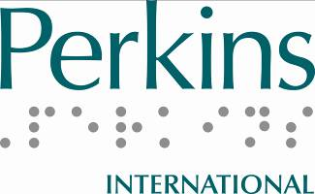

Latin American Permanent Survey on Services for People with Multiple Disabilities

Osvaldo Bertone, Graciela Ferioli, Maria Elena Nassif, Stephen Perreault, Paula Rubiolo & Maria Vazquez
Translated by Paula Rubiolo, Perkins International & FOAL

Introduction
This research was conducted during 2013. Similar work was done 23 years ago jointly by the Latin American Union of the Blind, ONCE Foundation-Latin America, and the Hilton/Perkins Program of Perkins School for the Blind. At that time, the research was conducted for 3 years, with information collected by traditional mail. However today we attempt to conduct the research via e-mail, which makes information-gathering more agile. While some institutions that provide services to people with multiple disabilities are still not very familiar with digital technology, this is changing. In the future, ongoing data collection will be a reality.

Objective
The objective of this study is to collect information on the services offered to people with multiple disabilities in Latin America. Such information will allow us to understand and evaluate the evolution of service-provision to these people in recent years.

Procedure
Participants in this study received questionnaires sent via e-mail. The answers were automatically recorded in a database that allows updated statistics of services, permanently. In order to identify which institutions are providing services to people with multiple disabilities, a first-stage questionnaire gathered general information. The second-stage questionnaire explored each institution’s services in more detail.

The procedure we used drew heavily upon the cooperation of key contact people in each country. These individuals provided the email addresses of all schools of special education in their nations and contacted the schools repeatedly to ensure they responded to the questionnaires.

Once we received the responses, we used the information to develop statistical databases as Google Forms. We then published the information.

Questionnaires
This study consists of two questionnaires that are applied in order. The first questionnaire, with 19 questions, asks for information about the institution, the characteristics of the population served, financing, and the age of the institution. The second questionnaire has 25 questions concerning the nature and the number of people with multiple disabilities is serviced. It also investigates the number of times per week these people attend the institution.

Results
It has been a major effort to get the email addresses updated. Moreover, being a very new procedure, people who answer the electronic questionnaires are not very familiar with digital technology. These are barriers that have delayed obtaining information on schedule for the development of this work. We hope to overcome these barriers in the near future.

From the 69 institutions that have responded to the first questionnaire it has been possible to obtain the following information:

The distribution of responses by country is quite extensive. Except for Nicaragua, Dominican Republic, Guatemala and Cuba, all other Latin American countries are included in the responses. However, the representativeness of the responses is questionable because large countries like Brazil and Mexico only record 2 replies, while much smaller countries record more than 2.

Countries | Institutions
Argentina | 14
Bolivia | 2
Brasil | 4
Chile | 4
Colombia | 4
Costa Rica | 9
Ecuador | 6
El Salvador | 2
Honduras | 1
México | 2
Panamá | 1
Paraguay | 3
Perú | 7
Uruguay | 8
Venezuela | 2
Grand Total | 69

Of the 69 institutions that responded to the first questionnaire, 62 serve people with multiple disabilities. Of the 7 institutions that do not serve this population, 6 have received requests for attention during the past year, as shown in the following table. This means that most likely there is a population currently not served.

 | Requests for attention
Number of serviced | 0 | 2 | 3 | More than 10 | Total
No | 1 | 3 | 1 | 2 | 7
Yes | * | * | * | * | 62
Total | 1 | 3 | 1 | 2 | 69

Considering the year of foundation of the institutions, it is striking that the number has increased decade after decade. The increase in population in Latin America is also likely to lead to an increase in the number of people with multiple disabilities. This result implies a greater demand for services. Although the number of institutions has increased, it is not possible to determine from this data whether that increase can satisfy the demand for services.

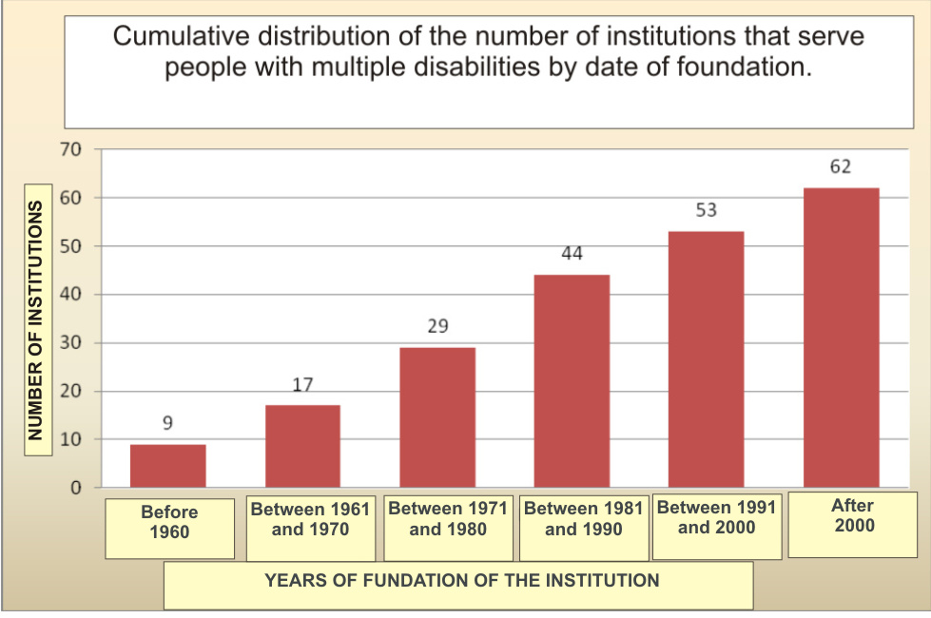

Regarding the sustainability of the institutions, the support of the state over the last few decades is observed. However, private subsidies have become increasingly important.

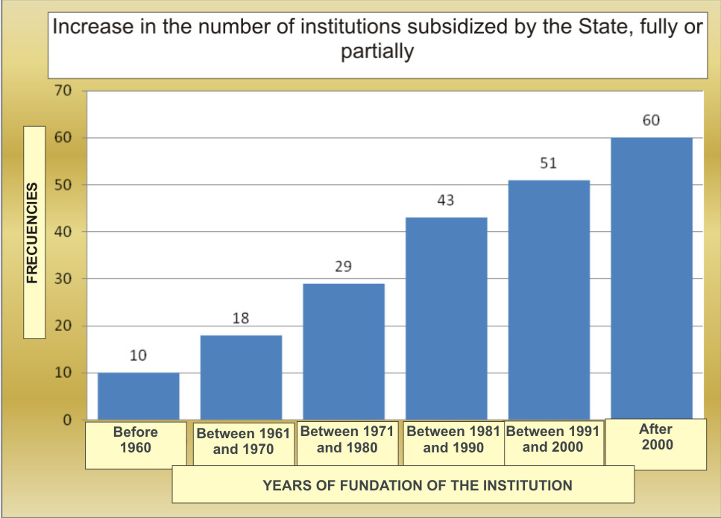

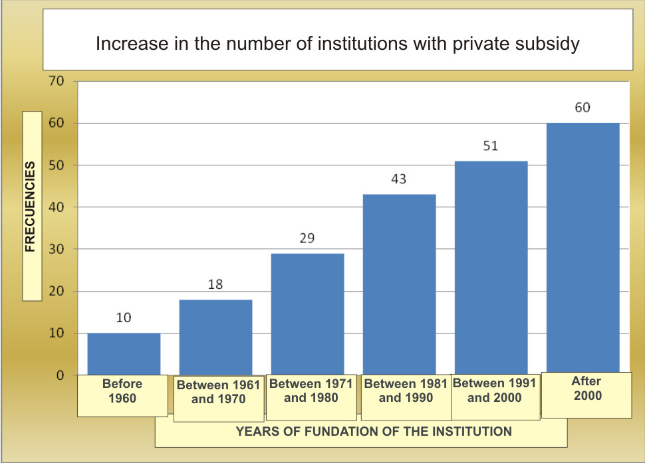

The type of institution serving persons with disabilities depends on regulatory aspects of the countries. In some nations, the agencies are mostly schools, and in others, rehabilitation centers or hospitals.

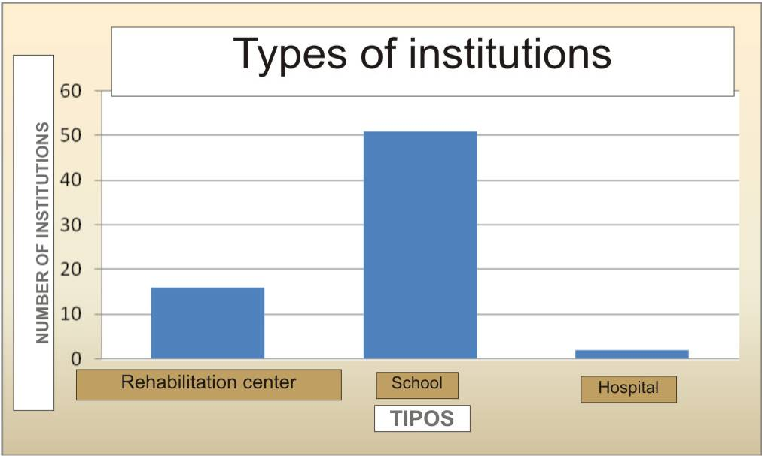

From observation, over recent decades the foundation of the institutions is taking similar types.

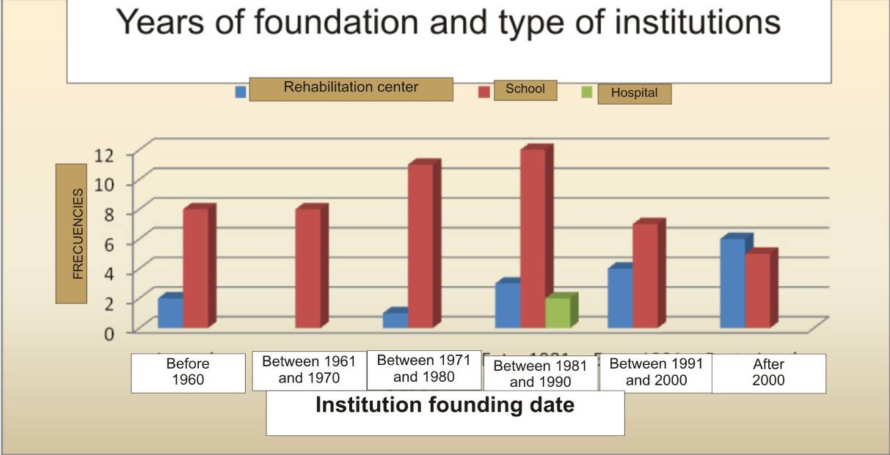

It can also be noticed in the results that the type of institution will take the format imposed by the organisation that supports it.

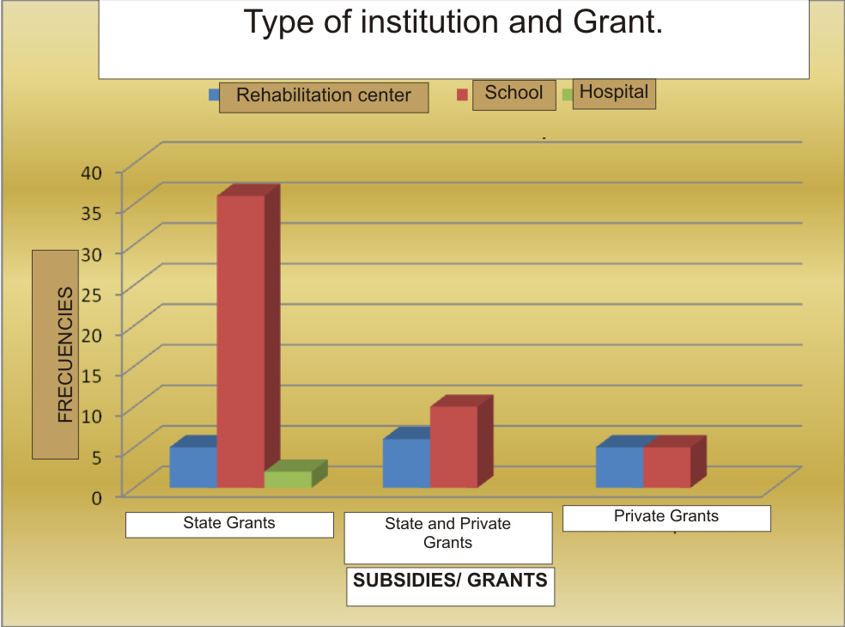

The second questionnaire, specific to institutions that serve people with multiple disabilities, was answered by 42 institutions with the following distribution by country.

Countries | Institutions
Argentina | 8
Brasil | 2
Chile | 4
Colombia | 2
Costa Rica | 4
Ecuador | 5
El Salvador | 1
México | 2
Panamá | 1
Paraguay | 1
Perú | 3
Uruguay | 7
Venezuela | 2
Total | 42

The distribution of institutions by country is quite large, presenting an adequate representation of the global information.

It is important to consider that the period when the institutions were founded correlates with the increase in demand for services for people with multiple disabilities. This increase may have been produced by the joint action of the demands of parents and also for professionals training to carry out programmes for that population in both new and pre-existing institutions.

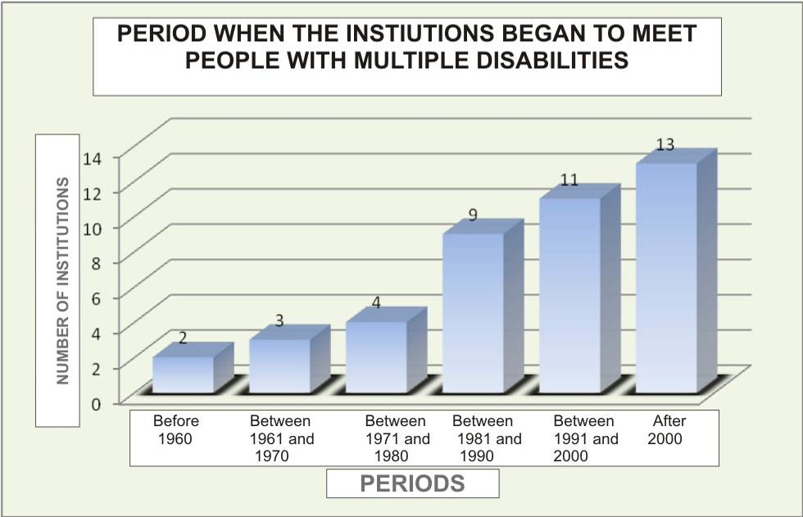

The increase of the institutions that care for persons with multiple disabilities is consistent with the assessment performed by professionals on the increase in this population.
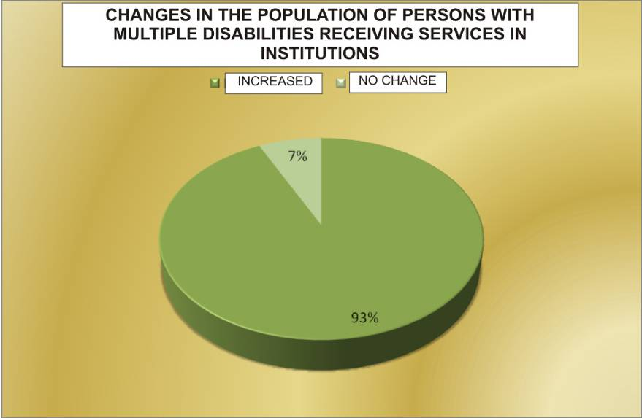

The type of multiple disabilities experienced by people is varied, as shown in the graph below.

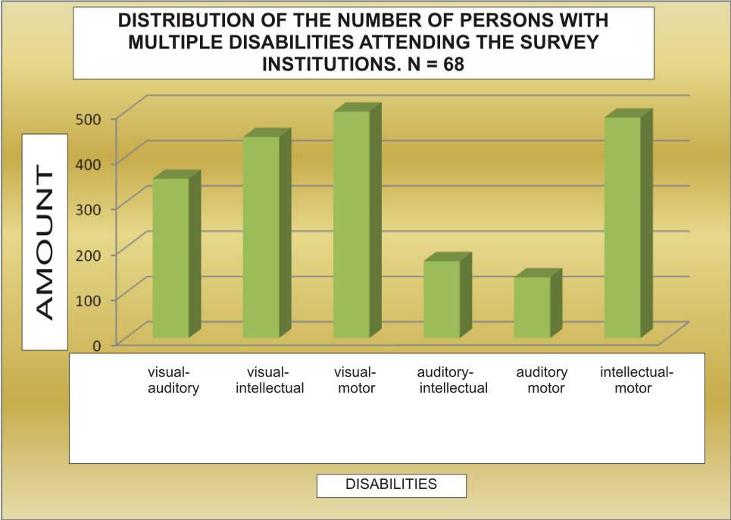

The frequency of care for people with multiple disabilities depends on several factors; however most of the institutions provide services for 5 or 6 days a week.
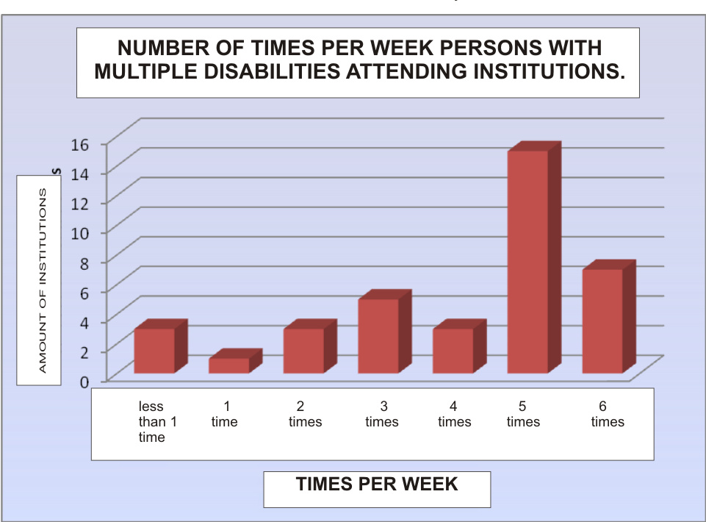

Many institutions have programmes for search and identification of people with multiple disabilities, so it can be assumed that parents should make the task of finding services for their children.

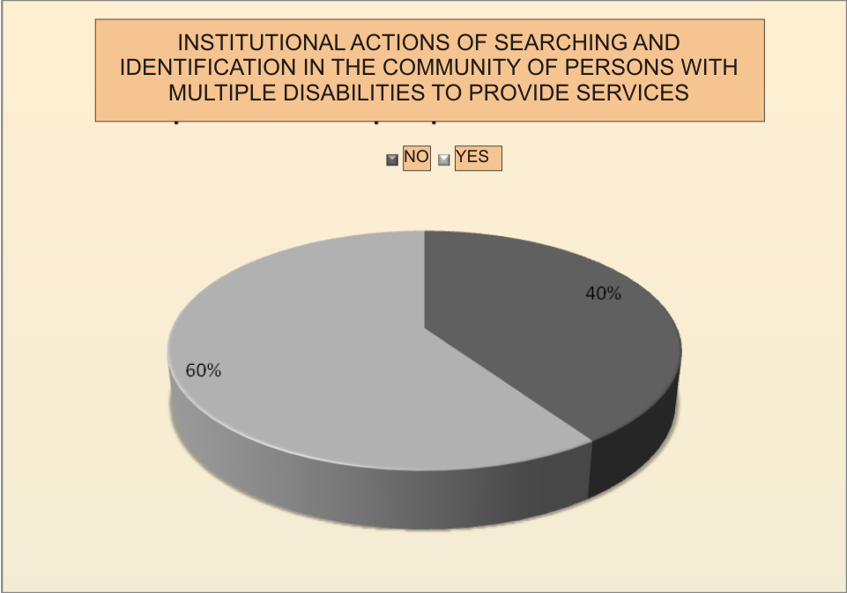

It is important to note that services are mostly funded by governmental funds, as seen in responses to Questionnaire 1. However, the institutions have the freedom to develop their own programmes, which reveals that states do not have clear definitions on what to do with the population of people with multiple disabilities in their organisations.

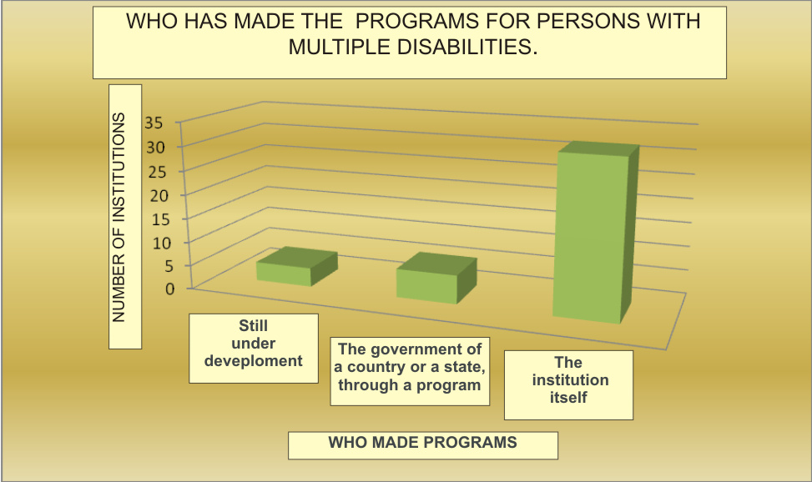

The information above is consistent with the findings of the institutions regarding the role of the state in developing policies for people with multiple disabilities, seen in the graph below.

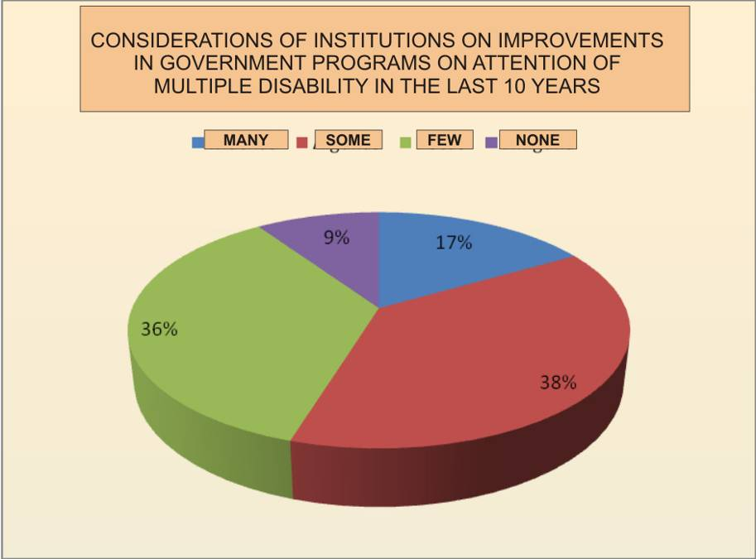

Most professionals report that they have easy access to materials to improve their services for persons with multiple disabilities.

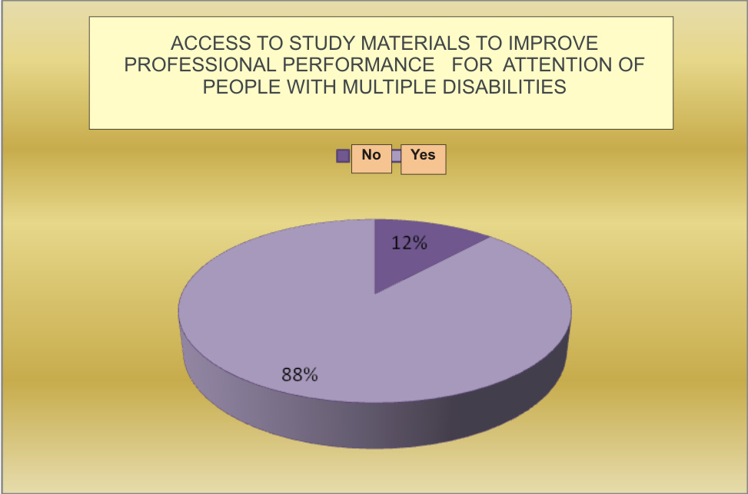

ICEVI’s collaboration with mainstream organizations

ICEVI is collaborating with global, regional and national organizations to promote education of children with visual impairment. The emphasis is upon mainstream education initiatives, and working with larger disability-related movements.

The following recent developments, are noteworthy. ICEVI:

▪ Took part at the high level meeting organised by the United Nations in New York in September 2013;
▪ Enjoys consultative status with the United Nations Economic and Social Council (UN-ECOSOC);
▪ Has been awarded membership with consultative status by UNESCO;
▪ Is a member of the Task Groups of UNICEF dealing with Policy Beyond 2015 and Teacher Preparation;
▪ Works as a member of the Inclusive Education Task Group of the International Disability and Development Consortium(IDDC);
▪ Is a member of the Global Campaign for Education;
▪ The Education for All Children with Visual Impairment (EFA-VI) Campaign has become an official programme of the African Decade.

In summary, ICEVI is collaborating with mainstream organisations in the field of education and also with disability-specific movements. This collaboration with larger initiatives is bringing a lot of synergy into the work of ICEVI.

ICEVI Executive Committee Meeting – Action Points

The most recent meeting of the Executive Committee (EXCO) of the ICEVI was held in Vienna, Austria, in November 2013. Following are the key action points suggested by the members of the EXCO:

1. The EXCO endorsed the recommendations of the Principal Officers, and have invited Mr. Hans Welling, Ex-Vice President of ICEVI, to serve as an Advisor – Regional Development, which includes working on membership issues for ICEVI.

2. ICEVI regions should take active part in the celebration of the Global Action Week (GAW) as a part of the Global Campaign for Education. The Regional Chairs of ICEVI will get in touch with the national contacts of the GCE in this regard.

3. ICEVI has joined with the IAPB and WBU, under the unified network Vision Alliance. This coalition will take part in the International Convention of Lions Clubs International in Toronto in July 2014. Vision Alliance will have an exhibition stand at this convention.

4. The Higher Education Project, supported by the Nippon Foundation, is being implemented in Cambodia, Indonesia, Myanmar, The Philippines, and Vietnam. It has facilitated education for over 1200 students with visual impairment in higher education institutions. The project is likely to be extended to Laos.

5. ICEVI has developed a Data Management System (DMS), which will ensure institutional memory and also credibility to the organisation for effective data documentation.

6. As part of ICEVI’s Education for All Children with Visual Impairment (EFA-VA) campaign, enrolment data for children with visual impairment will be collected systematically. ICEVI regions will provide inputs to the Shadow Reports being prepared by civil society organisations, and prepare Progress Reports for a few countries where the EFA-VI Global campaign is underway.

7. ICEVI member organisations are encouraged to make use of the positive impact of the EFA-VI campaign in their own activities for advocacy and fund raising.

8. Periodic re-launch of the EFA-VI campaign with some special thrust energises its implementation. The next re-launch will be in conjunction with the IDP Africa Forum in Kampala, Uganda, in October 2014.

9. ICEVI regional chairs will make efforts to collaborate with the larger initiatives on education. They will promote inter-regional activities that facilitate the exchange of resources, expertise, etc.

10. ICEVI regional organisations are encouraged to register themselves as legal entities and to develop regional membership structure.

11. ICEVI EXCO commends the collaboration between WBU and ICEVI, and endorses the Joint Assembly in 2016. At that assembly, further logistics will be finalised by the Principal Officers.

ICEVI North American/Caribbean Region Update

Kay Ferrell, US
CeleneGyles, Jamaica
Kim Zebehazy, Canada

The North American/Caribbean Region includes some of the richest and some of the poorest countries in the world. Yet, amazingly, they are very similar in terms of the proportion of both their governments’ budgets and their gross domestic product (GDP) spent on education. Obviously, there is great disparity in GDP among the countries in our region. However, the proportion of each country’s total budget spent on education averages 13.1%, ranging from a high of 21% in Aruba, to a low of 9.8% in Antigua and Barbuda. The countries with the highest GDP do not devote a larger proportion of their budgets to education. The average proportion of GDP spent on education in the region is 5.6%. Again, countries with the largest GDP do not spend a larger proportion of that GDP on education. Smaller countries, such as Aruba, Barbados, Belize, and Jamaica, actually spend a larger proportion of their GDP on education, although not significantly more (World Bank, 2013).

As we collected information on the state of education for students with visual impairment, we discovered that the issues raised in one part of the region were generally issues in the other areas as well. While the larger countries may seem to be doing better, if only because GDP is so much larger, they actually have much in common with the smaller countries in our region. This report is divided into service areas of most concern to the North American/Caribbean region at this time:
- Early intervention services for infants and toddlers;
- Provision of educational materials in Braille and other formats, including technology;
- Transition, or moving from school to work; and
- Teacher training and professional roles.

Early Intervention Services
Providing services to parents of infants and toddlers (ages birth – 3 years, generally) continues to be a concern. In the United States, legislation has existed since 1986 to provide these services through either the education or the health care system. Over time, the practice of early intervention has evolved into a family-oriented plan, with the emphasis on the concerns and priorities of parents and finding the resources to meet their needs. In building these services, however, the unique needs of children with visual impairments are often overlooked. The private agencies that have traditionally provided services are sometimes relegated to consultancy roles instead of being recognised as experts in the development of children with visual impairment. Early intervention services exist in all Canadian provinces and in some Caribbean countries (Jamaica, Belize, and St. Lucia), with plans to extend the services to other countries.

Provision of Educational Materials
Legislation passed in 2004 in the US created the National Instructional Materials Accessibility Center (NIMAC), based at the American Printing House for the Blind. NIMAC receives publishers’ digital files and distributes textbooks and other materials to students in a variety of formats: Braille, audio, text, text-to-speech, enlarged print. The larger Caribbean countries and the Canadian provinces have established facilities to do the same. Technology has largely been provided through private agencies with some government support. While technology opens up a world of opportunities for students with visual impairments, it remains expensive and somewhat dependent on the advocacy of individuals. Research suggests that technology is generally more available in specialised schools than it is in general education schools. There is no national source of funding for technology in any country in the region.

The Transforming Braille Group (TBG) was formed during the last quarter of 2011.Concerned about the lack of Braille for blind children in developing countries, fourteen nonprofit organisations around the world collaborated to identify a technology that will dramatically reduce the cost of electronic Braille displays. For approximately two years, TBG, in conjunction with an engineering company, reviewed 63 proposed technologies from 14 countries.

After identifying a technology that TBG believes can reduce the cost of refreshable Braille devices by 90%, an LLC was formed with additional financial requirements for participants. The nine member organisations of the LLC are the American Printing House for the Blind (USA), Association ValentinHaüy (France), National Federation of the Blind (USA), Norwegian Association of the Blind and Partially Sighted (Norway), Perkins School for the Blind (USA), Royal National Institute of Blind People (UK), Royal New Zealand Foundation of the Blind, Sightsavers (India), and Vision Australia. The President of the Transforming Braille Group is Kevin Carey, Chair of the Board of the Royal National Institute of Blind People. The American Printing House for the Blind is performing the executive function.

Transition Services
These are limited in the Caribbean, but more widely available in Canada and the US. Yet, the employment rate of young adults who are blind and visually impaired is largely unchanged for the last 50 years, even in the countries with legislation requiring attention to preparing youth for future work.

Teacher Training and Professional Roles
Canada has two teacher training universities and a certificate program; the Caribbean has one university teacher training program located in Jamaica; and the US has approximately 30 university teacher training programs. Our concerns are similar: we are not producing enough specialists to meet the needs of students in any country in the region. New training methods are particularly needed in Caribbean countries, since the university is located on one island, making travel mandatory.

There is growing concern that the role of the teacher of students with visual impairments is evolving into being more like a consultant, rather than a teacher providing direct instruction. In part, this has resulted from legislation passed by the national government (US), and in part this has occurred because of the shortage of qualified specialist teachers (Canada and the Caribbean).There is concern that both of these factors may impact inclusive practices and the quality of education in the region, as more and more students may find themselves in classrooms without the specialised support needed to ensure success. This is particularly true in rural areas of the region.

A Collaborative Future
The North American/Caribbean Region has generally made much progress in educating its children and youth with visual impairment, but there is more to do. No country can claim that 100% of children and youth with visual impairment are in school, inclusive or specialised, let alone are receiving appropriate educational services through trained personnel. But the future holds great promise, thanks to the work of our international partners, and we look forward to working together.

Reference
The World Bank.(2013).World development indicators. Retrieved from http://data.worldbank.org/data-catalog/world-development-indicators.

National Inclusive Education Programme
launched in Palestine

The Ministry of Education and Higher Education is collaborating with ICEVI and CBM on a new venture: the National Inclusive Education Programme. The aim is to provide better educational services for students with disabilities in Palestine.

There has been progress in reaching the goals of the United Nation’s Education for All initiative since 1990, with many more children in school. However, children with disabilities have been left behind, particularly children who require alternative modes of communication. The Palestinian Education Development Plan 2008-12 states the problem as a lack of facilities and services to support the educational needs of these children.

The collaborative National Programme for Inclusive Education is designed to improve this situation for Palestinian students with visual impairments. The Programme will improve education by equipping students and educators with adequate resources, improving physical accessibility, developing health services, and fostering partnerships. The Programme starts by focusing on students with visual impairments, but eventually will be extended to include those with other disabilities in both the school system and in higher education establishments.

The President of ICEVI, Lord Colin Low, said: "ICEVI wholeheartedly welcomes and supports this initiative. The UN Convention on the Rights of Persons with Disabilities recognises the right of all people with disabilities to inclusive education. Inclusive education helps to break down barriers between people with disabilities and others, transforms negative attitudes and enables students with disabilities to realise their full potential."

Dave McComiskey, President of CBM, said: "In also welcoming this initiative, we firmly believe that it will enable people with vision impairments to access better life opportunities, develop their personal capabilities and skills and become active members of Palestinian society. We would like to express our deep appreciation to all those who have collaborated with us through sharing information, knowledge and time to get the Programme to the launching pad."

For further information, contact:

Rima Canawati, Director of Programme Development

Bethlehem Arab Society for Rehabilitation

E-mail:rima@basr.org

Khadija Abukhader, National Coordinator for Inclusive Education of Children with Impaired Vision

DG for Special Education & Counseling/Ministry of Education & Higher Education

Ramallah, Palestine

E-mail: khabukhader@yahoo.com

Education for All Children with Visual Impairment
(EFA-VI) Global Campaign – Strategic Goals

What is EFA-VI?
The Global Campaign on Education for All Children with Visual Impairment (EFA-VI) was launched in 2006, as a partnership of the International Council for Education of People with Visual Impairment (ICEVI) and the World Blind Union (WBU).

The following organisations are now supporting the EFA-VI campaign:
- CBM (Christoffel-Blindenmission)
- DAISY
- Francophone Union of the Blind
- Light for the World
- The Nippon Foundation
- The Norwegian Association of the Blind and Partially Sighted
- ONCE (Organización Nacional de Ciegos Españoles)
- Perkins School for the Blind
- The Royal Dutch Visio
- RNIB (Royal National Institute of Blind People)
- Sightsavers
- Stichting tot Verbetering van het Lot der Blinden, The Netherlands
- Vision Australia
- WBU (World Blind Union)

EFA-VI addresses four of the Millennium Development Goals:
- Eradicate extreme poverty and hunger;
- Achieve universal primary education;
- Promote gender equality and empower women;
- Develop a global partnership for development.

The EFA-VI Vision
By 2020 all children with visual impairment will enrol and complete primary education and their educational and social achievement will be on a par with non-disabled children.

EFA-VI’s Mission
The mission of the Education for All Children with Visual Impairment Campaign is threefold:
- To harness the power of information and communications technology, enabling blind and partially sighted students to participate in mainstream schools alongside their sighted peers, and to acquire the specialist literacy skills they need to make their way in the world;
- To broker partnerships with relevant global education organisations, assisting them to put disability at the heart of their planning and delivery; and
- For ICEVI to maintain exemplary programmes, assisting with technical advice, and serving as a catalyst to help other agencies provide access to appropriate education for all visually impaired children and youth.

Context – Why this Campaign is Needed
In April 2000 the World Education Forum adopted the Dakar Framework for Action, entitled Education for All: Meeting our Collective Commitments. This declaration states that by 2015 all children, particularly girls, those in difficult circumstances, and those belonging to ethnic minorities, have access to complete, free and compulsory primary education of good quality.”

Despite this declaration and expenditure of considerable sums, in most developing countries education of children with a disability, including those with visual impairment, remains a low priority.

Of the reported 61 million children who are not attending primary school, it is estimated that at least 16 million (1 in 4) are children with disability, of whom 4 million have visual loss.

There are many reasons for this situation, including:

- General education systems that often fail to include children with impaired vision;
- An absence of action to mobilise and empower blind persons and their families to become effective advocates;
- Lack of public policy, or failure to enforce such policies where they exist;
- Public policies that result in children being placed in custodial care facilities rather than appropriate educational programmes;
- Severe shortage of trained general and special education human resources;
- Weak or non-existent early identification and intervention programmes;
- Insufficient empirical data on programme models that are effective and sustainable within the context of a developing country; and
- Shortage of affordable and accessible teaching aids, low vision devices, textbooks and new technologies that allow blind and low vision persons to do things that were only a dream just a few decades ago.

STRATEGIC OBJECTIVES AND OPERATIONAL GOALS OF THE EFA-VI CAMPAIGN

1. Building awareness among relevant global organisations of the needs of children with visual impairment

Operational goal: To ensure that the following organisations take account of the needs of children with a disability, and specifically visual impairment, in their work:

International Disability and Development Consortium (IDDC) - Aims to promote inclusive development that respects the full human rights of every person. This calls for acknowledging diversity, eradicating poverty, and ensuring that all people are fully included and can actively participate in development processes and activities regardless of age, gender, disability, state of health, ethnic origin or any other characteristic.

The Global Partnership for Education (GPE) - Works in developing countries with partners to ensure resources and technical support are in place to build and implement sound education plans.

The Global Campaign for Education (GCE) - A civil society organisation which aims to end the global education crisis. It holds governments to account for their repeated promises to provide Education for All. Its mission is to make sure that governments deliver the free, high-quality public education that is the right of every girl, boy, woman and man.

United Nations Education, Scientific and Cultural Organisation (UNESCO) - The leading agency coordinating the activities of governments, development agencies, civil society, and the private sector to reach the EFA goals.

United Nations Children's Fund (UNICEF) - The world's leading children's charity working with families, communities and governments in more than 190 countries to protect and promote the rights of children and young people. It helps governments to build schools, train teachers and provide textbooks so that every child can get an education.

United Nations Development Programme (UNDP) - The UN’s global development network, advocating for change and connecting countries to knowledge, experience and resources to help people build a better life. It focuses on the achievement of the Millennium Development Goals, including “achieving universal primary education”.

International Disability Alliance (IDA) - A network of global and, since 2007, regional disabled people’s organisations (DPOs). Its aim is to promote the full and effective implementation of the UN Convention on the Rights of Persons with Disabilities (CRPD) worldwide, as well as compliance with the CRPD within the UN system, through the active and coordinated involvement of representative organisations of persons with disabilities at the regional, national and international level.

The World Bank - Not a bank in the ordinary sense but a unique institution with the mission to reduce poverty and support development. Established in 1944, it is a vital source of financial and technical assistance to developing countries around the world.

The European Union (EU) - A unique economic and political partnership of 28 European countries with the aim of fostering economic cooperation, in the belief that countries that trade with each other become interdependent and are therefore more likely to avoid conflict.

USAID - An organisation which supports U.S. foreign policy by expanding stable, free societies, creating markets and trade partners for the United States, and fostering good will abroad. One of its nine key aims is to ‘further education’.

AusAID - The Australian Government agency responsible for managing Australia's overseas aid programme.

The achievement of this operational goal will be measured by:
Acknowledgement of EFA-VI and the needs of disabled children and those with visual impairment in all of these organisations’ public statements, documents and programmes.

2. The inclusion in National EFA plans and their implementation of the needs of children with visual impairment

Operational goal: National EFA Plans to show how the needs of children with visual impairment will be met to ensure that they are able to access and stay in education on the same terms as non-disabled children.

Achievement of this operational goal will be measured by:
The inclusion of EFA-VI components in national plans of education of countries where the EFA-VI campaign is implemented.

3. Capacity-building of teachers and other professionals

Operational goal: Capacity-building of teachers within the focus countries. The campaign will continue to focus on work in four main areas:

- The development of high quality curricula to prepare special teachers to work with children with visual impairment in mainstream and special schools;
- Training in the strategies used by blind and partially sighted students for acquiring literacy and accessing the curriculum using information and communications technology;
- The formulation of country-specific modules on special education for incorporation into general teacher preparation courses;
- The design of skill-based refresher courses for in-service teachers.

Achievement of this operational goal will be measured by:
- An increase in the number of teacher training establishments adopting the proposed curricula, including training courses in the use of information and communication technology (ICT);
- An increase in the number of in-service teachers participating in skill-based refresher courses, including those featuring ICT.

4. The Facilitation of collaboration and networking
ICEVI believes that the key factor in the achievement of EFA-VI is extensive collaboration and networking between relevant organisations, and the incorporation of EFA-VI into the organisations’ strategic objectives in the field of education and disability generally. A key operational goal is therefore to increase the level of collaboration and networking. ICEVI has begun this through increasing the number of partners within ICEVI and the EFA-VI campaign and will build on this success.

Achievement of this operational goal will be measured by:
- An increase in the number of organisations of and for the blind that are members of ICEVI;
- An increase in the number of organisations specialising in promoting Education for All that are involved in the EFA-VI campaign and accord it a central place in their work.

5. Formulation of best practice
ICEVI has considerable experience in developing best practice by getting stakeholders involved, including organisations of the blind, teachers, parents, voluntary organisations, funding bodies and government agencies. Best practice includes:
- Human resource development (teachers and other education professionals);
- Service delivery;
- Production of low-cost assistive devices.

Operational goal: Build on this work through EFA-VI and continue to develop best practice through research and collaboration.

Achievement of this operational goal will be measured by:
An increase in the number of research projects examining and developing best practice in these areas.

6. Promotion of the use of information and communications technology
To promote the use of ICT to make print-based curricula accessible to blind and partially sighted children and young people, in the requisite languages and at reduced cost.

Achievement of this operational goal will be measured by:
The amount of ICT in schools for enabling access to the curriculum for blind and partially sighted children and young people, and the number of teachers trained in its use.

7. Strengthening information exchange and marketing
It is vital for the success of the EFA-VI campaign that information about the education of children with visual impairment is accessible to all relevant organisations and agencies. Strengthening the effectiveness of information exchange and ensuring that the Campaign is ‘marketed’ is therefore a key operational goal.

Achievement of this operational goal will be measured by:
- Attendance at relevant conferences by ICEVI;
- An increase in the distribution of locally specific materials;
- Improvement of the website;
- The amount of accurate and positive press coverage.

Strengthening the ICEVI Network to Deliver EFA-VI
The regional structure is the principal strength and constitutional focus of ICEVI. Though the regional structure is relevant for advocacy, leadership training, etc., the national level is key to the success of the campaign. Central to the achievement of the strategy is the identification of one or two organisations in each country that have a long history of serving persons with visual impairment, and equipping them to become ‘National Resource Centres’ for the campaign. The selection of these centres will be decided on the basis of ten criteria:

1. Recognition for providing educational services for persons with visual impairment;
2. Availability of qualified professionals to guide its activities;
3. Involvement in training and extension activities dealing with visual impairment;
4. Adequacy of space for training programme;
5. Existence of mechanisms to make available low-cost assistive devices;
6. Effective collaboration with organisations of the visually impaired and persons with visual impairment;
7. Clearly defined administrative structure for implementing disability-related services;
8. Availability of technological resources;
9. Preparedness to undertake work for evaluating EFA-VI activities when implemented;
10. Current involvement with international programme and organisations.

Ethiopia, Mozambique, Vietnam, Cambodia, Kenya, Ghana, Rwanda, Ecuador, Honduras, Dominican Republic, Nicaragua, Paraguay, Nepal, El Salvador, India, Fiji, Guatemala, Bolivia, Palestine are involved in the implementation of the campaign. Preparation work is underway in Mali, Burkina Faso, Uganda, Malawi, Tajikistan, Laos, Bangladesh, Sri Lanka, and Papua New Guinea to implement the EFA-VI campaign.

Mainstream Education initiatives are also used for expanding the campaign activities beyond these focus countries. More information on the campaign is posted on ICEVI’s website www.icevi.org

Education for All Children with Visual Impairment
(EFA-VI) Global Campaign – Accomplishments and Challenges

Chronology of EFA-VI Global Campaign:
One of the strategic goals of ICEVI is to ensure access and full participation in education for all visually impaired children and youth by 2015. To this end, The Global Campaign on Education for All Children with Visual Impairment (EFA-VI) was launched in 2006 by ICEVI, in partnership with the World Blind Union (WBU). A chronology of the EFA-VI Global Campaign and the accomplishments are enumerated below:

2003
The first Executive Committee meeting of ICEVI for the quadrennium 2002-2006 was held in Stellenbosch, South Africa, in March. The meeting reinforced the need for concerted efforts to develop a concept paper for the global campaign.

2004
- A draft concept paper was discussed at a meeting of the Executive Committee of ICEVI in Kuala Lumpur, which provided specific direction for the development of a business plan for the campaign.

- While developing such a document, ICEVI simultaneously reviewed similar policy statements made by international funding organizations and incorporated some of these ideas into the development of the global campaign document.

2005
- The plan was further refined during the Executive Committee meeting of ICEVI held in Madrid in March. The formation of a global body to monitor the implementation of the global campaign and its programmes was proposed, consisting of the umbrella organisations, inter-governmental agencies, and international non-governmental organizations involved in the services for persons with disabilities in general, and education of children with visual impairment in particular.

- The culmination of all these efforts resulted in the formation of a Global Task Force (GTF) for the campaign at a meeting held in Pontevedra, Spain in November. The campaign was conceptualized as an initiative of the International Council for Education of People with Visual Impairment acting in partnership with the World Blind Union. The Global Task Force has met seven times between the Pontevedra meeting and late 2013.

2006
The campaign was formally launched at the12th World conference of ICEVI held in Kuala Lumpur, Malaysia in July.

2009
At the meeting held in Bensheim in 2009, it was decided to disband the Global Task Force and form four committees: Global Advocacy and Networking, Media and Materials, Programme Review and Monitoring, and Resource Mobilisation. The Terms of Reference for these committees were developed and the committees met once since their formation.

2012
A full-day Strategy development meeting on EFA-VI was held in Bangkok in November, involving key UN agencies and INGDOs to devise strategies to work with larger initiatives on education.

2011-2013
Regional Strategy development meetings were also organized in the Africa (2011), East Asia (2012), Latin America (2013) and West Asia (2013) regions.

2013
- At its February meeting in London, the ICEVI Executive Committee resolved to reinstate the Global Task Force, in order to develop ownership among different stakeholders for the campaign.

- The first meeting of the reconstituted GTF met in Madrid, Spain on 31st May and 1st June, to discuss the way forward for EFA-VI in the quadrennium 2013-16.

Accomplishments and challenges
The countries which participated or are currently involved in the EFA-VI campaign are as follows:

1. Ethiopia
2. Mozambique
3. Vietnam
4. Cambodia
5. Kenya
6. Ghana
7. Rwanda
8. Ecuador
9. Honduras
10. Dominican Republic
11. Nicaragua
12. Paraguay
13. Nepal
14. Pakistan
15. El Salvador
16. India
17. Fiji
18. Guatemala
19. Bolivia
20. Palestine

The following countries are likely to be included as per the recommendations made by the Regional Chairs of ICEVI

1. Mali
2. Burkina Faso
3. Uganda
4. Malawi
5. Tajikistan
6. Laos
7. Bangladesh
8. Sri Lanka
9. Papua New Guinea

- Data on enrolment of children with visual impairment reveals that 73,218 additional children with visual impairment have been enrolled in schools as a result of the campaign.
- 34,709 teachers and parents have been trained since the inception of the campaign.
- More than 200 capacity building programmes were conducted in the last six years in the ICEVI regions. The themes of the capacity building programmes include Low Vision, Early Detection and Assessment, Adapted Learning Materials, Abacus, Braille, Education of Children with Multiple Disabilities and Visual Impairment, Inclusive Education, Visual Stimulation, Orientation and Mobility, Child Protection Policies, Legislation, Role of Parents in Education of Children with Visual Impairment, and Activities of Daily Living.

- The EFA-VI Campaign is recognized as the first organized initiative to lobby for the education of children with visual impairment at the national and international levels.
- More international organisations, though not a part of the ICEVI EXCO, have come on board to promote the campaign.
- The campaign is recognized by UNESCO and UNICEF.
- A regional secretariat for the EFA-VI campaign is also functioning at the premises of the African Union of the Blind (AFUB) with a full time Regional Coordinator.
- EFA-VI campaign has been declared as an official programme of the African Decade providing a special impetus to work in the African countries.
- As the results of the campaign are tangible, co-funding opportunities with major donors or inter-governmental organizations are also brought to assist specific countries or regions where EFA-VI is implemented.
- The campaign is one of the driving forces strengthening the relationship between ICEVI and WBU, and led to the historic joint assembly in Bangkok, Thailand in November 2012. The next joint Assembly will be in 2016.
- The Strategy Development Day at the 2012 Bangkok Assembly brought together the UN bodies, international non-governmental development organisations, funders, WBU, and ICEVI, to emphasise the rights to education of children with disabilities in general and visual impairment in particular.
- The EFA-VI campaign also contributed to the formation of the Vision Alliance, a network of the International Agency for the Prevention of Blindness (IAPB), ICEVI, and WBU.
- ICEVI has developed a comprehensive curriculum for teacher preparation at all levels, and detailed guidelines for inclusive education.

There are still many challenges, including lack of country-level coordination between various organizations working in the disability sector, lack of trained human resources, in adequate legislative measures, lack of allocation of resources from governments for the education of children with disabilities, etc. The EFA-VI campaign is trying to address these issues in the regions and also in the countries where the campaign is underway. Update on the implementation of the EFA-VI campaign will be posted on ICEVI’s website www.icevi.org

HUMAN INTEREST STORIES

MALAWI

DEAFBLINDNESS IN MALAWI
Deaf-blindness is a unique disability. It is a combination of visual and hearing disability which limits activities of a person and can restrict full participation in a society. To overcome this, the individual needs specific services, such as environmental adaptation and/or technology.

Human Interest Story:
Brian Banda is 6 years old, from Kasungu district in Malawi
Main diagnosis: Malaria at the age of 9 months
Vision: Light perception in both eyes
Hearing: 75 dB on both ears

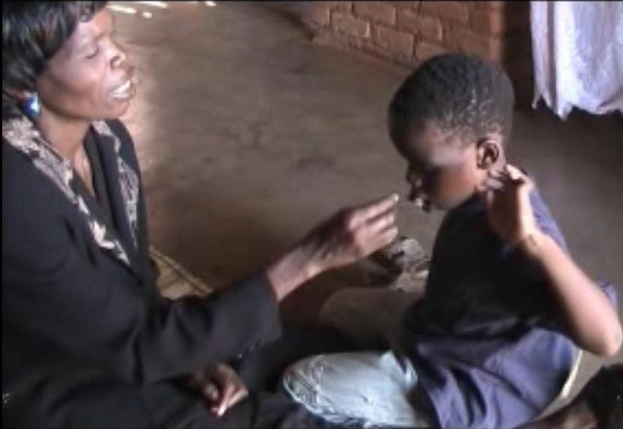

Brian is a boy living with deaf-blindness. He became deaf-blind after suffering from malaria at the age of 9 months. Since he acquired this disability, Brian was being locked in a house by his mother for fear of bumping into objects. Therefore he developed poor posture, mannerisms, and he could not move around. He is enrolled at Chisombezi Deaf-blind Centre about 650 km away from his home.

Video clip of Brian being fed by his mother
“Brian’s mother communicates to Brian that it’s time for eating porridge by pulling his hand with force. Brian does not know what happens; therefore he refuses by pulling back his hand.

Mother continues pulling Brian’s hand; Brian communicates to his mother by using body language. Brian’s mother does not understand this and he continues pulling his hand with force again.

Brian finally becomes so angry that he hits himself on the ear to let his mother know that what she was doing was wrong.”

Summary of the video clip and case study
There is miscommunication between Brian and his mother. Brian did not know that the pulling of his hand meant time for eating the porridge. This is a clear example of how family members need assistance in learning to communicate with persons who are deafblind. Lack of communication skills leaves persons with deafblindness without access to information, support services, and the environment.

Based upon a survey conducted by Visual Hearing Impairment Membership Association (VIHEMA) and the Malawi Council for the Handicap (MACOHA), it is estimated that there are more than 395 persons who are deafblind in Malawi. Of this number, 250 are children of school-going age. Only 13 children attend Chisombezi Deaf-Blind Centre, a school established by the Roman Catholic Sisters of the Servants of the Blessed Virgin Mary (SBVM), with support from VIHEMA. Located in Chiradzulu district, in the southern region of Malawi, the school gets financial support from Signo Foundation from Norway.

The situation for people with deaf-blindness in Malawi is very critical. There is only one school for children who are deaf-blind and there are no support services for them. The Malawi government has not yet established an education programme for deaf-blind persons. Because of this many children who are born deaf-blind have minimal survival chances, and die before they reach the age of four years.

The National Special Needs Education Policy (2011) states that all persons with disabilities shall receive education of good quality. In 2013 the International Council for Education of People with Visual Impairment (ICEVI), in partnership with the Ministry of Education, Malawi Union of the Blind (MUB), VIHEMA, Sightsavers, and other partners launched the EFA Campaign for the visually impaired in the country. These partners call upon the Malawi government to work hand-in-hand with them to establish and support units where deaf-blind children can access education and other support services.

Through support from the EFA Campaign, the Ministry of Education and MUB have already begun public awareness and capacity building programmes to promote access to education for the visually impaired. Moving stories, like that of Brian, serve to make people of the needs of children who are deaf-blind. The Ministry of education should train teachers in deaf-blind awareness programmes as soon as possible to minimise unnecessary deaths of deaf-blind children. Once the services are provided, deaf-blind persons can become productive citizens who can contribute to the socio-economic development of Malawi and live an independent life.

UGANDA

The Uganda Braille Cup Competition took place in June 2013, just a week after the Education for All Children with Visual Impairments (EFA-VI) Campaign was launched by the International Council for Education of People with Visual Impairment (ICEVI) in Uganda.

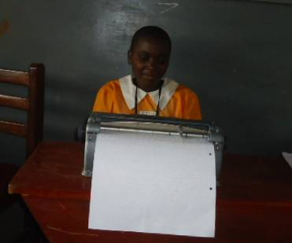

The Uganda Braille cup competition was the first of its kind. The event was supported by Perkins International, ICEVI, and Kyambogo University, which also hosted the event. It drew participants from 11 schools and various stakeholders. The activity was spearheaded by Uganda National Association of the Blind (UNAB).

Nakawooya Victoria is one of the participants, who participated in the Braille Cup Competition on 14th June, 2013. She is 14 years old, in primary seven, and studies at Salama School for the blind in Kampala. In her success story, she says, her ambition is to become an accountant, which requires her to read well, especially Mathematics Braille signs and symbols. Participants to the event had to vigorously prepare in advance and so did Victoria and her teachers.

Her participation in the competition has made her learn to:
- Socialise with different categories of people thus reducing her level of shyness;
- Improve in her reading and writing speed in Braille;
- Increase in general English literacy. including increased competency in spelling words;
- Improve her thinking capacity especially due to the time allocated to the questions.

She goes on to say that the competition has also made her pay attention to time management, especially during examination periods. It has also enabled her to acquire more friends which she did not have before. She adds that it was during this time that she acquired a white-cane to improve on her mobility both at school and at home.

Victoria emerged as a winner in the primary division, earning a trophy and a Perkins Brailler. She feels proud for having contributed towards the success of her school. She says this is a great legacy she will leave for those who will enrol after her, especially girls with visual impairment, who experience the double stigma of being female and having a disability. She also thanks ICEVI for supporting the competition in particular, and she hopes that the agency and its EFA Campaign shall continue the work in Uganda and to support the Braille Cup Competition in the future.

