Dear colleague,

My name is Annemiek van Leendert, I come from the Netherlands. I am a PhD student at Utrecht University and Erasmus University. Moreover, I work as an expert of mathematics of braille readers at Royal Visio. This organisation provides education and care to visually impaired students. The topic of my research is ”Improving the mathematical abilities of braille readers”.
Recently, I started a sub-study with the working title “Mathematical expressions in braille”. The ways in which mathematical expressions and equations are represented is crucial for the braille readers’ understanding and verbal communication with their classmates and teachers. We assume that this also depends on the context. For example, a certain representation may be too complex for a braille reader attending a regular school but very appropriate for a braille reader attending a special school – where teachers are more proficient in reading braille.
In this sub-study, we want to investigate what characteristics of a representation of a mathematical expression support braille readers and what that support exactly is. Your participation in the research will be of great importance to map out all the different representations and underlying principles and objectives. Therefore, you are kindly asked to complete the questionnaire (see attachment). The questionnaire consists of two parts. It takes approximately 10 minutes to complete the first part. It is difficult to predict how long it will take to complete the second part*. That depends, among other things, on the complexity of the Braille code used in your country. You can complete the questionnaire in Word or on paper. I would kindly ask you to complete this questionnaire before 13 September and send the completed Word document or a scan of the completed printed version to A.J.M.vanLeendert@uu.nl.
At the end of this study, we will send you an overview of the different braille codes and a report of our findings. We hope to finish this study in about four months.

If you have questions, you can contact me by e-mail. Thank you in advance.

Warm regards,
Annemiek van Leendert
A.J.M.vanLeendert@uu.nl

Questionnaire

Dear participant,
Please fill in the next questionnaire (Part 1) and complete the table with expressions in the graphical and linear notation (Part 2). Feel free to add comments to support or clarify your answer. All questions refer to the situation in your country.

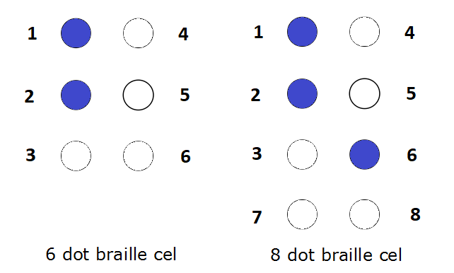

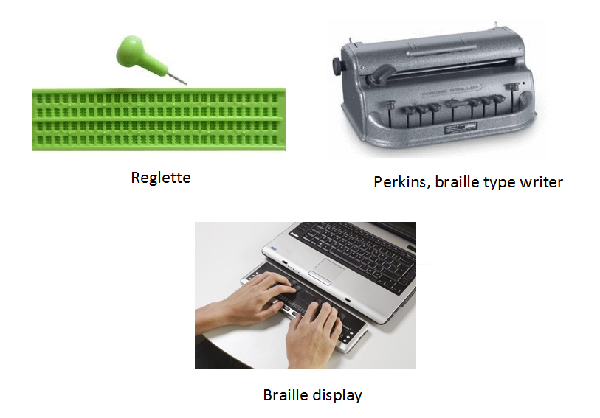

The figure on the top shows the standard numbering of dots positions in a 6-dots or 8-dots braille cell. The braille symbol on the left is numbered as dot 12, on the right as dot 126.
A reglette and a Perkins is a tool for writing in braille. A braille display is a tool for reading in braille.

PART 1
Demographic data

- Country

In which country do you live?
…

- Experience

How many years of experience do you have with teaching mathematics to braille readers?
☐ less than 1 year
☐ 1-3 years
☐ 3-5 years
☐ 5-10 years
☐ more than 10 years

- Education

Are braille readers educated in general education settings or in schools for visual impaired students?

Do you think most braille readers go to
☐ mainstream schools
☐ schools for visually impaired students
☐ partly in mainstream schools and at schools for students with a visual impairment
☐ other (specify) …

Reading and writing in braille

- Braille code: 6-dot or 8-dot braille

Do braille readers in your country use a 6-dot and/or 8-dot braille code for mathematics?
☐ 6 dot
☐ 8 dot
☐ 6 dot and 8 dot

- Main braille code
What is the main braille code used for mathematics in your country?
☐ Nemeth Unified Braille System code (NUBS code) or Nemeth braille code for mathematics
☐ Unified English Braille code (UEB)
☐ Marburg code
☐ Other (specify) …

- Another braille code
Do braille readers in your country sometimes use a different braille code than the main braille code?
Which one?

☐ Nemeth Unified Braille System code (NUBS code) or Nemeth braille code for mathematics
☐ Unified English Braille code (UEB)
☐ Marburg code
☐ a self-made code
☐ Other (specify) …

- Assistive devices for reading
How do braille readers read mathematical text?

☐ in braille on paper
☐ in braille on a refreshable braille display consisting < 24 braille cells
☐ in braille on a refreshable braille display consisting of 25 to 48 braille cells
☐ in braille on a refreshable braille display consisting of 48 to 80 braille cells
☐ in braille on a refreshable braille display consisting of > 80 braille cells
☐ with speech synthesis
☐ with a combination of braille (on the braille display) and speech synthesis
☐ other (specify)

- Assistive devices for writing
How do braille readers write mathematical text?
(see figures on the first page of this document)

☐ with a reglette or slate
☐ with a braille type writer (e.g. Perkins)
☐ with a braille keyboard
☐ with a computer keyboard
☐ with a combination of a braille and computer keyboard
☐ other (specify) …

- Keyboard
What computer keyboard is used in your country?

☐ qwerty keyboard
☐ azerty keyboard
☐ other (specify) …

- Advantages and disadvantages of the braille code

What are the advantages and disadvantages of the braille code for mathematics in your country? (If more braille codes are used, please answer this question for every braille code)

advantages: …..

disadvantages:…..

PART 2

Expressions and equations in the graphical and linear notation

Please write the expressions in Table 2 and Table 3 in the linear representation associated with the braille code used, i.e. in Ascii equivalents, in “dot” language or in braille characters (as illustrated in Table 1). If an expression or equation can’t be transcribed into braille, e.g. because the braille code is not suitable for advanced mathematics, put “can’t be transcribed into braille”.

Table 1
Example of the Dutch representation.

Graphical representation  (for sighted people) | Linear representation associated with the braille code used, i.e. in Ascii equivalents, in dots ”language” or in braille characters
$$2×3=$$ | 2 * 3 =
$$\frac{1}{4}$$ | dot 16 34 1456

Table 2
Graphical and linear representations of expressions and equations

 | Graphical representation  (for sighted people) | Linear representation associated with the braille code used, i.e. in Ascii equivalents, in dots ”language” or in braille characters
1 | $2×3=$
2 | $$\frac{1}{4}$$
3 | $$-3-9=$$
4 | $$ax^{2}+bx+c$$
5 | $$x^{a}+b$$
6 | $$y^{x^{a}+b}$$
7 | $$sinα=cos⁡(π-a)$$
8 | $$3\frac{1}{2}$$
9 | $$\frac{3}{7a}$$
10 | $$\frac{3}{7}a$$
11 | $$4+(1-\left(3+2\right))$$
12 | $$\frac{2a+3b}{n}$$
13 | $$p= \frac{2}{\frac{1}{3+4}}$$
14 | $$2>\sqrt{a}$$
15 | $$\sqrt{ab} ∙\sqrt[3]{c}$$
16 | $$\sqrt{\frac{x^{2}}{2}}= \sqrt{\frac{3+x}{2}}$$

Table 3
Graphical and linear representations of expressions and equations for advances mathematics

 | Graphical representation  (for sighted people) | Linear representation associated with the braille code used, i.e. in Ascii equivalents, in dots ”language” or in braille characters
1 | $$X_{n+2}= X_{n+1}+ X_{n}$$
2 | $$\int_{1}^{3}{x^{2}dx= }$$
3 | $$\lim_{h→0}{\frac{∆l(x)}{h}}$$
4 | $$M= \left(\begin{matrix}1 & 6 \\ 2 & 7 \\ 4 & 5\end{matrix}\right)$$
5 | $$\sum_{i=0}^{n}{a_{i}}$$

