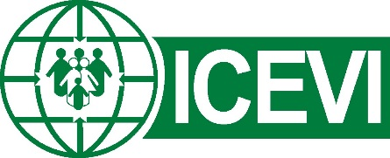
World Braille Day, 4th January 2020
The International Council for Education of People with Visual Impairment (ICEVI) joins the United Nations and global disability community in celebrating World Braille Day on Saturday 4th January 2020. This day marks the 211th anniversary of Louis Braille’s birth and his creation at age 15 of a tactile reading and writing system that is called Braille in his honour.
World Braille Day was established by the United Nations in 2019 to raise awareness of the importance of braille in the context of education, freedom of expression and opinion, and social inclusion – see https://www.un.org/en/observances/braille-day. The UN emphasises the provision of braille and other accessible forms of communication in the Convention on the Rights of Persons with Disabilities (CRPD, 2006, Articles 2, 9, 21 and 24).
ICEVI, in partnership with the World Blind Union (WBU), released a Braille Literacy Position Statement in 2016, in recognition of the importance placed on braille in the United Nations CRPD. ICEVI and WBU highlight that “Braille represents competency, independence, and equality…learning to read and write in braille can make a dramatic difference in the life of a visually impaired child or adult”. WBU and ICEVI set out the following four recommendations in the Braille Literacy Position Statement:
- We strongly recommend that all blind and severely partially-sighted children be given the opportunity to learn and become proficient in braille reading and writing skills and that they must receive instruction from those who are thoroughly trained and qualified to teach braille.
- We strongly recommend that all blind persons have access to a variety of books and publications in braille that are up-to-date and include such materials as textbooks, education support materials, leisure reading materials and materials that support their full and active participation in community life.
- While advances in technology enable faster and more efficient production and use of Braille, we recommend that technology should be used to enhance the use of Braille, not to replace it.
- We recommend that all governments should ratify the WIPO Marrakesh Treaty which allows for copyright exceptions to facilitate the creation of accessible versions of books and other copyrighted works for visually impaired persons and for the import and export of such materials across national boundaries.

On behalf of ICEVI, I invite you to join us in celebrating World Braille Day on 4th January, and in promoting braille as an essential means of communication and social and educational inclusion for persons with visual impairment.
Dr Frances Gentle,
President, ICEVI

