Kenneth (Ken) Stuckey 1938 – 2020

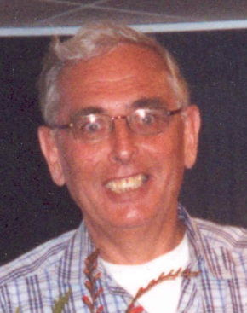

It is with great sadness that ICEVI shares with our membership the passing of Kenneth (Ken) Stuckey in Stockholm, Sweden on April 29th at the age of 82. Anyone who ever had the pleasure of knowing and working with Ken will never forget him. His knowledge and enthusiasm for all matters concerned with our field was legendary. Ken had a long and active involvement with ICEVI. In 2002 in celebration of the 50th anniversary of the founding of ICEVI Ken prepared a history of our organization entitled “Meeting the Challenge”.

Ken completed National Service in the British Army. He proudly served in a regiment under the 15th, 19th Royal Hussars. After his military service, he emigrated to the United States, where he was sponsored by the caring Jordan family who took him in as their own. Ken attended Everett Community College and eventually moved to the Boston area. He graduated from Northeastern University and The University of Rhode Island in the field of Library Science.

In 1965 Ken began his work as a Research Librarian at Perkins School for the Blind. He is well recognized for his extensive knowledge and research on topics related to blindness. Through his career he authored a number of publications and articles about Perkins history, Helen Keller, and the history of blind education. He is the main contributor to the book ¨Helen Keller: Author and Advocate¨, by Deborah Kent and he is the editor of the book ¨Biography of the Blind¨ by James Wilson. As a Boy Scout leader at Perkins, Ken was a pioneer in ensuring that all youth had equal access to adventures. In his mind, there was no trip that could not be made accessible. His troop braved multi day canoe trips, hiking excursions to the Rocky Mountains of New Mexico, and even flew to Greece to see the birthplace of Michael Anagnos.

He retired from Perkins in 1998 and moved to Sweden where he married Gunilla Stenberg. After his retirement, he spent years presenting his prestigious stamp collection, featuring topics on blindness, around the world. Ken enjoyed his years of membership in the Lion’s Club in both Watertown, MA and Stockholm, Sweden. He was a traveler and a lover of daily walks. He was gregarious and loved to share his excitement and enthusiasm for an upcoming trip or a past memory. His infectious optimism will be greatly missed. Ken is survived by his wife, Gunilla Stenberg/Stuckey, two children Heather Green and Christine Stuckey and four grandchildren.

