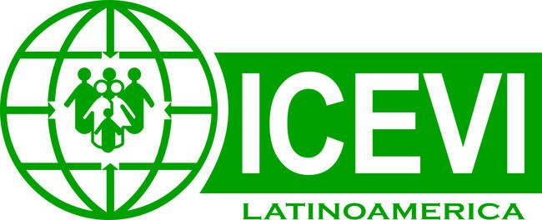
International Council for Education of People with Visual Impairment
Latin America Region
--------------------------------------------------------------------------------

Orientation and Mobility in times of pandemic – Technical Recommendations
In this COVID-19 pandemic context, it is necessary to re-think orientation and mobility (O&M) practices from another point of view, that is, to continue teaching O&M to children at school, to adults in rehabilitation centres, and to provide tools for people with visual impairment who are moving independently.
It is important to bear in mind that O&M is a specialized area that is cross-cutting with other areas. O&M is formed of strategies and techniques aimed at providing tools for the movement of people with visual impairment. The strategies need to be modified, thinking of the development of the person’s autonomy and independence, and allowing for safe movement.
Security during pandemics such as COVID-19 will have other considerations including the following:
- The compliance with all security measures, social distancing, use of face masks, hand washing, cleaning of objects, and lack of face touching. We must raise awareness on these habits.
- To create habits regarding the cleaning and disinfection of the white cane when arriving home. This means to disinfect the grip and cane with a cloth; and to clean the cap with a different cloth, or simply to spray with a sanitizer. Avoid storing the cane in its case without disinfecting it first.
The challenges we are going to face may include the following:
- The need of people with visual impairment to use touch.
- Use of touch when requesting or offering help during social distancing. The recommended distance is 2 meters.
- The reduction or modification in the use of other senses because of use of a face mask.
- Difficulties in the use of public transport; use of touch for handrails and grips.
- Access to information for people with low vision who need greater proximity to see.
- The development of people with deafblindness, who need more proximity to hear or the use of hands to communicate.
To solve these problems we can:
- Replace direct touch with indirect touch (e.g., using a tissue or handkerchief). Touch the commonly used objects with other parts of the body which are not used for touching the face; for example, use the knuckles to press the elevator buttons, or the elbow to touch door handles.
- Use of the cane to ensure physical distance. The cane allows for making contact with semi-distant objects. Also, the use of hearing, which is a long distance receiver, becomes more important. Whenever possible, request for verbal instructions in order to avoid physical contact.
- As a general rule, the recommended distance from any person who is not a cohabitant is two meters.
- Regarding the arm guidance technique, the grip of the arm shall be replaced by the holding of the shoulder or back part of the arm. Use hearing or the cane to keep physical distance, or request verbal instructions to avoid contact, whenever possible.
- People with low vision could use mobile phone apps to recognize objects, or take a photo of objects. Use of the cane when necessary, however the mouth cover or face mask may reduce vision in the lower visual field.
- Take emotional care of people during the pandemic.
- Propose indoor activities that can be then transferred to the outdoors, creating safe habits that can be first practiced indoors, with less stimulus contamination.
- Develop complementary skills such as balance, coordination, strength, laterality, etc., which can be performed at home during lockdown.
We cannot provide general solutions or recipes - we need to focus, more than ever, on each child, teenager or adult and their individuality.

