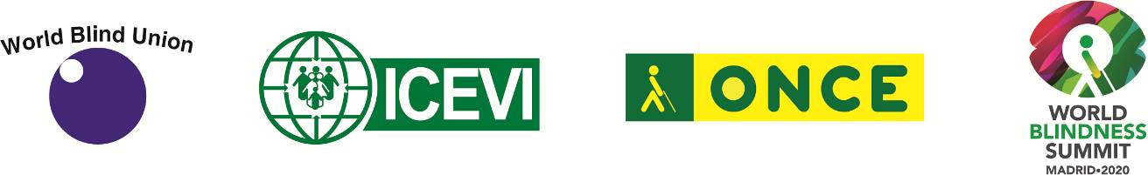

WBU-ICEVI General Assemblies

28 – 30 June 2021

Dear Members and Friends,
The World Blind Union (WBU), the International Council for Education of People with Visual Impairment (ICEVI), and the Organización Nacional de Ciegos Españoles (ONCE) are pleased to announce the new dates of the joint WBU and ICEVI general assemblies. The WBU-ICEVI General Assembly will be fully conducted online from 28 to 30 June 2021.
The overall theme of the General Assemblies is “World Blind Summit: What it means to be Blind and Visually Impaired”.
The International Organizing Committee postponed the WBU/ICEVI general assemblies this year to protect the health and safety of participants as the world continues to combat the on-going Coronavirus (COVID-19) pandemic.
We strongly appreciate your understanding and patience as we work diligently to ensure full participation virtually. Our host organization, ONCE, will provide logistical support to ensure the highest level of participation possible.
The new format of the joint General Assemblies requires certain adjustments in order to reflect the new normal but also, to ensure compliance with our constitutions.
The International Organising Committee of WBU, ICEVI and ONCE, chaired by Dr. Fredric Schroeder, President WBU, continues the overall planning to ensure the event is a great success.
As more detailed information becomes available, it will be sent to our members and posted on our organizations' websites.
With best regards,
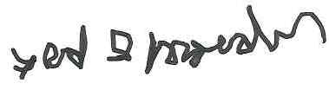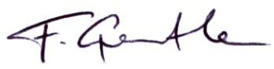
____________________ ____________________
Dr. Fredric K Schroeder Dr. Frances Gentle
President, WBU President, ICEVI

