The Educator

Volume XXXIV - Issue 1 July 2020

A Publication of

The International Council for Education of
People with Visual Impairment
PRINCIPAL OFFICERS

PRESIDENT
Frances Gentle
The Renwick Centre, Royal Institute for Deaf and Blind Children
Private Bag 29, Parramatta, NSW 2124, AUSTRALIA
e-mail: frances.gentle@ridbc.org.au

FIRST VICE PRESIDENT
Praveena Sukhraj-Ely
Department of Justice and Constitutional Development,
Momentum Centre, 329 Pretorius Street, Pretoria, SOUTH AFRICA
e-mail: psukhraj@justice.gov.za

SECOND VICE-PRESIDENT
Rima Canawati
Palestinian Disability Coalition, PALESTINE
e-mail: rima.qanawati@gmail.com

TREASURER
Nandini Rawal
Blind People’s Association, 132 Ft. Ring Road, Vastrapur,
Ahmedabad 380 015, INDIA
e-mail: bpaiceviad1@bsnl.in

IMMEDIATE PAST PRESIDENT
Lord Low of Dalston
Royal National Institute of Blind People
105 Judd Street, London WC1H 9NE, UNITED KINGDOM
e-mail: colin.low@rnib.org.uk

PRESIDENT EMERITUS
Lawrence F. Campbell
1, Center Street, Rockland, Maine 04841, USA
e-mail: larry.icevi@gmail.com

CHIEF EXECUTIVE OFFICER
Mani, M.N.G.
No.3, Professors’ Colony, Sri Ramakrishna Vidyalaya Post,
Coimbatore 641 020, Tamil Nadu, INDIA
e-mail: ceo201922@gmail.com
REGIONAL CHAIRPERSONS

AFRICA
Gertrude Oforiwa Fefoame
Sightsavers’ Global Advocacy Advisor
Densu Point, P.O. Box KIA 18190, North Dzorwulu, Accra, GHANA
e-mail: gofefoame@sightsavers.org

EAST ASIA
Aria Indrawati
Pertuni (The Indonesian Blind Association)
P.O.Box 386, Jalan Raya Bogor, Km.19 Ruko Blok Q No. 13-L,
RT01 RW04, Kramat Jati, East Jakarta, INDONESIA
e-mail: aria.indrawati@gmail.com

EUROPE
Hans Welling
Diependaalsedrift 32
1213cr Hilversum, The Netherlands
e-mail: wellingja@yahoo.com

LATIN AMERICA

María Cristina Sanz
avda. 13 n 1207, flor 9 dpto. A, (1900) LA PLATA, ARGENTINA
e-mail: latinoamericaicevi@gmail.com

NORTH AMERICA/CARIBBEAN
Kay Alicyn Ferrell
Professor of Special Education, Emerita, University of Northern Colorado
Campus Box 146, 501, 20th Street, Greeley, CO 80639, USA

e-mail: kay.ferrell@unco.edu

PACIFIC
Ben Clare
Project Manager, Pacific Islands Activities, Aspen Medical Foundation,
PO Box 231, Deakin West ACT 2601, AUSTRALIA
e-mail: bwclare@gmail.com

WEST ASIA
Bhushan Punani
Blind People’s Association, 132 Ft. Ring Road, Vastrapur,
Ahmedabad 380 015, INDIA
e-mail: blinabad1@bsnl.in
FOUNDING ORGANISATIONS

American Foundation for the Blind
Penny Rosenblum
1401 South Clark Street, Suite 730, Arlington, VA 22202
USA
e-mail: prosenblum@afb.org

Perkins School for the Blind
Dave Power
175 North Beacon Street, Watertown, MA 02472
USA.
e-mail: dave.power@perkins.org

Royal National Institute of Blind People
David Clarke
105 Judd Street, London WC1H 9NE
UNITED KINGDOM.
e-mail: david.clarke@rnib.org.uk

INTERNATIONAL NON-GOVERNMENTAL ORGANIZATIONS

Deafblind International
Mirko Baur
Alte Dorfstrasse 3d, CH-8135, Langnau am Albis
SWITZERLAND
e-mail: mirko.baur@tanne.ch

World Blind Union
José Viera
1929 Bayview Avenue, Toronto, Ontario M4G3E8
CANADA
e-mail: jose.viera@wbu.ngo

International Agency for the Prevention of Blindness
Peter Holland
Office 6068, Aldgate Tower, 2 Leman St., London E1 8FA
UNITED KINGDOM
e-mail: pholland@iapb.org

INTERNATIONAL PARTNER MEMBERS

CBM
Monika Brenes
Stubenwald-Allee 5
64625 Bensheim
GERMANY
e-mail: monika.brenes@cbm.org

Light for the World
Nafisa Baboo
26 Niederhofstrasse, A11-20 Vienna
AUSTRIA
e-mail: n.baboo@light-for-the-world.org

Norwegian Association of the Blind and Partially Sighted (NABPS)
Terje Iversen
P.O. Box 5900, Majorstua0308 Oslo
NORWAY
e-mail: terje.iversen@blindeforbundet.no

Organización Nacional de Ciegos Españoles
Ana Peláez
C/ Almansa, 66, 28039 Madrid, SPAIN
e-mail: apn@once.es

Overbrook School for the Blind
Todd Reeves
6333 Malvern Avenue, Philadelphia, PA 19151-2597
USA
e-mail: todd.reeves@obs.org

Perkins School for the Blind
Katherine Holland
175 North Beacon Street, Watertown, MA 02472
USA
e-mail: katherine.holland@perkins.org

Royal Institute for Deaf and Blind Children
Frances Gentle
Private Bag 29, Parramatta, NSW 2124
AUSTRALIA
e-mail: frances.gentle@ridbc.org.au
Royal National Institute of Blind People
David Clarke
105 Judd Street, London WC1H 9NE
UNITED KINGDOM
e-mail: david.clarke@rnib.org.uk

Sightsavers
Andrew Griffiths
35 Perrymount Road, Haywards Heath, Haywards Heath
West Sussex RH16 3BW
UNITED KINGDOM
e-mail: agriffiths@sightsavers.org

Visio
Sabine Fijn van Draat
Amersfoortsestraatweg 180, 1272 RR Houses
THE NETHERLANDS
E-mail: sabinefijnvandraat@visio.org
International Partner Members

CBM
www.cbm.org

Light for the World
www.light-for-the-world.org

Norwegian Association of the Blind and Partially Sighted (NABPS)
www.blindeforbundet.no

Organización Nacional de Ciegos Españoles
www.once.es

Overbrook School for the Blind
www.obs.org

Perkins School for the Blind
www.perkins.org

Royal Institute for Deaf and Blind Children
www.ridbc.org.au

Royal National Institute of Blind People
www.rnib.org.uk

Sightsavers
www.sightsavers.org

Visio
www.visio.org

Organisational Members

American Printing House for the Blind
www.aph.org

Canadien National Institute for the Blind
www.cnib.ca

Federazione Nazionale Delle Istituzioni Pro Ciechi
www.prociechi.it

Hadley School for the Blind
www.hadley.edu

LES DOIGTS QUI REVENT (Typhlo & Tactus)
www.tactus.org

Lions Clubs International Foundation
www.lcif.org

Round Table on Information Access for People with Print Disabilities
www.printdisability.org

WBU/ICEVI Joint General Assemblies

28-30 June 2021

The World Blind Union (WBU), the International Council for Education of People with Visual Impairment (ICEVI), and the Organización Nacional de Ciegos Españoles (ONCE) are pleased to announce the new dates of the joint WBU and ICEVI general assemblies. The WBU-ICEVI General Assembly will be fully conducted online from 28 to 30 June 2021.

The overall theme of the General Assemblies is “World Blind Summit: What it means to be Blind and Visually Impaired”.

The International Organizing Committee postponed the WBU/ICEVI general
assemblies this year to protect the health and safety of participants as the world continues to combat the on-going Coronavirus (COVID-19) pandemic.

We strongly appreciate your understanding and patience as we work diligently to ensure full participation virtually. Our host organization, ONCE, will provide logistical support to ensure the highest level of participation possible.

The new format of the joint General Assemblies requires certain adjustments in order to reflect the new normal but also, to ensure compliance with our
constitutions.

The International Organising Committee of WBU, ICEVI and ONCE, chaired by Dr. Fredric Schroeder, President WBU, continues the overall planning to ensure the event is a great success.

As more detailed information becomes available, it will be sent to our members and posted on our organizations’ websites.
Editor
Kay Ferrell
Professor Emerita, Special Education
University of Northern Colorado
Campus Box 146
Greeley, CO 80639
USA

Associate Editor
M.N.G. Mani
CEO, ICEVI

Assistant Editors
Bhushan Punani
Nandini Rawal

Editorial Committee
Frances Gentle
Kay Ferrell
M.N.G. Mani

Designing
ICEVI Secretariat
No.3, Professors’ Colony
S.R.K. Vidyalaya Post
Coimbatore - 641 020
Tamil Nadu, INDIA
Telefax : 91-422-2693414
e-mail : ceo201922@gmail.com
Contents

1. Message from the President and CEO
2. Message from the Editor
3. Braille in a Digital Age
- A.K. Mittal
4. Accessible and Affordable Software Solutions for the Blind from Sao Mai
- Dang Hoai Phúc
5. Braille, the Magic Wand of the Blind
- Helen Keller
6. Include Me -The Voice of a child with multiple disabilities or deafblindness
7. Talking Technology
- Ben Clare
8. Parent Perspectives
9. A Bill of Rights for All Children with Visual Impairment and their Families
10. News from International Partners
11. Reconnecting with ICEVI Partners
12. Meeting with UNICEF officials
13. Finalisation of the Governance Framework
14. Yet another year of progress in Higher Education
15. Mathematics Initiative
16. ICEVI West Asia Regional Conference
17. Obituaries
18. ICEVI Fact Sheet

Message from the President and CEO

Welcome to the July 2020 issue of The Educator. As this issue goes to print, ICEVI members and partners around the world are finding new ways to ensure children with vision impairments or other disabilities are included in education and community. The pandemic has highlighted ICEVI’s role as a convening organisation for generating insight and action around shared goals, bringing together education leaders and practitioners to create innovative approaches in support of education for children with vision impairment. The United Nations, in an August 2020 policy brief, noted that the COVID-19 pandemic has created the largest disruption of education systems in history, and is exacerbating pre-existing education disparities by reducing the opportunities for children, youth and adults with disabilities or other vulnerabilities to continue their learning - UN Education Policy Brief, August 2020

In this issue of The Educator, we explore braille and digital literacy. We are privileged to include an article entitled “Braille in a Digital Age” by the late A.K. Mittal, Secretary General of World Blind Union and Member of the ICEVI Executive Committee. A.K. Mittal’s substantive contribution to the field of Vision Impairment Education extended over a 50 year period, during which time, multi-modal literacy access using braille, print and digital media has become the norm in many countries. The growth of accessible digital technologies, to which A.K. Mittal refers in his article, has enabled ICEVI to respond to changing local contexts as the pandemic spread from community to community. ICEVI has reached out to education administrators, teachers, parents and communities using teleconferencing, social media and the global and regional ICEVI websites. Guidelines and webinars have been developed by ICEVI’s Regional Committees, and we anticipate online communication and information sharing will continue into the future.

One significant disruption caused by the pandemic has been the transition from an in-person to online joint WBU-ICEVI General Assembly. We extend our sincere appreciation to ONCE, our international partner member and host of the World Blindness Summit/General Assembly in June 2021.
We wish to thank our members and partners for their efforts to ensure that children and young people with vision impairment continue their education during these unprecedented times. The pandemic has emphasised the importance of community and connection – connection to loved ones, colleagues, and the individuals and communities that we serve.

Frances Gentle, President;

and

M.N.G. Mani, Chief Executive Officer.

Message from the Editor
I hope this issue of The Educator finds you well and enjoying the 2020 holiday season with your loved ones in safe and secure surroundings. This has been quite a year for us all – among the lessons we have learned is how much we share in common and how much we rely upon each other.
This issue was planned as a topical issue on Braille, and it begins with one of the last writings of Mr. A. K. Mittal, former Secretary General of the World Blind Union. I had invited Mr. Mittal to write the lead article for this issue and, true to form, he submitted it in early August. When I wrote to him soon after to review my editorial changes, he did not respond, which seemed uncharacteristic of him. Shortly thereafter, I learned that he had passed. His death is a great personal loss to us all – which will be obvious once you read his article. In my opinion, no one has made a better argument for why braille is and will continue to be an educational priority for children with visual impairment. The next time someone suggests that braille is outdated or no longer needed, we can point to A.K.’s essay for the definitive counter-argument. Mr. Mittal was always very kind to me, encouraging me when he liked my ideas, challenging me when he did not, and his agreement to write this article is a cherished honor. We have lost a truly great man.
This issue includes information on braille software created by the Sao Mai Vocational & Assistive Technology Centre in Vietnam, a 2021 winner of the Zero Project Awards, written by the Centre’s Executive Director, Dang Hoai Phúc. Include Me, a collaborative booklet created with several ICEVI partners, is also included in this issue. The booklet has been created in English and 17 other languages, and all versions are available for download and printing (A4 size paper, landscape page layout) on the ICEVI website — http://icevi.org/include-me-mdvi-deafblindness-publication/.
My thanks to ICEVI’s founding partner, the American Foundation for the Blind, for permission to reprint Braille, the Magic Wand of the Blind, written by Helen Keller.
The Educator includes its first Talking Technology column, written by the Pacific Regional President, Ben Clare. With our reliance on Zoom and other forms of electronic communication, you will find this issue’s column particularly helpful.
Good reading! And let’s all wish for a less chaotic new year and a return to “business as usual” – which for us means assuring a truly inclusive education for children with visual impairment.

Kay Alicyn Ferrell, PhD
Broomfield, Colorado, USA
kay.ferrell@comcast.net

Braille in a Digital Age

A.K. Mittal
President, All India Confederation of the Blind
Secretary General, World Blind Union
Member, World Blind Council

Purpose

On June 25, 2020, the International Disability Alliance (IDA) launched its Flagship Report on Inclusive Education. The Report was prepared by a four-member IDA Inclusive Education Task Team and informed by the experience of national Organizations of Persons with Disabilities and other stakeholders. IDA, as many of our readers would recall, is a network of eight international and six regional organizations of persons with disabilities, representing about one billion persons with disabilities worldwide.

But, one might ask: "Why talk about IDA and its Report here? We are dealing with Braille, aren't we?"

Well, we do so for the simple reason that this IDA Report makes as many as nine references to Braille, testifying to its relevance in the context of striving for SDG 4 for children with visual impairment, in compliance with UNCRPD and especially its Article 24 dealing with the right to inclusive education.

Of course, some – perhaps, more than some – would express reservations – even doubts – about the continuing importance of Braille in this age of digitization. These we shall deal with, albeit briefly, presently.

What we seek to do in this article is to present the entire issue in its proper perspective, in an objective and dispassionate manner, shorn of all rhetoric! The article is based on the author’s work with thousands of visually impaired children and adults, serving in-training teachers of the blind, and also upon his interaction with a large number of national and international organizations of and for the blind, extending over a period of about 50 years.

Why Braille?

Let's then begin with the critical question: Why do we say that we need Braille today? Also it is sometimes contended that Braille is no longer relevant for the blind, that it has become “outdated.” It is also stated that hard copy Braille material tends to be bulky, requiring considerable storage space. Further, is touch-reading not much more cumbersome than audio-reading? Let's then look at some important answers in this context.

To begin with, it would be no exaggeration to state that Braille occupies the same status in reading and writing for the blind as print for the sighted. Can recorded books/e-texts be thought of as adequate replacements for hard copy books for the sighted? Similarly, books in Braille are integral components of meaningful education and rehabilitation for the blind.

That is why Braille has stood the test of time and competition from various quarters for about 166 years, since its acceptance by the French in 1854, two years after the death of Louis Braille.

Braille can rightly be designated as a “super script.” We can almost describe it as "the queen of all scripts." For it is the only script in the world in which any language of the world can be read or written. No other script has this unique capacity. Braille will remain the doyen of systems for giving to the visually impaired access to knowledge, which is the main source of empowerment.

Besides, Braille has many distinct practical/functional advantages for the education and socio-economic inclusion of the blind. Continuous Braille reading holds the key to learning good spelling. Also, Braille is essential for subjects requiring intensive study like mathematics, science, geography, grammar, semantics, phonetics, foreign languages, and so forth. In this context, it would be pertinent to quote here the following extract from the WBU-ICEVI Joint Position Statement on Braille Literacy (2016):

Braille is also essential to perform particular tasks for which spoken output is no substitute, e.g. where it is necessary to make close and detailed reference to a text such as a legal document, where it is necessary to be able to check the accuracy of things like spelling and punctuation or where it is desired to deliver the verbatim text of a speech or a dramatic performance. (pp. 3-4)

Besides, once the child has gained mastery over the script, Braille reading and writing tends to build a kind of emotional and cultural bridge between the blind and his or her sighted counterparts. Many teachers have expressed the view that the student's critical faculties seem to be most alert in touch reading--another solid reason for the continuing and enduring relevance of the system.

International Perspectives

A number of historic international instruments, declarations, pronouncements, and statements also bear testimony to the importance of Braille, not only for the visually impaired in developing countries, but for the entire world-- clearly dismissing the contention that Braille is fast declining in more advanced countries. Nothing can be farther from the truth – Braille is recognized everywhere. Let us now take a look at some of the specific international instruments which support Braille as a major means of knowledge-acquisition for the visually impaired.

We have already alluded to the important references to Braille in the June 25 IDA Report on Inclusive Education. Section 2.2.1 of the report even admits the fact that learners may attend a specialized educational institution to get specific support for Braille and other unique learning strategies if they are not yet available in their community, village, or town's schools.

Similarly, the ICEVI Start-Up Mobile Phone Curriculum for Training Teachers (2018-2019), also accords priority to teaching of Braille and assigns it a place of pride under its Module 17, “Building Literacy." Serial 5 of the Module states: "Braille is an essential skill for children who are blind and is the foundation of literacy development.”

And, now, we come to the epoch-making UN General Assembly Resolution 73/161, dated December 17, 2018. The Resolution proclaims Louis Braille's birth anniversary, 4th January, as World Braille Day, “in order to raise awareness of the importance of Braille as a means of communication in the full realization of the human rights for blind and partially sighted people” (p. 2). The Resolution affirms that “the use of Braille by individuals who are blind or partially sighted ensures the communication of important information to them and others and represents competency, independence and equality” (p. 2). It marks the culmination of the ardent wishes and aspirations of millions of visually impaired persons and other stakeholders across the world.

We can go on and on citing international documentary evidence in support of Braille. WBU and ICEVI came up with a Joint Position Statement on Braille literacy in 2016. The Statement opens with the following revealing sentence: “Braille represents information and education, the currency of the future” (p. 1).

World Braille Usage, third edition (2013), further highlights the wide use of Braille when it states that Braille is currently being used in over 140 countries. As Judy Dixon has so aptly explained in the Foreword to that document: “Braille continues to develop as a vibrant means of communication that enables people who are blind to participate in society, pursue educational opportunities, attain commensurate employment, and enjoy the many activities of everyday life.”

Provision of reading material in Braille and other accessible formats has received a major fillip with the adoption in June, 2013 of the Marrakesh Treaty to Facilitate Access to Published Works for Persons who are Blind, or Print Disabled. This also marks an important milestone in recognizing the urgency of reading material in Braille and other accessible formats.

The “Braille 21” World Congress organized by the World Blind Union-World Braille Council in partnership with the German Central Library in Leipzig in September 2011, has also given out a clarion call for the continuing relevance of Braille throughout the world. A Conference Statement issued at the conclusion of that Congress emphatically states: “The Congress calls on stakeholders to work together to increase the availability of braille, enhance its visibility in society and positively improve its affordability for all.”

Finally, we would like to make a special mention of the UN Convention on the Rights of Persons with Disabilities (UNCRPD) (2006) which is like the word of gospel for us in the disability sector. Article 2 of UNCRPD mentions Braille as an important part of communication. Article 9.2(d) calls upon States Parties to take appropriate measures, inter alia, to provide in buildings and other facilities open to the public, signage in Braille. Article 21(b) further enjoins upon States Parties to accept and facilitate the use of Braille in official interactions. Most importantly, Articles 24.3(a) and 24.4 of the Convention dealing with Education, lay stress on "Facilitating the learning of Braille" and employment of teachers “who are qualified in sign language and/or Braille” respectively.

Thus, we have seen in the preceding paragraphs how a number of ground-breaking international documents and events relating to the disability/visual impairment sector, ranging from the UNCRPD of 2006 to IDA's Report on Inclusive Education of 2020, have, in the current digital age, clearly affirmed the continuing value of Braille. In particular, the adoption of the UN Resolution about World Braille Day is a fitting answer to those who contend against Braille.

Braille and Technology

It is argued, at times, that Braille has now outlived its utility with the advent of several new technologies. One finds it rather difficult to give credence to this contention. The fact is that emerging technologies in the present digital age have provided further support and strength to Braille. It is now possible to produce thousands of Braille pages a day at an increasing number of Braille production centres. In fact, this has come as a great blessing for large numbers of blind children in developing countries, in particular, who could now get much easier and faster access to reading material for their education. We still find large Braille production centres in countries like the United Kingdom, the United States, Germany, Canada, Australia. Some of them even bring out Braille magazines containing information about the week's radio and T.V. programmes. Yes, in some advanced countries, production of hard copy Braille is on a decline, but, thanks to digital technology of today, they still have electronic Braille in abundance. This in no way detracts from the relevance of the Braille system. For, after all, Braille is based on touch-reading, whether it is on paper or on electronic devices.

In Europe and North America, where Braille is alleged to be on the wane, there is a clear movement to have Braille labels on signages, household appliances, consumer items and pharmaceutical products. In fact, Braille signages on lifts (elevators) and buildings have become quite popular all around the world.

Various forms of Braille translation software and heavy-duty high-speed Braille embossers have ushered in a new and revolutionary era of almost instant access to the required reading material. It used to take us any amount of time to get copies of even a small textbook in the past. But it can now be available to us within minutes, free from irritating Braille errors. We also now have, thanks again to the present-day digital technology, electronic devices such as refreshable braille displays, notetakers, and teaching-learning devices. Their high cost had been a major prohibitive factor in acquiring these electronic devices, especially for users in developing countries. However, now with the emergence of products like Orbit Reader or Braille-Me, such devices are beginning to be much less expensive than general piezo-based and other technical display-based devices. In fact, such electronic substitutes help answer the charge of Braille material being so bulky, requiring so much more storage space.

However, in the context of electronic devices, it would be relevant to refer here to a report brought out by the Danish Association of the Blind and ICEVI (Europe) in 2018. The report investigated the situation about Braille teaching and literacy in nine European countries--five Nordic countries, plus Austria, Estonia, France and Italy. One very pertinent recommendation emerging from the report is that good Braille proficiency starts with practising and handling Braille on paper. Sighted people are introduced to print with more than one line while learning to read and the same should apply to blind people.

This gives an initial and important understanding of spatial and dimensional aspects and allows the blind reader to experience structures involving several lines. When proficiency has been reached, the Braille reader should be introduced to the Braille from a Braille display. (Danish Association of the Blind et al., p. 22)

This Study Report also makes the following meaningful observation: “The availability of Braille is essential to the quality of life of visually impaired users because it underpins choice, control, freedom and personal development in daily life” (p. 19).

As time passes, new and innovative technologies continue to be mobilised to produce a wide range of Braille reading and writing options as well as varied teaching-learning devices, bearing further testimony to the enduring importance of the system. We now have the eight-dot Braille code, along with the traditional six-dot system. This is directly related to innovation and emerging trends. The code is usable mainly on electronic devices that are the direct outcome of developing technology. Also, we now have Unified English Braille, which seeks to establish maximum correspondence between English print symbols and Braille signs. This is an interesting development, since it signifies that Braille is an evolving, dynamic system, not a static code.

The Challenge

Today, Braille – or rather, the teaching-learning part of Braille – is facing a major challenge. This arises from the fact that schools and training institutions have been closed for the last several months, due to the Covid-19 pandemic. So, the challenge now is: How do we reach out to our children and young adults for teaching/refining Braille skills? This, naturally, would need to be done on-line and as a part of language teaching transactions, for, as we know, Braille must be taught as a part of a broader language curriculum. The situation is further exacerbated by problems like the “digital divide,” the non-availability of teachers with the necessary skills and orientation, and the lack of appropriate modules for virtual Braille-teaching, especially in developing countries. We need action (and that, too) fast. Otherwise, Braille and our children and adults may run the risk of being left far behind.

So, on a priority basis, the regional structures of WBU and ICEVI, through their knowledgeable Braille and language teachers, may develop a few “master modules” for on-line Braille and language teaching, which could then be replicated or suitably modified by their national affiliates. Time is of essence here and we need to act with speed, professional skill, efficiency, and commitment.

Braille and Other Formats

As is implicit in the Marrakesh Treaty (World Intellectual Property Organization, 2013), there are other accessible formats, apart from Braille, for information and knowledge acquisition. Thus, we have material in enlarged print as well as audio and digital books. However, it is not a question of “either/or,” but rather of “more and more.” The fact of the matter is that various other accessible formats and Braille do not compete, but supplement each other and are essential for helping the visually impaired reader to keep himself/herself abreast of the modern-day explosion of knowledge and information.

Conclusion

Let us, then, conclude this article by quoting from “Open Letter to Louis Braille” composed by the former Secretary-General, World Blind Union, Pedro Zurita, words that remain as valid today as they were twenty-four years back, when these were articulated:

And you know what, Louis? . . . I exhibit your invention everywhere. I read material the way you invented it standing, lying down, sitting, in any position, . . . Because your code, Louis, has afforded many, many blind people--myself among them, naturally – dignity, freedom, and many hours of incomparable spiritual enjoyment. (Zurita, 1996, p. 3)

References

Danish Association of the Blind, the International Council for Education of People with Visual Impairment, & Woodin, S. (2018, January). Braille teaching and literacy: A report for the European Blind Union and European Commission. Retrieved September 15, 2020, from http://www.icevi-europe.org/files/2018/braille_report_final_version.pdf
International Council for Education of People with Visual Impairment (ICEVI). (2018-2019). The startup mobile phone curriculum for training teachers of students with visual impairments. Module 17: Building literacy. Retrieved September 15, 2020, from https://icevi.org/building-literacy/
International Disability Alliance (IDA). (2020). What an inclusive, equitable, quality education means to us. Report of the International Disability Alliance. Retrieved September 15, 2020, from https://www.internationaldisabilityalliance.org/sites/default/files/ida_ie_flagship_report_29.06.2020.pdf
Perkins, International Council on English Braille, National Library Service for the Blind and Physically Handicapped, & UNESCO. (2013). World braille usage (3d ed.). Washington, DC: National Library Service for the Blind and Physically Handicapped. Retrieved September 15, 2020, from http://www.worldblindunion.org/English/resources/Documents/world-braille-usage-third-edition.pdf
United Nations. (2006). Convention on the rights of persons with disabilities (UNCRPD). Retrieved September 15, 2020, from https://www.internationaldisabilityalliance.org/sites/default/files/documents/crpd_english.pdf
United Nations General Assembly. (2018, Dec. 17). Resolution 73/161, World Braille Day. Retrieved September 15, 2020, from https://undocs.org/A/RES/73/161.
World Blind Union, & International Council on Education of People with Visual Impairment. (2016). WBU-ICEVI joint position statement: Braille literacy. Retrieved September 15, 2020, from http://www.worldblindunion.org/English/resources/Pages/WBU-External-Position-Statements-and-Resource-Papers.aspx
World Intellectual Property Organization. (2013). Marrakesh treaty to facilitate access to published works for persons who are blind, visually impaired, or otherwise print disabled. Retrieved September 15, 2020, from https://www.wipo.int/edocs/pubdocs/en/wipo_pub_218.pdf
Zurita, P. (1996, March 27). Open letter to Louis Braille. Retrieved September 15, 2020, from https://view.officeapps.live.com/op/view.aspx?src=http%3A%2F%2Fwww.worldblindunion.org%2FEnglish%2Fresources%2FDocuments%2FA%2520Letter%2520to%2520Louis%2520Braille.doc

Accessible and Affordable Software Solutions

for the Blind from Sao Mai

Dang Hoai Phúc
Executive Director, Sao Mai Center for the Blind
phuc@saomaicenter.org

Editor’s note: ICEVI is pleased to announce that ON-NET and ICEVI project with the Sao Mai Vocational & Assistive Technology Center for the Blind is one of 82 awardees (out of 475 submitted) for the 2021 Zero Project Award. Congratulations to all!

Sao Mai Center for the Blind (SMCB), a non-profit organization based in Vietnam, was established in 2001 as the achievement of the Bung Sang Computer Project (1999-2001). The Bung Sang Computer project was sponsored by Mantovan Association, Italy. SMCB’s missions are:
- Empowering the blind by using and developing assistive technology in education, employment, and daily living activities;
- Solutions consultation and providing assistive products for the blind; and
- Vocational, job training, and placement for the blind.

For more information, please visit the website at: www.saomaicenter.org/en
One of SMCB’s main activities is to research and develop assistive software to empower visually impaired people in education, employment, and daily independent living. SMCB has developed 14 different softwares, all of which are given free of charge. The first product is the Sao Mai VNVoice, the first Vietnamese text-to-speech engine. Since 2002, it has been used by all Vietnamese visually impaired computer users.
From 2017, SMCB began developing additional software and released three new programs:
- SM Music Reader: available on Android and iOS platforms, the first fully accessible app to let both the blind and sighted read music scores.
- Sao Mai Braille: available on the Windows platform, a Braille translation program to convert text, math, graphics, and music into Braille.
- SM Myanmar TTS: available on Android and Windows platforms, the first text-to-speech engine for the Burmese language.
In June 2020, the three mentioned software’s were nominated for the Zero Project award 2021 by ICEVI and ON-NET. In the announcement from Zero Project in December 3, 2020, SMCB is selected as a 2021 awardee for innovative technologies (ICT).
In this article, I would like to introduce more details about these three softwares. Hopefully, it will be helpful for your work, especially in supporting accessible material reading and production solutions.

SM Music Reader
SM Music Reader is a free and fully accessible Android + iOS app for both blind and sighted users to read music scores written in MusicXML format. It also includes a simple guitar tuner, the Metronome, and an optical music recognition engine to convert image-based score files into MusicXML. Besides the functions to draw music scores and play MIDI files, SM Music Reader also offers full accessibility options to read notes with speech via screen readers and Braille shown on the connected Braille display via the SM Braille Viewer app, or export to BRF file. In addition, visually impaired users can freely access thousands of scores on SMCB’s online music library.
The app is developed with the initial fund support from The Nippon Foundation through the Overbrook School for the Blind.
Please visit its main page for more information: https://www.saomaicenter.org/en/smsoft/sm-music-reader

Sao Mai Braille
Sao Mai Braille (SMB) is a free rich text editing and Braille translation software for Windows. This additional tool will help blind individuals/organizations for/of visually impaired people produce Braille materials quickly and at less cost. Some of its main features include:
- Editing and translating rich text into Braille.
- 6-key input method with FDSJKL and VCXM.
- Supporting to translate into Braille for more than 60 languages with the LibLouis library.
- Working and translating into Braille correctly with popular document formats such as TXT, RTF, HTML, Microsoft Word (*.doc, *.docx).
- Allowing to translate document written in multiple languages by their correct Braille translation table.
- Inputting math equations and translating into Braille (UEB standard).
- Inserting, editing, and converting images into Braille tactile graphics.
- Translating music scores in MusicXML format into Braille.
- Highly customizing translation options to process Braille formats with built-in styles set.
- Multi-lingual user interface.
- Providing full speech support for both user interface and inside document editing window.
This software project is implemented with the initial fund support from The Nippon Foundation through Overbrook School for the Blind.
Please visit its main page for more information: https://www.saomaicenter.org/en/smsoft/smb

SM Myanmar TTS
The Myanmar Text-To-Speech engine on Android and Windows platforms for the Burmese language was developed by SMCB in collaboration with Myanmar Assistive Technology Research and Development Center. The project is sponsored by The Nippon Foundation through ICEVI and Overbrook School for the Blind.
The SM Myanmar TTS was first developed for the Windows platform and released in late 2018, complying with SAPI5 standard, so all Windows screen reading software like NVDA and Jaws should support reading Burmese and Parli documents. The TTS also has features to allow users to wasconfigure the second voice to read text written in other languages than the Burmese and Parli default one. The Android version was released in May, 2019, complying with Google TTS standard, so Android screen reading apps like Talkback and Voice Assistant can work well with it.
SM Myanmar TTS is the first usable text-to-speech for the Burmese language, so it is a breakthrough to help visually impaired people in Myanmar to access technology in their native language, bringing more equal opportunities in education and employment.
Please visit its main page for more information: https://www.saomaicenter.org/en/smsoft/burmesetts

On behalf of the development team and SMCB people, I would like to express our sincere thanks to the sponsors, The Nippon Foundation, ICEVI, and Overbrook School for the Blind!
I hope that our software solutions will give blind individuals and organizations for/of the blind additional tools to improve better access to education, employment and independent living.

Braille, the Magic Wand of the Blind
Helen Keller
Copyright ©American Foundation for the Blind, Helen Keller Archive

Editor’s note: While A. K. Mittal has given us an updated perspective on braille, we thought it might be interesting to revisit the words of Helen Keller. This essay is reprinted with permission from one of ICEVI’s founding organisations, the American Foundation for the Blind: https://www.afb.org/about-afb/history/helen-keller/books-essays-speeches/education/braille-magic-wand-blind. AFB’s archivist, Helen Selsdon, believes this must have been written around 1924.

If we should look for the greatest benefactor of the sightless — the individual who has given them a perpetual source of delight and profit, the choice would certainly fall upon Louise [sic] Braille.
Not a century ago this humble blind Frenchman, a pupil of the Institution Nationale des Jeunes Aveugles in Paris, waved a magic wand which opened a new way for the sightless to knowledge and mental delight. Today on the anniversary of his discovery, we who are without sight celebrate gratefully the achievement of one who poured the sweetness of tangible printed words into the bitter waters of our affliction.
Such a significant event should not pass unnoticed; the longest forward stride in the progress of the blind is the invention of Louise [sic] Braille. Without the word, visible or tangible, there can be no education. When one thinks of the sufferings of the sightless in all countries before they could read, one does not wonder that it is said in the Bible, "In the beginning the Word was with God, . . . and the Word was the Light of men."
It was obvious from the beginning that if the blind were to be educated a method must be devised by which they would read and study like the seeing. Louis Braille invented the embossed system which has ever since borne his name and which enables the blind to read and write easily with their fingers. His magic wand was a group of six dots in which the vertical line consists of three dots, and the horizontal of two. The combination of these dots in all kinds of positions produces characters to each of which we assign a particular meaning, just as the seeing do to the characters of ink print.
For instance, the two dots at the top of the oblong represent C, the upper and lower dots on the left side stand for K, and the addition of the other upper dot to K changes it to M [sic]. It is amazing how six dots can be so combined to represent so many things — letters, marks of punctuation, signs, numerals, a musical notation and accents in foreign languages.
Braille's invention was as marvellous [sic] as any fairy tale. Only six dots! Yet when he touched a blank sheet of paper, lo! it became alive with words that sparkled in the darkness of the blind! Only six dots! Yet he made them vibrate with harmonies that charmed away their lonely hours! Only six dots! Yet the magic of his genius gave them the power of mighty vehicles of thought! With them he captured words that sing and dance with the joy of life — words that sigh and moan — words burning with holy fire, words that weave bonds of companionship between those who cannot see and those who can, words that bring to us the dawn, the rainbow and the splendor of sunset skies, words that, like swift ships, bear us far away from the monotony of blindness, the trivial incidents of time and place and the pain of thwarted effort! So long as the memory of brave men is cherished in the world, there shall be warm gratitude to Louis Braille who, himself blind, was a light to stumbling feet along the paths of knowledge and intelligence.
1829-1929 — what a strange story, what a long, slow journey for the blind from the first clumsy attempts at reading a type resembling that of ink print to the Braille books now within their reach! How many men and women today are trying to increase this supply of Braille literature on all subjects where a century ago one blind man stood up and pleaded with well intentioned but blundering teachers to abandon the difficult Roman Line type and adopt the more readable Braille system! Today thousands of sightless people learn Braille where a hundred years ago it had to be taught to a few almost surreptitiously and out of school hours. In order to understand more fully the importance of Braille's work, it may be well to go back to the beginning and give a brief history of embossed types for the blind. It is a history of incredible obstacles, tireless experimenting and queer misconceptions of blindness and the problems arising from it.
The seeing person who knows anything about the blind knows that they employ a tactile system of reading and writing. It is not, as many imagine, a system of signs or shorthand and it is a print in which the letters, punctuation marks and abbreviations are composed of dots combined in different positions. It is called Braille. Braille is almost universally used by the reading blind, but when the education system of the blind began in 1784, the first method of printing books for them was a system of characters resembling the Latin alphabet — the Roman Line Letter Type. Valentin Haüy, the first educator of the blind, discovered this method accidentally, while watching the process of the ordinary press. He observed that sheets fresh from the press and printed only on one side showed the letters in rather sharp relief, and he at once set about enlarging the characters for the fingers, and having them printed the reverse of the usual type, so that they would read from left to right on the sheet. He reasoned that, since the characters could be felt, the only thing needed was to enlarge them so that the blind could distinguish them by touch. Accordingly, in his first experiment, he simply had the types reversed and made larger, with the result that the letters read from left to right on the sheet. He did not ask what kind of characters could be most easily read with the fingers, and this was his initial mistake. He laid down the fundamental principle that we must establish all possible contacts between the blind and the seeing, and he pushed his idea to the extent of insisting that the letters of their alphabets should be similar in appearance, forgetting that it is not really the eye nor the finger that reads, but the brain.
Language, in its orthographic form as we are accustomed to use it in writing and printing, is addressed to sight, but it can also be addressed to the touch through points, and any one can learn to read it as easily as he can read the printed page.
There is no difference between the way the blind and the seeing read except that the blind use one nerve-channel while the seeing use another. One of the fallacies among people who see about those who cannot see is that as soon as the sense of sight is lost, an exquisite touch is developed. Every human being has a natural sense of touch; but the great majority do not train it to any considerable extent. Only a fortunate few possess a sensitive touch to start with when they are blinded, and strange to say, a man whose hand is hardened by manual labor is as likely to have this advantage as another whose fingers are more delicate.
Many seeing people have learned Braille so as to be able to write their blind friends letters they could read themselves. A letter always seems more to belong to me if I can read it than it does when someone reads it to me. As for the benefit which the seeing derive from it, Sir Arthur Pearson, who could see until late in life, and who founded St. Dunstan's Hostel for Blinded Soldiers and Sailors in London, said, "Learning to read by a new method undoubtedly helps a man to do many other things in unaccustomed ways. I would go so far as to say that it would well repay a man to learn Braille even if he were never to read a line of a Braille book, of so much value is the exercise and stimulus it gives to the mental faculties."
Hauy's method was spread rapidly from Paris to Great Britain, Germany, Austria and America. It was hailed as a path to deliverance for the blind; but the rejoicing gave way to disappointment when it was discovered that from one-third to one-half of the blind in the schools could not decipher Haüy's Line Letter.
The chief defect of his method was that he used curved forms, which the blind reader finds extremely difficult. Size was his first consideration, not shape. He did not know that the more elaborate a raised letter is, the less easy it is for the blind to recognize, or that the finger detects sharp angles much more quickly than curves, or that points like the period are perceived very clearly.
Countless modifications of Haüy's Line Letter were attempted in France, England and other countries with the object of discovering a more legible type; but none of them was successful, as is shown by the rapidity with which they were tested and thrown aside. Only one linear type has survived to this day — the angular Moon Type, invented by an Englishman, William Moon. This is a very large and distinct print adapted to the fingers of the adult blind, who need something to practice their touch on before they learn Braille.
So obvious was the failure of these early systems that in 1832 the Scottish Art Society offered a gold medal for the most practical method of embossing for the sightless. Fifteen typographic systems made their appearance, in which angular forms predominated, and there was one which somewhat resembled the dot system of our day. In spite of the fact that points are distinguished more readily than lines, the jury of awards decided upon the Alston form of line type.
It requires a philosophic spirit to understand this apparently foolish disregard of the most workable way to overcome the handicap of blindness. The jury had a sincere desire to keep the blind and the seeing as close together as might be in their reading and writing and in all the activities of life. Besides, little was known about the sense of touch in those days. Educators and inventors were under the delusion that the loss of vision renders the other senses far keener and more alert. They supposed that what looked good to the eye would with modifications be equally acceptable to the fingers. Among the many who advanced theories concerning the blind, Diderot alone pointed out that while they may acquire the same amount of knowledge as the seeing, their processes of acquiring it would probably be quite different. He wrote his famous essay on the blind about the year 1749; but his wise words fell upon barren soil. Those who took an interest in the handicapped were governed by tradition and custom. Independent thought and action were not encouraged. There was no philosophy of life which took into account the need of modifying principles so as to meet the requirements of peculiarly situated human beings. Pragmatism had not taken its place in the life of society.
These facts enable us to realize in some measure what a formidable task it was to establish a system of arbitrarily formed point characters like Braille as a part of the blind man's life equipment. In 1819 Charles Barbier, a Frenchman with a rare combination of good eyes and good sense, invented a dot system which the genius of Louis Braille, a sightless man, brought to perfection. Braille was a student at the Institution Nationale des Jeunes Aveugles in Paris, and the dot system has borne his name ever since. The vast superiority of Braille to all line types in embossing and in facility of writing was at once perceived by the teachers and pupils; but for some reason the authorities of the Institution insisted upon the continued use of line types.
For many years Braille remained comparatively obscure in the city of its origin, and it was still a harder fight for recognition in other countries, especially in Great Britain and America. Almost unnoticed and nearly always through blind persons who learned it, the system came to be known and approved outside of Paris. It was not recognized as the standard type for the blind in England until 1869, and even then the institutions were slow in discarding the other systems.
As Braille progressed little by little it encountered three rivals — mighty dragons breathing fire and smoke. The first was the Roman Line which Dr. Howe, Director of the Perkins Institution for the Blind in Boston, had improved for his young sightless pupils. His faith that "obstacles were things to overcome" inspired them with a determination to master even the Line Letter; and he turned out books so rapidly that soon he had the largest and finest embossed library in the world. Every school for the blind in the United States used them, and no others were to be had. The second rival of Braille was New York Point which made its appearance some time before 1868. The third was another modification called American Braille.
Each system had its zealous adherents, and the controversy as to which should be generally used was long and fierce. It did great harm because it interfered with the discussion of other important matters connected with the blind, and increased the cost of embossing books and music. The money appropriated by the Government to emboss books had to be used for all types. The same books, which were expensive enough printed once, had to be duplicated in the different types for different institutions. The long, fierce struggle between the advocates of Line Letter, New York Point and American Braille was a repetition on a small scale of the fight that goes on daily between realists and idealists, radicals and conservative, science and superstition. It was a pitiable spectacle in which friends of the blind became foes when they should have worked together toward a common end — a beautiful service to a most handicapped group of their fellowmen.
But there was one influential friend of the sightless who put service before theory or controversy. It was the generosity of Mr. M.C. Migel, President of the American Foundation for the Blind, that made possible the investigation and tests of the various raised prints, and ensured the final victory for uniformity. He gave thousand (sic) dollars to finance the committee which studied the type question. This was a tremendous benefaction to the blind of America. The only fitting expression of gratitude to him is to declare publicly the mental relief and happiness of the blind in at last having, like those who see, a unified, easy method of reading and writing, a method adequate to all the practical uses of life and work. Thus, at last the blind of both hemispheres were united in one method of embossed writing. It is now necessary to print books only in this type to make them available to all the blind.
Truly, books are lamps in my own life and in the lives of countless other blind people. They are a haven of peace sweet to rest in after we have been tossed on the waves of discouragement. They deliver us from the dreary monotony of blindness! With words of light they transport us from our little corner in the dark to the colorful, throbbing, creative life of mankind. They roll up the curtain of night, as it were, and reveal to us the glory of dawn and starry skies, the sea and mighty forests. As Madame Bertha Galeron, a [sic] French deaf blind poet, says, "To put a book on our knee is more than a benefit, it is almost a work of salvation."
The importance of a common embossed print is still more evident when we remember that one of the first things an adult person who loses his sight must do is to learn how to read and write by touch. He has to learn how to do the old thing in a new way, and that is hard enough without confusing him with a Babel of types.
Braille has been a most precious aid to me in many ways. It made my going to college possible — it was the only method by which I could take notes of lectures. All my examination papers were copied for me in this system. I use Braille as a spider uses its web — to catch thoughts that flit across my mind for speeches, messages and manuscripts.
Without Braille I should not have had courage to jump into "Midstream," — my new book bringing up to date the story of my life which is to be published in this autumn. I wrote out in Braille a synopsis of what I wanted to say, then I copied the manuscript on the typewriter.
Oh, how often I blessed Louis Braille for his invention! Oh the appearance of my study in those days! — my table, desk, chairs, couch and floor covered with what Conrad describes as " the litter of a cruel battle-field [sic], — living pages, pages scored and wounded, dead pages" and pages that a vagrant breeze had spirited away into a corner! Without Braille I could not have held the thread of my discourse. O the miracle of Louis Braille's invention — the strange dotted characters which gave eyes to the blind, redeemed them from despair and knit their souls with the soul of mankind in sweet unison. They who once sat brooding through sad, interminable days of emptiness now look with rapt gaze upon the universe as they read with the eyes in their fingers. From the tomb of sealed sense they have risen to the morning light and the ecstasy of thought. They live fully, instead of only the half-life of darkness! Happy, they no longer remember their hours of solitude — they are not alone any more! Like friends their books speak to them with words of enchantment.
O the joy of being able to think! O the precious power of self-expression! O the comfort of forgetting sorrow in love's confidences! O the blessedness of treading the high places of the spirit unfettered! O the delicious taste of independence that comes with an embossed book, and a Braille tablet!
Yes, the blind can now work, they can study, they can sing, they can add their share to the good and happiness in the world. And it was Louis Braille, a captive bearing a yokecruel [sic] as their own, who found the golden key to unlock their prison-door.

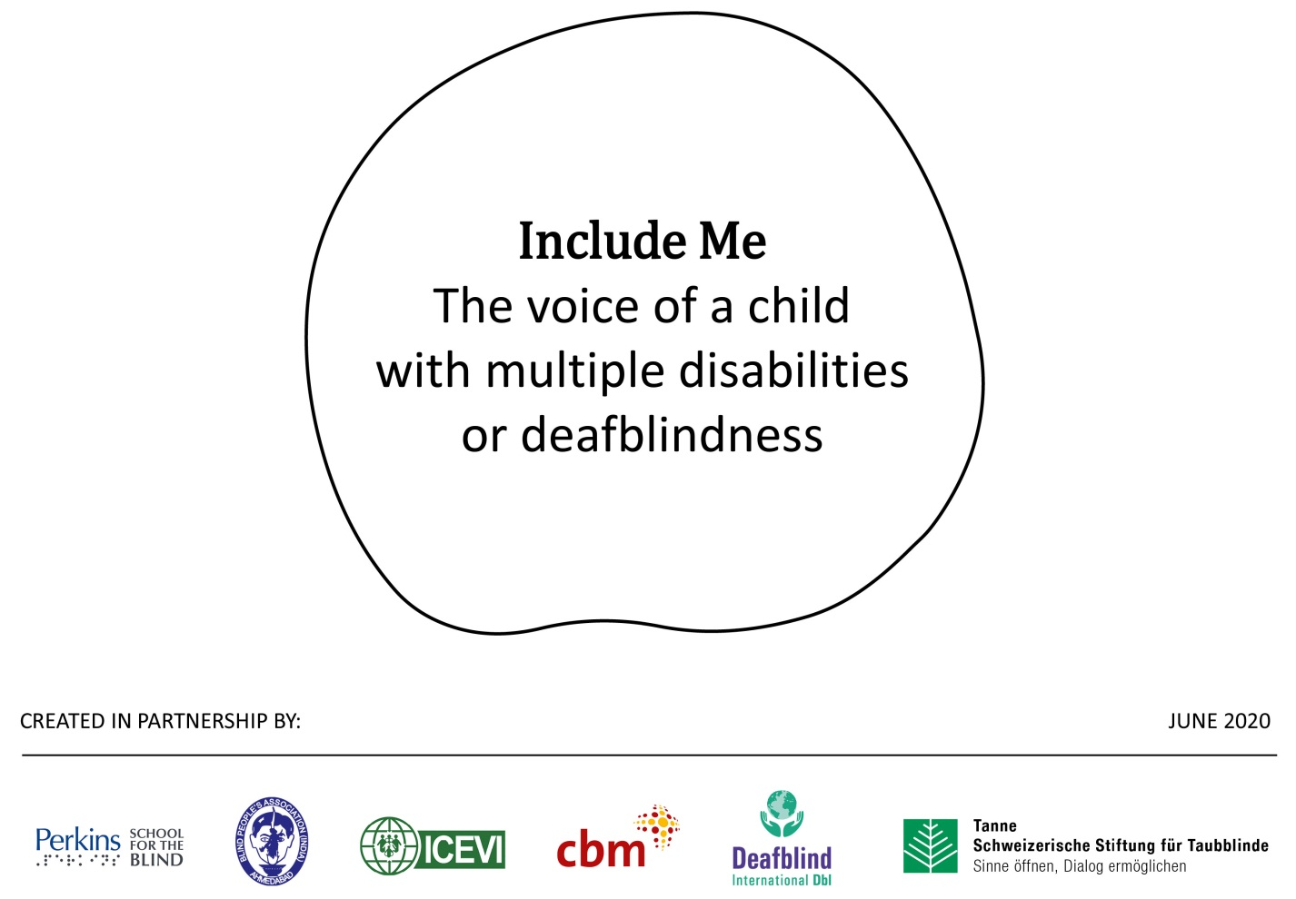
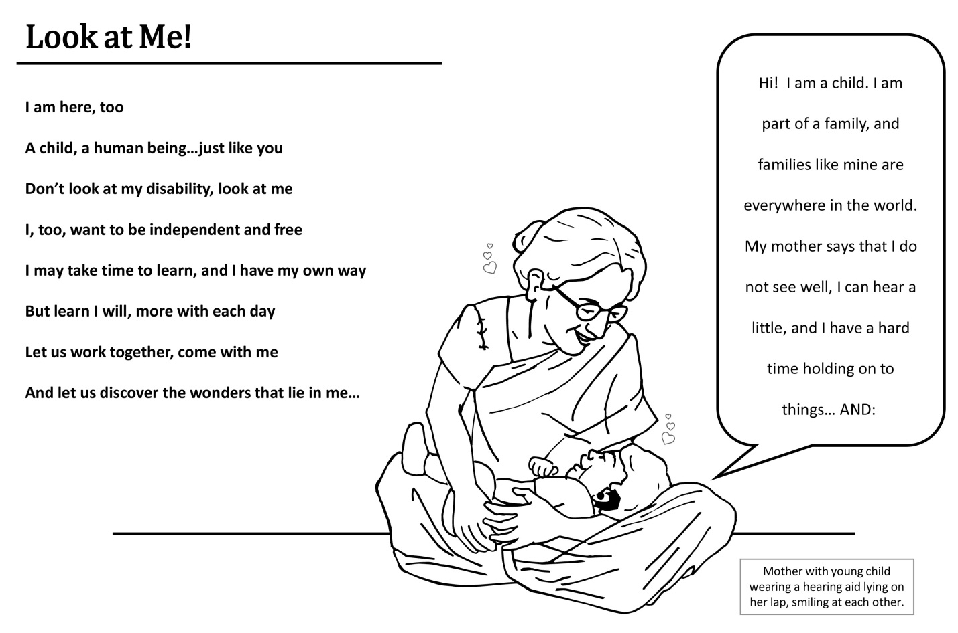

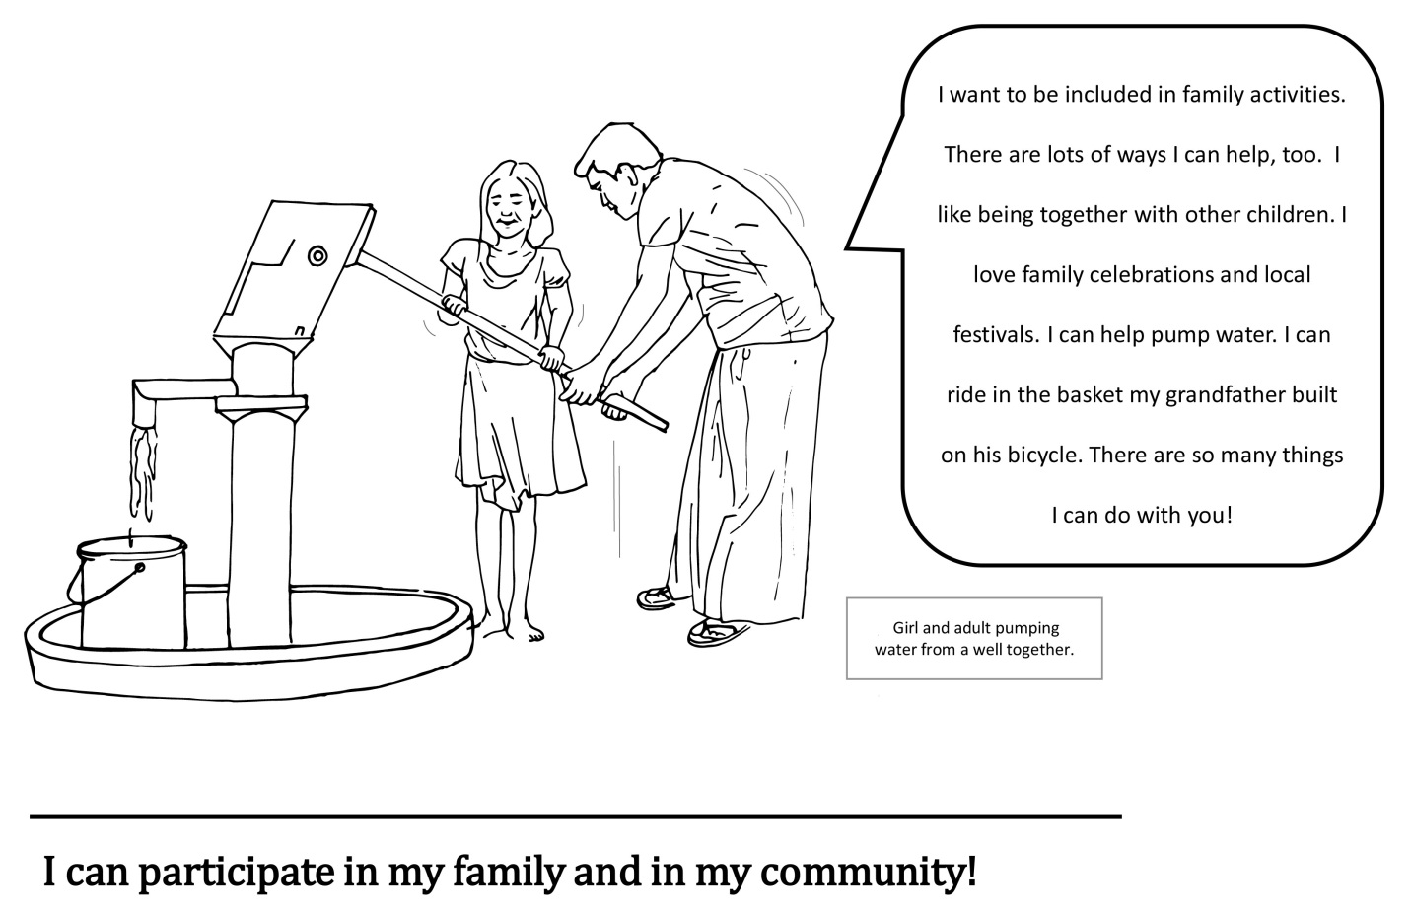

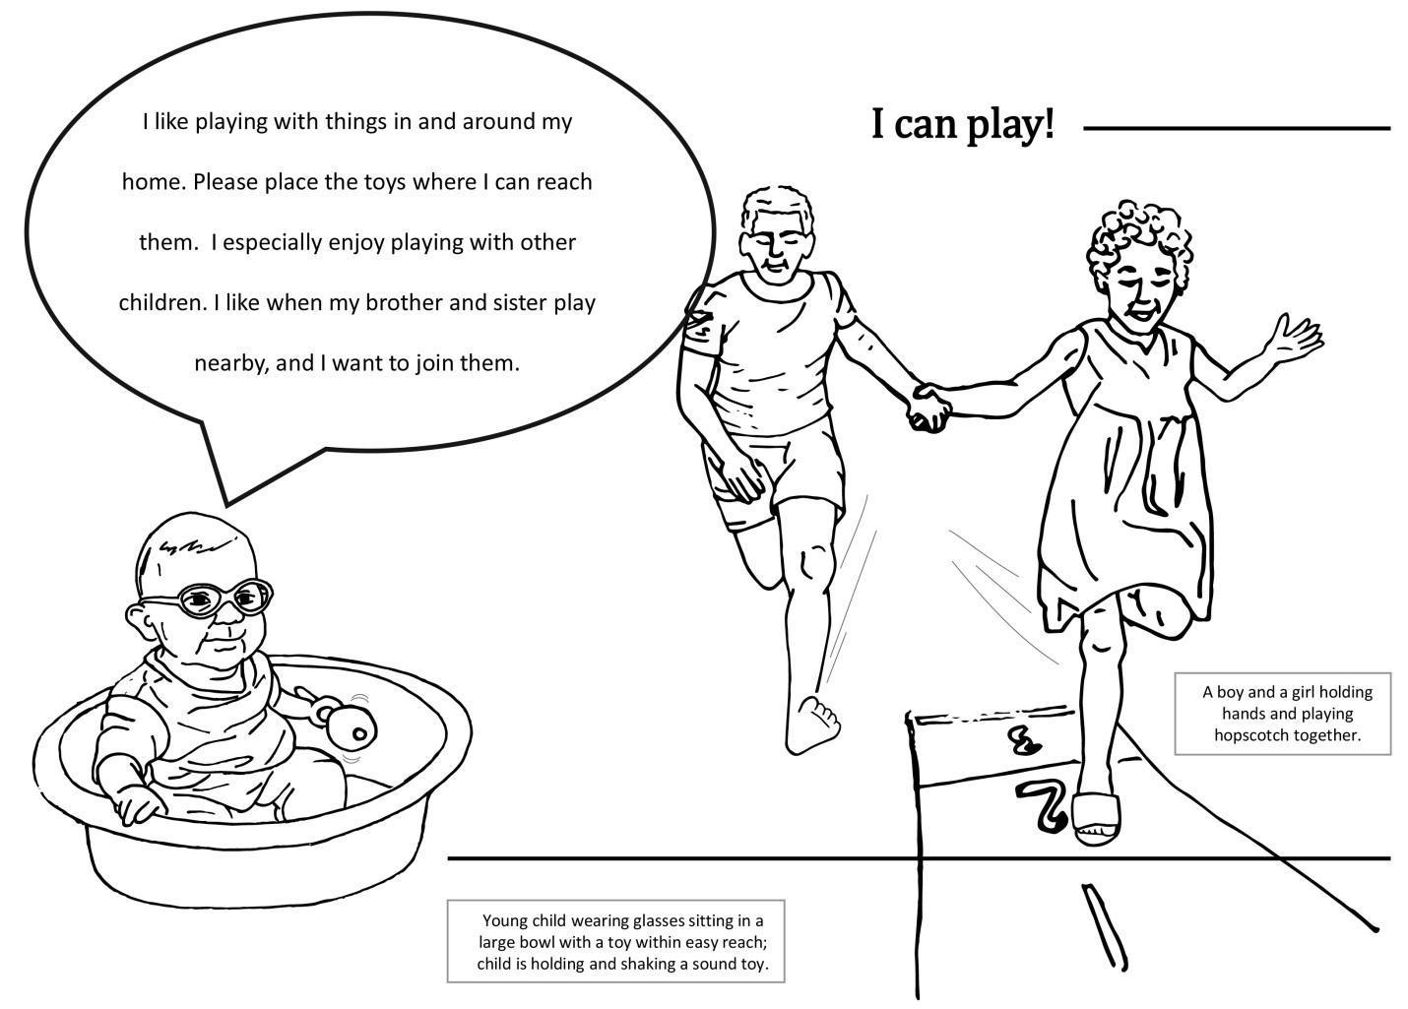

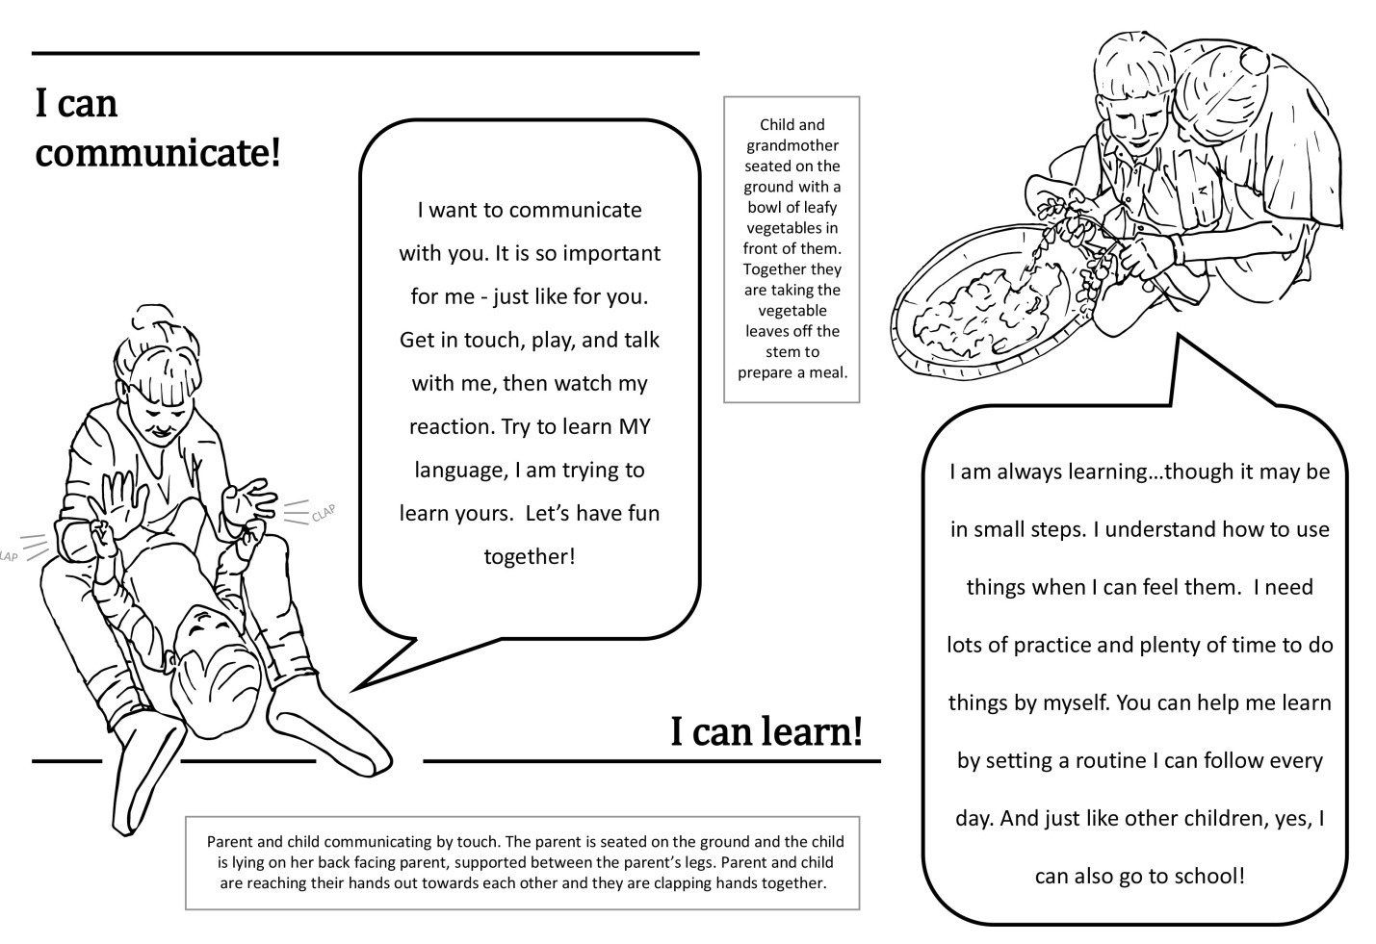

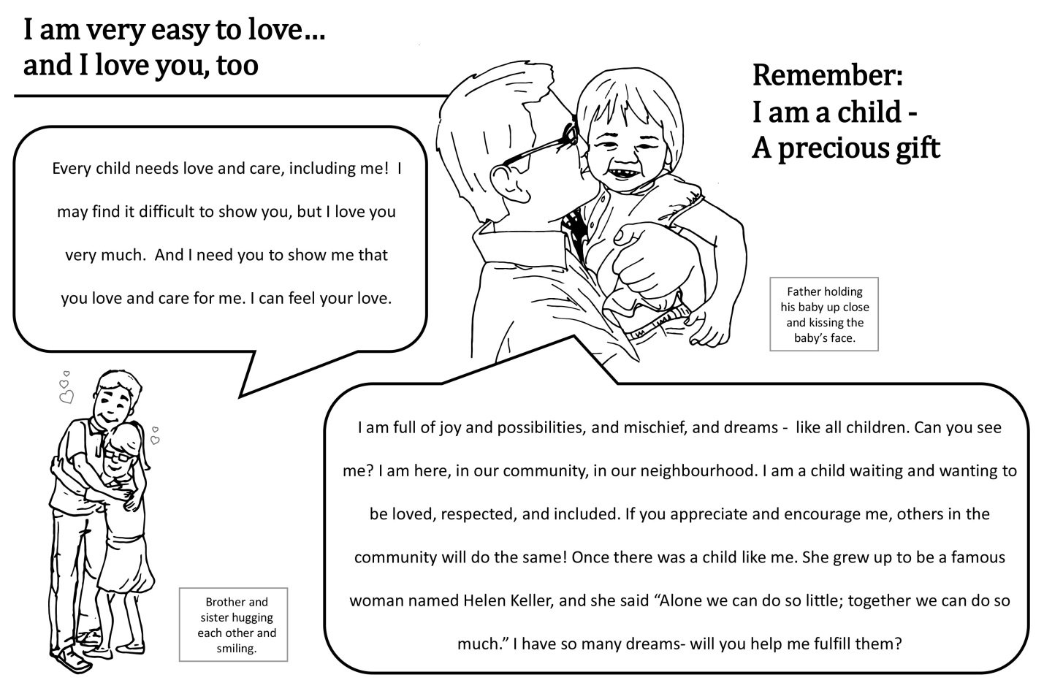

Parent Perspectives:
The Pandemic has Brought to Life Inequities that Already Exist:
Braille Illiteracy

Susan LaVenture
(laventuresusam506@gmail.com)
President International Association of Parents of Children with Visual Impairments

COVID - 19 brings forth inequities at many levels including educational access to technology for learning remotely for children who are blind, visually impaired and those with multiple disabilities. Furthermore, instruction in Braille becomes difficult to learn remotely.

Families struggle with managing children’s special education, whether the child’s educational placement is remote learning full time, part time hybrid learning model, or attending school full time. Whether parents have the ability to work from home or are essential workers who need to go to work to provide for their families or are one of the many unemployed that are suffering financially with lack of food or homelessness, families need support more than ever as they suddenly become responsible for their children’s special education. Parents need to be vigilant to make sure their children’s education is accessible.

Through parent associations around the world some immediate efforts to meet families’ needs during this time has been the development of parent education and support group virtual meetings on topics such as resources for remote learning, advocacy and accessibility for the education of students with visual impairments. “ICEVI believes in the essential nature of parent-educator partnerships,” stated Frances Gentle, ICEVI President. In 2021, ICEVI in corporation with the International Association for Parents of Children with Visual Impairments (IAPVI) will be building a platform on the ICEVI website designated for parent networking and dissemination of information. ICEVI’s main mission is the promotion of education for people who are visually impaired, and it has made an excellent platform through its organization for the international community. Parents will soon benefit from this, too.
Tremendous accomplishments have been made through the Accessible Books Consortium (ABC) a library of accessible literacy and work being done to connect these services to countries around the world (https://www.accessiblebooksconsortium.org/portal/en/index.html).
An issue that we still see for the education of students with visual impairments—even for those who are in inclusive environments—is lack of and shortage of Teachers of the Visually Impaired (TVI) who specialize in the instruction of Braille. Although the international blindness community of people who are blind, parents, educators and service providers have worked tirelessly for years to advocate for equity in education and have made great strides—we still have blind children at home or in schools who do not have instruction in Braille or accessibility to Braille. We must continue to address these hard realities on the ground of inequities in education and lack of Braille Literacy.

No child should be left sitting and waiting! This is a Call to Action!

Talking Technology

Ben Clare
ICEVI Pacific Regional President

Welcome to the all new Talking Technology column! A forum where we’ll discuss the latest happenings in the technology sector that are relevant to people with vision impairment, their families and teachers. While we will certainly talk about assistive devices and software, we will also highlight mainstream technology; devices and software that aren’t necessarily marketed at the disability community but can be easily used and-or adapted for successful and beneficial use. These columns will periodically appear in ICEVI publications such as The Educator and ICEVI eNews.

As this is our first ever column, I think it’s a good idea to introduce myself and perhaps tell you a little about how I got to where I am now which is the great honour of authoring this column for the amazing organisation that ICEVI is.

My name is Ben Clare and I’m from the lovely southern land of Australia. We are known for many things, our laid-back attitude, kangaroos, koalas, the vast emptiness of the outback, etc., etc.. For International travellers, we are known as being a long flight from just about anywhere and that’s certainly true.

As for me, I’m in my early 40s, am totally blind and have a passion for all things fun-related including the cinema, scary carnival rides, swimming in the ocean, and lots of travel and socialising.

Professionally, I have worked as a volunteer teacher in several developing countries, have worked for many disabled people’s organisations, have taught assistive and regular IT courses in college and resource poor settings and am currently the Pacific Regional President in ICEVI.

I also love interaction and am aiming to involve you, the avid reader as much as I can. If you have a technology related story to tell, a question you’d like answered or just want to drop by and say hello, you can Email me at bwclare@gmail.com

Happy reading!

Introduction

It was some months ago when I first sat down to write this column. In preparing, I browsed various assistive technology websites, social media pages and blogs for news on the latest assistive and regular technology updates and releases. Then came the Covid-19 pandemic which disrupted all our lives and halted many upcoming technology developments. Instead of pressing on with my original article, I thought I’d sit tight and see what impact, negative or otherwise the pandemic would have on technology and its use in the world of lockdowns, self-isolation, and general disruption. Almost immediately, a trend emerged when schools all over the world began shutting down and in many countries, students were forced to take up remote and online learning as an alternative to face to face education. Initially and in Australia at least, the transition was somewhat chaotic with Internet systems being overrun and a range of existing remote collaboration platforms being tried and rejected in quick succession. Many people who previously only had a limited understanding of meeting software suddenly had to master many new skills in becoming familiar with this technology, its options and limitations as well as preparing educational materials for students.

In other countries, schools ceased altogether with no alternative education options while others provided written materials, often inaccessible to the vision impaired learner and with little or no support service being offered. An interesting approach in some places was to have lessons broadcast on government owned national radio stations. While this provided a vital and somewhat accessible learning experience, interactivity was not possible.

While it is still to be made clear as to whether the sudden transition to online learning has been successful, we can be reasonably confident online learning in some form is here to stay and will likely be a much more popular option in the post pandemic era. The positives include major cost savings for institutions and students, decrease in the need for travel, the ability to provide tuition to a worldwide audience, and so forth. Negatives could include exclusion of those who do not have reasonable Internet access, the lack of important social interaction, and more.

For the vision impaired learner, transitioning to the online environment is as challenging for them as it is for everyone else, but the accessibility of the materials being presented in the online environment and the software being used to present that material are two very important factors to consider.

Fortunately and as software companies become more aware of the need for their products to be accessible with screen reading technology, the majority of the most popular applications used for online meetings, webinars, etc., can be successfully accessed with standard screen readers such as Voiceover, NVDA and JAWS.

Perhaps the most popular of these is Zoom, a comprehensive but easy to use online collaboration program that enables meetings and webinars with many participants at a time. Zoom was developed in 2013 by San Jose, California, USA based Zoom Video Communications and had accessibility options from the beginning, a pleasing trend among software developers today. Initially Zoom was only really accessible on the iPhone and iPad but with the development of the desktop client and improvements to the browser plugins, the program became accessible on Windows PC’s as well.

While Zoom was slowly gaining in popularity up to 2020, the pandemic saw it become one of the most downloaded apps in March and into April as people were advised to stay home and work remotely. While Zoom is free to use, some of its features are enabled or advanced through paid subscriptions.

Zoom

Fortunately, most of Zoom’s features are fully accessible with the main screen readers including NVDA, JAWS and Voiceover and much interactive content when screen changes are initiated by the meeting host and-or participants is automatically read out to the vision impaired user. Features such as raising your hand, muting and unmuting your audio, starting and stopping your video, sharing your screen, scheduling meetings and webinars, adding participants from the waiting room, reading list of meeting participants, chatting with individuals or the entire meeting via text, all are fully accessible and can be reached by using the Tab key to move between options or a series of shortcut keys which I’ll highlight shortly.

Unfortunately (and as is common with most software), there are some important Zoom features that are not yet accessible at the time of writing; these include the inability of the screen reader to speak the contents of a shared screen as it is essentially an image that is not readily recognised by optical character recognition; the lack of verbal content when hands are raised during meetings (it is possible to raise your own hand but impossible to see whether others in the meeting have activated this feature); and there are difficulties with assigning large numbers of participants to chatrooms within meetings. The latter can actually be performed, but does require a lot of patience and the shortcut keys often fail to work after a lot of use when performing this function. Another limitation, if not an inaccessible feature, is the screen reader sometimes being heard during meetings as the vision impaired user navigates the screen. This is especially prevalent in later versions of NVDA running the latest version of Zoom and where headphones are not present. This can be somewhat overcome by making sure the microphone is muted as much as possible when navigating the screen and/or using headphones whenever possible.

Shortcut keys

I am including a list of the most commonly used shortcut keys for Zoom which are applicable to NVDA, JAWS and Voiceover as provided by Zoom: http://www.zoom.us. These can be changed in the desktop client for Windows and IOS if you wish. For obvious reasons, keystrokes aren’t applicable on both IOS and Android devices unless a keyboard is connected.

Windows

• F6: Navigate among Zoom popup windows.
• Ctrl+Alt+Shift: Move focus to Zoom's meeting controls
• PageUp: View previous 25 video streams in gallery view
• PageDown: View next 25 video streams in gallery view
• Alt: Turn on/off the option; always show meeting control toolbar in Accessibility Settings
• Alt+F1: Switch to active speaker view in video meeting
• Alt+F2: Switch to gallery video view in video meeting
• Alt+F4: Close the current window
• Alt+V: Start/Stop Video
• Alt+A: Mute/unmute audio
• Alt+M: Mute/unmute audio for everyone except host.
(Note: For the meeting host only.)
• Alt+S: Launch share screen window and stop screen share
(Note: Will only work when meeting control toolbar has focus.)
• Alt+Shift+S: Start/stop new screen share
(Note: Will only work when meeting control toolbar has focus.)
• Alt+T: Pause or resume screen share
(Note: Will only work when meeting control toolbar has focus.)
• Alt+R: Start/stop local recording
• Alt+C: Start/stop cloud recording
• Alt+P: Pause or resume recording
• Alt+N: Switch camera
• Alt+F: Enter or exit full screen
• Alt+H: Display/hide In-Meeting Chat panel
• Alt+U: Display/hide Participants panel
• Alt+I: Open Invite window
• Alt+Y: Raise/lower hand
• Alt+Shift+R: Gain Remote Control
• Alt+Shift+G: Stop Remote Control
• Ctrl+2: Read active speaker name
• Ctrl+Alt+Shift+H: Show/Hide floating meeting controls
• Alt+Shift+T: S creenshot
• Alt+L: Switch to Portrait/Landscape View:
• Ctrl+W: Close current chat session
• Ctrl+Up: Go to previous chat
• Ctrl+Down: Go to next chat
• Ctrl+T: Jump to chat with someone
• Ctrl+F: Search
• Ctrl+Tab: Move to the next tab (right)
• Ctrl+Shift+Tab: Move to the previous tab (left)

Apple

• Command(⌘)+J: Join Meeting
• Command(⌘)+Control+V: Start Meeting
• Command(⌘)+J: Schedule Meeting
• Command(⌘)+Control+S: Screen Share via Direct Share
• Command(⌘)+Shift+A: Mute/unmute audio
• Command(⌘)+Control+M: Mute audio for everyone except the host (only available to the host)
• Command(⌘)+Control+U: Unmute audio for everyone except host (only available to the host)
• Space: Push to talk
• Command(⌘)+Shift+V: Start/stop video
• Command(⌘)+Shift+N: Switch camera
• Command(⌘)+Shift+S: Start/stop screen share
• Command(⌘)+Shift+T: Pause or resume screen share
• Command(⌘)+Shift+R: Start local recording
• Command(⌘)+Shift+C: Start cloud recording
• Command(⌘)+Shift+P: Pause or resume recording
• Command(⌘)+Shift+W: Switch to active speaker view or gallery view, depending on current view
• Control+P: View previous 25 participants in gallery view
• Control+N: View next 25 participants in gallery view
• Command(⌘)+U: Display/hide Participants panel
• Command(⌘)+Shift+H: Show/hide In-Meeting Chat Panel
• Command(⌘)+I: Open invite window
• Option+Y: Raise hand/lower hand
• Ctrl+Shift+R: Gain remote control
• Ctrl+Shift+G: Stop remote control
• Command(⌘)+Shift+F: Enter or exit full screen
• Command(⌘)+Shift+M: Switch to minimal window
• Ctrl+Option+Command+H: Show/hide meeting controls
• Ctrl+Shift+R: Gain remote control
• Ctrl+Shift+G: Stop remote control
• Ctrl+\: Toggle the "Always Show meeting controls" options in Settings/Accessibility
• Command(⌘)+W: Prompt to End or Leave Meeting
Chat Shortcuts
• Command(⌘)+K: Jump to chat with someone
• Command(⌘)+T: Screenshot
General Shortcuts
• Command(⌘)+W: Close the current window
• Command(⌘)+L: Switch to Portrait or Landscape View, depending on current view
• Ctrl+T: Switch from one tab to the next

Security Issue

It is common that with the sudden rise in popularity of a particular operating system or app, security vulnerabilities are exposed or deliberately created. Some of us would remember when Windows operating systems became hugely popular in the late 90s and people created viruses and other dangerous malware aimed at lessening the security of private data and other important files, causing maximum disruption. In late March and as Zoom was enjoying a major boom in popularity, hackers intent on causing disruption went to work and targeted the Zoom app in several ways, most commonly making meeting invites insecure to the point uninvited participants could join meetings, listen to and view content, and post inappropriate, often pornographic material to unsuspecting participants. Fortunately, this issue seems to have been tackled early and effectively with Zoom updating its platform, reissuing software and introducing additional security features such as passwords that are part of meeting and webinar invitations.

Are there other software programs that are accessible for the vision impaired user?

As the popularity of online meeting and learning continues to grow, so does the number of relevant platforms enabling these activities to take place. Skype, which has been around for some years and which arguably popularised the Internet free call and video call industry, has focused on business related online activity since being acquired by Microsoft. Unfortunately, this program, which was once very accessible, has become more difficult to use with cluttered screens of information, the inability to move quickly among features and many former keystrokes now being disabled. This said, Skype is a viable option, even with the accessibility difficulties.

Microsoft Teams is another Zoom like program and has many accessible features similar to Zoom itself.

Other News

Freedom Scientific (FS), the manufacturer of the popular JAWS and Fusion programs is offering free subscriptions for a limited time and duration to their 365 service, allowing full access to all FS products for the duration of the special subscription period. This offer was initially available in the US and Canada only but has since been extended to include many more countries. To find out more, log onto the Freedom Scientific website at: http://www.freedomscientific.com/jaws.

Webinars

All the major assistive technology manufacturers, including Perkins, Humanware and Freedom Scientific, are offering frequent and free webinars related to their products and ways they can be used. Google the websites for times and other information.

Finally and as I said previously, please feel free to Email me with comments, suggestions, news, whatever and I’d be happy to hear from you!

In my next column, I’ll be talking about some of the things you’ll find on the ICEVI website and what our programs can do for you as a student, teacher or parent.

Until next time, this is Ben signing off.

Stay well and stay safe!

A Bill of Rights for All Children with Visual Impairment and their Families

Preamble: In addition to numerous educational principles that have been proven to be beneficial for children with visual impairment, all the provisions of what constitutes a “Free and Appropriate Public Education” under the federal Individuals with Disabilities Education Act of 1990 shall be assumed along with this bill of rights.

1. Children with all levels of visual impairment (including those with multiple disabilities and those who are DeafBlind) have a right to early intervention/instruction provided by highly trained and qualified teachers of students with visual impairment and certified orientation and mobility specialists, that is timely, ambitious, and results in the highest possible achievement for each child.
2. Children with visual impairment have the right to a functional vision evaluation and a learning media assessment by highly trained and qualified teachers of students with visual impairment to determine appropriate services following the initial clinical eye exam.
3. Parents/guardians of children with visual impairment have the right to assistance in interpreting the educational implications of the diagnosed visual impairment that is provided by highly trained and qualified teachers of students with visual impairment and certified mobility specialists and the right to seek assistance from regional/national agencies (including consumer advocacy organizations) that can help them make informed decisions on behalf of their child.
4. As required in the Individuals with Disabilities Education Act “in the case of a child who is blind or visually impaired, the Individualized Education Program (IEP) Team must provide for instruction in braille and the use of braille unless the IEP Team determines, after an evaluation of the child's reading and writing skills, needs, and appropriate reading and writing media (including an evaluation of the child's future needs for instruction in braille or the use of braille), that ins” Appropriate reading and writing media are determined by conducting a learning media assessment.
5. Children and families have the right to be fully informed about the “Expanded Core Curriculum” of skills unique to students with visual impairment, which includes: compensatory skills, orientation and mobility, social interaction skills, independent living skills, recreation and leisure skills, career education, assistive technology, sensory efficiency skills, and self-determination.
6. Children have the right to assessment and instruction, in school and in their communities, in every area of the Expanded Core Curriculum that is deemed appropriate by the educational team and includes the parents/guardians as the primary decision makers and includes the student when appropriate. The Expanded Core Curriculum is equal in importance to the standard academic curriculum and will not be overlooked in the educational plan.
7. Children have the right to receive school materials that are accessible, in the preferred format and at the same time as their sighted peers. Children have an absolute right to testing procedures and instruments that are fair and accessible, that take into consideration the results of the functional vision evaluation, and include all accommodations identified in the IEP.
8. It is the right of children and families for a full range of educational placement settings to be discussed at IEP meetings, including the variety of unique programs and options offered in specialized schools/services for children who are visually impaired. A specialized school may offer the best opportunity for achievement and be the “least restrictive environment” for some children
9. All children with a visual impairment have the right to teams that enthusiastically assist them in preparing for transition to independence and adulthood.
10. Children with visual impairment, including those with multiple disabilities and DeafBlindness, have the right to be perceived and treated as equal, active, and contributing members of their communities, classrooms, and schools. As with all children, their engagement through belonging increases the collective value of each setting within which they participate.
The rights listed in this document consist of a combination of legal rights, ethical rights, and human rights. This document exists as a resource for students, parents, and professionals. The authors hope that this resource will be widely distributed and endorsed (formally or informally) by interested individuals and organizations. It is not fully inclusive of all rights; it is a starting point for teams when planning individualized programs for children with visual impairments.

This resource is the result of a joint project between the leaders of the Association for the Education and Rehabilitation of the Blind and Visually Impaired (AER) and the Council of Schools and Services for the Blind (COSB).

May, 2019

News from ICEVI International Partners

From Royal Dutch Visio . . .

Tactual Profile MDVI

Tactual Profile MDVI is an instrument to assess tactual functioning in children and adults with a severe visual impairment and a mental disability.

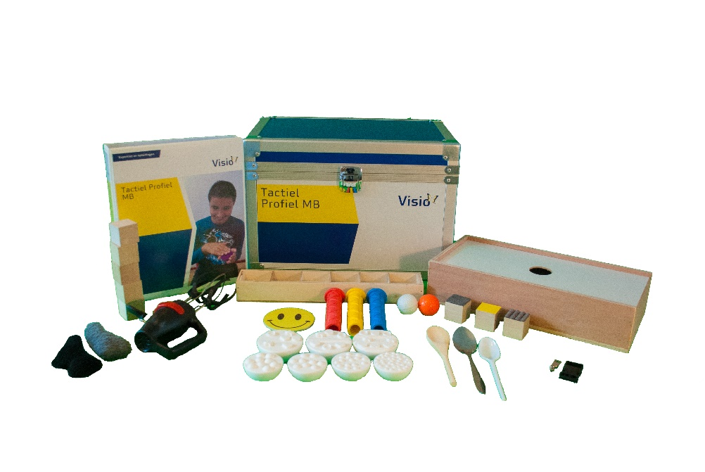

Professionals who use the regular Tactual Profile asked for an adjusted version for MDVI persons.

There are several differences between the original Tactual Profile and the MDVI version. The first is that prior to an assessment, an interview will take place with a person who knows the MDVI person well. The steps in an assessment are more refined and the instruction is, as much as possible, non-verbal.

The main categories are almost the same as in the original Tactual Profile, which are:

Tactual sensory functioning : Noticing, Body awareness, Touch Sensitivity, Proprioception.
Tactual motor functioning : Manipulation, Two-Handedness
Tactual-perceptual functioning : Recognition, Perception of Detail, Part-Whole Relationships, Tactile-Spatial Perception, Figure-Ground Perception, Tactual Language, Touch Strategy

The mental developmental phase of the client or pupil, will determine where to start the assessment of the instrument. There are three categories:

- A : Birth – 2 years
- B : 2 – 4 years
- C : 4 – 6 years

Tactual Profile MDVI also offers an overview of Influencing Factors on tactual perception and functioning. There are Client Variables – such as Motor Development, Alertness, Incentive Regulation; Exploration Style -- such as Taking Initiative, Preference For Touch; Stimulus Variables – Living Environment Variables, Impact Of Atmosphere; and Distractors – Sound, Smell, Amount of Sensory Stimuli.

The items of the instrument were reviewed by an expert group and several pilot studies were carried out to come to the final item-set. For the assessment a special set of materials was composed, which are included in the observation kit. Additional materials should be collected from the environment of the client.

This survey can be used when evaluating the performance of a person on the assessment and discussing this performance in a team of professionals.

In the last year the instrument has been proven valuable for MDVI persons. With this instrument professionals, working with MDVI persons will gain important information regarding the tactual skills of this group. They will be able to provide better interventions for these vulnerable people to help them use their sense of touch within their possibilities.

For ideas for intervention Feel Free MDVI has been written.

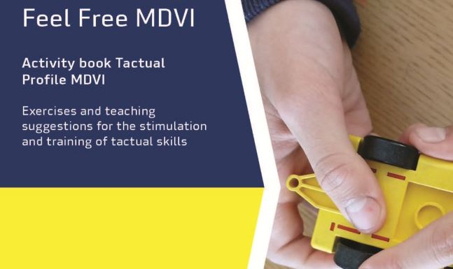

People with multiple disabilities and visual impairment (MDVI) often gain less tactile experiences. In Feel Free MDVI, activities are described to stimulate the sense of touch. Touch is an important compensatory sense for the visual impaired. Feel Free MDVI is a source of inspiration with ideas and lesson suggestions to stimulate tactual functioning in practice.

All the information can be found on the website of Tactual Profile, www.tactualprofile.org. Go to Tactual Profile MDVI and click Feel Free MDVI.

On the page Activities you’ll find almost a 100 activities in PDF-format.

Every activity shows a photo and a description how to use and under which conditions.

Tactual Profile MDVI and Feel Free MDVI are translated in English and German.

For information www.tactualprofile.org, or contact: tactualprofile@visio.org

Reconnecting with ICEVI Partners

Dr. Frances Gentle, President; Dr. Mani, CEO; and Dr. Kay Ferrell, Regional President of the North America and the Caribbean Region, visited the Hadley Institute for the Blind in November 2019. The Hadley Institute for the Blind was the first international organisation to enter into a Memorandum of Understanding with ICEVI in 2003, soon after the ICEVI Golden Jubilee Conference. At that time, Hadley and ICEVI launched a joint program called ‘INDEPTH’, meaning ‘ICEVI Network Distance Education Program Through Hadley’. The purpose of the program was to facilitate online training opportunities for teachers around the world using the Hadley learning materials. Many teachers from the ICEVI regions enrolled in the INDEPTH program and made use of the online learning facility, especially at a time when ICEVI was preparing for the launch of the WBU-ICEVI Global Campaign on Education for All Children with Visual Impairment (EFA-VI) in 2006.

The Hadley Institute for the Blind and ICEVI have decided that the connection between the two organisations should be further strengthened through establishment of a network of parents. Following the visit in November 2019, the ICEVI team has held further discussions with Julie S. Tye, President, Hadley Institute and Hadley staff. It is anticipated the collaboration will be finalised before the General Assembly of ICEVI in 2021, and Julie Tye will deliver a presentation on progress in developing the parent network. In response to this initiative, we are delighted that that Hadley Institute for the Blind has renewed its organisational membership with ICEVI.

The ICEVI team also visited the American Printing House for the Blind (APH) in Kentucky, Louisville. Extensive discussions were held with Dr. Craig Meador, President, and key APH leaders on potential future collaboration in vision impairment education. It was agreed to link the ICEVI regional networks with the extensive learning resources of APH, for the benefit of children with visual impairment and their families. We are pleased to welcome the American Printing House for the Blind as an organisational member of ICEVI, and have invited Craig Meador to deliver a presentation at the forthcoming General Assembly. We look forward to connecting APH with the ICEVI Regional Presidents to improve understanding of the regional and country-specific learning and resource requirements of children and young people with visual impairment.

ICEVI has plans to reconnect with other leading organisations in the field of vision impairment to discuss the mission of ICEVI and possible areas of synergy in our efforts to support and promote equitable quality education for all children and young people around the world.

Meeting with UNICEF officials

The ICEVI team consisting of Frances, Kay and Mani held a meeting in November 2019 with Rosangela Berman Bieler, Senior Advisor, and Julie De Barbeyrac, Program Coordinator of the Children with Disabilities Program Division of UNICEF. Discussions included progress in implementing the UNICEF Accessible Digital Textbook initiative, the ICEVI online instructional mathematics videos and Start-up teacher training curriculum in visual impairment. It was agreed that ICEVI and UNICEF would publicise their online educational resources across their networks. The UNICEF officials emphasised the relevance and usefulness of the mathematics instructional videos to class teachers of all children. The ICEVI team took the opportunity to invite Rosangela Berman Bieler and her UNICEF staff to take part in the May 2021 WBU-ICEVI General Assemblies.

Finalisation of the Governance Framework

As a part of the strategic plan for the 2017-2020 ICEVI quadrennium, a Governance Committee was established in 2017 with the objective of reviewing and clarifying the governance and administrative structures and processes of ICEVI at global and regional levels. Since its formation, the Governance Committee has conducted online meetings to discuss the structure and functions of ICEVI, its broad mission and vision, codes of conduct of office bearers, financial management, and membership structure. Through the process of discussion, the Committee developed a Governance Framework that sets out the governance principles and practices underlying and connecting ICEVI's global and regional bodies. The draft Governance Framework was tabled and endorsed at the ICEVI Executive Committee meeting held in Ethiopia in October 2019.

The ICEVI Executive Committee has requested the Governance Committee to review the current ICEVI constitution in light of the Governance Framework and the transition of several of the ICEVI regions to legal entities in their own right. The Committee has commenced work on developing a list of potential amendments to the ICEVI Articles of Association and Memorandum of Association. It is the requirement in ICEVI as per the existing constitution that any proposed amendments be published in The Educator, ICEVI's official magazine at least three months prior to the conduct of the General Assembly. Therefore, ICEVI plans to publish the proposed list of constitutional amendments in the January 2021 issue of The Educator for the benefit of the ICEVI constituency. More updates will be provided going forward.

Yet another year of progress in Higher Education

The Higher Education program of ICEVI, with the substantive support of The Nippon Foundation, is achieving its targets in the focus countries of Cambodia, Indonesia, Laos, Myanmar, Mongolia, Philippines, and Vietnam. Between 2006 and October 2019, more than 2500 students with visual impairment have been assisted to complete their graduation in various areas and the details are as follows:

Country | 2006 – 2007 | 2006 – 2011 | 2006 – 2014 | 2006 – 2015 | 2006 – 2016 | 2006  –  2017 | 2006  -  Dec 2017 | 2006  -  2018 | 2006  -  2019
Indonesia | 250 | 385 | 480 | 609 | 631 | 637 | 644 | 660 | 678
Vietnam | 28 | 354 | 470 | 563 | 630 | 689 | 736 | 757 | 799
Philippines | 32 | 460 | 489 | 671 | 710 | 726 | 732 | 751 | 769
Cambodia | 04 | 14 | 22 | 52 | 83 | 91 | 91 | 105 | 127
Myanmar | - | - | 29 | 54 | 69 | 88 | 88 | 114 | 114
Laos | - | - | 07 | 16 | 19 | 25 | 25 | 33 | 33
Mongolia | - | - | - | - | - | - | 08 | 14 | 16
Students Enrolled | 314 | 1213 | 1497 | 1965 | 2142 | 2256 | 2324 | 2434 | 2536

The higher education projects continue to expand educational opportunities for students with visual impairments and higher education enrolments are growing steadily in the implementing countries. During the early years of the project, funds were used for the creation of resource centre facilities through higher education institutions. In recent years, the project partners have started using local resources and influencing stakeholders, including Governments at the country level, to create the required facilities for increasing the admission of students with visual impairment in the higher education institutions and also ensuring sustainability.

The higher education project is also working to facilitate employment opportunities and as a result more than 300 graduates have already been assisted to secure gainful employment. The country-wise details of employment of the higher education graduates are presented in the following table follows:

Country | 2015 – 2016 | 2016 – 2017 | April – Dec  2017 | Jan – Dec 2018 | Jan – Dec 2019 | Employment Till Date
Indonesia | 39 | - | - | 09 | - | 48
Vietnam | 27 | 27 | 24 | 13 | 10 | 101
Philippines | 13 | 12 | 11 | 18 | 17 | 71
Cambodia | 38 | 36 | 02 | 14 | 04 | 94
Myanmar | - | - | 10 | 01 | - | 11
Mongolia | - | - | - | 02 | - | 02
Total | 117 | 75 | 47 | 57 | 31 | 327

Mathematics Initiative

In the Annual Report for 2018-19, ICEVI announced commencement of its mathematics project with the support of The Nippon Foundation. The purpose of the project is to prepare open-access Mathematics Instructional Videos for the benefit of students and teachers.

A workshop on this subject was conducted in conjunction with the Africa Forum in October 2019 and was attended by a large number of participants who found the Mathematics Instructional Videos extremely useful.

Although the project had the objective of preparing about 150 instructional videos by the end of 2020, the actual production of videos has exceeded this target and current expectations are that 175 videos will be produced. The videos cover all thematic areas of mathematics, cutting across the different grade levels of primary and secondary education. The videos can be accessed from the homepage of the ICEVI website – go to the ICEVI Math Made Easy YouTube Channel, https://www.youtube.com
/channel/UCrmcpSzNg_9EXLbqExtVlAQ

The videos are presented under specific playlists, as per the following details:

S.  No. | Playlists | No. of Videos
1 | Algebra | 8
2 | Basic Operations in Mathematics | 5
3 | Decimals | 2
4 | Fractions | 12
5 | General | 7
6 | Geometry | 29
7 | Inequalities | 6
8 | Lines | 12
9 | Matrices | 24
10 | Multiplication of Numbers | 10
11 | Numbers | 10
12 | Set Theory | 19
13 | Tests of Divisibility | 10
14 | Trigonometry | 22
TOTAL |  | 176

ICEVI is extremely pleased that the instructional videos are considered as significant learning resources by teachers, parents and students with visual impairments. The importance of open access availability has been highlighted during the current COVID-19 pandemic, when schools around the world have been closed and children are learning from home. The subscription to the ICEVI Math Made Easy YouTube channel is increasing and viewership is also steadily growing. ICEVI plans to prepare more videos soon after the lock down period is over and will upload them periodically for the benefit of the users.

ICEVI West Asia Regional Conference

The ICEVI West Asia Region, in collaboration with the Sense International India, hosted a regional conference with the theme of “Inclusive Education: Leaving No One Behind” in Kathmandu, Nepal from 16 to 18 February 2020. Although a Regional-level Conference, the event attracted over 300 participants from 15 countries in the West Asia region and globally. The delegates appreciated the range of sessions provided, and the Plenary and Concurrent sessions were well-attended.

The major administrative tasks of the conference were undertaken by the Blind People’s Association, Ahmedabad, under the leadership of Dr. Bhushan Punani, Regional President, West Asia region, Nandini Rawal, Treasurer, ICEVI, and Akhil Paul, Director, Sense International India. The local host committee was guided by Mr. Birendra Raj Pokharel, Action on Disability Rights and Development (ADRAD-Nepal) and Mr. Madhav Prasad Aryal, Country Representative of ICEVI in Nepal.

It is noteworthy that Nepal was the first country in the West Asia region to implement the ICEVI-WBU EFA-VI Global Campaign and it was a fitting recognition of the efforts of the country that the Regional Conference of ICEVI and SENSE International India was held in Kathmandu.

Prior to the Regional Conference, ICEVI conducted a Workshop on Mathematics Instructional Materials in Kathmandu. The workshop was attended by specialist teachers, general education teachers, teacher educators, and students with visual impairments. The participants found the Mathematics Instructional Videos prepared by ICEVI extremely useful. Most of them reiterated the need for ICEVI to organise similar workshops in the future in order to prepare master trainers who can popularise the teaching of mathematics to students with visual impairments.

A video of the workshop along with participant testimonials were prepared and shared with the delegates of the Regional Conference. ICEVI plans to organise the first master trainers’ program on mathematics in early 2021.

It was also a fitting recognition to the West Asia Regional Conference that the January 2020 issue of ICEVI’s magazine, The Educator, was fully devoted to the Regional Conference, with special reference to select presentations made at the conference. More details of the Regional Conference can be accessed from the websites of ICEVI global and ICEVI West Asia region. February 2020 was the beginning of the spread of the COVID-1 pandemic and it is gratifying that the 300+ participants were able to attend the conference in Kathmandu.

OBITUARIES - Our Tributes to Great Friends of ICEVI

Bill Brohier, Past President, ICEVI

William G Brohier from Penang, Malaysia popularly known as ‘Bill’ was the President of ICEVI from 1987 to 1997. Bill was a great visionary and a team player. He also served as the Regional Director of the East Asia region for both Christoffel Blindenmission (CBM) and the Sightsavers. Being a teacher and teacher educator of persons with visual impairment, he had a sound knowledge in the field and emphasised the need for effective Human Resource development to improve the quality of education. During his tenure as President, he was also instrumental in bringing out many concept papers on education of children with visual impairment.

Bill along with Mr Lal Advani of the World Blind Union lobbied for the inclusion of persons with disabilities in the Jomtien Declaration on Education For All in the year 1990. Bill was also instrumental in establishing close collaboration of ICEVI with the UN bodies. ICEVI provided technical expertise for many programmes on disability organised by the Bangkok office of the United Nations Economic and Social Commission for Asia and the Pacific (UN-ESCAP). Regional development also got additional focus when Bill was the President of ICEVI.

Bill assisted ICEVI colleagues to organise the 9th Quinquennial conference of ICEVI in the Asia region and the event was conducted in Bangkok, Thailand in 1992 and since then ICEVI’s popularity in the Asia region is growing. Bill also worked hard to enrich the ICEVI publication - The Educator. In summary, Bill contributed significantly for the growth of ICEVI and the organisation will remember him for ever.

He passed away in April 2020 after prolonged illness. The ICEVI constituency pays its respect and tribute to one of the greatest stalwarts of the organisation.
Ken Stuckey, Editor, ICEVI’s History Book, 2002

It is with great sadness that ICEVI shares with our membership the passing of Kenneth (Ken) Stuckey in Stockholm, Sweden on April 29th at the age of 82. Anyone who ever had the pleasure of knowing and working with Ken will never forget him. His knowledge and enthusiasm for all matters concerned with our field was legendary. Ken had a long and active involvement with ICEVI. In 2002 in celebration of the 50th anniversary of the founding of ICEVI Ken prepared a history of our organization entitled “Meeting the Challenge”.

Ken completed National Service in the British Army. He proudly served in a regiment under the 15th, 19th Royal Hussars. After his military service, he emigrated to the United States, where he was sponsored by the caring Jordan family who took him in as their own. Ken attended Everett Community College and eventually moved to the Boston area. He graduated from Northeastern University and The University of Rhode Island in the field of Library Science.

In 1965 Ken began his work as a Research Librarian at Perkins School for the Blind. He is well recognized for his extensive knowledge and research on topics related to blindness. Through his career he authored a number of publications and articles about Perkins history, Helen Keller, and the history of blind education. He is the main contributor to the book ¨Helen Keller: Author and Advocate¨, by Deborah Kent and he is the editor of the book ¨Biography of the Blind¨ by James Wilson. As a Boy Scout leader at Perkins, Ken was a pioneer in ensuring that all youth had equal access to adventures. In his mind, there was no trip that could not be made accessible. His troop braved multi day canoe trips, hiking excursions to the Rocky Mountains of New Mexico, and even flew to Greece to see the birthplace of Michael Anagnos.

He retired from Perkins in 1998 and moved to Sweden where he married Gunilla Stenberg. After his retirement, he spent years presenting his prestigious stamp collection, featuring topics on blindness, around the world. Ken enjoyed his years of membership in the Lion’s Club in both Watertown, MA and Stockholm, Sweden. He was a traveler and a lover of daily walks. He was gregarious and loved to share his excitement and enthusiasm for an upcoming trip or a past memory. His infectious optimism will be greatly missed. Ken is survived by his wife, Gunilla Stenberg/Stuckey, two children Heather Green and Christine Stuckey and four grandchildren.

Mr. A.K. Mittal - WBU Representative on ICEVI EXCO

Mr A K Mittal, Secretary-General, World Blind Union (WBU) passed away on 22nd September 2020 after a brief illness. Mr. Mittal was a member of ICEVI EXCO and an ardent supporter of activities of ICEVI Global in general and West Asia region in particular. The last international conference, he attended was ICEVI Sense Kathmandu conference held during 16-18 February, 2020. All the 300 participants of the conference had the opportunity of listening him during inauguration ceremony as during a plenary presentation. He very ably steered the Resolutions Committee to finalize resolutions of the conference. While expressing shock on sudden and untimely demise of Mr Mittal, the members of ICEVI family paid glowing tributes to his memory.

According to our President, Frances Gentle, “He was a man of such compassion, intelligence and human spirit. One of his current contributions has been to establishing an ICEVI-WBU project to promote braille for children who are greatly disadvantaged and marginalised due to the severity of their disabilities”.

Our CEO, Dr MNG Mani recognizes Mr A K Mittal’s enormous contribution to the field of vision impairment education, and a passionate promotion of the rights of children to braille literacy. According to Lord Colin Low, our Former President, ICEVI “His wide grasp of policy issues, especially regarding braille, was unrivalled and will not be easily replaced”. Nandini Rawal, our Treasurer “A towering personality, A Braille Wizard, a prolific speaker, a brilliant strategist, able administrator, advocate for the cause…such rare qualities all to be found in one person…our beloved AK Mittal Sir. Dr S R Mittal, Members ICEVI WA considers him a crusader of high quality education, staunch promoter of Braille and a great champion of protection of rights of persons with visual impairment.

Akhil Paul, Executive Director, Sense India and supporter of ICEVI WA has always been impressed with his fine vocabulary and public speaking. The real hero of “Sparsh” (a popular Hindi movie which projected his role as a Principal of a School for Children with Visual Impairment) passed away today.

Dr S R Mittal, Member of ICEVI West Asia who know Mr A K Mittal for the last 43 years remarked, “His love, passion and dedication towards promotion, use, teaching and development of Braille was so much that he wrote last article of his for “The Educator” on development of Braille.

Mr. Mittal was a great friend and admirer of ICEVI as well as ICEVI West Asia. In India, he is known as one of the most outstanding promoters of Braille as well as Trainer of the Special Educators. With his excellent command over reading of Braille, he was known for using the latest technology for accessing the material. A great and prolific orator, he was invited as a Plenary Speaker on numerous national and international level conferences. He was invited to all national as well as regional conferences organized ICEVI West Asia as Keynote Speaker or as a plenary speaker. He always provided his services in these conferences as a Member of the Resolution Committees also. With Mr. A K Mittal’s demise ICEVI, ICEVI West Asia and ICEVI Global have lost a great friend and India have lost a great crusader of Braille. We pray to Almighty God to grant peace to departed soul and give strength to his wife Meera and daughter Neetika to bear the irreparable loss.

ICEVI Fact Sheet

Mission
In recognition of the continuing global challenges in achieving access to quality education for the millions of out-of-school children with blindness and partial sight, the International Council for Education of People with Visual Impairment (ICEVI) is a membership organisation with a mission to promote access to inclusive, equitable, and quality education for all people with visual impairment

Goals
Goal 1: Promoting access to quality education for people with visual impairment including those with blindness, partial sight, deafblindness and additional disabilities.

Goal 2: Influencing governments’ and relevant stakeholders’ implementation of the SDGs and UNCRPD in the area of education of people with visual impairment

Goal 3: Improving networking, information sharing and collaboration at national, regional and global levels

History of the Organisation
Founded in 1952 in the Netherlands, the ICEVI conducted its Golden Jubilee conference in the Netherlands from 28 July to 2 August 2002.

ICEVI Regions
The 7 regions of ICEVI and their coverage of countries are as follows:

Africa Region : 52 countries
East Asia Region : 19 countries
Europe Region : 49 countries
Latin America Region : 19 countries
North America and the Caribbean Region : 15 countries
Pacific Region : 15 countries
West Asia Region : 25 countries
Currently, more than 4000 individuals and organizations in over 180 countries are actively involved in ICEVI.

Networking with other organisations
ICEVI works closely with International Non-Governmental Development Organizations (INGDOs) and UN bodies such as United Nations Economic and Social Council (UN-ECOSOC), UNESCO, UNICEF, and WHO.

Publications
ICEVI’s biannual magazine “The Educator” is available in electronic version in both English and Spanish and is also posted on our website www.icevi.org ICEVI also publishes a biannual electronic newsletter that is currently distributed to more than 4000 individuals and organizations.

Website of ICEVI
www.icevi.org

