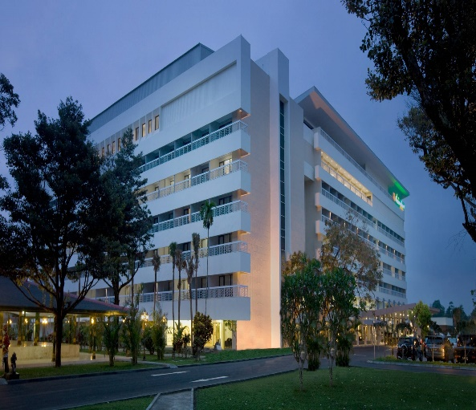

International Council for Education of
People with Visual Impairment

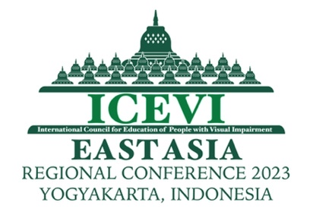
East Asia Regional Conference

Reasonable Accommodation and Accessibility in
Education of Children with Visual Impairment

Organized by
ICEVI INDONESIA NETWORK

VENUE OF CONFERENCE
Hotel Royal Ambarrukmo, Yogyakarta, Indonesia

18-21 September, 2023

ICEVI
International Council for Education of People with Visual Impairment (ICEVI) is a global association of individuals and organizations that promotes equal access to appropriate education for all visually impaired children and youth so that they may achieve their full potential. For more information on ICEVI, visit the website at www.icevi.org

East Asia Regional Conference
Facilitating successful inclusion of students with visual impairment is one of the objectives of education in the blindness sector. Though there are many parameters contributing to successful inclusion, reasonable accommodation and accessibility are vital ingredients as strongly mandated by the United Nations Convention on the Rights of Persons with Disabilities (UNCRPD). Though many students and institutions working for inclusion face challenges in this area, it is also true that there are good practices around the world supporting effective inclusion through strategies addressing reasonable accommodation and accessibility.

The East Asia region, through this regional conference will be deliberating on the challenges and showcase good practices. The region had also demonstrated various strategies of accommodation and accessibility in terms of devices, learning environment, instructional materials and therefore, the presentations to be made by practitioners will be of great value for the participants of the conference.

Theme
“Reasonable Accommodation and Accessibility in Education of Children with Visual Impairment.”

The conference theme will be discussed in the light of Global perspectives on education for all, Legislations, Access, Training and Resources and the plenary sessions will focus on the following main topics.
- Reasonable accommodation and accessibility in education for students with visual disability.
- Employment strategy in blindness sector - Experiences of ICEVI Higher Education Project in South East Asia.
- Role of Technology in the education and employment of people with visual impairment.
- Development of youth with visual impairment.
- Role of parents and organisations of people with disabilities in the education, employment and advocacy of people with visual impairment.

Focus on Youth Movement: There will be an exclusive plenary session of Youth with Visual Impairment from the Higher Education project of ICEVI discussing the barriers and strategies adopted to overcome those in education as well as in the employment avenues.

Registration fee Details:

Type of Registration | Fees
Early Bird Registration  (1st February to 30th April 2023) | US $ 225  (Participants & Companion)
Post Early Bird Registration  (1st May to 15th September 2023) | US $ 275 (Participants)
 | US $ 225 (Companion)
Special Registration Fee for Indonesian Participants | IDR 2,500,000

Bank Details:

Overseas Bank Name : Bank Mandiri KCP Padalarang- Kotabaru Parahyangan
Bumi Paranggelang Bussines Office Park – KBP
Bank Address : Jalan Raya Panyawangan Kav 6A No. 3A-3B
Bandung Barat – Indonesia
Account Name : Perkumpulan Pemerhati Pendidikan. Untuk Tunanetra Indonesia ICEVI
Account Number : 132-00-3356633-3 (For USD Payment)
132-00-3356666-3 (For IDR Payment)
Overseas Bank Swift Code : BMRIIDJA

After paying the Registration fee, please email the payment receipt along with Registration Form to: Rahayu Wijayanti indonesia.icevi@yahoo.co.id
The conference organisers will then send confirmation letter and Letters of Invitation for the purposes of Visa.

Hotel Accommodation

The Conference Hotel and venue of the conference is Royal Ambarrukmo Hotel, - Yogyakarta, Jalan Laksda Adisucipto (E-mail: info@royalambarrukmo.com ; Website: https://www.royalambarrukmo.com. The participants are requested to book rooms directly via email : sean@royalambarrukmo.com cc to reservations@royalambarrukmo.com and inform to Sean : +62 821-3547-0634 (WA).

The organisers of the conference will also be happy to assist the participants with hotel booking, if there is a need.
Room tariff:

Room type | Period | Price IDR | Price USD
Deluxe | September 18-21, 2023 | 1,100,000 | USD 80.00
Premier | September 18-21, 2023 | 1,200,000 | USD 90.00
Junior Suite |  | 2,600,000 | USD 175.00
Executive Suite |  | 4,800,000 | USD 320.00

There are also many other hotels located surrounding Royal Ambarukmo that participants may choose from. Those who stay in other hotels have to make their own transport arrangements to reach the conference venue.

Transportation

From Yogyakarta International Airport:

First option facilitated by conference organizer:
- Airport train from Yogyakarta International Airport to Yogyakarta Train Station;
- Shuttle bus: from Yogyakarta Train Station to Hotel Royal Ambarrukmo.

Other options:
Paid by participants personally:
- Setel Qu : From Yogyakarta International Airport to Hotel: IDR 75,000
- Airpot taxi : Golden Bird: approx IDR 500,000
More details on transport will be given nearer to the conference.

Call for Abstracts

There will be 6 concurrent sessions during the conference. Presenters who are willing to share their expertise and experiences may choose from the topics listed below:
- Inclusive education strategy and implementation in various countries.
- Accessible Teaching mathematics and science for students with visual impairment: Guided Workshop.
- Early intervention practices - including role of parents in the East Asia region.
- Human Resource Development for augmenting education for all children with visual impairment.
- Reasonable accommodation and accessibility in education for children with low vision and children with MDVI (Multiple Disabilities and Visual Impairment).
- Accessible Technology in supporting education and employment of people with visual impairment – Workshop.
Abstracts should be submitted by email to indonesia.icevi@yahoo.co.id, aria.indrawati@gmail.com and oficevi@gmail.com no later than 15th April 2023.

International Council for Education of
People with Visual Impairment

EAST ASIA REGIONAL CONFERENCE

Hotel Royal Ambarrukmo, Yogyakarta, Indonesia
18-21 September 2023

“Reasonable Accommodation and Accessibility in Education of
Children with Visual Impairment”

Secretariat:
ICEVI Indonesia Network, RSKG Habibie, Jl Tubagus Ismail Raya No 46,
Bandung, INDONESIA. E-mail: indonesia.icevi@yahoo.co.id

OFFICIAL ABSTRACT FORM

Full Name :
Position :
Address :

City / Town :
State / Region :
Country :
Postal / Zip Code :
Telephone : Home : Work :
E-mail :

1. My preferred presentation format is

- Lecture with power point presentation
- Poster Session
- CD Rom/Video (20 minutes)

2. The topic of the presentation is (Please tick the appropriate category)

1 | Inclusive education strategy and implementation in various countries.
2 | Accessible Teaching mathematics and science for students with visual impairment: Guided Workshop
3 | Early intervention practices - including role of parents in the East Asia region
4 | Human Resource Development for augmenting education for all children with visual impairment
5 | Reasonable accommodation and accessibility in education for children with low vision and children with MDVI (Multiple Disabilities and Visual Impairment)
6 | Accessible Technology in supporting education and employment of people with visual impairment – Workshop
- My preferred presentation language is

English Bahasa

- Title of Presentation (not more than 25 words)

5. Abstract (Not more than 200 words in English only)

Suggested format:

Title

Author/Co-Authors
Designation and Institution

Block format, Left Margin – 1.5 inches; Right Margin – 1 inch justify

References: APA Format

6. Date of Submission for Abstracts : On or before April 15, 2023
7. Acceptance of Paper presentation : On or before June 15, 2023
8. Date of Submission for the power point presentation : On or before July 31, 2023

Please send the Abstract form to:

Sri Soedarsono, Chairperson, ICEVI Indonesia Network
RSKG Habibie, Jl Tubagus Ismail Raya No 46, Bandung, INDONESIA.
E-mail: indonesia.icevi@yahoo.co.id
&
Aria Indrawati, President, ICEVI East Asia region &
President, Pertuni (The Indonesian Blind Union)
Jl Kramat Sentiong No. 57 A, Jakarta, INDONESIA
E-mail: aria.indrawati@gmail.com
&
ICEVI Secretariat
No.3, Professors’ Colony, S.R.K.V. Post, Coimbatore – 641 020, Tamil Nadu, INDIA
E-mail: oficevi@gmail.com

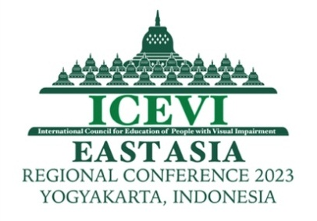
International Council for Education of
People with Visual Impairment

EAST ASIA REGIONAL CONFERENCE

Hotel Royal Ambarrukmo, Yogyakarta, Indonesia
18-21 September 2023

“Reasonable Accommodation and Accessibility in Education of
Children with Visual Impairment”

Secretariat:
ICEVI Indonesia Network, RSKG Habibie, Jl Tubagus Ismail Raya No 46,
Bandung, INDONESIA. E-mail: indonesia.icevi@yahoo.co.id

PARTICIPANT’S REGISTRATION FORM

(Please make copies of this form, if needed. Separate registration form needs to be submitted for accompanying person.)
1. Surname :
2. Given Name :
3. Nationality :
4. Gender : Male Female
5. Title : Mr. Mrs. Ms. Dr. Prof.
6. Designation :
7. Address of the Organization/Agency :

8. Country :
9. Telephone (Office) :
10. Telephone (Personal / Mobile) :
11. Email :

13. Diet Preference : Vegetarian Non-Veg Halal
13. Are you a Person with
Visual Impairment? : Yes No
14. If YES, are you travelling alone? : Yes No
15. If travelling with Escort,
name of Escort :
16. Do you present paper? : Yes No
If yes, tick the topic of your choice:
1 | Inclusive education strategy and implementation in various countries.
2 | Accessible Teaching mathematics and science for students with visual impairment: Guided Workshop
3 | Early intervention practices - including role of parents in the East Asia region
4 | Human Resource Development for augmenting education for all children with visual impairment
5 | Reasonable accommodation and accessibility in education for children with low vision and children with MDVI (Multiple Disabilities and Visual Impairment)
6 | Accessible Technology in supporting education and employment of people with visual impairment – Workshop

17. Registration Categories: (Please check the appropriate category)
S.  No. | Type of Registration | Fees | Check if appropriate
1 | Early Bird Registration  (1st February to 30th April 2023) | US $ 225  (Participants & Companion)
2 | Post Early Bird Registration  (after 1st May to 15th September 2023) | US $ 275 (Participants)
 |  | US $ 225 (Companion)
3 | Special Registration Fee for Indonesian Participants | IDR 2,500,000

18. Hotel Preference (Please refer to the details in the brochure)
Hotel | Room Type | Tariff  per day (USD) | Arrival  date | Departure date | Number of nights of stay | Total Charges
Royal Ambarrukmo Hotel, Yogyakarta | Deluxe | 80.00
 | Premier | 90.00
 | Junior Suite | 175.00
 | Executive Suite | 320.00

19. Total Charges Payable (Registration + Hotel):
(In case participants want the organisers to book hotel).
In the case of direct booking, the Registration Fee alone is transferred to the Conference Organisers.
20. Bank Details for Transfer:
Overseas Bank Name : Bank Mandiri KCP Padalarang- Kotabaru Parahyangan
Bumi Paranggelang Bussines Office Park – KBP
Bank Address : Jalan Raya Panyawangan Kav 6A No. 3A-3B
Bandung Barat – Indonesia
Account Name : Perkumpulan Pemerhati Pendidikan. Untuk Tunanetra Indonesia ICEVI
Account Number : 132-00-3356633-3 (For USD Payment)
132-00-3356666-3 (For IDR Payment)
Overseas Bank Swift Code : BMRIIDJA

Please indicate the date of transfer and reference number.

To register, send this completed form with details of payment to:

Sri Soedarsono, Chairperson, ICEVI Indonesia Network
RSKG Habibie, Jl Tubagus Ismail Raya No 46, Bandung, INDONESIA
E-mail: indonesia.icevi@yahoo.co.id

Note:
Conference material would be provided in electronic format; Link for download would be informed in The Conference Book.

