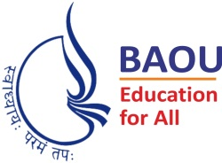
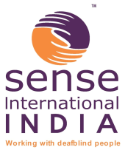
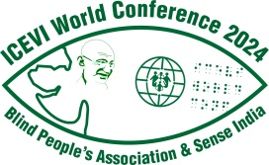

International Council for Education of
People with Visual Impairment

World Conference and General Assembly

Call for Papers

“Inclusion in diversity:
Equity and accessibility for all”

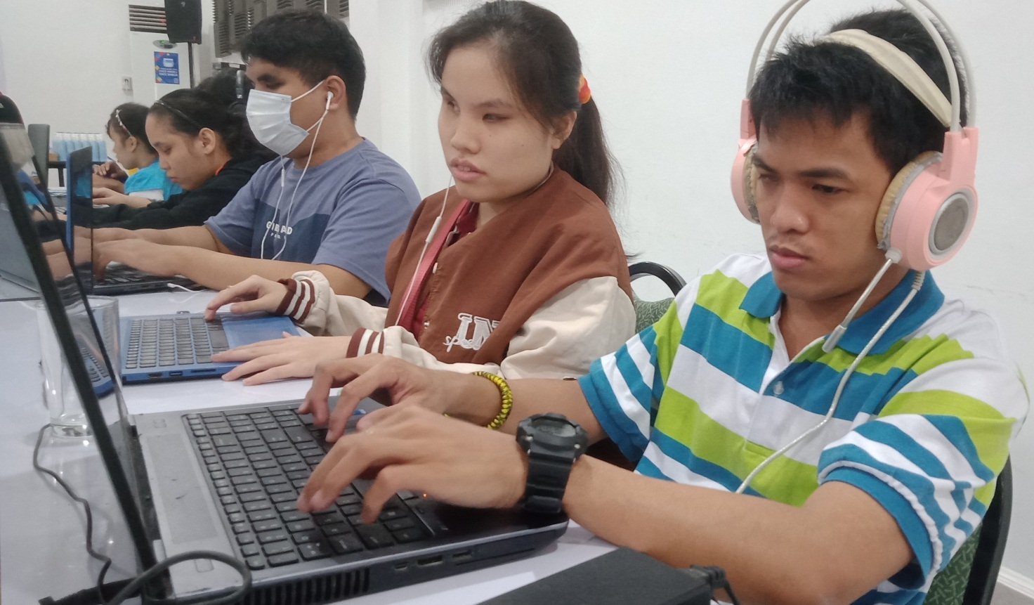

14-17 November 2024 ♦ Ahmedabad, INDIA

President’s Message

It is with much pleasure that I extend to you on behalf of the Executive Board of ICEVI an invitation to join us in Ahmedabad, India for our World Conference and General Assembly, in November, 2024. The Host Committee is already hard at work and determined that the World Conference will be a great learning experience.

We are delighted that Ms Siân Tesni has agreed to serve as Chair of the Programme Committee and we hope that many of you will respond to this “Call for Papers” by submitting an abstract for consideration.

I have known and worked with many members of the Host Committee for years and can assure you that this is a group that will spare no effort in assuring you a warm welcome and a fabulous Indian experience.

I look forward to welcoming you to the 2024 World Conference and sharing insights into current research and practice in the field of visual impairment.

Sincerely,

Frances Gentle
President, ICEVI

Programme Committee’s Invitation

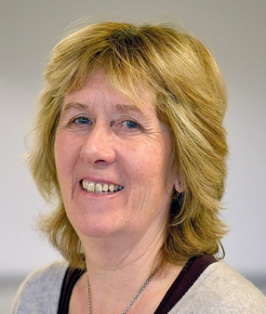
On behalf of the Programme Committee for the ICEVI 2024 World Conference, it is my great pleasure to invite you to respond to this Call for Papers by submitting an Abstract no later than 30 November 2023.

The theme of the conference is “Inclusion in Diversity: Equity and Accessibility For All”.

To support this overall theme, the Programme Committee is seeking abstracts for high quality presentations.
Types of presentations:

- Oral Presentations
- Interactive workshops
- Poster sessions

We look forward to receiving your abstract for consideration no later than 30 November 2023.

Siân Tesni
Chair, Programme Committee

Conference Aims

Inclusion in Diversity: Equity and Accessibility For All
- To promote dialogue on issues and practices that reflect the conference theme of “Inclusion in Diversity: Equity and Accessibility For All”.
- To facilitate the exchange of ideas, experience, research and practice through formal and informal interactions.
- To explore the status of equitable, quality education, habilitation and rehabilitation for children and young people with a visual impairment, deafblindness or multiple disabilities at national, regional and global levels.
- To facilitate interaction with international experts, researchers and practitioners in the field of visual impairment as they respond to the conference theme.

We invite you to submit an abstract on one of topic themes listed linked to the overall conference theme of “Inclusion in Diversity: Equity and Accessibility For All”:

- Accessibility
- Equity of Access to and participation in Education (lifelong learning)
- Multiple Disability, Deafblindness and Visual Impairment (MDVI)
- Innovations
- Low Vision
- Assessment Procedures
- Community Based Inclusive Development Approaches
- Life Skills
- Access to ICT and Adaptive / Assistive Technology
- Professional Collaboration / Multidisciplinary and Transdisciplinary Teams
- Advocacy
- Climate Change
- Inclusive Eye Health and Education
- Mental Health

On your abstract form, you will be asked to state your area of focus, the topic and type of presentation. For example

Area : Access to Literacy through Alternative Formats
Topic : Methods of teaching braille to children with multiple disabilities
Type of Presentation : ☐ Oral Presentations
☐ Interactive workshops
☐ Poster sessions

Programme Presentation Descriptions

Oral Paper presentation (lecture)
You are invited to submit an abstract in English, no longer than 200 words, describing a presentation of approximately 15 - 20 minutes in length. All abstracts must be linked to one of the themes listed above.

Abstracts on similar topics will be grouped together within a parallel session.

Workshops
A workshop presents an opportunity for a ‘hands-on’ interactive, participatory session. Workshops will be allocated 60-90 minutes and the abstract must demonstrate how the presentation fits the above criterion.

Posters
A Poster offers the opportunity to present research findings, special projects, programme descriptions, educational materials or equipment etc., in an informal way.

Translation
There will be stage translation of the plenary presentations only into English, French and Spanish languages. No translation will be available for concurrent sessions.

The following equipment will be available for the presentations: Overhead projector, Laptop

Requirements for Abstract Submission

Please complete the ‘Official Abstract Form’ and submit online using the ICEVI website www.icevi.org / Conference website www.icevi2024wc.org or by email or post to the Conference Secretariat by 30 November 2023. The Programme Committee will review all abstracts submitted when creating the conference programme. All types of presentation will be considered equally.

The Programme Committee can only accept Abstracts that are written in English. If accepted, the abstract will appear in print in the exact form as it is received.

Pre and Post Conference Workshops

The Programme and Host Committees are planning for Pre and Post conference workshops on a variety of topics. More information on the workshops will be posted on ICEVI website and the dedicated ICEVI Conference Website.

For abstract submission by email or post, contact:

Ms Siân Tesni
Chair, Programme Committee
ICEVI SECRETARIAT
No.3, Professors’ Colony, Sri Ramakrishna Vidyalaya Post,
Coimbatore - 641 020, Tamil Nadu,
INDIA.
E-mail: oficevi@gmail.com
Website: www.icevi.org

For registration and accommodation, contact:

Dr Bhushan Punani
Chair, Host Committee
Executive Secretary, Blind People’s Association (India)
132 Ft. Ring Road, Vastrapur, Ahmedabad, Gujarat - 380 015,
INDIA.
E-mail: icevi2024wc@gmail.com
Website: www.icevi2024wc.org ; https://iceviwestasia.in

ICEVI World Conference

14-17 November 2024 ♦ Ahmedabad, INDIA

Inclusion in Diversity: Equity and Accessibility For All

OFFICIAL ABSTRACT FORM

Lead Presenter (Contact Person)

Title : Prof. ☐ Dr. ☐ Mr. ☐ Ms. ☐ Mrs. ☐

Last Name Middle Name Full Name
Position :
Address :
City/Town :
State/Region :
Country :
Postal/Zip Code :
Telephone : Home : Work :
Mobile : Email :

Co-presenter/s (if applicable*)

Title : Prof. ☐ Dr. ☐ Mr. ☐ Ms. ☐ Mrs. ☐

Last Name Middle Name Full Name

Position :
Address :
City/Town :
State/Region :
Country :
Postal/Zip Code :
Telephone : Home : Work :
Mobile : Email :

*Only include those presenters who are attending the conference
1. My preferred presentation format is
☐ Oral Presentation (15-20 minutes)
☐ Interactive Workshop (45 minutes)
☐ Poster session

2. My presentation will fall under the Topic
- Accessibility
A1 ☐ Communication: Access to Literacy through Alternative Formats (e.g., Braille, Print, Digital)
A2 ☐ Reasonable accommodations

- Equity of Access to and participation in Education (lifelong learning)
B1 ☐ Early Childhood Intervention
B2 ☐ Lifelong learning
B3 ☐ Teacher Capacity
B4 ☐ Capacity building of the education workforce
B5 ☐ Inclusive education practices
B6 ☐ Alternative Education Models for Children and Young Adults with Visual Impairment
B7 ☐ Creating Educational Equity for Women and Girls with Visual Impairment
B7 ☐ Access to Curricular and Extra-Curricular activities
B8 ☐ Rebuilding Educational Systems in Countries affected by War, Emergencies or Natural Disasters.
B9 ☐ Education in emergencies: considerations for on-going education provision for persons with visual impairment
B10 ☐ Accessing the STEM curriculum
B11 ☐ Access and participation in education throughout the education journey (from early years through to Higher Education)
B12 ☐ Transition
B13 ☐ Arts and recreation as important aspects of development

- ☐ Multiple Disability, Deafblindness and Visual Impairment (MDVI)

- Innovations
D1 ☐ Service delivery models
D2 ☐ Innovative Use of Community Resources

- ☐ Low Vision

- Assessment Procedures
F1 ☐ Theory / practice
F2 ☐ Flexible formats of assessment
- Community Based Inclusive Development Approaches
G1 ☐ Working with Families and Caregivers
G2 ☐ Working with community-based stakeholders, including OPDs
G3 ☐ Multi-stakeholder engagement in service delivery: from detection to education
G4 ☐ Involving representatives of Organisations of Persons with Disabilities (OPDs) in service delivery

- Life Skills
H1 ☐ Orientation and Mobility
H2 ☐ Social Skills
H3 ☐ Livelihood
H4 ☐ Vocational Skills
H5 ☐ Adult education

- Access to ICT and Adaptive / Assistive Technology
I1 ☐ Latest developments in digital technology
I2 ☐ e-learning

- ☐ Professional Collaboration / Multidisciplinary and Transdisciplinary Teams

- Advocacy
K1 ☐ Influencing in the Education Sector
K2 ☐ Leaving no one behind – the SDG challenge
K3 ☐ The Marrakesh Treaty: Access to literacy

- Climate change
L1 ☐ Impact of climate change on the lives of persons with visual impairment, deafblindness or multiple disabilities
L2 ☐ Climate Education for children with visual impairment

- Inclusive Eye Health and Education
M1 ☐ Multi-stakeholder engagement in inclusive eye health delivery
M2 ☐ Eye health and education

- Mental Health
N1 ☐ Psychosocial needs and support
N2 ☐ Requirements for counselling services

3. My preferred presentation language is

4. Title for Presentation (not more than 25 words)

5. Abstract (Not more than 200 words in English only)

Please email or post your completed Official Abstract Form by 30th November 2023 to:

Siân Tesni
Chairperson of the Programme Committee
C/o. ICEVI SECRETARIAT
No.3, Professors’ Colony, Sri Ramakrishna Vidyalaya Post, Coimbatore 641 020,
Tamil Nadu, INDIA
E-mail: oficevi@gmail.com

