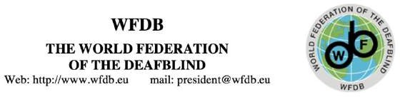

Manifesto for the Recognition of the International Day of Deafblindness

Introduction
Every year, on the 27th of June, on Helen Keller's birthday, we rally to remind the world that the deafblind community exists and it must be visible. Through various events, manifestations, conferences, and exhibitions, we highlight the importance and contributions of the deafblind community globally.

Our Mission
We urge governments and international organizations to officially recognize the International Day of Deafblindness. The World Federation of the Deafblind (WFDB) has launched a formal campaign to achieve this recognition at the United Nations. This initiative gathered interest to support from Croatia, Malta, Germany, Finland, Poland, Italy, and Jordan. Official recognition is essential for ensuring our community receives visibility, support, and resources.
Call to Action
This year, we call on every individual to get involved in their local organizations and for those organizations to connect with their global counterparts. Only together we can realize our dream of achieving official UN recognition of the International Day of Deafblindness.

Deafblind dreams become Deafblind reality!!

Goals
- Official Recognition: We seek official recognition from the United Nations of the International Day of Deafblindness.
- Increased Awareness: Raise global awareness about the challenges that Deafblind individuals face every day.
- Empowerment and Inclusion: Promote empowerment and inclusion of deafblind individuals in all aspects of society.

Inspiration from Recognized Days
Our movement is inspired by the other internationally recognized days, such as:
  - White Cane Safety Day
  - International Day of Sign Languages
  - World Down Syndrome Day

A Unified Movement
Now is the key moment to move TOGETHER towards our goal. We must ensure that no one is left behind. By uniting our efforts, we can make every Deafblind individual seen, heard, and celebrated.
Conclusion
Unite with us in our efforts to gain the recognition and support we need. Be part of this historical movement and help us achieve our dream!
Join us in this transformative movement. Stand with us as we push for the recognition we deserve. Together, we can make our dreams come true.

Deafblind dreams become Deafblind's reality!!!

President: Sanja Tarczay
Medulićeva 34, Zagreb 10 000, Croatia E-mail:president@wfdb.eu
Facebook: https://www.facebook.com/wfdb.eu

